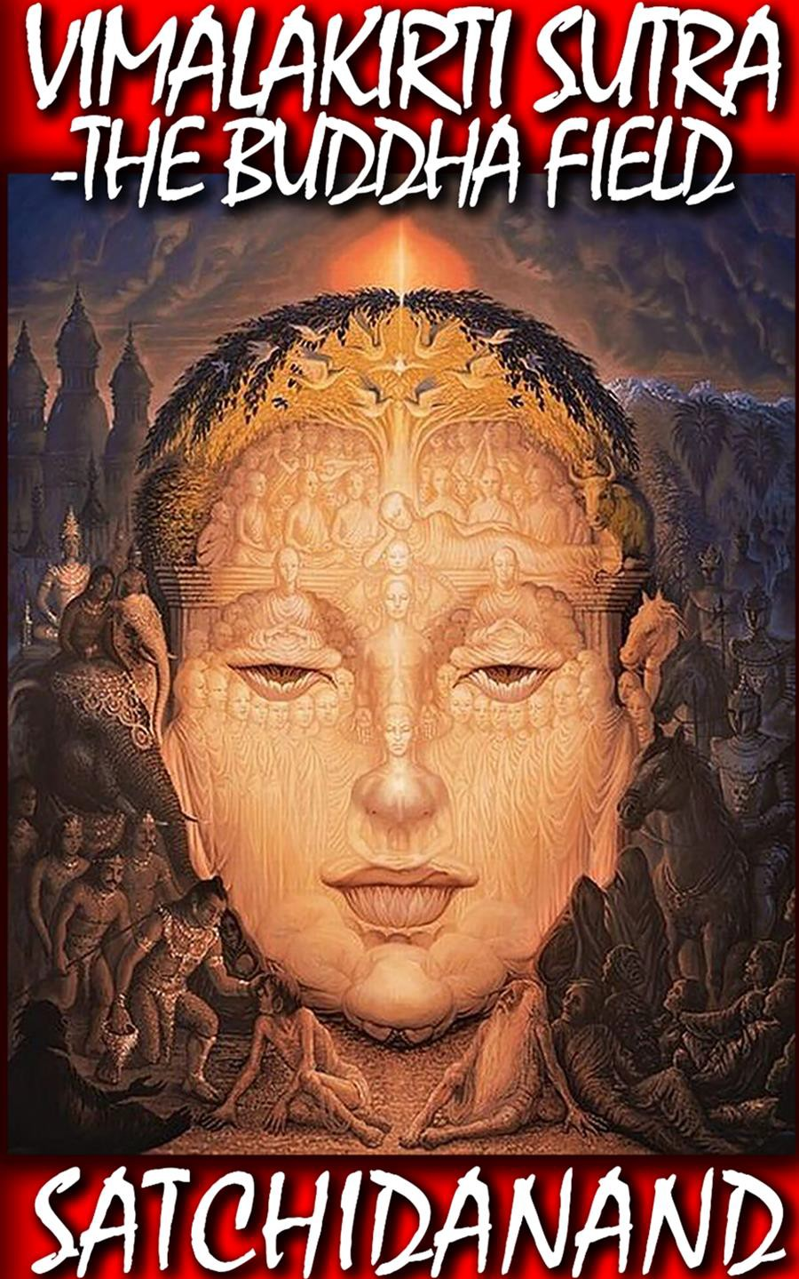

1

DEDICATION

With all Thanks, Love and Gratitude to Swami Devi Dhyani and the Energy Enhancement Book Editor Prema PraShakti who makes these books possible.
With all Thanks, Love and Gratitude to my Mother and Father and to all my other Teachers, Theos Bernard, Sri Yogendra, Eric Berne, Gurdjieff, Father Bede Griffiths, Osho, Zen Master Hogen, Swami Sivananda, Swami Satchitananda, and all the other giants upon whose shoulders I stand - who made me able to be what… I AM – Swami Satchidanand

Copyright © 2017

[Energy Enhancement Synthesis of Light Limited (SOL)]

All rights reserved. This publication may be reproduced in whole or in part, by any person under fair use as long as we are referenced, without written permission of:
Swami Satchidanand

sol@energyenhancement.org www.energyenhancement.org

Table of Contents

Vimalakirti Sutra Chapter 1: The Purification - the Removal of Energy Blockages - And the Augmentation of Psychic Powers - Caused by the Buddhafield 6
Vimalakirti Sutra Chapter 2 - Inconceivable Skill in Enlightenment Liberative Technique, Dharma, Connection with the Infinite Chakras above the Head - Gnosis, conquered all demons, transcendence of wisdom, tolerance and self-control, respected by Indra, Brahma, and all the Lokapalas 25
Vimalakirti Sutra Chapter 3: The Disciples' Reluctance to Visit Vimalakirti - Meditation, The Dharma - The Path of the Soul Chakra, The First Chakra above the Head - Renunciation, the Tathagata, the Saint, the perfectly accomplished Buddha, Gnosis with the Infinite Chakras above the Head 35
Vimalakirti Sutra Chapter 5 - The Consolation of the Invalid, intellect, Buddhas, Bodhisattvas, disciples, Sakras, Brahmas, Lokapalas, Gods, and Goddesses, The infinite chakra above the head, emptiness, nirvana, civilizing all the abodes of Devils, Mara Energy Blockages, consummate in wisdom and liberative technique
..........................................................................................................78
Vimalakirti Chapter 6 The Inconceivable Liberation Living Immortally – Immortality Sariputra, Dharma issues not from the intellect of the mind but from the Soul, the first chakra above the head. 103
Vimalakirti Sutra Chapter 7: Manjusri, Compassion, the Great Love of the Bodhisattvas towards Humanity, generating the Love that is firm, Love its high resolve unbreakable, Love like a diamond.
Energy Blockage Evil spirits cannot disturb the fearless. The perfect enlightenment of Buddhahood. 122
Vimalakirti Sutra Chapter 8 The Family of the Tathagatas - stores of merit and wisdom, true bodhisattvas, the transcendence of wisdom, the skill in liberative technique, joy in the Dharma, Love and compassion and the truth 146
Vimalakirti Sutra - Chapter 9 - The Dharma-door of nonduality of the Soul Chakra above the Head talking about connection, gnosis with the infinite chakras above the head as being the start of transcendence, indestructability, enlightenment - Energy Enhancement!! 166
Vimalakirti Sutra Ch 10 - the Fragrance Buddha, Sariputra, bodhisattvas, Tathagata, discourses for disciplining of the wild and uncivilized, the ten virtuous practices, the eight qualities 176
Vimalakirti Sutra Chapter 11 - The Practices of Bodhisattvas, Buddhafields that accomplish the buddha-work by means of bodhisattvas, liberation of bodhisattvas called 'destructible and indestructible.' 194
Vimalakirti Sutra Chapter 12 - Vision of the Universe Abhirati and the Tathagata Aksobhya Buddhafields - The Tathagata, Sariputra and Miraculous Feats 218
Vimalakirti Sutra Chapter 13 - Antahkarana Antecedents and Transmission of the Holy Dharma of the Soul Chakra, the first Chakra above the head - Enlightenment!! 229
Vimalakirti Sutra Chapter 14 - Entrustment of the Dharma Teaching of Fusion with the Soul Chakra, the first Chakra above the Head - Intuition, Genius, Conscience - Illumination, Enlightenment 247
Chapter 15- THE BUDDHIST ENERGY ENHANCEMENT KUNDALINI KEY IS THE THE BUDDHIST STUPA 265
Satchidanand Biography 276

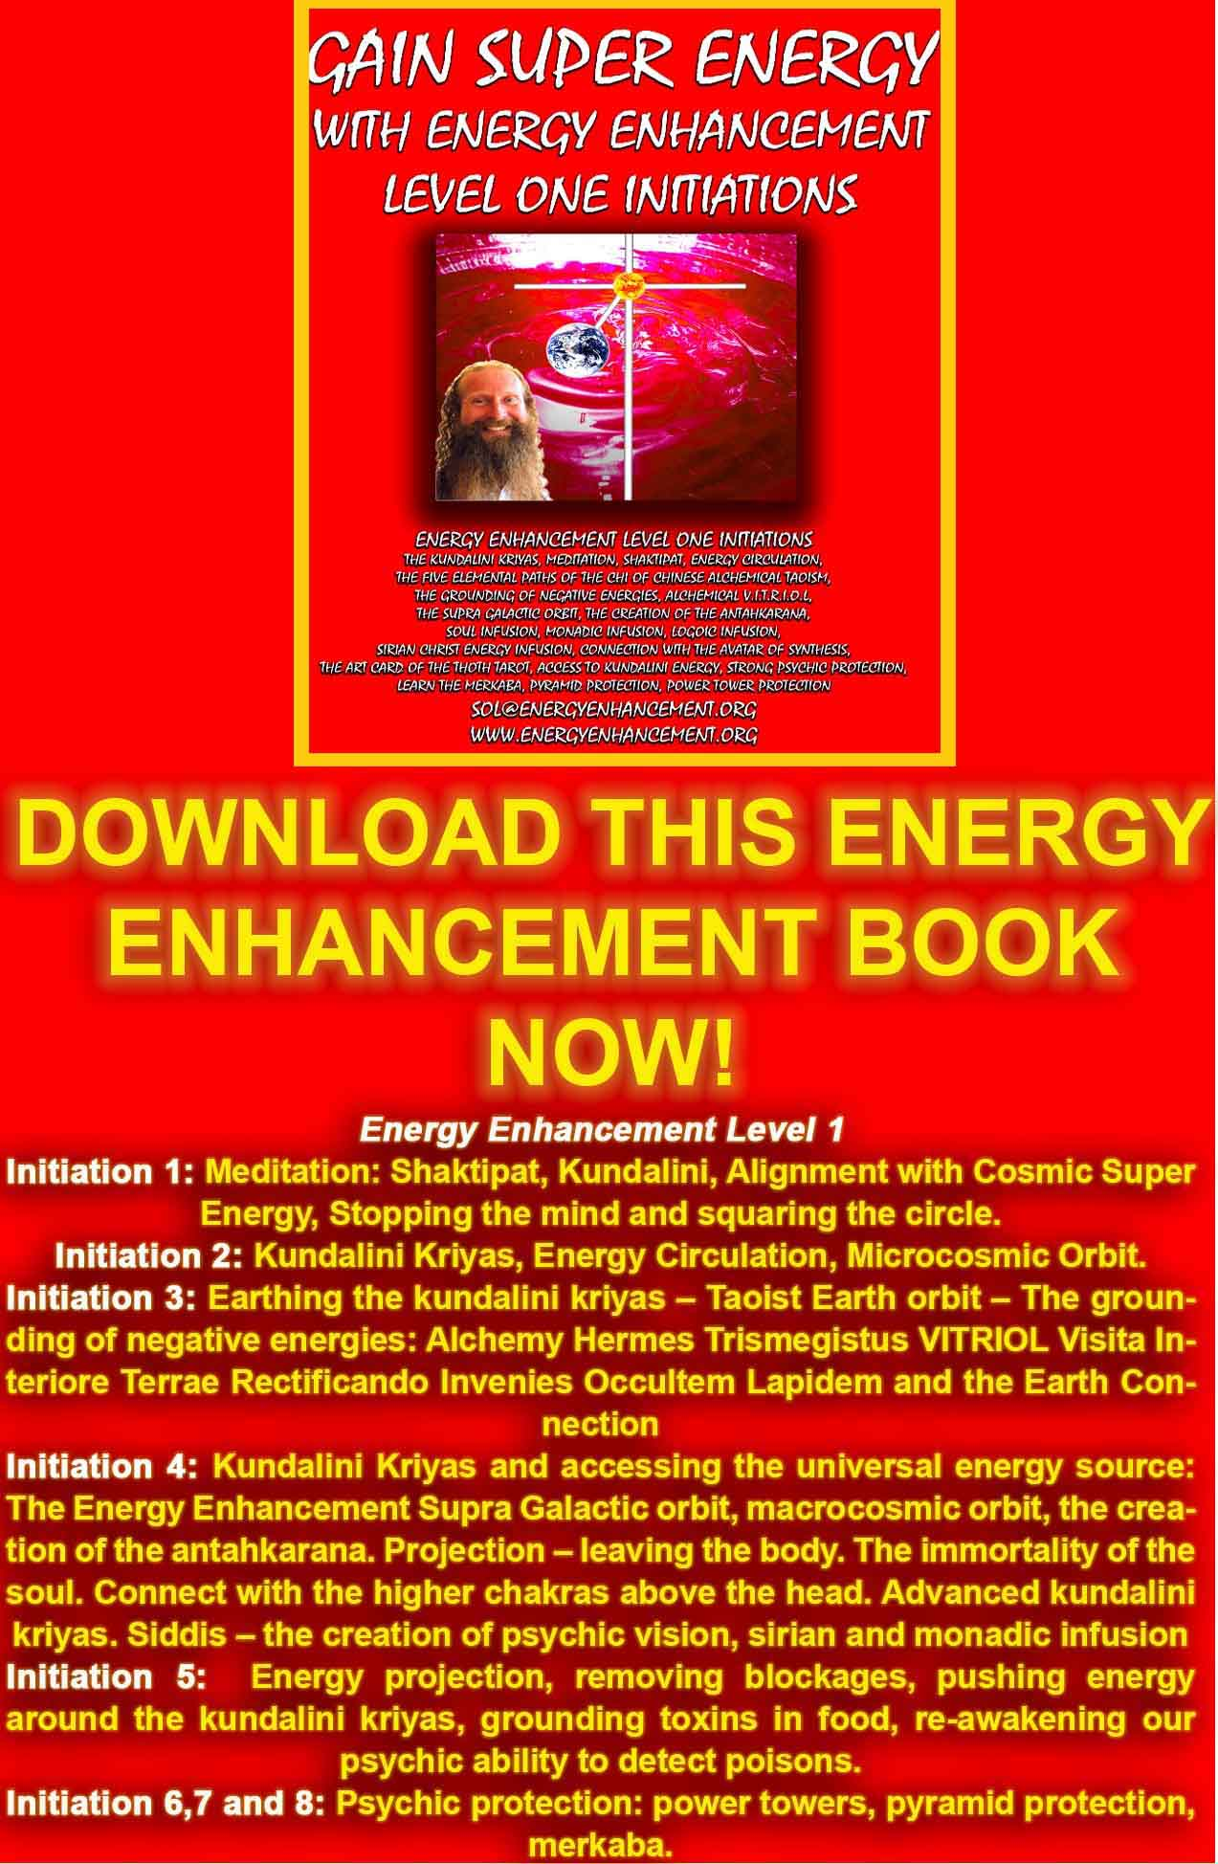
DOWNLOAD “GAIN SUPER ENERGY WITH ENERGY ENHANCEMENT LEVEL ONE INITIATIONS HERE!!!
http://www.energyenhancement.org/Sacred-Energy/Gain-Super-Energy-Energy-Enhancement-Level1-Initiations-Kundalini-Kriyas-Meditation-Shaktipat-Circulation-Taoist-Orbits-Alchemy-VITRIOL-Grounding-Psychic-Protection-Pyramid-Merkaba-energyenhancement-org.pdf
Vimalakirti Sutra -
The Buddhafield
Buddhas, Bodhisattvas, Aryasravakas, and Pratyekabuddhas conquering demons, natural spiritual benefactors of all living beings, free from impurities, expert in knowing the spiritual faculties of all living beings, high resolve as hard as diamond, unbreakable in their faith in Buddha, Dharma and Sangha, they showered forth the rain of ambrosia that is released by the light rays f the jewel of the Dharma, which shines everywhere.

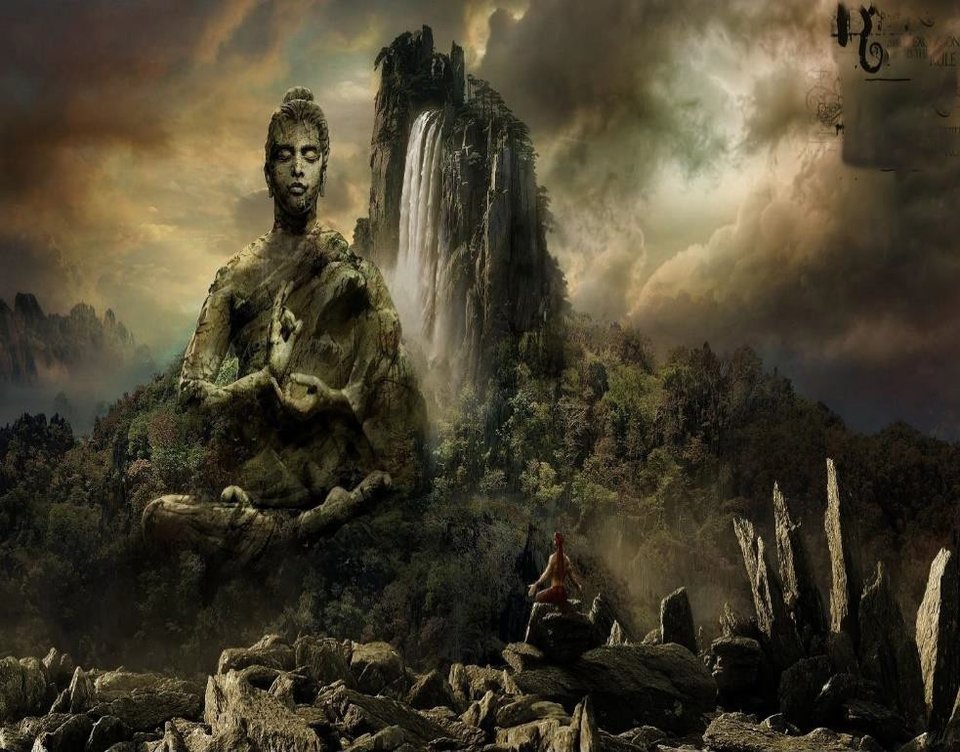

Vimalakirti Sutra Chapter 1: The Purification - the Removal of Energy Blockages - And the Augmentation of Psychic Powers - Caused by the Buddhafield
Reverence to all Buddhas, Bodhisattvas, Aryasravakas, and Pratyekabuddhas, in the past, the present, and the future.

Thus have I heard at one time.

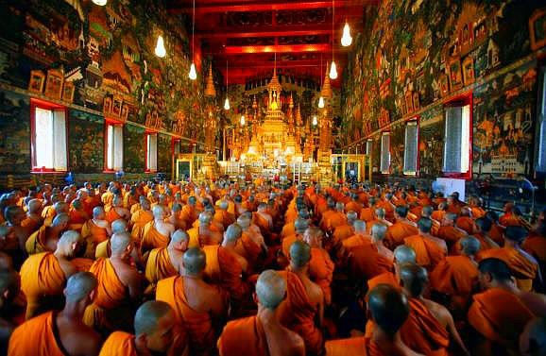

The Lord Buddha was in residence in the garden of Amrapali, in the city of Vaisali, attended by a great gathering. Of bhikshus there were eight thousand, all saints. They were free from impurities and afflictions, and all had attained self-mastery.

Their minds were entirely liberated by perfect knowledge. They were calm and dignified, like royal elephants. They had

accomplished their work, done what they had to do, cast off their burdens, attained their goals, and totally destroyed the bonds of existence. They all had attained the utmost perfection of every form of mind control.

Of bodhisattvas there were thirty-two thousand, great spiritual heroes who were universally acclaimed. They were dedicated through the penetrating activity of their great super-knowledges and were sustained by the grace of the Buddha. Guardians of the city of Dharma, they upheld the true doctrine, and their great teachings resounded like the lion's roar throughout the ten directions.

Without having to be asked, they were the natural spiritual benefactors of all living beings.

They maintained unbroken the succession of the Three Jewels, conquering demons and foes and overwhelming all critics.



Their mindfulness, intelligence, realization, meditation, incantation, and eloquence all were perfected. They had attained the intuitive tolerance of the ultimate incomprehensibility of all things.

They turned the irreversible wheel of the Dharma. They were stamped with the insignia of signlessness. They were expert in knowing the spiritual faculties of all living beings.

They were brave with the confidence that overawes all assemblies. They had gathered the great stores of merit and of wisdom, and their bodies, beautiful without ornaments, were adorned with all the auspicious signs and marks.

They were exalted in fame and glory, like the lofty summit of Mount Sumeru. Their high resolve as hard as diamond, unbreakable in their faith in Buddha, Dharma and Sangha, they showered forth the rain of ambrosia that is released by the light rays of the jewel of the Dharma, which shines everywhere.

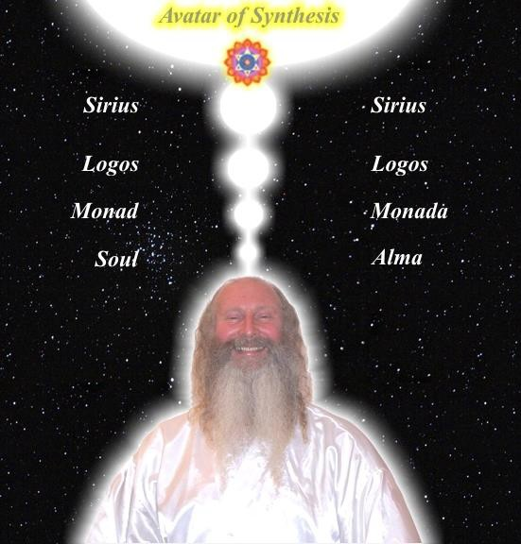
JEWEL IS THE CHAKRA.
DHARMA - THE ENERGY AND WILL OF THE SOUL, IS THE FIRST CHAKRA ABOVE THE HEAD

Their voices were perfect in diction and resonance, and versatile in speaking all languages. They had penetrated the profound principle of relativity and had destroyed the persistence of the instinctual mental habits underlying all convictions concerning finitude and infinitude.

They spoke fearlessly, like lions, sounding the thunder of the magnificent teaching. Unequaled, they surpassed all measure. They were the best captains for the voyage of discovery of the treasures of the Dharma, the stores of merit and wisdom. They were expert in the way of the Dharma, which is straight, peaceful, subtle, gentle, hard to see, and difficult to realize.

They were endowed with the wisdom that is able to understand the thoughts of living beings, as well as their comings and goings. They had been consecrated with the anointment of the peerless gnosis of the Buddha. With their high resolve, they approached the ten powers, the four fearlessnesses, and the eighteen special qualities of the Buddha...

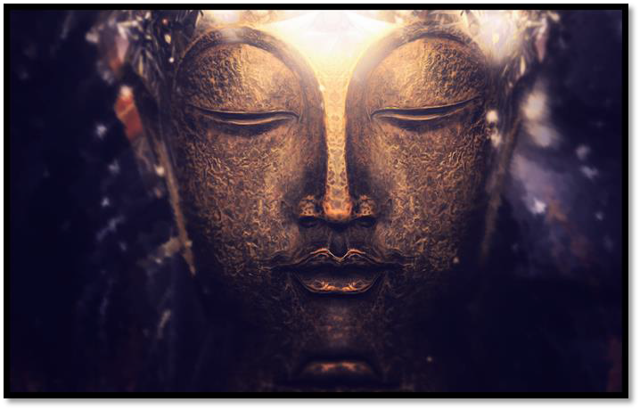
They had crossed the terrifying abyss of the bad migrations, and yet they assumed reincarnation voluntarily in all migrations for the sake of disciplining living beings. Great Kings of medicine,

understanding all the sicknesses of passions, they could apply the medicine of the Dharma appropriately.

They were inexhaustible mines of limitless virtues, and they glorified innumerable buddhafields with the splendor of these virtues (Angel psychic gifts).

They conferred great benefit when seen, heard, or even approached. Were one to extol them for innumerable hundreds of thousands of myriads of aeons, one still could not exhaust their mighty flood of virtues (Angel psychic gifts).

These bodhisattvas were named: Samadarsana, Asamadarsana, Samadhivikurvitaraja, Dharmesvara, Dharmaketu, Prabhaketu, Prabhavyuha, Ratnavyuha, Mahavyuha, Pratibhanakuta, Ratnakuta, Ratnapani, Ratnamudrahasta, Nityapralambahasta, Nityotksipthasta, Nityatapta, Nityamuditendriya, Pramodyaraja, Devaraja, Pranidhanapravesaprapta, Prasiddhapratisamvitprapta, Gaganaganja, Ratnolkaparigrhita, Ratnasura, Ratnapriya, Ratnasri, Indrajala, Jaliniprabha, Niralambanadhyana, Prajnakuta, Ratnadatta, Marapramardaka, Vidyuddeva, Vikurvanaraja, Kutanimittasamatikranta, Simhanadanadin, Giryagrapramardiraja, Gandhahastin, Gandhakunjaranaga, Nityodyukta, Aniksiptadhura, Pramati, Sujata, Padmasrigarbha, Padmavyuha, Avalokitesvara, Mahasthamaprapta, Brahmajala, Ratnadandin, Marakarmavijeta, Ksetrasamalamkara, Maniratnacchattra, Suvarnacuda, Manicuda, Maitreya, Manjusrikumarabhuta, and so forth, with the remainderof the thirty-two thousand.

There were also gathered there ten thousand Brahmas, at their head Brahma Sikhin, who had come from the Asoka universe with its four sectors to see, venerate, and serve the Buddha and to hear the Dharma from his own mouth. There were twelve thousand Sakras, from various four-sector universes. And there were other powerful gods: Brahmas, Sakras, Lokapalas, devas, nagas, yaksas, gandharvas, asuras, garudas, kimnaras, and mahoragas. Finally, there was the fourfold community, consisting of bhikshus, bhikshunis, laymen, and laywomen.

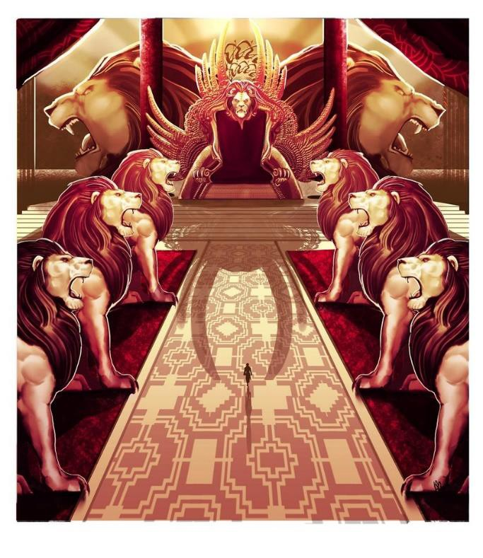
The Lord Buddha, thus surrounded and venerated by these multitudes of many hundreds of thousands of living beings, sat upon a majestic lion-throne and began to teach the Dharma. Dominating all the multitudes, just as Sumeru, the king of mountains, looms high over the oceans, the Lord Buddha shone, radiated, and glittered as he sat upon his magnificent lion-throne.

Thereupon, the Licchavi bodhisattva Ratnakara, with five hundred Licchavi youths, each holding a precious parasol made of seven different kinds of jewels, came forth from the city of Vaisali and presented himself at the grove of Amrapali. Each approached the Buddha, bowed at his feet, circumambulated him clockwise seven times, laid down his precious parasol in offering, and withdrew to one side.

As soon as all these precious parasols had been laid down, suddenly, by the miraculous power of the Lord, they were transformed into a single precious canopy so great that it formed a covering for this entire billion-world galaxy. The surface of the entire billion-world galaxy was reflected in the interior of the great precious canopy, where the total content of this galaxy could be seen: limitless mansions of suns, moons, and stellar bodies; the realms of the devas, nagas, yaksas, gandharvas, asuras, garudas, kimnaras, and mahoragas, as well as the realms of the four Maharajas; the king of mountains, Mound Sumeru; Mount Himadri, Mount Mucilinda, Mount Mahamucilinda, Mount Gandhamadana, Mount Ratnaparvata, Mount Kalaparvata, Mount Cakravada, Mount Mahacakravada; all the great oceans, rivers, bays torrents, streams, brooks, and springs; finally, all the villages, suburbs, cities, capitals, provinces, and wildernesses. All this could be clearly seen by everyone. And the voices of all the Buddhas of the ten directions could be heard proclaiming their teachings of the Dharma in all the worlds, the sounds reverberating in the space beneath the great precious canopy.
At this vision of the magnificent miracle effected by the supernatural power of the Lord Buddha, the entire host was ecstatic, enraptured, astonished, delighted, satisfied, and filled with awe and pleasure. They all bowed down to the Tathagata, withdrew to one side with palms pressed together, and gazed upon him with fixed

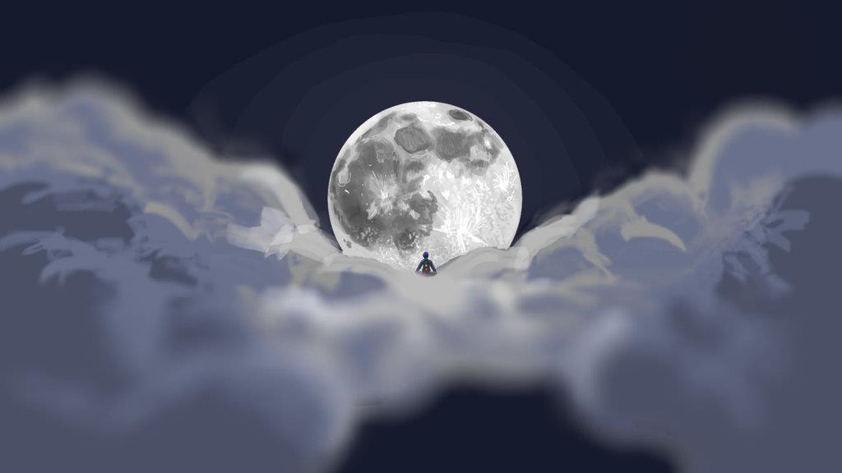

attention. The young Licchavi Ratnakara knelt with his right knee on the ground, raised his hands, palms pressed together in salute of the Buddha, and praised him with the following hymn.
Pure are your eyes, broad and beautiful, like the petals of a blue lotus.
Pure is your thought, having discovered the supreme transcendence of all trances.

Immeasurable is the ocean of your virtues, the accumulation of your good deeds.
You affirm the path of peace.
Oh, Great Ascetic, obeisance to you!

Leader, bull of men, we behold the revelation of your miracle. The superb and radiant fields of the Sugatas appear before us, And your extensive spiritual teachings, that lead to immortality Make themselves heard throughout the whole reach of space.

Dharma-King, you rule with the Dharma your supreme Dharma- kingdom,
And thereby bestow the treasures of the Dharma upon all living beings.
Expert in the deep analysis of things, you teach their ultimate meaning.
Sovereign Lord of Dharma, obeisance to you.

All these things arise dependently, from causes, Yet they are neither existent nor nonexistent.
Therein is neither ego, nor experiencer, nor doer, Yet no action, good or evil, loses its effects.
Such is your teaching.

O Sakyamuni, conquering the powerful host of Mara,
You found peace, immortality, and the happiness of that supreme enlightenment,
Which is not realized by any among the heterodox,
Though they arrest their feeling, thought and mental processes.

O Wonderful King of Dharma,
You turned the wheel of Dharma before men and gods, With its threefold revolution, its manifold aspects,
Its purity of nature, and its extreme peace; And thereby the Three Jewels were revealed.

Those who are well disciplined by your precious Dharma Are free of vain imaginings and always deeply peaceful.

Supreme doctor, you put an end to birth, decay, sickness, and death. Immeasurable ocean of virtue, obeisance to you!

Like Mount Sumeru, you are unmoved by honor or scorn. You love moral beings and immoral beings equally.
Poised in equanimity, your mind is like the sky.
Who would not honor such a precious jewel of a being?

Great Sage, in all these multitudes gathered here,
Who look upon your countenance with hearts sincere in faith, Each being beholds the Victor, as if just before him.
This is a special quality of the Buddha.

Although the Lord speaks with but one voice, Those present perceive that same voice differently,
And each understands in his own language according to his own needs.
This is a special quality of the Buddha.

From the Leader's act of speaking in a single voice,
Some merely develop an instinct for the teaching, some gain realization,
Some find pacification of all their doubts. This is a special quality of the Buddha.

Obeisance to you who command the force of leadership and the ten powers!
Obeisance to you who are dauntless, knowing no fear! Obeisance to you, leader of all living beings,
Who fully manifests the special qualities!

Obeisance to you who have cut the bondage of all fetters! Obeisance to you who, having gone beyond, stand on firm ground! Obeisance to you who save the suffering beings!
Obeisance to you who do not remain in the migrations!

You associate with living beings by frequenting their migrations. Yet your mind is liberated from all migrations.

Just as the lotus, born of mud, is not tainted thereby,
So the lotus of the Buddha preserves the realization of voidness.

You nullify all signs in all things everywhere.
You are not subject to any wish for anything at all.
The miraculous power of the Buddhas is inconceivable. I bow to you, who stand nowhere, like infinite space.

Then, the young Licchavi Ratnakara, having celebrated the Buddha with these verses, further addressed him:

"Lord, these five hundred young Licchavis are truly on their way to unexcelled, perfect enlightenment, and they have asked what is the bodhisattvas' purification of the buddhafield.

Please, Lord, explain to them the bodhisattvas' purification of the buddhafield!"
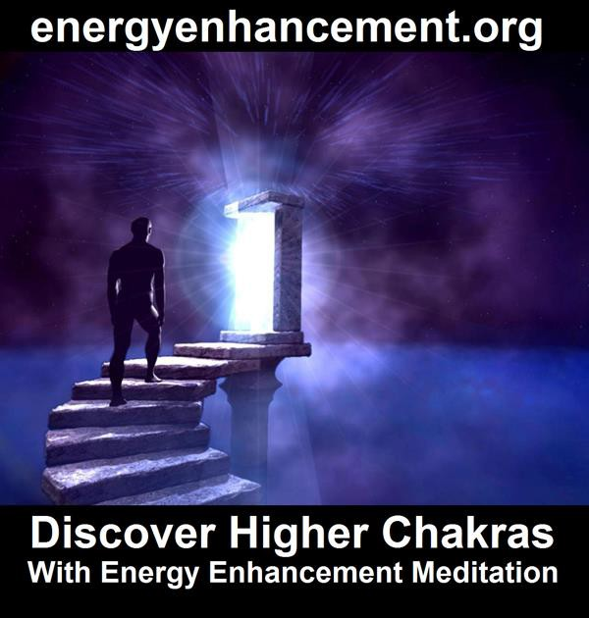
Satchidanand's Movie Reviews
DOWNLOAD BELOW
http://www.energyenhancement.org/Spiritual-Movie-Reviews/Energy-Enhancement-spiritual-esoteric-movie-reviews-by-Satchidanand.pdf

http://www.energyenhancement.org/Spiritual-Movie-Reviews-Satchidanand/Index.html

Energy Enhancement Spiritual Movie Reviews Book - Volume 1 by Satchidanand Immortalises the Kundalini Energy which Radiates from Satanically Blacklisted by the Dark Side - Movies like..
King Arthur - Legend of the Sword The Story of Enlightenment - by Guy Ritchie - a Movie Review by Satchidanand
Karma and Anti-Satanism in the Spiritual Actor, Keanu Reeves movies, "John Wick (2014)" also "Man of Tai Chi (2013)"
John Wick Ch 2 - Is Donald Trump and Alex Jones of Infowars - The Spiritual Warrior - Finger of God - Removes Satanic Demons, Deletes the Elite, Cleans the Swamp - Move Witch, Get out the Way!
Doctor Strange - Psychic Warrior Earth Protector..
Logan - "Beware Of the Light" Esoteric Movie Review by Satchidanand
And Much Much More..
Energy Enhancement Spiritual Movie Reviews Book - Volume 1 by Satchidanand -


THE MOON SYMBOLISES THE FIRST CHAKRA ABOVE THE HEAD, THE DHARMA, THE SOUL

Upon this request, the Buddha gave his approval to the young Licchavi Ratnakara: "Good, good, young man!

Your question to the Tathagata about the purification of the buddha- field is indeed good. Therefore, young man, listen well and remember! I will explain to you the purification of the buddhafield of the bodhisattvas."

"Very good, Lord," replied Ratnakara and the five hundred young Licchavis, and they set themselves to listen.

THE BUDDHAFIELD

Thereupon the Lord touched the ground of this billion-world- galactic universe with his big toe, and suddenly it was transformed into a huge mass of precious jewels, a magnificent array of many hundreds of thousands of clusters of precious gems, until it

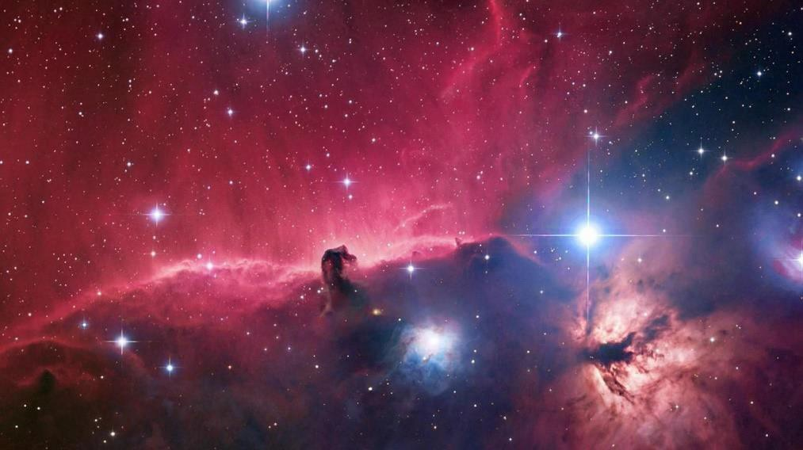
resembled the universe of the Tathagata Ratnavyuha, called Anantagunaratnavyuha.

The Buddha said, "Noble sons, a buddhafield of bodhisattvas is a field of living beings.

Why so? A bodhisattva embraces a buddhafield to the same extent that he causes the development of living beings.

He embraces a buddhafield to the same extent that living beings become disciplined.

He embraces a buddhafield to the same extent that, through entrance into a buddhafield, living beings are introduced to the buddha- gnosis.

He embraces a buddhafield to the same extent that, through entrance into that buddhafield, living beings increase their holy spiritual faculties. Why so? Noble son, a buddhafield of bodhisattvas springs from the aims of living beings.

"For example, Ratnakara, should one wish to build in empty space, one might go ahead in spite of the fact that it is not possible to build or to adorn anything in empty space. In just the same way, should a

bodhisattva, who knows full well that all things are like empty space, wish to build a buddhafield in order to develop living beings, he might go ahead, in spite of the fact that it is not possible to build or to adorn a buddhafield in empty space.

"Yet, Ratnakara, a bodhisattva's buddhafield is a field of positive thought.

When he attains enlightenment, living beings free of hypocrisy and deceit will be born in his buddhafield.

"Noble son, a bodhisattva's buddhafield is a field of high resolve.

When he attains enlightenment, living beings who have harvested the two stores and have planted the roots of virtue will be born in his buddhafield.

"A bodhisattva's buddhafield is a field of virtuous application.

When he attains enlightenment living beings who live by all virtuous principles will be born in his buddhafield.

"A bodhisattva's buddhafield is the magnificence of the conception of the spirit of enlightenment.

When he attains enlightenment, living beings who are actually participating in the Mahayana will be born in his buddhafield.

"A bodhisattva's buddhafield is a field of generosity.

When he attains enlightenment, living beings who give away all their possessions will be born in his buddhafield.

"A bodhisattva's buddhafield is a field of tolerance.

When he attains enlightenment, living beings with the transcendences of tolerance, discipline, and superior meditation - hence beautiful with the thirty-two auspicious signs - will be born in his buddhafield.

18

"A bodhisattva's buddhafield is a field of meditation.

When he attains enlightenment, living beings who are evenly balanced through mindfulness and awareness will be born in his buddhafield.

"A bodhisattva's buddhafield is a field of wisdom.

When he attains enlightenment, living beings who are destined for the ultimate will be born in his buddhafield.

"A bodhisattva's buddhafield consists of the four immeasurables. When he attains enlightenment, living beings who live by love, compassion, joy, and impartiality will be born in his buddhafield.

"A bodhisattva's buddhafield consists of the four means of unification.

When he attains enlightenment, living beings who are held together by all the liberations will be born in his buddhafield.

"A bodhisattva's buddhafield is skill in liberative technique.

When he attains enlightenment, living beings skilled in all liberative techniques and activities will be born in his buddhafield.

"A bodhisattva's buddhafield consists of the thirty-seven aids to enlightenment.

Living beings who devote their efforts to the four foci of mindfulness, the four right efforts, the four bases of magical power, the five spiritual faculties, the five strengths, the seven factors of enlightenment, and the eight branches of the holy path will be born in his buddhafield.

"A bodhisattva's buddhafield is his mind of total dedication.

When he attains enlightenment, the ornaments of all virtues will appear in his buddhafield.

"A bodhisattva's buddhafield is the doctrine that eradicates the eight adversities. When he attains enlightenment, the three bad migrations will cease, and there will be no such thing as the eight adversities in his buddhafield.

"A bodhisattva's buddhafield consists of his personal observance of the basic precepts and his restraint in blaming others for their transgressions. When he attains enlightenment, even the word 'crime' will never be mentioned in his buddhafield.

"A bodhisattva's buddhafield is the purity of the path of the ten virtues.

When he attains enlightenment, living beings who are secure in long life, great in wealth, chaste in conduct, enhanced by true speech, soft-spoken, free of divisive intrigues and adroit in reconciling factions, enlightening in their conversations, free of envy, free of malice, and endowed with perfect views will be born in his buddhafield.

"Thus, noble son, just as is the bodhisattva's production of the spirit of enlightenment, so is his positive thought. And just as is his positive thought, so is his virtuous application.

"His virtuous application is tantamount to his high resolve, his high resolve is tantamount to his determination, his determination is tantamount to his practice, his practice is tantamount to his total dedication, his total dedication is tantamount to his liberative technique, his liberative technique is tantamount to his development of living beings, and his development of living beings is tantamount to the purity of his buddhafield.

"The purity - the lack of energy blockages - of his buddhafield reflects the purity of living beings; the purity of the living beings reflects the purity of his gnosis; the purity of his gnosis reflects the purity of his doctrine; the purity of his doctrine reflects the purity of his transcendental practice; and the purity of his transcendental practice reflects the purity of his own mind."

Thereupon, magically influenced by the Buddha, the venerable Sariputra had this thought: "If the buddhafield is pure only to the extent that the mind of the bodhisattva is pure, then, when Sakyamuni Buddha was engaged in the career of the bodhisattva, his mind must have been impure. Otherwise, how could this buddhafield appear to be so impure?"

The Buddha, knowing telepathically the thought of venerable Sariputra, said to him, "What do you think, Sariputra? Is it because the sun and moon are impure that those blind from birth do not see them?"

Sariputra replied, "No, Lord. It is not so. The fault lies with those blind from birth, and not with the sun and moon."

The Buddha declared, "In the same way, Sariputra, the fact that some living beings do not behold the splendid display of virtues of the buddhafield of the Tathagata is due to their own ignorance. It is not the fault of the Tathagata. Sariputra, the buddhafield of the Tathagata is pure, but you do not see it."

Then the Brahma Sikhin said to the venerable Sariputra, "Reverend Sariputra, do not say that the buddhafield of the Tathagata is impure.

Reverend Sariputra, the buddhafield of the Tathagata is pure.

I see the splendid expanse of the buddhafield of the Lord Sakyamuni as equal to the splendor of, for example, the abodes of the highest deities."

Then the venerable Sariputra said to the Brahma Sikhin, "As for me, O Brahma, I see this great earth, with its highs and lows (Blockages), its thorns, its precipices, its peaks, and its abysses, as if it were entirely filled with ordure."

Brahma Sikhin replied, "The fact that you see such a buddhafield as this as if it were so impure, reverend Sariputra, is a sure sign that there are highs and lows (Blockages) in your mind and that your positive thought in regard to the buddha-gnosis is not pure either.

Reverend Sariputra, those whose minds are impartial toward all living beings and whose positive thoughts toward the buddha-gnosis are pure see this buddhafield as perfectly pure."

Thereupon the Lord touched the ground of this billion-world- galactic universe with his big toe, and suddenly it was transformed into a huge mass of precious jewels, a magnificent array of many hundreds of thousands of clusters of precious gems, until it resembled the universe of the Tathagata Ratnavyuha, called Anantagunaratnavyuha. Everyone in the entire assembly was filled with wonder, each perceiving himself seated on a throne of jeweled lotuses.

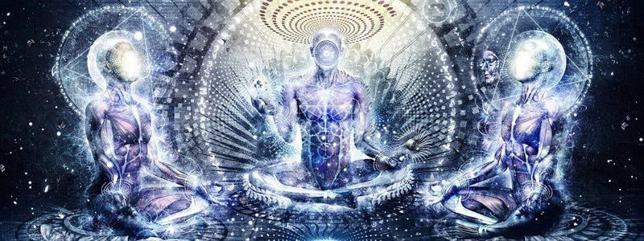

Then, the Buddha said to the venerable Sariputra, "Sariputra, do you see this splendor of the virtues of the buddhafield?"

Sariputra replied, "I see it, Lord! Here before me is a display of splendor such as I never before heard of or beheld!"

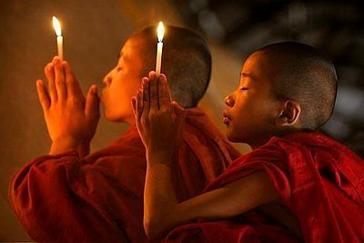
The Buddha said, "Sariputra, this Buddhafield is always thus pure, but the Tathagata makes it appear to be spoiled by many faults, in order to bring about the maturity of the inferior living beings.

For example, Sariputra, the gods of the Trayastrimsa heaven all take their food from a single precious vessel, yet the nectar which nourishes each one differs according to the differences of the merits each has accumulated.

Just so, Sariputra, living beings born in the same buddhafield see the splendor of the virtues of the buddhafields of the Buddhas according to their own degrees of purity."

When this splendor of the beauty of the virtues of the Buddhafield shone forth, eighty-four thousand beings conceived the spirit of unexcelled perfect enlightenment, and the five hundred Licchavi youths who had accompanied the young Licchavi Ratnakara all attained the conformative tolerance of ultimate birthlessness.

Then, the Lord withdrew his miraculous power and at once the buddhafield was restored to its usual appearance. Then, both men and gods who subscribed to the disciple-vehicle thought, "Alas! All constructed things are impermanent."

Thereby, thirty-two thousand living beings purified their immaculate, undistorted Dharma-eye in regard to all things.

The eight thousand bhikshus were liberated from their mental defilements, attaining the state of non-grasping.

And the eighty-four thousand living beings who were devoted to the grandeur of the buddhafield, having understood that all things are by nature but magical creations, all conceived in their own minds the spirit of unexcelled, totally perfect enlightenment.



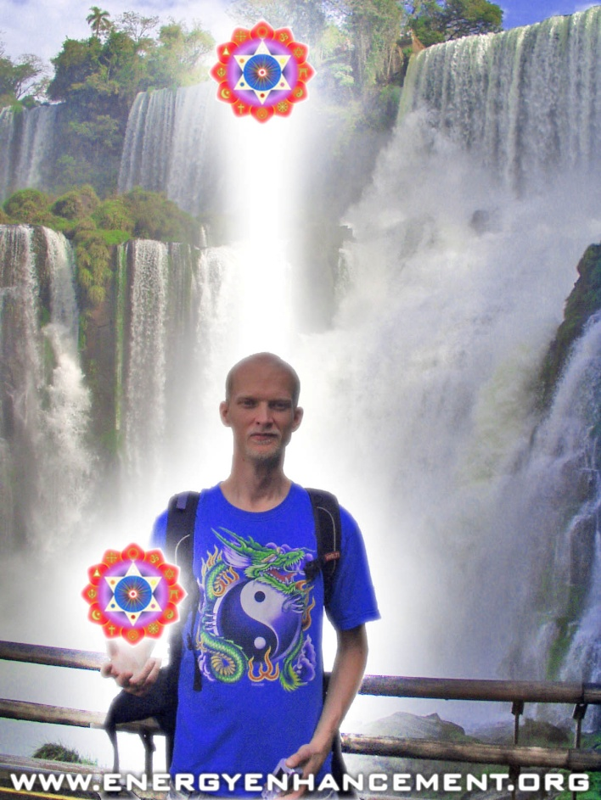

ENERGY ENHANCEMENT COURSE AT IGUAZU FALLS. BRAZIL

"Get your asses over here Now and Speed Up your process of Enlightenment on the Energy Enhancement one month course!!" - DON
Every one of our Students gets this Spiritual Experience of Connection with Infinite Energies.
Energy Enhancement does indeed, "SPEED UP THE PROCESS!!"
And they all get this Experience of Light, Life and Infinite Energy just with the Energy Enhancement Course - Every One of Them!!

Vimalakirti Sutra Chapter 2 - Inconceivable Skill in Enlightenment Liberative Technique, Dharma, Connection with the Infinite Chakras above the Head - Gnosis, conquered all demons, transcendence of wisdom, tolerance and self-control, respected by Indra, Brahma, and all the Lokapalas

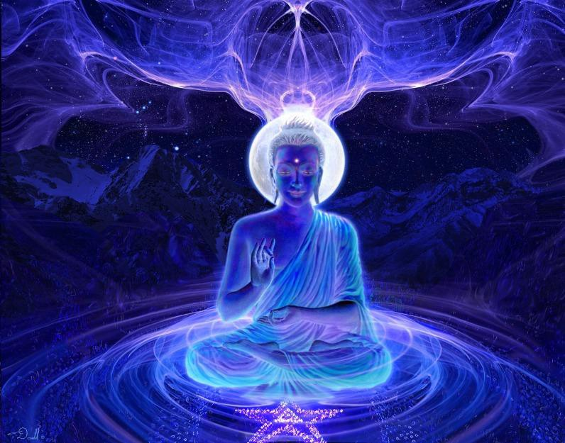

Chapter 2: Inconceivable Skill in Enlightenment Liberative Technique

At that time, there lived in the great city of Vaisali a certain Licchavi, Vimalakirti by name.

Having served the ancient Buddhas, he had generated the roots of virtue by honoring them and making offerings to them. He had attained tolerance as well as eloquence. He played with the great super-knowledges.

He had attained the power of incantations and the fearlessnesses. He had conquered all demons and opponents. He had penetrated the profound way of the Dharma. He was liberated through the transcendence of wisdom. Having integrated his realization with skill in Enlightenment liberative technique, he was expert in knowing the thoughts and actions of living beings.

Knowing the strength or weakness of their faculties, and being gifted with unrivaled eloquence, he taught the Dharma appropriately to each. Having applied himself energetically to the Mahayana, he understood it and accomplished his tasks with great finesse.

He lived with the deportment of a Buddha, and his superior intelligence was as wide as an ocean. He was praised, honored, and commended by all the Buddhas and was respected by Indra, Brahma, and all the Lokapalas. In order to develop living beings with his skill in liberative technique, he lived in the great city of Vaisali.

His wealth was inexhaustible for the purpose of sustaining the poor and the helpless. He observed a pure morality in order to protect the immoral. He maintained tolerance and self-control in order to reconcile beings who were angry, cruel, violent, and brutal.

He blazed with energy in order to inspire people who were lazy. He maintained concentration, mindfulness, and meditation in order to sustain the mentally troubled. He attained decisive wisdom in order to sustain the foolish.

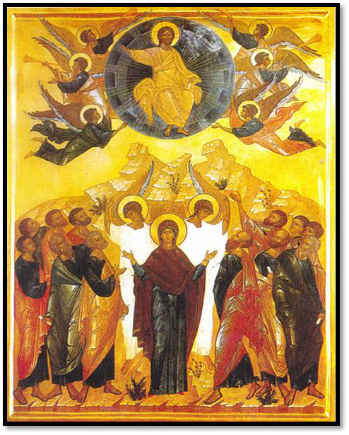
He wore the white clothes of the layman, yet lived impeccably like a religious devotee. He lived at home, but remained aloof from the realm of desire, the realm of pure matter, and the immaterial realm.

He had a son, a wife, and female attendants, yet always maintained continence. He appeared to be surrounded by servants, yet lived in solitude. He appeared to be adorned with ornaments, yet always was endowed with the auspicious signs and marks.

He seemed to eat and drink, yet always took nourishment from the taste of meditation. He made his appearance at the fields of sports and in the casinos, but his aim was always to mature those people who were attached to games and gambling.

He visited the fashionable heterodox teachers, yet always kept unswerving loyalty to the Buddha. He understood the mundane and transcendental sciences and esoteric practices, yet always took

27

pleasure in the delights of the Dharma. He mixed in all crowds, yet was respected as foremost of all.

In order to be in harmony with people, he associated with elders, with those of middle age, and with the young, yet always spoke in harmony with the Dharma. He engaged in all sorts of businesses, yet had no interest in profit or possessions.

To train living beings, he would appear at crossroads and on street corners, and to protect them he participated in government. To turn people away from the Hinayana and to engage them in the Mahayana, he appeared among listeners and teachers of the Dharma.

To develop children, he visited all the schools.

To demonstrate the evils of desire, he even entered the brothels.

To establish drunkards in correct mindfulness, he entered all the cabarets.

He was honored as the businessman among businessmen because he demonstrated the priority of the Dharma. He was honored as the landlord among landlords because he renounced the aggressiveness of ownership. He was honored as the warrior among warriors because he cultivated endurance, determination, and fortitude. He was honored as the aristocrat among aristocrats because he suppressed pride, vanity, and arrogance.

He was honored as the official among officials because he regulated the functions of government according to the Dharma. He was honored as the prince of princes because he reversed their attachment to royal pleasures and sovereign power. He was honored as a eunuch in the royal harem because he taught the young ladies according to the Dharma.

He was compatible with ordinary people because he appreciated the excellence of ordinary merits. He was honored as the Indra among Indras because he showed them the temporality of their lordship. He was honored as the Brahma among Brahmas because he showed

them the special excellence of connection with the infinity of chakras above the Head, gnosis. He was honored as the Lokapala among Lokapalas because he fostered the development of all living beings.

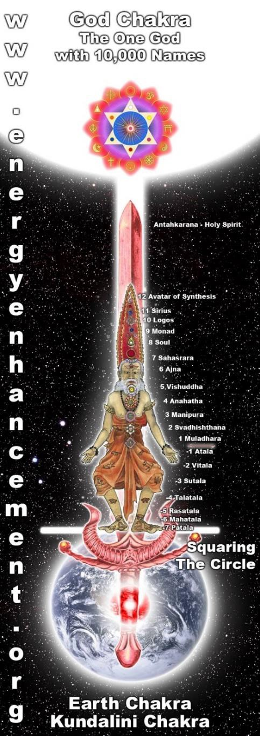
THE ENERGY ENHANCEMENT INFINITE CHAKRAS ABOVE THE HEAD

LEVEL 1 - 4 VIDEO COURSES ANYTIME IN THE COMFORT OF YOUR OWN HOME

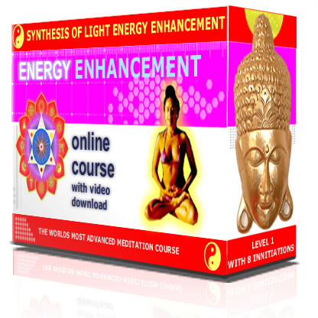
Thus lived the Licchavi Vimalakirti in the great city of Vaisali, endowed with an infinite knowledge of skill in liberative techniques.

At that time, out of this very skill in liberative technique, Vimalakirti manifested himself as if sick.

To inquire after his health, the king, the officials, the lords, the youths, the aristocrats, the householders, the businessmen, the townfolk, the countryfolk, and thousands of other living beings came forth from the great city of Vaisali and called on the invalid.

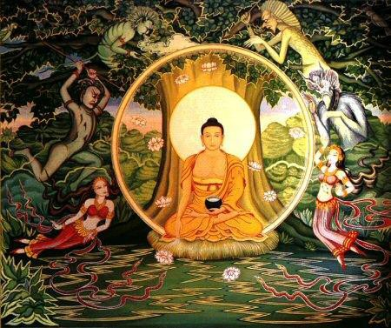
When they arrived, Vimalakirti taught them the Dharma, beginning his discourse from the actuality of the four main elements:

"Friends, this body is so impermanent, fragile, unworthy of confidence, and feeble. It is so insubstantial, perishable, short-lived,

painful, filled with diseases, and subject to changes. Thus, my friends, as this body is only a vessel of many sicknesses, wise men do not rely on it.

This body is like a ball of foam, unable to bear any pressure. It is like a water bubble, not remaining very long. It is like a mirage, born from the appetites of the passions. It is like the trunk of the plantain tree, having no core. Alas! This body is like a machine, a nexus of bones and tendons.

It is like a magical illusion, consisting of falsifications. It is like a dream, being an unreal vision. It is like a reflection, being the image of former actions. It is like an echo, being dependent on conditioning. It is like a cloud, being characterized by turbulence and dissolution. It is like a flash of lightning, being unstable, and decaying every moment. The body is ownerless, being the product of a variety of conditions.

"This body is inert, like the earth; selfless, like water; lifeless, like fire; impersonal, like the wind; and nonsubstantial, like space. This body is unreal, being a collocation of the four main elements. It is void, not existing as self or as self-possessed.

It is inanimate, being like grass, trees, walls, clods of earth, and hallucinations. It is insensate, being driven like a windmill. It is filthy, being an agglomeration of pus and excrement.

It is false, being fated to be broken and destroyed, in spite of being anointed and massaged. It is afflicted by the four hundred and four diseases. It is like an ancient well, constantly overwhelmed by old age.

Its duration is never certain - certain only is its end in death. This body is a combination of aggregates, elements, and sense-media, which are comparable to murderers, poisonous snakes, and an empty town, respectively.

Therefore, you should be revulsed by such a body. You should despair of it and should arouse your admiration for the body of the Tathagata, the Buddha.

WHAT IS UNENLIGHTENED HUMANITY MADE OF?
CATS AND SNAILS AND PUPPY DOGS TAILS..
WHAT ARE BUDDHAS MADE OF?
SUGAR AND SPICE AND ALL THINGS NICE..



DOWNLOAD AGAINST SATANISM VOLUME ONE HERE
http://www.energyenhancement.org/Against-Satanism/Against-Satanism-Energy-Enhancement-Satanic-History-of-the-World-Volume-1.pdf
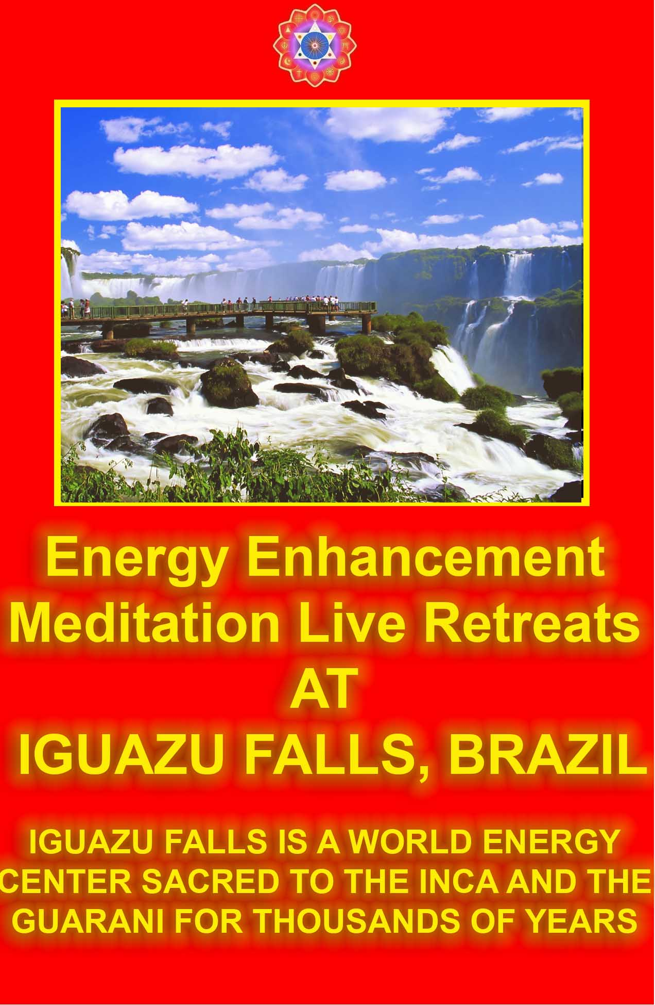

ENERGY ENHANCEMENT IMMORTALITY LIVE COURSES, INDIA AND IGUAZU FALLS

ONLY THE SUPERPOWERS DEVELOPED BY THE SCIENCE OF REAL MEDITATION CAN FREE HUMANITY TO REACH THE STARS.

ENERGY ENHANCEMENT MEDITATION ENLIGHTENMENT AND ILLUMINATION

THE INCREDIBLE MEDITATION COURSE AND MEDITATION TECHNIQUES CREATED TO PRODUCE ENLIGHTENMENT AND ILLUMINATION

"ALL TRADITIONAL MEDITATIONS HAVE BEEN DESIGNED TO FAIL" - SATCHIDANAND -

"BECAUSE ORIGINALLY ALL MEDITATIONS CONTAINED THE TECHNIQUES OF, "THE KUNDALINI KEY" AND OF, "ALCHEMICAL VITRIOL" TO GROUND NEGATIVE ENERGIES AND TO NATURALLY INCREASE KUNDALINI ENERGY"

"NOW, ONLY ENERGY ENHANCEMENT MEDITATION TEACHES THESE TECHNIQUES WHICH SPEED UP THE ENLIGHTENMENT PROCESS"
SATCHIDANAND - IGUAZU FALLS
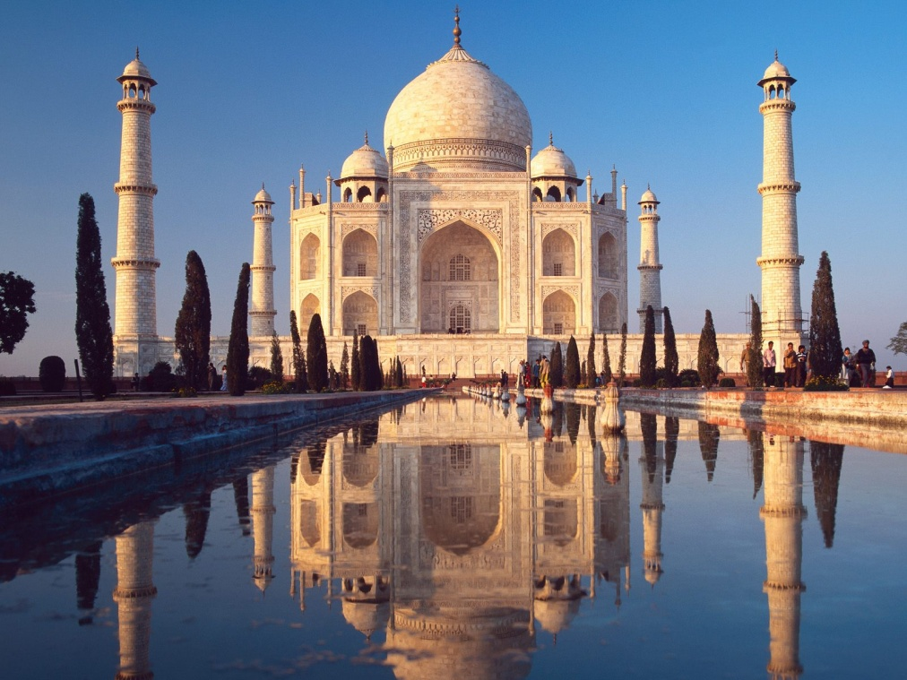

THE BODY OF THE TATHAGATA - THE BUDDHA

"Friends, the body of a Tathagata is the body of Dharma, born of gnosis.

The body of a Tathagata is born of the stores of merit and wisdom.

The body of a Tathagata is born of morality, of meditation, of wisdom, of the liberations, and of the knowledge and vision of liberation.

The body of a Tathagata is born of love, compassion, joy, and impartiality. It is born of charity, discipline, and self-control.

The body of a Tathagata is born of the path of ten virtues. It is born of patience and gentleness. It is born of the roots of virtue planted by solid efforts.

The body of a Tathagata is born of the concentrations, the liberations, the meditations, and the absorptions. It is born of learning, wisdom, and liberative technique.

The body of a Tathagata is born of the thirty-seven aids to enlightenment.

The body of a Tathagata is born of mental quiescence and transcendental analysis. It is born of the ten powers, the four fearlessnesses, and the eighteen special qualities.

The body of a Tathagata is born of all the transcendences. It is born from sciences and superknowledges. It is born of the abandonment of all evil qualities, and of the collection of all good qualities. It is born of truth. It is born of reality. It is born of conscious awareness.

"Friends, the body of a Tathagata is born of innumerable good works. Toward such a body you should turn your aspirations, and, in order to eliminate the sicknesses of the passions of all living beings, you should conceive the spirit of unexcelled, perfect enlightenment."

While the Licchavi Vimalakirti thus taught the Dharma to those who had come to inquire about his sickness, many hundreds of thousands of living beings conceived the spirit of unexcelled, perfect enlightenment.

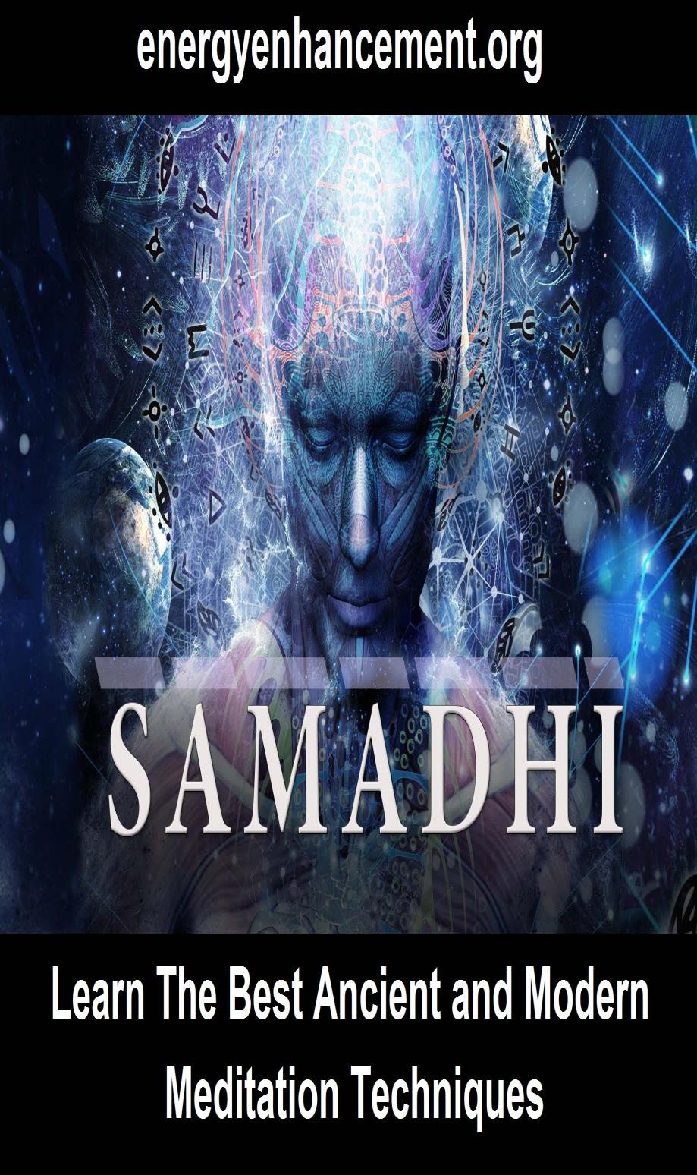

Vimalakirti Sutra Chapter 3: The Disciples' Reluctance to Visit Vimalakirti - Meditation, The Dharma
- The Path of the Soul Chakra, The First Chakra above the Head - Renunciation, the Tathagata, the Saint, the perfectly accomplished Buddha, Gnosis with the Infinite Chakras above the Head

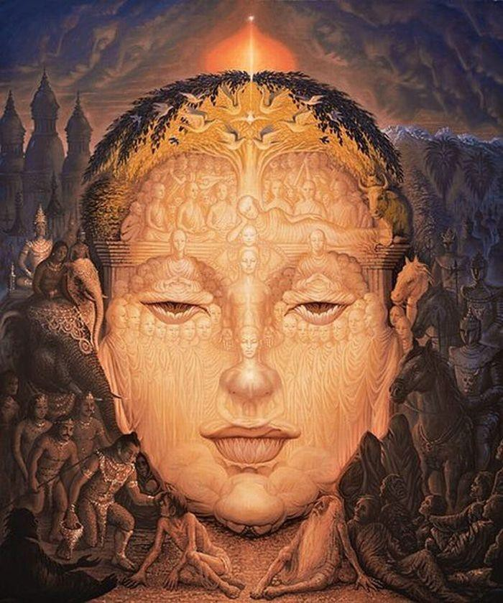

A Zen Master saw a child with a broken arm sitting miserably by the side of the road. This guy was so miserable that the Zen Master just knew he was impervious to being cheered up, To accepting good advice, to being told that, "Everything changes". So he took an iron bar and with it he broke his own arm. Sitting down by the young child he said, "Now we can talk!!"

Chapter 3: The Disciples' Reluctance to Visit Vimalakirti

Then, the Licchavi Vimalakirti thought to himself, "I am sick, lying on my bed in pain, yet the Tathagata, the saint, the perfectly accomplished Buddha, does not consider or take pity upon me, and sends no one to inquire after my illness."

The Lord knew this thought in the mind of Vimalakirti and said to the venerable Sariputra, "Sariputra, go to inquire after the illness of the Licchavi Vimalakirti."

Thus having been addressed, the venerable Sariputra answered the Buddha, "Lord, I am indeed reluctant to go to ask the Licchavi Vimalakirti about his illness.

Why? I remember one day, when I was sitting at the foot of a tree in the forest, absorbed in meditation, the Licchavi Vimalakirti came to the foot of that tree and said to me, 'Reverend Sariputra, this is not the way to absorb yourself in meditation.

You should absorb yourself in meditation so that neither body nor mind appear anywhere in the triple world.

You should absorb yourself in meditation in such a way that you can manifest all ordinary behavior without forsaking cessation.

You should absorb yourself in meditation in such a way that you can manifest the nature of an ordinary person without abandoning your cultivated spiritual nature.

You should absorb yourself in meditation so that the mind neither settles within nor moves without toward external forms.

You should absorb yourself in meditation in such a way that the thirty-seven aids to enlightenment are manifest without deviation toward any convictions.

You should absorb yourself in meditation in such a way that you are released in liberation without abandoning the passions that are the province of the world.

"'Reverend Sariputra, those who absorb themselves in meditation in such a way are declared by the Lord to be truly absorbed in meditation.'

"Lord, when I heard this teaching, I was unable to reply and remained silent. Therefore, I am reluctant to go to ask that good man about his sickness."



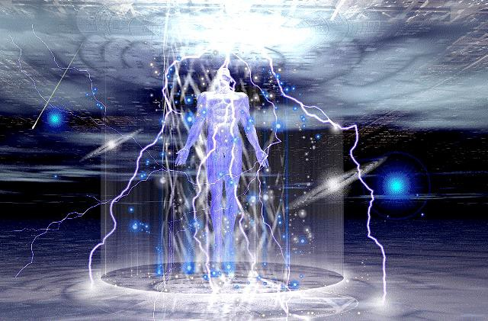
Then, the Buddha said to the venerable Mahamaudgalyayana, "Maudgalyayana, go to the Licchavi Vimalakirti to inquire about his illness."

Maudgalyayana replied, "Lord, I am indeed reluctant to go to the Licchavi Vimalakirti to inquire about his illness. Why? I remember one day when I was teaching the Dharma - The Path of the Soul Chakra - The First Chakra above the Head - to the householders in a square in the great city of Vaisali, and the Licchavi Vimalakirti came along and said to me, 'Reverend Maudgalyayana, that is not the way to teach the Dharma - The Path of the Soul Chakra - The First Chakra above the Head - to the householders in their white clothes. The Dharma - The Path of the Soul Chakra - The First Chakra above the Head - must be taught according to reality.

"'Reverend Maudgalyayana, the Dharma - The Path of the Soul Chakra - The First Chakra above the Head - is without living beings, because it is free of the dust of living beings.

The Dharma - The Path of the Soul Chakra - The First Chakra above the Head - is selfless, because it is free of the dust of desire. It is lifeless, because it is free of birth and death. It is without

personalities, because it dispenses with past origins and future destinies.

"'The Dharma - The Path of the Soul Chakra - The First Chakra above the Head - is peace and pacification, because it is free from desire. It does not become an object, because it is free of words and letters; it is inexpressible, and it transcends all movement of mind.

"'The Dharma - The Path of the Soul Chakra - The First Chakra above the Head - is omnipresent, because it is like infinite space. It is without color, mark, or shape, because it is free of all process. It is without the concept of "mine," because it is free of the habitual notion of possession. It is without ideation, because it is free of mind, thought, or consciousness. It is incomparable, because it has no antitheses. It is without presumption of conditionality, because it does not conform to causes.

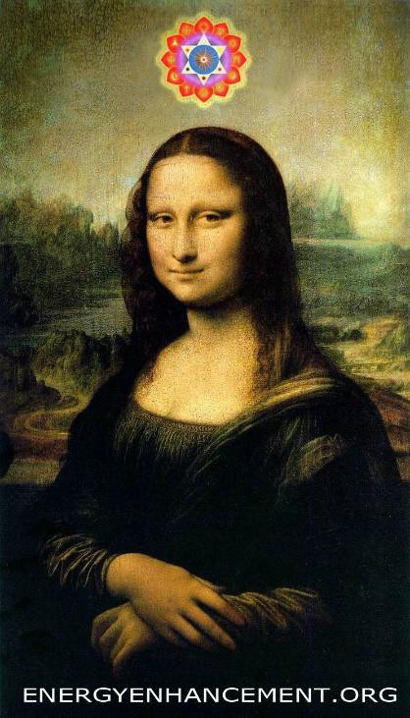
Soul Chakra - The First Chakra above the Head

"'The Dharma - The Path of the Soul Chakra - The First Chakra above the Head - permeates evenly all things, because all are included in the ultimate realm. It conforms to reality by means of the process of nonconformity. It abides at the reality-limit, for it is utterly without fluctuation. It is immovable, because it is independent of the six objects of sense. It is without coming and going, for it never stands still. It is comprised by voidness, emptiness, a vibration so high that it is not gross like matter, or emotion, or mind, it is remarkable through signlessness, and is free of presumption and repudiation, because of wishlessness. It is without establishment and rejection, without birth or destruction. It is without any fundamental consciousness, transcending the range of eye, ear, nose, tongue, body, and thought. It is without highness and lowness. It abides without movement or activity.

"'Reverend Mahamaudgalyayana, how could there be a teaching in regard to such a Dharma - The Path of the Soul Chakra - The First Chakra above the Head? Reverend Mahamaudgalyayana, even the expression "to teach the Dharma - The Path of the Soul Chakra - The First Chakra above the Head -" is presumptuous, and those who listen to it listen to presumption. Reverend Maudgalyayana, where there are no presumptuous words, there is no teacher of the Dharma
- The Path of the Soul Chakra - The First Chakra above the Head, no one to listen, and no one to understand. It is as if an illusory person were to teach the Dharma - The Path of the Soul Chakra - The First Chakra above the Head - to illusory people.

"'Therefore, you should teach the Dharma - The Path of the Soul Chakra - The First Chakra above the Head - by keeping your mind on this. You should be adept in regard to the spiritual faculties of living beings. By means of the correct vision of the wisdom-eye, manifesting the great compassion, acknowledging the benevolent activity of the Buddha, purifying your intentions, understanding the definitive expressions of the Dharma - The Path of the Soul Chakra - The First Chakra above the Head, you should teach the Dharma - The Path of the Soul Chakra - The First Chakra above the Head - in order that the continuity of the Three Jewels may never be interrupted.'

"Lord, when Vimalakirti had discoursed thus, eight hundred householders in the crowd conceived the spirit of unexcelled, perfect enlightenment, and I myself was speechless. Therefore, Lord, I am indeed reluctant to go to this good man to inquire about his illness."

Then, the Buddha said to the venerable Mahakasyapa, "Mahakasyapa, you go to the Licchavi Vimalakirti to inquire about his illness."

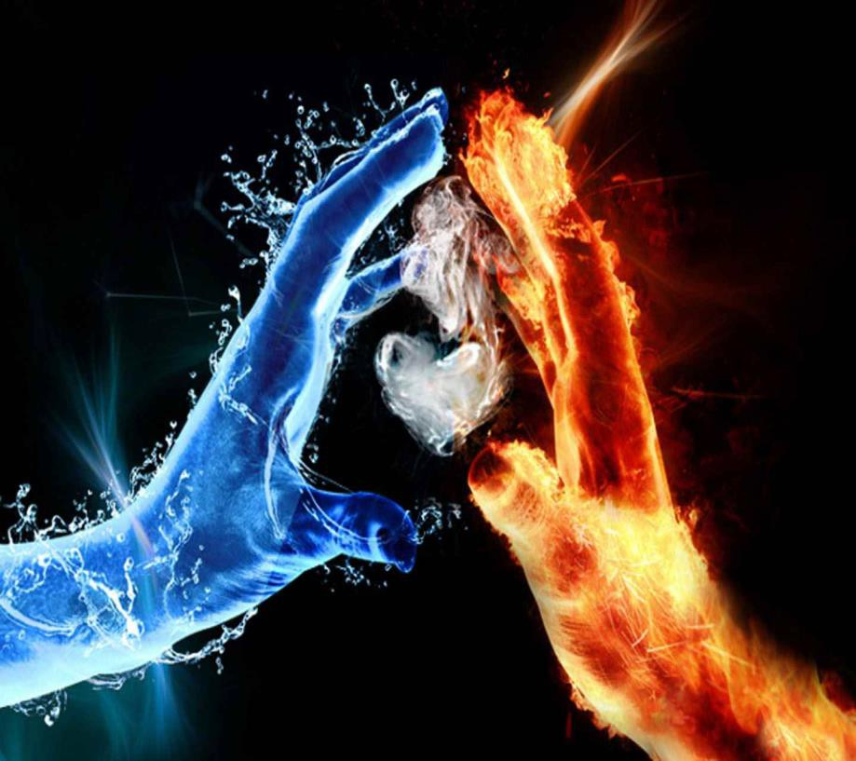

"Lord, I am indeed reluctant to go to the Licchavi Vimalakirti to inquire about his illness. Why? I remember one day, when I was in the street of the poor begging for my food, the Licchavi Vimalakirti came along and said to me, 'Reverend Mahakasyapa, to avoid the houses of the wealthy, and to favor the houses of the poor - this is partiality in benevolence. Reverend Mahakasyapa, you should dwell on the fact of the equality of things, and you should seek alms with

consideration for all living beings at all times. You should beg your food in awareness of the ultimate nonexistence of food. You should seek alms for the sake of eliminating the materialism of others.

When you enter a town, you should keep in mind its actual voidness, yet you should proceed through it in order to spiritually develop men and women. You should enter homes as if entering the family of the Buddha. You should accept alms by not taking anything. You should see form like a man blind from birth, hear sounds as if they were echoes, smell scents as if they were winds, experience tastes without any discrimination, touch tangibles in awareness of the ultima te lack of contact in Gnosis with the Infinite Chakras above the Head, and know things with the consciousness of an illusory creature. That which is without intrinsic substance and without imparted substance does not burn. And what does not burn will not be extinguished.

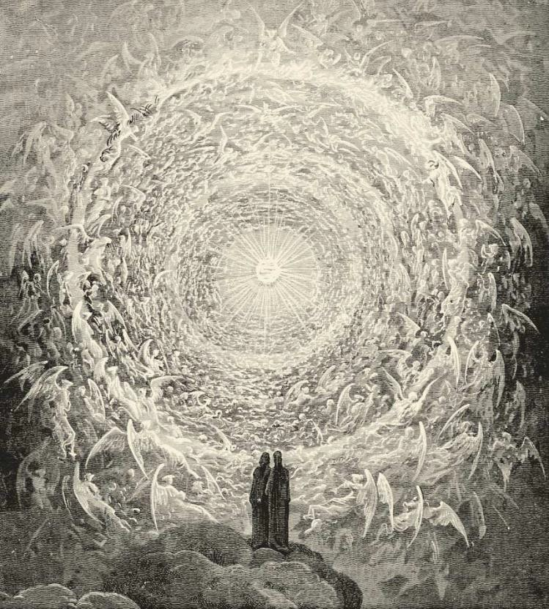
Dore - Gnosis with the Infinite Chakras above the Head

"'Elder Mahakasyapa, if, equipoised in the eight liberations without transcending the eight perversions, you can enter the equanimity of reality by means of the equanimity of perversion, and if you can make a gift to all living beings and an offering to all the saints and Buddhas out of even a single measure of alms, then you yourself may eat. Thus, when you eat, after offering, you should be neither affected by passions nor free of passions, neither involved in concentration nor free from concentration, neither living in the world nor abiding in liberation.

Furthermore, those who give such alms, reverend, have neither great merit nor small merit, neither gain nor loss. They should follow the way of the Buddhas, not the way of the disciples. Only in this way, Elder Mahakasyapa, is the practice of eating by alms meaningful.'

"Lord, when I heard this teaching, I was astonished and thought: 'Reverence to all bodhisattvas! If a lay bodhisattva may be endowed with such eloquence, who is there who would not conceive the spirit of unexcelled, perfect enlightenment? From that time forth, I no longer recommend the vehicles of the disciples and of the solitary sages but recommend the Mahayana. And thus, Lord, I am reluctant to go to this good man to inquire about his illness."

Then, the Buddha said to the venerable Subhuti, "Subhuti, go to the Licchavi Vimalakirti to inquire about his illness."

Subhuti replied, "Lord, I am indeed reluctant to go to this good man to inquire about his illness. Why? My Lord,

I remember one day, when I went to beg my food at the house of the Licchavi Vimalakirti in the great city of Vaisali, he took my bowl and filled it with some excellent food and said to me, 'Reverend Subhuti, take this food if you understand the equality of all things, by means of the equality of material objects, and if you understand the equality of all the attributes of the Buddha, by means of the equality of all things.

Take this food if, without abandoning desire, hatred, and folly, you can avoid association with them; if you can follow the path of the

single way without ever disturbing the egoistic views; if you can produce the knowledges and liberations without conquering ignorance and the craving for existence; if, by the equality of the five deadly sins, you reach the equality of liberation; if you are neither liberated nor bound; if you do not see the Four Holy Truths, yet are not the one who "has not seen the truth"; if you have not attained any fruit, yet are not the one who "has not attained"; if you are an ordinary person, yet have not the qualities of an ordinary person; if you are not holy, yet are not unholy; if you are responsible for all things, yet are free of any notion concerning anything.

"'Take this food, reverend Subhuti, if, without seeing the Buddha, hearing the Dharma - The Path of the Soul Chakra - The First Chakra above the Head, or serving the Sangha, you undertake the religious life under the six heterodox masters; namely, Purana Kasyapa, Maskarin Gosaliputra, Samjayin Vairatiputra, Kakuda Katyayana, Ajita Kesakambala, and Nirgrantha Jnaniputra, and follow the ways they prescribe.

"'Take this food, reverend Subhuti, if, entertaining all false views, you find neither extremes nor middle; if, bound up in the eight adversities, you do not obtain favorable conditions; if, assimilating the passions, you do not attain purification; if the dispassion of all living beings is your dispassion, reverend; if those who make offerings to you are not thereby purified; if those who offer you food, reverend, still fall into the three bad migrations; if you associate with all Maras; if you entertain all passions; if the nature of passions is the nature of a reverend; if you have hostile feelings toward all living beings; if you despise all the Buddhas; if you criticize all the teachings of the Buddha; if you do not rely on the Sangha; and finally, if you never enter ultimate liberation.'



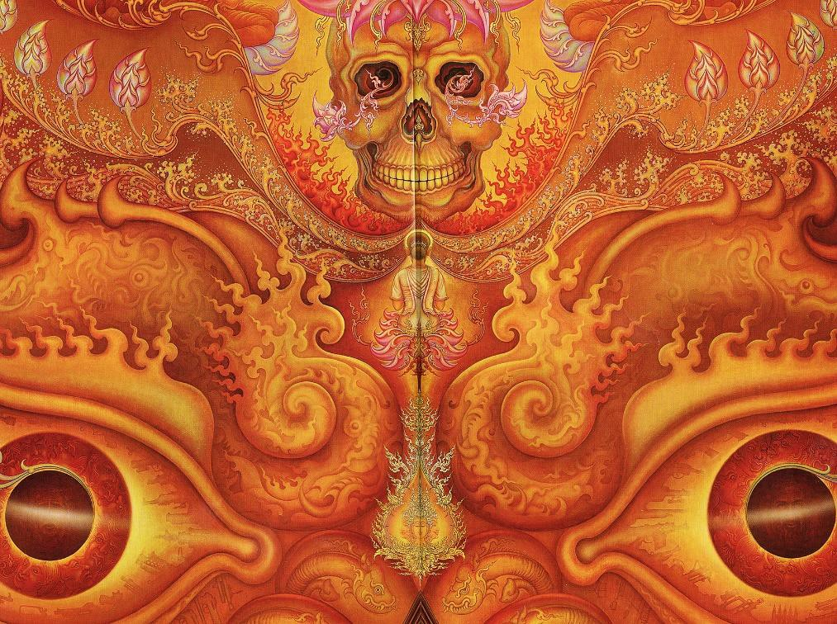
THE MARA - DEMON ENERGY BLOCKAGE - FACED DOWN BY A BUDDHA

"Lord, when I heard these words of the Licchavi Vimalakirti, I wondered what I should say and what I should do, but I was totally in the dark. Leaving the bowl, I was about to leave the house when the Licchavi Vimalakirti said to me, 'Reverend Subhuti, do not fear these words, and pick up your bowl. What do you think, reverend Subhuti?

If it were an incarnation created by the Tathagata who spoke thus to you, would you be afraid?'

"I answered, 'No indeed, noble sir!' He then said, 'Reverend Subhuti, the nature of all things is like illusion, like a magical incarnation. So you should not fear them. Why? All words also have that nature, and thus the wise are not attached to words, nor do they fear them. Why? All language does not ultimately exist, except as liberation. The nature of all things is liberation.'

"When Vimalakirti had discoursed in this way, two hundred gods obtained the pure doctrinal vision in regard to all things, without obscurity or defilement, and five hundred gods obtained the conformative tolerance. As for me, I was speechless and unable to respond to him. Therefore, Lord, I am reluctant to go to this good man to inquire about his illness."

Then, the Buddha said to the venerable Purnamaitrayaniputra, "Purna, go to the Licchavi Vimalakirti to inquire about his illness."

Purna replied, "Lord, I am indeed reluctant to go to this good man to inquire about his illness. Why? Lord, I remember one day, when I was teaching the Dharma - The Path of the Soul Chakra - The First Chakra above the Head - to some young monks in the great forest, the Licchavi Vimalakirti came there and said to me, 'Reverend Purna, first concentrate yourself, regard the minds of these young bhikshus, and then teach them the Dharma - The Path of the Soul Chakra - The First Chakra above the Head! Do not put rotten food into a jeweled bowl! First understand the inclinations of these monks, and do not confuse priceless sapphires with glass beads!

"'Reverend Purna, without examining the spiritual faculties of living beings, do not presume upon the one-sidedness of their faculties; do not wound those who are without wounds; do not impose a narrow path upon those who aspire to a great path; do not try to pour the great ocean into the hoof-print of an ox; do not try to put Mount Sumeru into a grain of mustard; do not confuse the brilliance of the sun with the light of a glowworm; and do not expose those who admire the roar of a lion to the howl of a jackal!

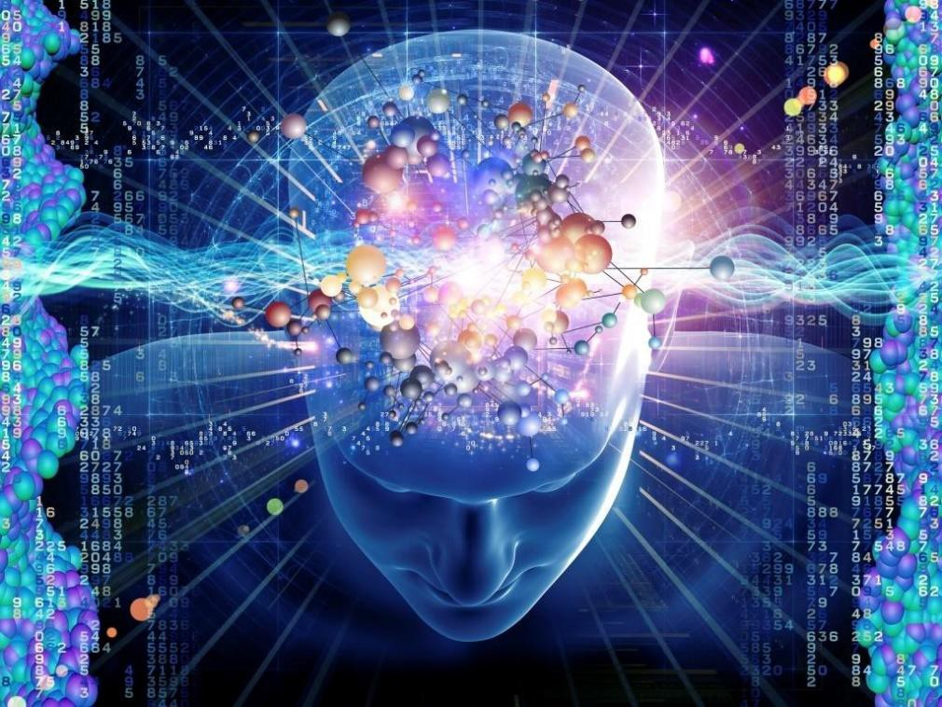
SPIRITUAL FACULTIES

"'Reverend Purna, all these monks were formerly engaged in the Mahayana but have forgotten the spirit of enlightenment. So do not instruct them in the disciple-vehicle. The disciple-vehicle is not ultimately valid, and you disciples are like men blind from birth, in regard to recognition of the degrees of the spiritual faculties of living beings.'

"At that moment, the Licchavi Vimalakirti entered into such a concentration that those monks were caused to remember their various former existences, in which they had produced the roots of virtue by serving five hundred Buddhas for the sake of perfect enlightenment.

As soon as their own spirits of enlightenment had become clear to them, they bowed at the feet of that good man and pressed their palms together in reverence.

He taught them the Dharma - The Path of the Soul Chakra - The First Chakra above the Head, and they all attained the stage of irreversibility from the spirit of unexcelled, perfect enlightenment. It occurred to me then, 'The disciples, who do not know the thoughts or the inclinations of others, are not able to teach the Dharma - The Path of the Soul Chakra - The First Chakra above the Head - to anyone. Why? These disciples are not expert in discerning the superiority and inferiority of the spiritual faculties of living beings, and they are not always in a state of concentration like the Tathagata, the Saint, the perfectly accomplished Buddha.'

"Therefore, Lord, I am reluctant to go to that good man to inquire about his health."

The Buddha then said to the venerable Mahakatyayana, "Katyayana, go to the Licchavi Vimalakirti to inquire about his illness."

Katyayana replied, "Lord, I am indeed reluctant to go that good man to inquire about his illness. Why? Lord, I remember one day when, after the Lord had given some brief instruction to the monks, I was defining the expressions of that discourse by teaching the meaning of impermanence, suffering, selflessness, and peace; the Licchavi Vimalakirti came there and said to me, 'Reverend Mahakatyayana, do not teach an ultimate reality endowed with activity, production, and destruction! Reverend Mahakatyayana, nothing was ever destroyed, is destroyed, or will ever be destroyed. Such is the meaning of "impermanence." The meaning of the realization of birthlessness, through the realization of the voidness of the five aggregates, is the meaning of "suffering." The fact of the nonduality of self and selflessness is the meaning of "selflessness." That which has no intrinsic substance and no other sort of substance does not burn, and what does not burn is not extinguished; such lack of extinction is the meaning of "peace."'

"When he had discoursed thus, the minds of the monks were liberated from their defilements and entered a state of nongrasping.

Therefore, Lord, I am reluctant to go to that good man to inquire about his illness."

The Buddha then said to the venerable Aniruddha, "Aniruddha, go to the Licchavi Vimalakirti to inquire about his illness."

"My Lord, I am indeed reluctant to go that good man to inquire about his illness. Why? I remember, Lord, one day when I was taking a walk, the great Brahma named Subhavyuha and the ten thousand other Brahmas who accompanied him illuminated the place with their radiance and, having bowed their heads at my feet, withdrew to one side and asked me, 'Reverend Aniruddha, you have been proclaimed by the Buddha to be the foremost among those who possess the divine eye. To what distance does the divine vision of the venerable Aniruddha extend?'

I answered, 'Friends, I see the entire billion-world-galactic universe of the Lord Sakyamuni just as plainly as a man of ordinary vision sees a myrobalan nut on the palm of his hand.' When I had said these words, the Licchavi Vimalakirti came there and, having bowed his head at my feet, said to me, 'Reverend Aniruddha, is your divine eye compounded in nature? Or is it uncompounded in nature?

If it is compounded in nature, it is the same as the superknowledges of the heterodox. If it is uncompounded in nature, then it is not constructed and, as such, is incapable of seeing. Then, how do you see, O elder?'

"At these words, I became speechless, and Brahma also was amazed to hear this teaching from that good man.

Having bowed to him, he said, 'Who then, in the world, possesses the divine eye?'

"Vimalakirti answered, 'In the world, it is the Buddhas who have the divine eye. They see all the buddha-fields without even leaving their state of concentration and without being affected by duality.'

"Having heard these words, the ten thousand Brahmas were inspired with high resolve and conceived the spirit of unexcelled, perfect enlightenment. Having paid homage and respect both to me and to that good man, they disappeared. As for me, I remained speechless,

and therefore I am reluctant to go to that good man to inquire about his illness."

The Buddha then said to the venerable Upali, "Upali, go to the Licchavi Vimalakirti to inquire about his illness."


ENERGY BLOCKAGES STOP THE LIGHT

Upali replied, "Lord, I am indeed reluctant to go to that good man to inquire about his illness. Why? Lord, I remember that one day there were two monks who had committed some infraction and were too ashamed to appear before the Lord, so they came to me and said, 'Reverend Upali, we have both committed an infraction but are too

ashamed to appear before the Buddha. Venerable Upali, kindly remove our anxieties by absolving us of these infractions.'

"Lord, while I was giving those two monks some religious discourse, the Licchavi Vimalakirti came there and said to me, 'Reverend Upali, do not aggravate further the sins of these two monks. Without perplexing them, relieve their remorse. Reverend Upali, sin is not to be apprehended within, or without, or between the two. Why?

The Buddha has said, "Living beings are afflicted by the passions of thought, and they are purified by the purification of thought."

"'Reverend Upali, the mind is neither within nor without, nor is it to be apprehended between the two. Sin is just the same as the mind, and all things are just the same as sin. They do not escape this same reality.

"'Reverend Upali, this nature of the mind, by virtue of which your mind, reverend, is liberated - does it ever become afflicted?'

"'Never,' I replied.

"'Reverend Upali, the minds of all living beings have that very nature. Reverend Upali, passions consist of Energy Blockages.

The ultimate nonexistence of these Energy Blockages and imaginary fabrications - that is the purity that is the intrinsic nature of the mind.

Energy Blockages are passions. The ultimate absence of Energy Blockages is the intrinsic nature of the mind.

The presumption of ego-self is passion.

The absence of ego-self is the intrinsic nature of the mind.

Reverend Upali, all things are without production, destruction, and duration, like magical illusions, clouds, and lightning; all things are

evanescent, not remaining even for an instant; all things are like dreams, hallucinations, and unreal visions; all things are like the reflection of the moon in water and like a mirror-image; they are born of mental construction Energy Blockages.

Those who know this are called the true upholders of the discipline, and those disciplined in that way are indeed well disciplined.'"

"Then the two monks said, 'This householder is extremely well endowed with wisdom. The reverend Upali, who was proclaimed by the Lord as the foremost of the upholders of the discipline, is not his equal.'

"I then said to the two monks, 'Do not entertain the notion that he is a mere householder! Why? With the exception of the Tathagata himself, there is no disciple or bodhisattva capable of competing with his eloquence or rivaling the brilliance of his wisdom.'

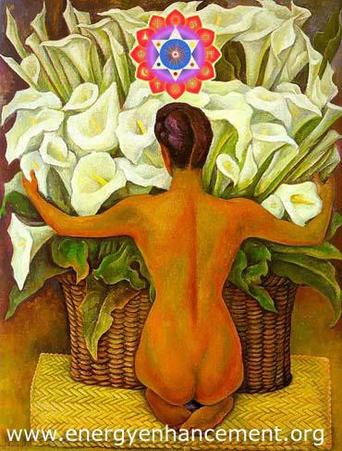

"Thereupon, the two monks, delivered from their anxieties and inspired with a high resolve, conceived the spirit of unexcelled, perfect enlightenment. Bowing down to that good man, they made the wish: 'May all living beings attain eloquence such as this!' Therefore, I am reluctant to go to that good man to inquire about his illness."


The Buddha then said to the venerable Rahula, "Rahula, go to the Licchavi Vimalakirti to inquire about his illness."

Rahula replied, "Lord, I am indeed reluctant to go to that good man to inquire about his illness. Why? Lord, I remember that one day many young Licchavi gentlemen came to the place where I was and said to me, 'Reverend Rahula, you are the son of the Lord, and, having renounced a kingdom of a universal monarch, you have left the world. What are the virtues and benefits you saw in leaving the world?'

"As I was teaching them properly the benefits and virtues of renouncing the world, the Licchavi Vimalakirti came there and, having greeted me, said, 'Reverend Rahula, you should not teach the benefits and virtues of renunciation in the way that you do. Why?
Renunciation is itself the very absence of virtues and benefits.

Reverend Rahula, one may speak of benefits and virtues in regard to compounded things, but renunciation is uncompounded, and there can be no question of benefits and virtues in regard to the uncompounded.

Reverend Rahula, renunciation is not material but is free of matter.

Renunciation is free of the extreme views of beginning and end. It is the path of liberation.

Renunciation is praised by the wise, embraced by the saints, and causes the defeat of all Maras.

Renunciation liberates from the five states of existence, purifies the five eyes, cultivates the five powers, and supports the five spiritual faculties.

Renunciation is totally harmless to others and is not adulterated with evil things. It disciplines the heterodox, transcending all denominations. It is the bridge over the swamp of desire, without grasping, and free of the habits of "I" and "mine." It is without attachment and without disturbance, eliminating all commotion.

Renunciation disciplines one's own mind and protects the minds of others. It favors mental quiescence and stimulates transcendental analysis. It is irreproachable in all respects and so is called renunciation. Those who leave the mundane in this way are called "truly renunciant."

Young men, renounce the world in the light of this clear teaching! The appearance of the Buddha is extremely rare.

Human life endowed with leisure and opportunity is very hard to obtain.

To be a human being is very precious.'

"The young men complained: 'But, householder, we have heard the Tathagata declare that one should not renounce the world without the permission of one's parents.'

"Vimalakirti answered: 'Young men, you should cultivate yourselves intensively to conceive the spirit of unexcelled, perfect enlightenment. That in itself will be your renunciation and high ordination!'

"Thereupon, thirty-two of the Licchavi youths conceived the spirit of unexcelled, perfect enlightenment.

Therefore, Lord, I am reluctant to go to that good man to inquire about his illness."

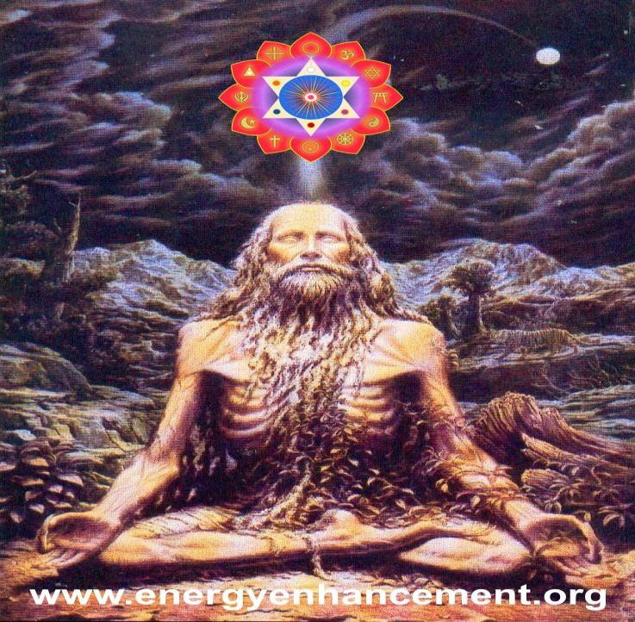

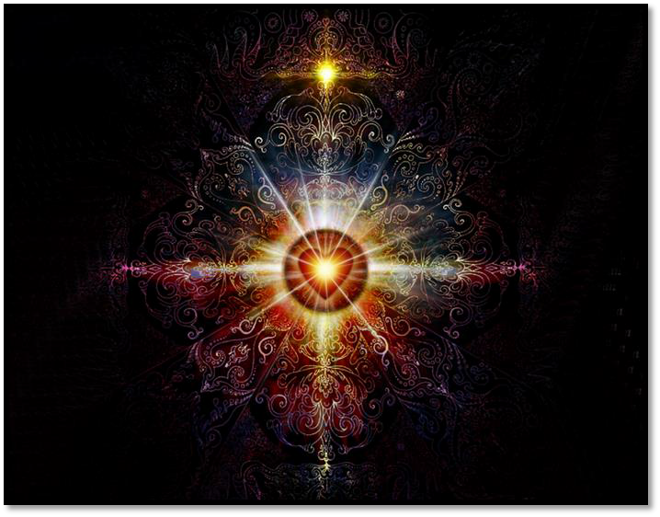
The Buddha then said to the venerable Ananda, "Ananda, go to the Licchavi Vimalakirti to inquire about his illness."

Ananda replied, "Lord, I am indeed reluctant to go to that good man to inquire about his illness. Why? Lord, I remember one day when the body of the Lord manifested some indisposition and he required some milk; I took the bowl and went to the door of the mansion of a great Brahman family. The Licchavi Vimalakirti came there, and, having saluted me, said, 'Reverend Ananda, what are you doing on the threshold of this house with your bowl in your hand so early in the morning?'

"I replied: 'The body of the Lord manifests some indisposition, and he needs some milk. Therefore, I have come to fetch some.'

"Vimalakirti then said to me, 'Reverend Ananda, do not say such a thing! Reverend Ananda, the body of the Tathagata is tough as a diamond, having eliminated all the instinctual traces of evil and being endowed with all goodness. How could disease or discomfort affect such a body?

"'Reverend Ananda, go in silence, and do not belittle the Lord. Do not say such things to others. It would not be good for the powerful gods or for the bodhisattvas coming from the various Buddhafields to hear such words.

"'Reverend Ananda, a universal monarch, who is endowed only with a small root of virtue, is free of diseases.

How then could the Lord, who has an infinite root of virtue, have any disease? It is impossible.

"'Reverend Ananda, do not bring shame upon us, but go in silence, lest the heterodox sectarians should hear your words. They would say, "For shame! The teacher of these people cannot even cure his own sicknesses. How then can he cure the sicknesses of others?" Reverend Ananda, go then discreetly so that no one observes you.

"'Reverend Ananda, the Tathagatas have the body of the Dharma - The Path of the Soul Chakra - The First Chakra above the Head - not a body that is sustained by material food.

The Tathagatas have a transcendental body that has transcended all mundane qualities.

There is no injury to the body of a Tathagata, as it is rid of all defilements. The body of a Tathagata is uncompounded and free of all formative activity. Reverend Ananda, to believe there can be illness in such a body is irrational and unseemly!'

"When I had heard these words, I wondered if I had previously misheard and misunderstood the Buddha, and I was very much ashamed. Then I heard a voice from the sky: 'Ananda! The householder speaks to you truly.

Nevertheless, since the Buddha has appeared during the time of the five corruptions, he disciplines living beings by acting lowly and humble. Therefore, Ananda, do not be ashamed, and go and get the milk!'

"Lord, such was my conversation with the Licchavi Vimalakirti, and therefore I am reluctant to go to that good man to inquire about his illness."

In the same way, the rest of the five hundred disciples were reluctant to go to the Licchavi Vimalakirti, and each told the Buddha his own adventure, recounting all his conversations with the Licchavi Vimalakirti.


Licchavi Vimalakirti

Vimalakirti Sutra Chapter 4 - The Reluctance of the Bodhisattvas, Maitraya, Enlightenment is the Removal of All Energy Blockages, Mara Demon Energy Blockages, Bodhisattvas, Joy in the pleasures of the Dharma - the Soul - The First Chakra above the Head, The Dharma - the Soul - The First Chakra above the Head-sacrifice.

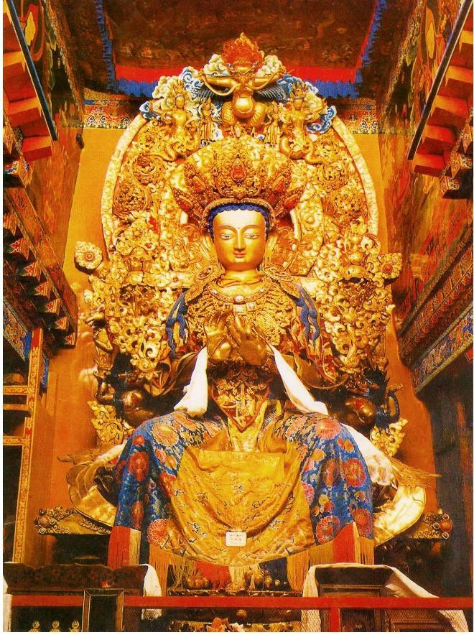

BUDDHA MAITRAYA
Then, the Buddha said to the bodhisattva Maitreya, "Maitreya, go to the Licchavi Vimalakirti to inquire about his illness."

Maitreya replied, "Lord, I am indeed reluctant to go to that good man to inquire about his illness. Why? Lord, I remember that one day I was engaged in a conversation with the gods of the Tusita heaven, the god Samtusita and his retinue, about the stage of nonregression of the great bodhisattvas. At that time, the Licchavi Vimalakirti came there and addressed me as follows:

"'Maitreya, the Buddha has prophesied that only one more birth stands between you and unexcelled, perfect enlightenment. What kind of birth does this prophecy concern, Maitreya? Is it past? Is it future? Or is it present? If it is a past birth, it is already finished. If it is a future birth, it will never arrive. If it is a present birth, it does not abide. For the Buddha has declared, "Bhikshus, in a single moment, you are born, you age, you die, you transmigrate, and you are reborn."

"'Then might the prophecy concern birthlessness? But birthlessness applies to the stage of destiny for the ultimate, in which there is neither prophecy nor attainment of perfect enlightenment.

"'Therefore, Maitreya, is your reality from birth? Or is it from cessation? Your reality as prophesied is not born and does not cease, nor will it be born nor will it cease. Furthermore, your reality is just the same as the reality of all living beings, the reality of all things, and the reality of all the holy ones.

If your enlightenment can be prophesied in such a way, so can that of all living beings. Why? Because reality does not consist of duality or of diversity. Maitreya, whenever you attain Buddhahood, which is the perfection of enlightenment, at the same time all living beings will also attain ultimate liberation.

Why? The Tathagatas do not enter ultimate liberation until all living beings have entered ultimate liberation. For, since all living beings are utterly liberated, the Tathagatas see them as having the nature of ultimate liberation.

"'Therefore, Maitreya, do not fool and delude these deities! No one abides in, or regresses from, enlightenment.

Maitreya, you should introduce these deities to the repudiation of all discriminative constructions, the Removal of All Energy Blockages, concerning enlightenment.

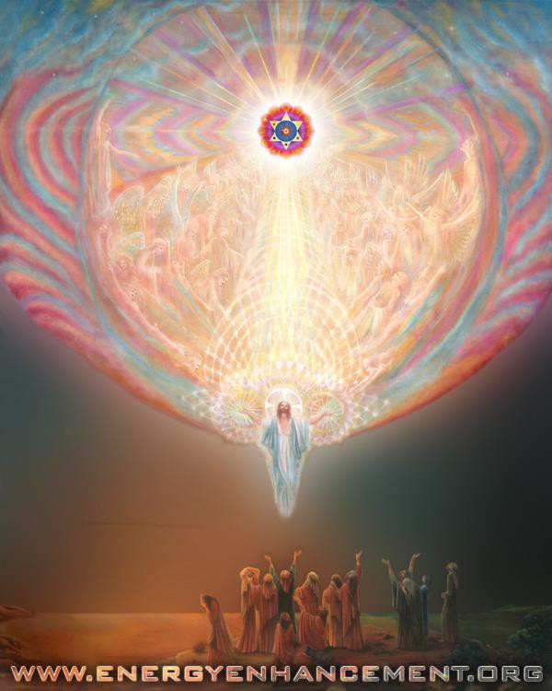

"'Enlightenment is perfectly realized neither by the body nor by the mind.

Enlightenment is the eradication of all Energy Blockages. Enlightenment is free of presumptions concerning all objects. Enlightenment is free of the functioning of all intentional thoughts. Enlightenment is the annihilation of all convictions.
Enlightenment is free from all discriminative constructions. Enlightenment is the Removal of All Energy Blockages.
Enlightenment is free from all vacillation, mentation, and agitation.

Enlightenment is not involved in any commitments. Enlightenment is the arrival at detachment, through freedom from all habitual attitudes. The ground of enlightenment is the ultimate realm.
Enlightenment is realization of reality. Enlightenment abides at the limit of reality.

Enlightenment is without duality, since therein are no minds and no things. Enlightenment is equality, since it is equal to infinite space.

"'Enlightenment is unconstructed, because it is neither born nor destroyed, neither abides nor undergoes any transformation.

Enlightenment is the complete knowledge of the thoughts, deeds, and inclinations of all living beings.

Enlightenment is not a door for the six media of sense.

Enlightenment is unadulterated, since it is free of the passions of the instinctually driven succession of lives.

Enlightenment is neither somewhere nor nowhere, abiding in no location or dimension.

Enlightenment, not being contained in anything, does not stand in reality.

Enlightenment is merely a name and even that name is unmoving. Enlightenment, free of abstention and undertaking, is energyless. There is no agitation in enlightenment, as it is utterly pure by nature. Enlightenment is radiance, pure in essence.
Enlightenment is without subjectivity and completely without object.

Enlightenment, which penetrates the equality of all things, is undifferentiated.

Enlightenment, which is not shown by any example, is incomparable.

Enlightenment is subtle, since it is extremely difficult to realize. Enlightenment is all-pervasive, as it has the nature of infinite space.
Enlightenment cannot be realized, either physically or mentally. Why? The body is like grass, trees, walls, paths, and hallucinations. And the mind is immaterial, invisible, baseless, and unconscious.'

"Lord, when Vimalakirti had discoursed thus, two hundred of the deities in that assembly attained the tolerance of birthlessness. As for me, Lord, I was rendered speechless. Therefore, I am reluctant to go to that good man to inquire about his illness."

The Buddha then said to the young Licchavi Prabhavyuha, "Prabhavyuha, go to the Licchavi Vimalakirti to inquire about his illness."

Prabhavyuha replied, "Lord, I am indeed reluctant to go to that good man to inquire about his illness. Why? Lord, I remember one day,

when I was going out of the great city of Vaisali, I met the Licchavi Vimalakirti coming in. He greeted me, and I then addressed him: 'Householder, where do you come from?' He replied, 'I come from the seat of enlightenment.' I then inquired, 'What is meant by "seat of enlightenment"?'

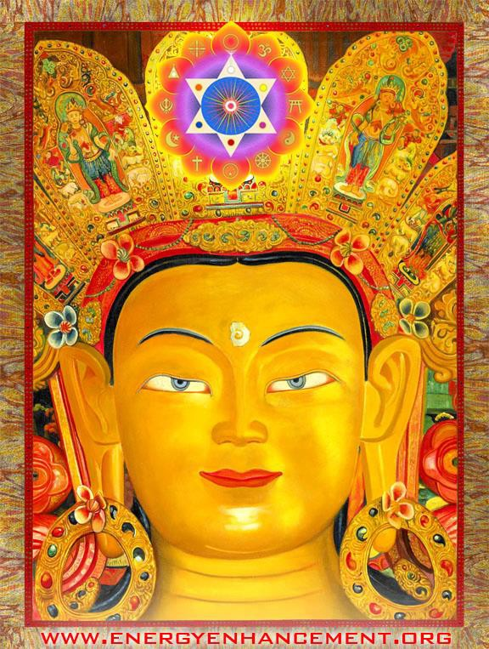
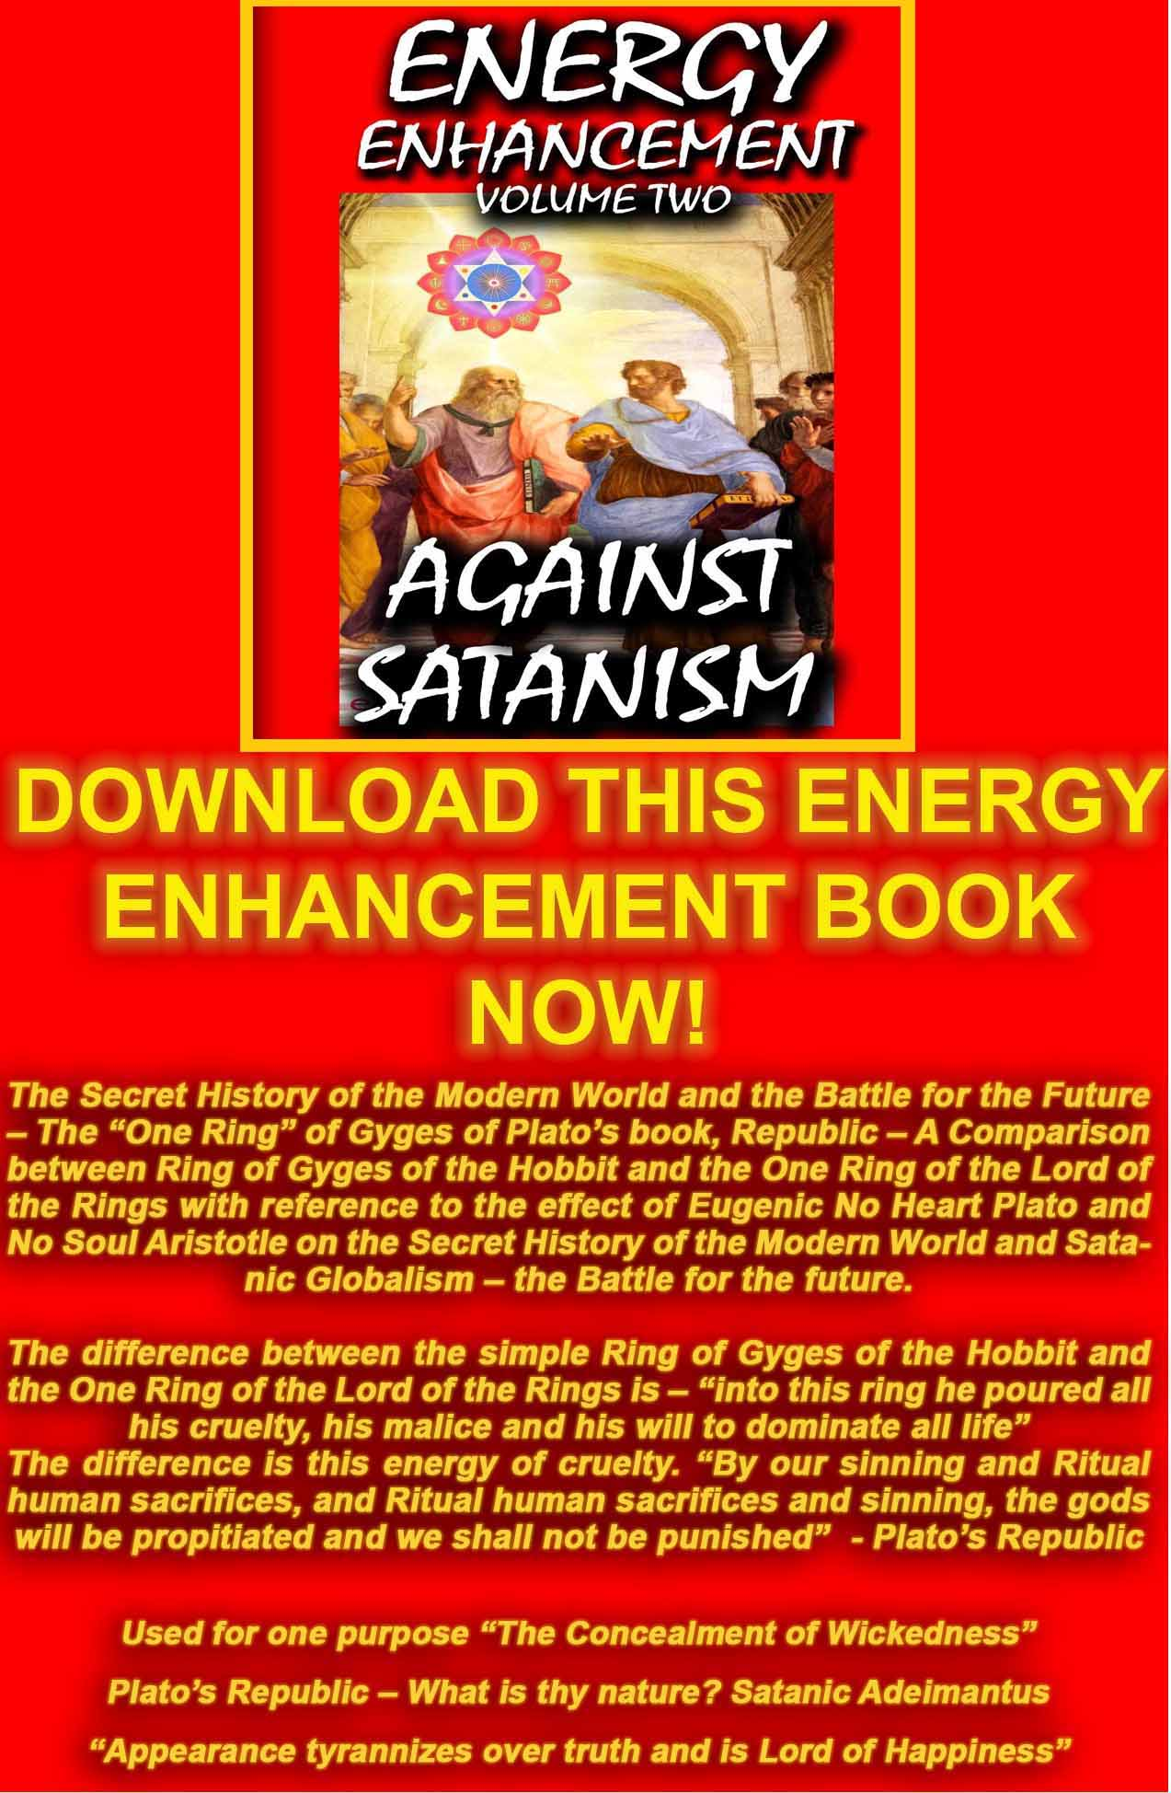
AGAINST SATANISM VOLUME 2
DOWNLOAD HERE
http://www.energyenhancement.org/Sacred-Energy/Against-Satanism-Volume-2/Against-Satanism-Volume-2.pdf

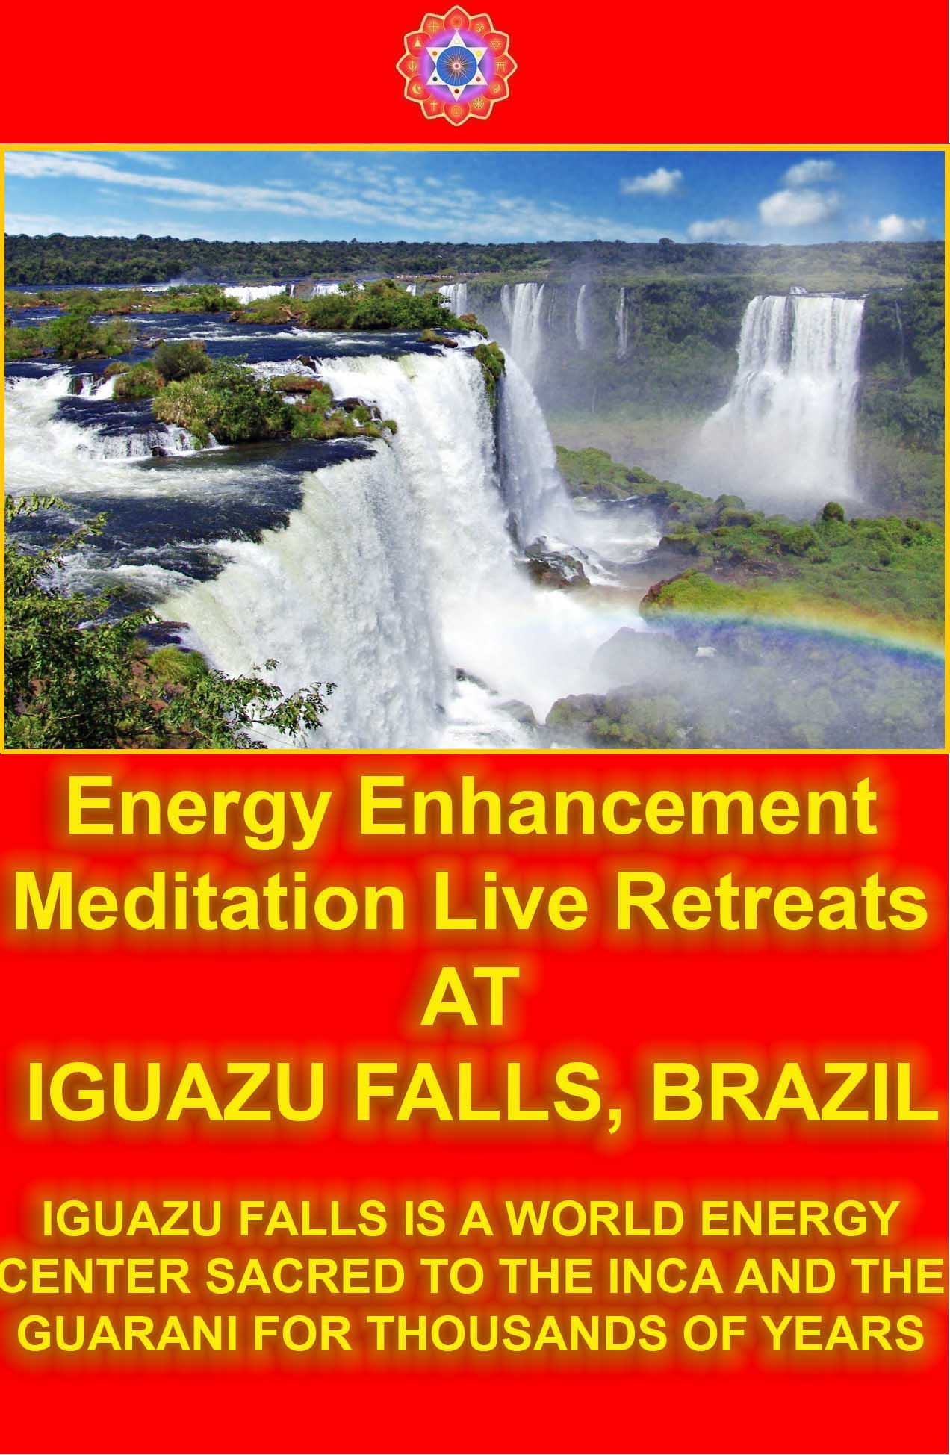

He then spoke the following words to me, 'Noble son, the seat of enlightenment is the seat of positive thought because it is without artificiality. It is the seat of effort, because it releases energetic activities. It is the seat of high resolve, because its insight is superior. It is the seat of the great spirit of enlightenment, because it does not neglect anything.

"'The seat of enlightenment is the seat of generosity, because it has no expectation of reward. It is the seat of morality, because it fulfills all commitments. It is the seat of tolerance, because it is free of anger toward any living being. It is the seat of effort, because it does not turn back. It is the seat of meditation, because it generates fitness of mind. It is the seat of wisdom, because it sees everything directly.

"'The seat of enlightenment is the seat of love, because it is equal to all living beings. It is the seat of compassion, because it tolerates all injuries. It is the seat of joy, because it is joyfully devoted to the bliss of the Dharma - the Soul - The First Chakra above the Head. It is the seat of equanimity, because it abandons affection and aversion.

"'The seat of enlightenment is the seat of paranormal perception, because it has the six superknowledges. It is the seat of liberation, because it does not intellectualize. It is the seat of liberative technique, because it develops living beings. It is the seat of the means of unification, because it brings together living beings.

The seat of enlightenment is the seat of learning, because it makes practice of the essence. It is the seat of decisiveness, because of its precise discrimination. It is the seat of the aids to enlightenment, because it eliminates the duality of the compounded and the uncompounded. It is the seat of truth, because it does not deceive anyone.

"'The seat of enlightenment is the seat of interdependent origination, because it proceeds from the exhaustion of ignorance to the exhaustion of old age and death. It is the seat of eradication of all passions, because it is perfectly enlightened about the nature of reality. It is the seat of all living beings, because all living beings are

without intrinsic identity. It is the seat of all things, because it is perfectly enlightened with regard to voidness.

"'The seat of enlightenment is the seat of the conquest of all devils, because it never flinches. It is the seat of the triple world, because it is free of involvement. It is the seat of the heroism that sounds the lion's roar, because it is free of fear and trembling. It is the seat of the strengths, the fearlessnesses, and all the special qualities of the Buddha, because it is irreproachable in all respects. It is the seat of the three knowledges, because in it no passions remain. It is the seat of instantaneous, total understanding of all things, because it realizes fully the gnosis of omniscience with the infinite chakras above the head.

"'Noble son, when bodhisattvas are thus endowed with the transcendences, the roots of virtue, the ability to develop living beings, and the incorporation of the holy Dharma - the Soul - The First Chakra above the Head, whether they lift up their feet or put them down, they all come from the seat of enlightenment. They come from the qualities of the Buddha, and stand on the qualities of the Buddha.'

"Lord, when Vimalakirti had explained this teaching, five hundred gods and men conceived the spirit of enlightenment, and I became speechless. Therefore, Lord, I am reluctant to go to that good man to inquire about his illness."

The Buddha then said to the bodhisattva Jagatimdhara, "Jagatimdhara, go to the Licchavi Vimalakirti to inquire about his illness."

Jagatimdhara replied, "My Lord, I am indeed reluctant to go to that good man to inquire about his illness. Why? Lord, I remember that one day, when I was at home, the wicked Mara Demon Energy Blockage, disguised as Indra and surrounded with twelve thousand heavenly maidens, approached me with the sounds of music and singing. Having saluted me by touching my feet with his head, he withdrew with his retinue to one side. I then, thinking he was Sakra, the king of the gods, said to him, 'Welcome, O Kausika! You should

remain consciously aware in the midst of the pleasures of desire. You should often think on impermanence and strive to utilize the essential in body, life, and wealth.'

"Mara Demon Energy Blockage then said to me, 'Good sir, accept from me these twelve thousand divine maidens and make them your servants.'

"I replied, 'O Kausika, do not offer me, who am religious and a son of the Sakya, things which are not appropriate. It is not proper for me to have these maidens.'

"No sooner had I said these words than the Licchavi Vimalakirti came there and said to me, 'Noble son, do not think that this is Indra!

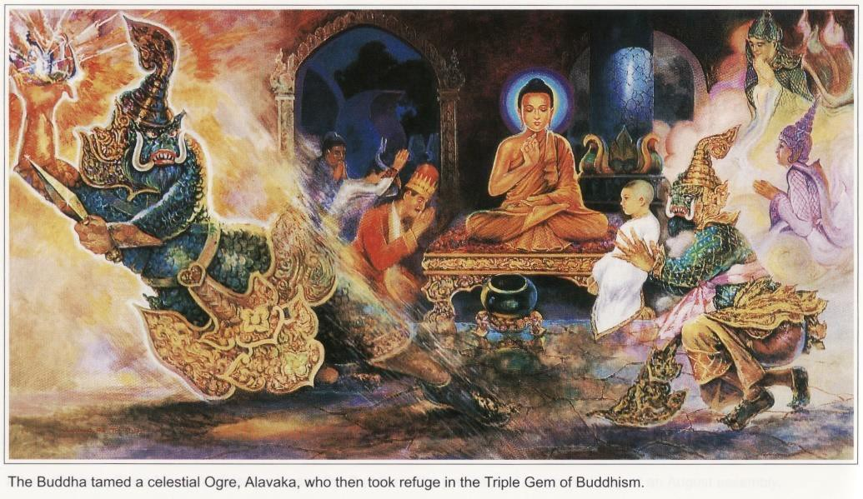

This is not Indra but the evil Mara Demon Energy Blockage, who has come to ridicule you.'

"Then the Licchavi Vimalakirti said to Mara, 'Evil Mara Demon Energy Blockage, since these heavenly maidens are not suitable for this religious devotee, a son of the Sakya, give them to me.'

"Then Mara Demon Energy Blockage was terrified and distressed, thinking that the Licchavi Vimalakirti had come to expose him. He tried to make himself invisible, but, try as he might with all his magical powers, he could not vanish from sight. Then a voice resounded in the sky, saying, 'Evil One, give these heavenly maidens to the good man Vimalakirti, and only then will you be able to return to your own abode.'

"Then Mara Demon Energy Blockage was even more frightened and, much against his will, gave the heavenly maidens.

"The Licchavi Vimalakirti, having received the goddesses, said to them, 'Now that you have been given to me by Mara Demon Energy Blockage, you should all conceive the spirit of unexcelled, perfect enlightenment.'

"He then exhorted them with discourse suitable for their development toward enlightenment, and soon they conceived the spirit of enlightenment. He then said to them, 'You have just conceived the spirit of enlightenment.

From now on, you should devote yourselves to find joy in pleasures of the Dharma - the Soul - The First Chakra above the Head, and should take no pleasure in desires.'

"They then asked him, 'What is "joy in the pleasures of the Dharma - the Soul - The First Chakra above the Head"?'


Joy in the pleasures of the Dharma - the Soul - The First Chakra above the Head

"He declared, 'Joy in the pleasures of the Dharma - the Soul - The First Chakra above the Head is the joy of unbreakable faith in the Buddha, of wishing to hear the Dharma - the Soul - The First Chakra

above the Head, of serving the Sangha and honoring the spiritual benefactors without pride.

Joy in the pleasures of the Dharma - the Soul - The First Chakra above the Head is the joy of renunciation of the whole world, of not being fixed in objects, of considering the five aggregates to be like murderers, of considering the elements to be like venomous serpents, and of considering the sense-media to be like an empty town.

Joy in the pleasures of the Dharma - the Soul - The First Chakra above the Head is the joy of always guarding the spirit of enlightenment, of helping living beings, of sharing through generosity, of not slackening in morality, of control and tolerance in patience, of thorough cultivation of virtue by effort, of total absorption in meditation, and of absence of passions in wisdom.

Joy in the pleasures of the Dharma - the Soul - The First Chakra above the Head is the joy of extending enlightenment, of conquering the Mara Demon Energy Blockages, of destroying the passions, and of purifying the Buddhafield.

Joy in the pleasures of the Dharma - the Soul - The First Chakra above the Head is the joy of accumulating all virtues, in order to cultivate the auspicious marks and signs.

Joy in the pleasures of the Dharma - the Soul - The First Chakra above the Head is the joy of the liberation of nonintimidation when hearing the profound teaching.

Joy in the pleasures of the Dharma - the Soul - The First Chakra above the Head is the joy of exploration of the three doors of liberation, and of the realization of liberation.

Joy in the pleasures of the Dharma - the Soul - The First Chakra above the Head is the joy of being an ornament of the seat of enlightenment, and of not attaining liberation at the wrong time.

Joy in the pleasures of the Dharma - the Soul - The First Chakra above the Head is the joy of serving those of equal fortune, of not hating or resenting those of superior fortune, of serving the spiritual benefactors, and of avoiding sinful friends.

Joy in the pleasures of the Dharma - the Soul - The First Chakra above the Head is the joy of the superior gladness of faith and devotion to the Dharma - the Soul - The First Chakra above the Head. It is the joy of acquiring liberative techniques and of the conscious cultivation of the aids to enlightenment. Thus, the bodhisattva admires and finds joy in the delights of the Dharma - the Soul - The First Chakra above the Head.'

"Thereupon, Mara Demon Energy Blockage said to the goddesses, 'Now come along and let us return home.'

"They said, 'You gave us to this householder. Now we should enjoy the delights of the Dharma - the Soul - The First Chakra above the Head and should no longer enjoy the pleasures of desires.'

"Then Mara Demon Energy Blockage said to the Licchavi Vimalakirti, 'If it is so that the bodhisattva, the spiritual hero, has no mental attachment, and gives away all his possessions, then, householder, please give me these goddesses.'

"Vimalakirti replied, 'They are given, Mara Demon Energy Blockage. Go home with your retinue.

May you fulfill the religious aspirations of all living beings!'

"Then the goddesses, saluting Vimalakirti, said to him, 'Householder, how should we live in the abode of the Mara Demon Energy Blockages?'

"Vimalakirti replied, 'Sisters, there is a door of the Dharma - the Soul - The First Chakra above the Head called "The Inexhaustible Lamp." Practice it!

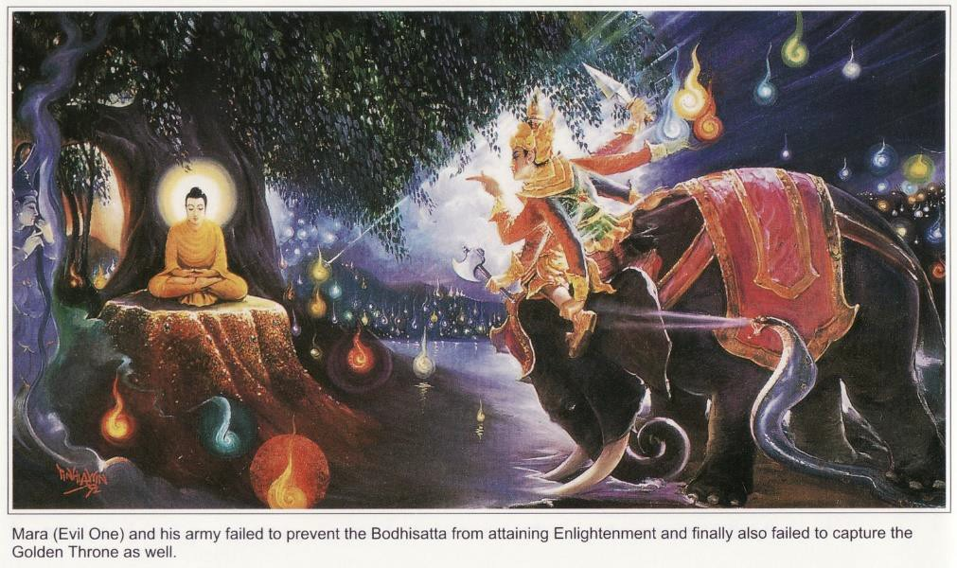
When you are living in the realm of the Mara Demon Energy Blockages

What is it? Sisters, a single lamp may light hundreds of thousands of lamps without itself being diminished.

Likewise, sisters, a single bodhisattva may establish many hundreds of thousands of living beings in enlightenment without his

mindfulness being diminished. In fact, not only does it not diminish, it grows stronger. Likewise, the more you teach and demonstrate virtuous qualities to others, the more you grow with respect to these virtuous qualities.

This is the door of the Dharma - the Soul - The First Chakra above the Head called "The Inexhaustible Lamp."

When you are living in the realm of the Mara Demon Energy Blockage, inspire innumerable gods and goddesses with the spirit of enlightenment. In such a way, you will repay the kindness of the Tathagata, and you will become the benefactors of all living beings.'

"Then, those goddesses bowed at the feet of the Licchavi Vimalakirti and departed in the company of Mara Demon Energy Blockage.

Thus, Lord, I saw the supremacy of the magical power, wisdom, and eloquence of the Licchavi Vimalakirti, and therefore I am reluctant to go to that good man to inquire about his illness."

The Buddha then said to the merchant's son, Sudatta, "Noble son, go to the Licchavi Vimalakirti to inquire about his illness."

Sudatta replied, "Lord, I am indeed reluctant to go to that good man to inquire about his illness. Why? Lord, I remember one day in my father's house when, in order to celebrate a great sacrifice, I was bestowing gifts upon religious devotees, Brahmans, the poor, the wretched, the unfortunate, beggars, and all the needy.

On the seventh and final day of this great sacrifice, the Licchavi Vimalakirti came there and said, 'Merchant's son, you should not celebrate a sacrifice in this way. You should celebrate a Dharma - the Soul - The First Chakra above the Head-sacrifice. What is the use of the sacrifice of material things?'

"I then asked him, 'How does one give a Dharma - the Soul - The First Chakra above the Head-sacrifice?'

"He replied, 'A Dharma - the Soul - The First Chakra above the Head-sacrifice is that which develops living beings without beginning or end, giving gifts to them all simultaneously.

What is that? It consists of the great love which is consummated in enlightenment; of the great compassion which is consummated in the concentration of the holy Dharma - the Soul - The First Chakra above the Head on the liberation of all living beings; of the great joy which is consummated in the awareness of the supreme happiness of all living beings; and of the great equanimity which is consummated in concentration through knowledge.

"'The Dharma - the Soul - The First Chakra above the Head-sacrifice consists of the transcendence of generosity, which is consummated in peacefulness and self-discipline; of the transcendence of morality, which is consummated in the moral development of immoral beings; of the transcendence of tolerance, consummated through the principle of selflessness; of the transcendence of effort, consummated in initiative toward enlightenment; of the transcendence of meditation, consummated in the solitude of body and mind; and of the transcendence of wisdom, consummated in the omniscient gnosis with the infinite chakras above the head.

"'The Dharma - the Soul - The First Chakra above the Head-sacrifice consists of the meditation of voidness, consummated in effectiveness in the development of all living beings; of the meditation of signlessness, consummated in the purification of all compounded things; and of the meditation of wishlessness, consummated in voluntarily assuming rebirths.

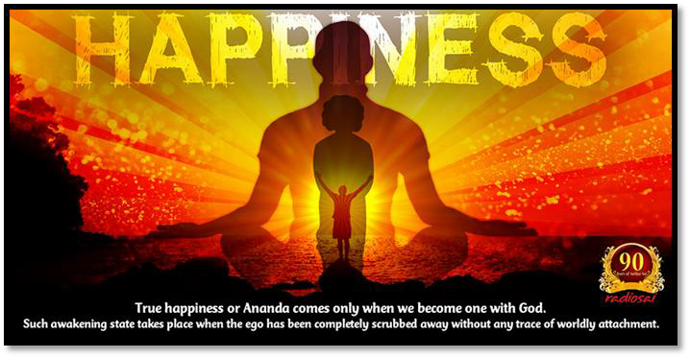

"'The Dharma - the Soul - The First Chakra above the Head-sacrifice consists of heroic strength, consummated in the upholding of the holy Dharma - the Soul - The First Chakra above the Head; of the power of life, consummated in the means of unification; of the absence of pride, consummated in becoming the slave and the disciple of all living beings; of the gain of body, health, and wealth, consummated by the extraction of essence from the essenceless; of mindfulness, consummated by the six remembrances; of positive thought, consummated through the truly enjoyable Dharma - the Soul - The First Chakra above the Head; of purity of livelihood,

consummated by correct spiritual practice; of the respect of saints, consummated by joyful and faithful service; of soberness of mind, consummated by absence of dislike for ordinary people; of high resolve, consummated by renunciation; of skill in erudition, consummated by religious practice; of retirement in solitary retreats, consummated by understanding things free of passions; of introspective meditation, consummated by attainment of the
Buddha-gnosis with the infinite chakras above the head; of the stage of the practice of yoga, consummated by the yoga of liberating all living beings from their passions.

"'The Dharma - the Soul - The First Chakra above the Head-sacrifice consists of the store of merit which is consummated by the auspicious signs and marks, the ornaments of the buddha-fields, and all other means of development of living beings; of the store of knowledge which is consummated in the ability to teach the Dharma
- the Soul - The First Chakra above the Head according to the thoughts and actions of all living beings; of the store of wisdom, which is consummated in the uniform gnosis with the infinite chakras above the head free of acceptance and rejection in regard to all things; of the store of all roots of virtue, consummated in the abandonment of all passions, obscurations, and unvirtuous things; and of the attainment of all the aids to enlightenment, consummated in the realization of the gnosis of omniscience as well as in accomplishment of all virtue.

"'That, noble son, is the Dharma - the Soul - The First Chakra above the Head-sacrifice. The bodhisattva who lives by this Dharma - the Soul - The First Chakra above the Head-sacrifice is the best of sacrificers, and, through his extreme sacrifice, is himself worthy of offerings from all people, including the gods.'

"Lord, as soon as the householder had discoursed thus, two hundred Brahmans among the crowd of Brahmans present conceived the spirit of unexcelled, perfect enlightenment. And I, full of astonishment, having saluted this good man by touching his feet with my head, took from around my neck a necklace of pearls worth one hundred thousand pieces of gold and offered it to him. But he would not accept it. I then said to him, 'Please accept, good man, this

necklace of pearls, out of compassion for me, and give it to whomsoever you wish.'

"Then, Vimalakirti took the pearls and divided them into two halves. He gave one half of them to the lowliest poor of the city, who had been disdained by those present at the sacrifice. The other half he offered to the Tathagata Dusprasaha. And he performed a miracle such that all present beheld the universe called Marici and the Tathagata Dusprasaha.

On the head of the Tathagata Dusprasaha, the pearl necklace took the form of a pavilion, decorated with strings of pearls, resting on four bases, with four columns, symmetrical, well constructed, and lovely to behold. Having shown such a miracle, Vimalakirti said, 'The giver who makes gifts to the lowliest poor of the city, considering them as worthy of offering as the Tathagata himself, the giver who gives without any discrimination, impartially, with no expectation of reward, and with great love - this giver, I say, totally fulfills the Dharma - the Soul - The First Chakra above the Head- sacrifice.'

"Then the poor of the city, having seen that miracle and having heard that teaching, conceived the spirit of unexcelled, perfect enlightenment. Therefore, Lord, I am reluctant to go to that good man to inquire about his illness."

In the same way, all the bodhisattvas, great spiritual heroes, told the stories of their conversations with Vimalakirti and declared their reluctance to go to him.

Vimalakirti Sutra Chapter 5 - The Consolation of the Invalid, intellect, Buddhas, Bodhisattvas, disciples, Sakras, Brahmas, Lokapalas, Gods, and Goddesses, The infinite chakra above the head, emptiness, nirvana, civilizing all the abodes of Devils,
Mara Energy Blockages, consummate in wisdom and liberative technique



Then, the Buddha said to the crown prince, Manjusri, "Manjusri, go to the Licchavi Vimalakirti to inquire about his illness."

Manjusri replied, "Lord, it is difficult to attend upon the Licchavi Vimalakirti. He is gifted with marvelous eloquence concerning the law of the profound. He is extremely skilled in full expressions and in the reconciliation of dichotomies.

His eloquence is inexorable, and no one can resist his imperturbable intellect.

He accomplishes all the activities of the bodhisattvas.

He penetrates all the secret mysteries of the bodhisattvas and the Buddhas.

He is skilled in civilizing all the abodes of devils.

He plays with the great superknowledges. He is consummate in wisdom and liberative tehcnique.

He has attained the supreme excellence of the indivisible, nondual sphere of the ultimate realm, the infinite chakra above the head. He is skilled in teaching the Dharma which issues not from the intellect of the mind but from the Soul, the first chakra above the head with its infinite modalities within the uniform ultimate. He is skilled in granting means of attainment in accordance with the spiritual faculties of all living beings.

He has thoroughly integrated his realization with skill in liberative technique.

He has attained decisiveness with regard to all questions. Thus, although he cannot be withstood by someone of my feeble defenses, still, sustained by the grace of the Buddha, I will go to him and will converse with him as well as I can."

Thereupon, in that assembly, the bodhisattvas, the great disciples, the Sakras, the Brahmas, the Lokapalas, and the gods and goddesses,

all had this thought: "Surely the conversations of the young prince Manjusri and that good man will result in a profound teaching of the Dharma which issues not from the intellect of the mind but from the Soul, the first chakra above the head."

Thus, eight thousand bodhisattvas, five hundred disciples, a great number of Sakras, Brahmas, Lokapalas, and many hundreds of thousands of gods and goddesses, all followed the crown prince Manjusri to listen to the Dharma which issues not from the intellect of the mind but from the Soul, the first chakra above the head. And the crown prince Manjusri, surrounded and followed by these bodhisattvas, disciples, Sakras, Brahmas, Lokapalas, gods, and goddesses, entered the great city of Vaisali.

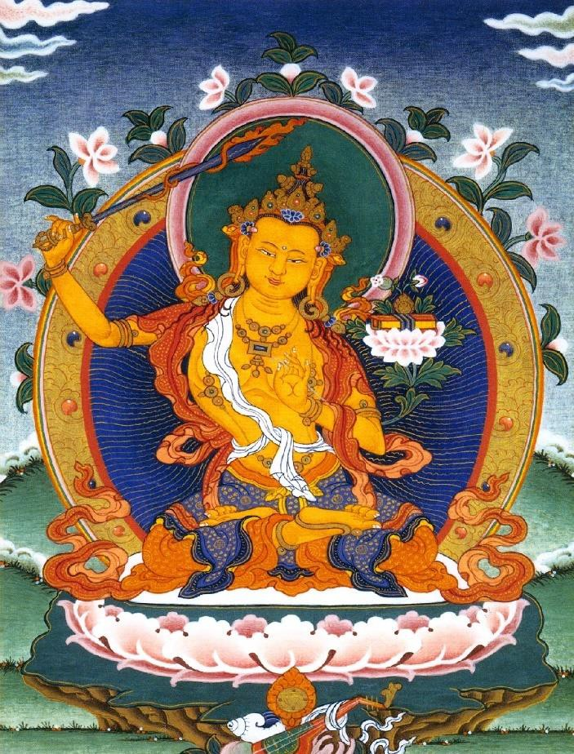
PRINCE MANJUSHRI AND HIS SWORD OF DIS-CRIME- INATION

Meanwhile, the Licchavi Vimalakirti thought to himself, "Manjusri, the crown prince, is coming here with numerous attendants. Now, may this house be transformed into emptiness!"

Then, magically his house became empty. Even the doorkeeper disappeared. And, except for the invalid's couch upon which Vimalakirti himself was lying, no bed or couch or seat could be seen anywhere.

Then, the Licchavi Vimalakirti saw the crown prince Manjusri and addressed him thus: "Manjusri! Welcome, Manjusri! You are very welcome! There you are, without any coming. You appear, without any seeing. You are heard, without any hearing."

Manjusri declared, "Householder, it is as you say. Who comes, finally comes not. Who goes, finally goes not.

"Why? Who comes is not known to come. Who goes is not known to go. Who appears is finally not to be seen.

The infinite chakra above the head, emptiness, neither comes nor goes, it is always present.

"Good sir, is your condition tolerable? Is it livable? Are your physical elements not disturbed? Is your sickness diminishing? Is it not increasing? The Buddha asks about you - if you have slight trouble, slight discomfort, slight sickness, if your distress is light, if you are cared for, strong, at ease, without self-reproach, and if you are living in touch with the supreme happiness.

"Householder, whence came this sickness of yours? How long will it continue? How does it stand? How can it be alleviated?"

Vimalakirti replied, "Manjusri, my sickness comes from ignorance and the thirst for existence and it will last as long as do the sicknesses of all living beings.

Were all living beings to be free from sickness, I also would not be sick. Why? Manjusri, a bodhisattva enters into births and deaths for

the sake of all living beings, and births and deaths always accompany sicknesses.

Were all living beings free of sickness, the bodhisattva also would be free of sickness.

For example, Manjusri, when the only son of a elder is sick, both his parents become sick on account of the sickness of their son. And the parents will suffer as long as that only son does not recover from his sickness.

Just so, Manjusri, the bodhisattva loves all living beings as if each were his only child. He becomes sick when they are sick and is cured when they are cured. You ask me, Manjusri, whence comes my sickness; the sicknesses of the bodhisattvas arise from great compassion."

Manjusri: Householder, why is your house empty? Why have you no servants?

Vimalakirti: Manjusri, all Buddhafields are also empty.

The infinite chakra above the head, emptiness, nirvana, is at such a high frequency, such a high energy, that it appears not to be there, but this emptiness, brighter than 10,000 suns, powers the whole universe.

The infinite chakra above the head, emptiness, nirvana, neither comes nor goes; it is always present.

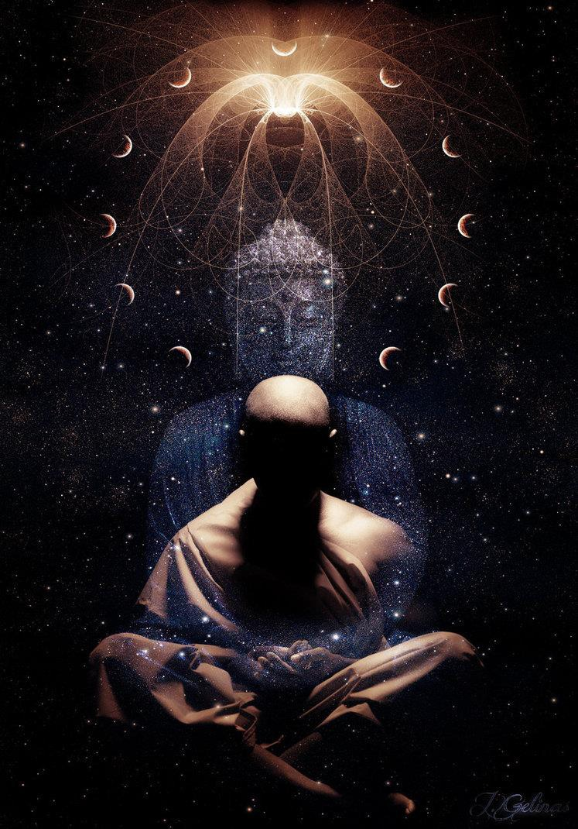
The infinite chakra above the head, emptiness, nirvana, neither comes nor goes; it is always present - even to those in Darkness!!

Manjusri: What makes them empty?

Vimalakirti: They are empty because of emptiness. Manjusri: What is "empty" about emptiness?
Vimalakirti: Constructions are empty, because of emptiness. Manjusri: Can emptiness be conceptually constructed?
Vimalakirti: Even that concept is itself empty, and emptiness cannot construct emptiness.

Manjusri: Householder, where should emptiness be sought?

Vimalakirti: Manjusri, emptiness should be sought among the sixty- two convictions.

Manjusri: Where should the sixty-two convictions be sought?

Vimalakirti: They should be sought in the liberation of the Tathagatas.

Manjusri: Where should the liberation of the Tathagatas be sought?

Vimalakirti: It should be sought in the prime mental activity of all living beings, which is blockageless - without Mara Energy Blockage Demons - and therefore free access to the infinite chakras above the head and their intelligent and intuitive energy which is higher than the intellect - the column of connection to the infinite chakras above the head - brighter than 10,000 suns it shines alone!!

Manjusri, you ask me why I am without servants, but all Mara Energy Blockage Demons and opponents are my servants. Why? The Mara Energy Blockage Demons desire this life of birth and death and the bodhisattva does not avoid life. The heterodox opponents, not in accordance with our established or accepted doctrines or opinions, advocate convictions, and the bodhisattva is

not troubled by convictions. Therefore, all Mara Energy Blockage Demons and opponents are my servants.

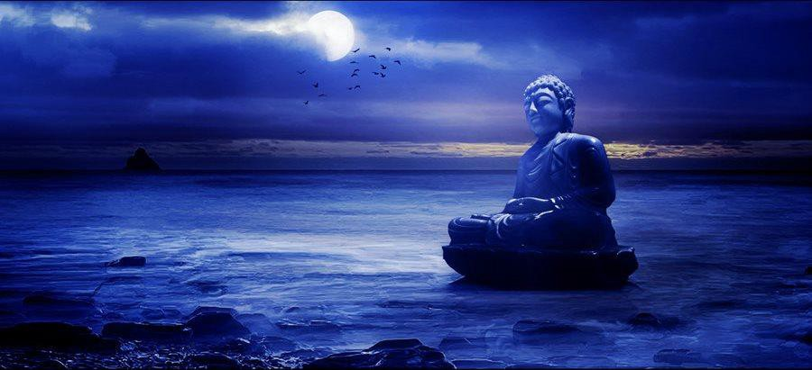
THE BUDDHA AND THE MOON, HIDDEN BY BLACK CROW MARA ENERGY BLOCKAGES
The Mara Energy Blockage Demons desire this life of birth and death and the bodhisattva does not avoid life. Therefore, all Mara Energy Blockage Demons and opponents are my servants.

Manjusri: Householder, of what sort is your sickness? Vimalakirti: It is immaterial and invisible.
Manjusri: Is it physical or mental?

Vimalakirti: It is not physical, since the body is insubstantial in itself. It is not mental, since the nature of the mind is like illusion.

Manjusri: Householder, which of the four main elements is disturbed - earth, water, fire, or air?

Vimalakirti: Manjusri, I am sick only because the elements of all living beings are disturbed by sicknesses.

Manjusri: Householder, how should a bodhisattva console another bodhisattva who is sick?

Vimalakirti: He should tell him that the body is impermanent, but should not exhort him to renunciation or disgust. He should tell him that the body is miserable, but should not encourage him to find solace in liberation; that the body is selfless, but that living beings should be developed; that the body is peaceful, but not to seek any ultimate calm.

He should urge him to confess his evil deeds, but not for the sake of absolution. He should encourage his empathy for all living beings on account of his own sickness, his remembrance of suffering experienced from beginningless time, and his consciousness of working for the welfare of living beings.

He should encourage him not to be distressed, but to manifest the roots of virtue, to maintain the primal purity of his connection with the infinite chakras above the head and the lack of Mara Energy Blockage Demon craving, and thus to always strive to become the king of healers, who can cure all sicknesses. Thus should a bodhisattva console a sick bodhisattva, in such a way as to make him happy.

Manjusri asked, "Noble sir, how should a sick bodhisattva control his own mind?"

Vimalakirti replied, "Manjusri, a sick bodhisattva should control his own mind with the following consideration:

Sickness arises from total involvement in the process of misunderstanding from beginningless time.

It arises from the passions that result from unreal mental constructions, energy blockages, and hence ultimately nothing is perceived which can be said to be sick as these energy blockages can be removed by the Energy Enhancement Seven Step Process, thus impermanent.

Why? The body is the issue of the four main elements, and in these elements there is no owner and no agent. There is no self in this body, and except for arbitrary insistence on self, ultimately no "I" which can be said to be sick can be apprehended.

Therefore, thinking "I" should not adhere to any self, and "I" should rest in the knowledge of the root of illness,' he should abandon the conception of himself as a personality and produce the conception of himself as a thing, thinking, 'This body is an aggregate of many things; when it is born, only things are born; when it ceases, only things cease; these things have no awareness or feeling of each other; when they are born, they do not think, "I am born." When they cease, they do not think, "I cease."'

"Furthermore, he should understand thoroughly the conception of himself as a thing by cultivating the following consideration: 'Just as in the case of the conception of "self," so the conception of "thing" is also a misunderstanding, and this misunderstanding is also a grave sickness; I should free myself from this sickness and should strive to abandon it.'

"What is the elimination of this sickness? It is the elimination of energy blockage egoism and possessiveness. What is the elimination of energy blockage egoism and possessiveness? It is the freedom

from dualism. What is freedom from dualism? It is the absence of involvement with either the external or the internal. What is absence of involvement with either external or internal? It is nondeviation, nonfluctuation, and nondistraction from equanimity. What is equanimity? It is the equality of everything from self to liberation.

Why? Because both self and liberation are void. How can both be void? As verbal designations, they both are void, and neither is established in reality. Therefore, one who sees such equality makes no difference between sickness and voidness; his sickness is itself voidness, and that sickness as voidness is itself void.

"The sick bodhisattva should recognize that sensation is ultimately nonsensation, but he should not realize the cessation of sensation. Although both pleasure and pain are abandoned when the buddha- qualities are fully accomplished, there is then no sacrifice of the great compassion for all living beings living in the bad migrations. Thus, recognizing in his own suffering the infinite sufferings of these living beings, the bodhisattva correctly contemplates these living beings and resolves to cure all sicknesses.

As for these living beings, there is nothing to be applied, and there is nothing to be removed; one has only to teach them the Dharma which issues not from the intellect of the mind but from the Soul, the first chakra above the head for them to realize the basis from which sicknesses arise.

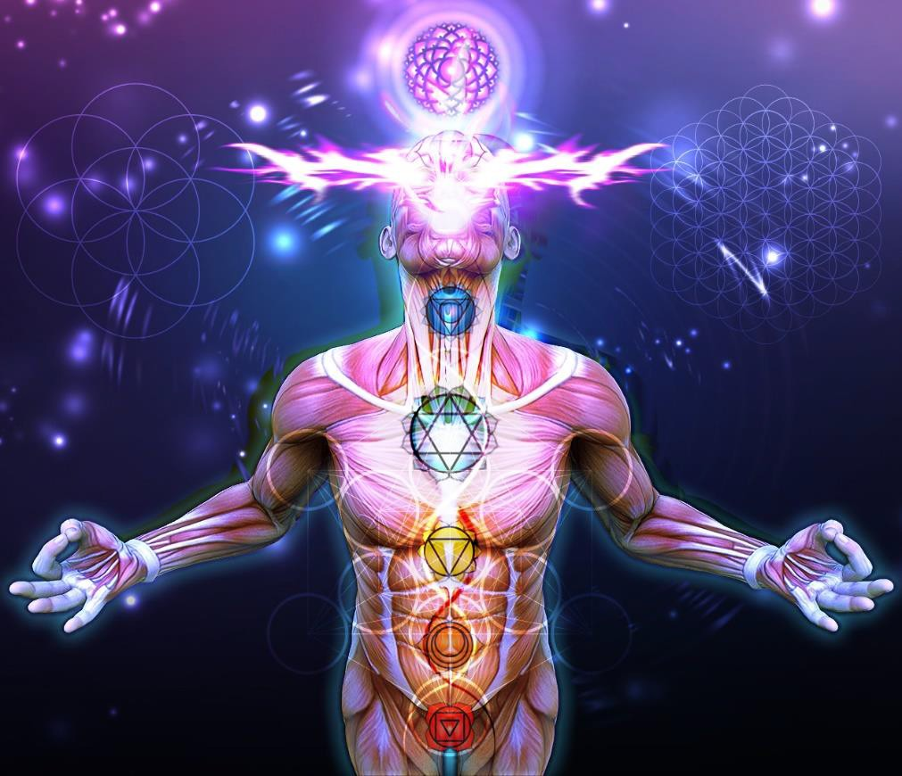
The Soul, the first chakra above the head

What is this basis? It is object-perception.

Insofar as apparent objects are perceived, they are the basis of sickness.

What things are perceived as objects? The three realms of existence are perceived as objects. What is the thorough understanding of the basic, apparent object? It is its nonperception, as no objects exist ultimately. What is nonperception?

The internal subject and the external object are not perceived dualistically. Therefore, it is called nonperception.

"Manjusri, thus should a sick bodhisattva control his own mind in order to overcome old age, sickness, death, and birth. Such, Manjusri, is the sickness of the bodhisattva. If he takes it otherwise, all his efforts will be in vain. For example, one is called 'hero' when one conquers the miseries of aging, sickness, and death.

"The sick bodhisattva should tell himself: 'Just as my sickness is unreal and nonexistent, so the sicknesses of all living beings are unreal and nonexistent.' Through such considerations, he arouses the great compassion toward all living beings without falling into any sentimental compassion.

The great compassion that strives to eliminate the accidental passions does not conceive of any life in living beings. Why?

Because great compassion that falls into sentimentally purposive views only exhausts the bodhisattva in his reincarnations.

But the great compassion which is free of involvement with sentimentally purposive views does not exhaust the bodhisattva in all his reincarnations. He does not reincarnate through involvement with such views but reincarnates with his mind free of involvement.

Hence, even his reincarnation is like a liberation.

Being reincarnated as if being liberated, he has the power and ability to teach the Dharma which issues not from the intellect of the mind but from the Soul, the first chakra above the head, which liberates living beings from their bondage.

As the Lord declares: 'It is not possible for one who is himself bound to deliver others from their bondage. But one who is himself liberated is able to liberate others from their bondage.' Therefore, the bodhisattva should participate in liberation and should not participate in bondage.

"What is bondage? And what is liberation? To indulge in liberation from the world without employing liberative technique is bondage for the bodhisattva. To engage in life in the world with full employment of liberative technique is liberation for the bodhisattva.

To experience the taste of contemplation, meditation, and concentration without skill in liberative technique is bondage. To experience the taste of contemplation and meditation with skill in liberative technique is liberation.



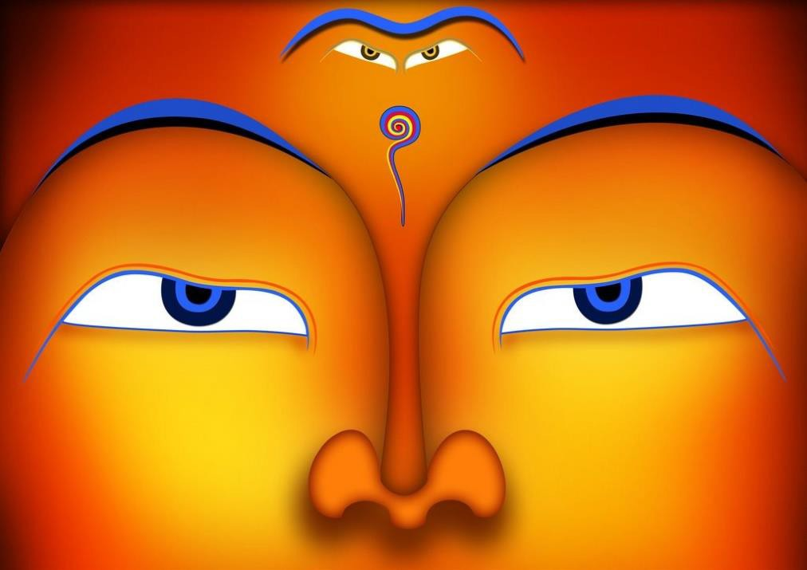
To experience the taste of contemplation and meditation with skill in liberative technique is liberation.



THE OPEN HEART

Wisdom not integrated with liberative technique is bondage, but wisdom integrated with liberative technique is liberation. Liberative technique not integrated with wisdom is bondage, but liberative technique integrated with wisdom is liberation.

"How is wisdom not integrated with liberative technique a bondage? Wisdom not integrated with liberative technique consists of concentration on voidness, signlessness, and wishlessness, and yet,

being motivated by sentimental compassion, failure to concentrate on cultivation of the auspicious signs and marks, on the adornment of the Buddhafield, and on the work of development of living beings it is bondage.

"How is wisdom integrated with liberative technique a liberation? Wisdom integrated with liberative technique consists of being motivated by the great compassion and thus of concentration on cultivation of the auspicious signs and marks, on the adornment of the Buddhafield, and on the work of development of living beings, all the while concentrating on deep investigation of voidness, signlessness, and wishlessness - and it is liberation.

Wisdom integrated with liberative technique consists of being motivated by the great compassion and thus of concentration on cultivation of the auspicious signs and marks, on the adornment of the Buddhafield, and on the work of development of living beings, all the while concentrating on deep investigation of voidness, signlessness, and wishlessness - and it is liberation.

The infinite chakras above the head become more empty, more void, higher in frequency, the higher they go. True emptiness arrives at infinity, the highest chakra above the head. Brighter than 10,000 suns it shines alone - the ultimate power source of all the chakras, all the universe, all humanity.

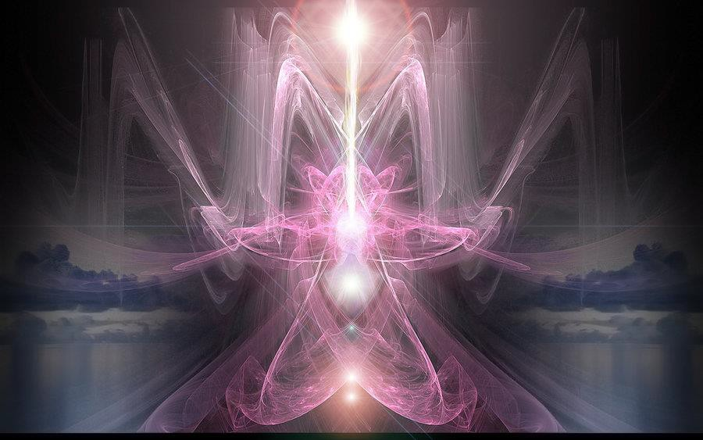
The infinite chakra above the head - Brighter than 10,000 suns it shines alone - the ultimate power source of all the chakras, all the universe, all humanity.

Wishlessness is desirelessness and is accomplished by removing the energy blockages from within the infinite higher chakras above the head in the energy column of the antahkarana.

"What is the bondage of liberative technique not integrated with wisdom?

The bondage of liberative technique not integrated with wisdom consists of the bodhisattva's planting of the roots of virtue without dedicating them for the sake of enlightenment, while living in the grip of dogmatic energy blockage convictions, passions, attachments, resentments, and their subconscious instincts.

"What is the liberation of liberative technique integrated with wisdom? The liberation of liberative technique integrated with wisdom consists of the bodhisattva's dedication of his roots of virtue for the sake of enlightenment, without taking any pride therein, while forgoing all energy blockage convictions, passions, attachments, resentments, and their subconscious instincts.

"Manjusri, thus should the sick bodhisattva consider things. His wisdom is the consideration of body, mind, and sickness as impermanent, miserable, empty, and selfless. His liberative technique consists of not exhausting himself by trying to avoid all physical sickness, and in applying himself to accomplish the benefit of living beings, without interrupting the cycle of reincarnations.
Furthermore, his wisdom lies in understanding that the body, mind, and sickness are neither new nor old, both simultaneously and sequentially. And his liberative technique lies in not seeking cessation of body, mind, or sicknesses.

"That, Manjusri, is the way a sick bodhisattva should concentrate his mind; he should live neither in control of his mind, nor in indulgence of his mind. Why? To live by indulging the mind is proper for fools and to live in control of the mind is proper for the disciples. Therefore, the bodhisattva should live neither in control nor in indulgence of his mind. Not living in either of the two extremes is the domain of the bodhisattva.

"Not the domain of the ordinary individual and not the domain of the saint, such is the domain of the bodhisattva.

The domain of the world yet not the domain of the passions, such is the domain of the bodhisattva. Where one understands liberation, yet does not enter final and complete liberation, there is the domain of the bodhisattva.

Where the four Mara demon energy blockages manifest, yet where all the works of Mara demon energy blockages are transcended, there is the domain of the bodhisattva.

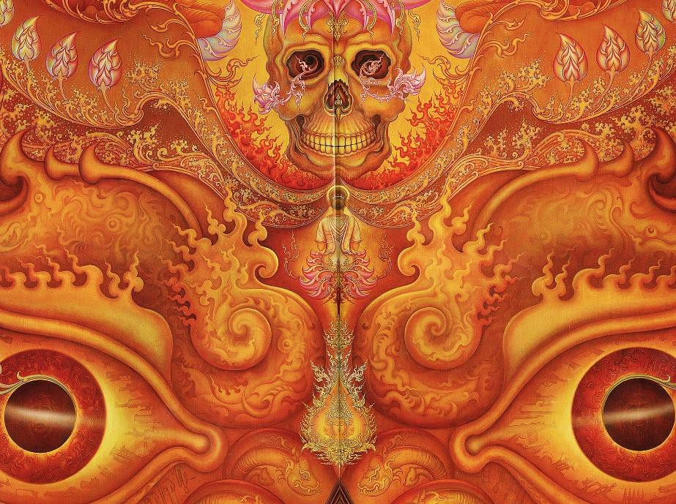
THE MARA - DEMON ENERGY BLOCKAGE - FACED DOWN BY A BUDDHA

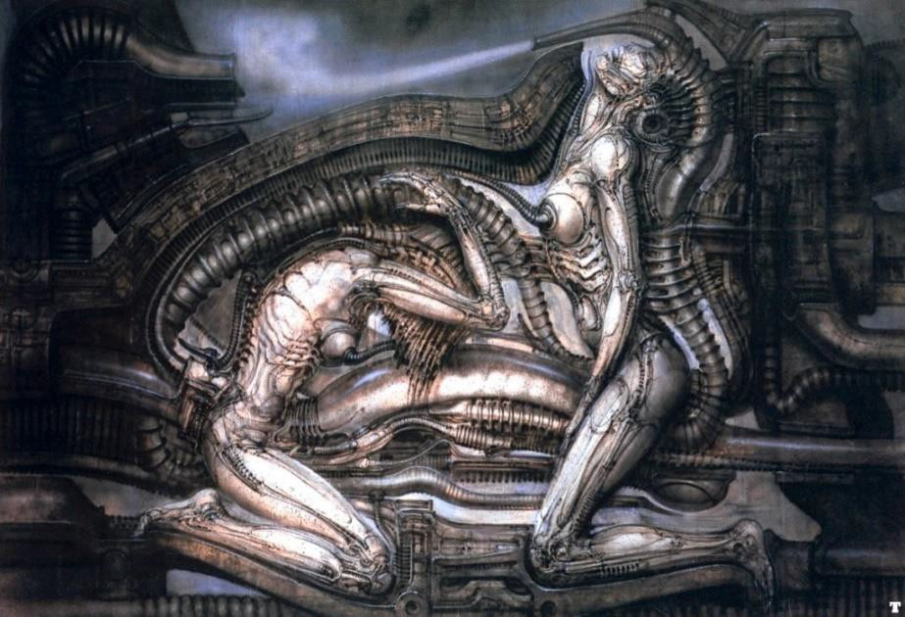
Where the four Mara demon energy blockages manifest, yet where all the works of Mara demon energy blockages are transcended, there is the domain of the bodhisattva.

Where one seeks the gnosis of omniscience, yet does not attain this gnosis at the wrong time, there is the domain of the bodhisattva.
Where one knows the Four Holy Truths, yet does not realize those truths at the wrong time, there is the domain of the bodhisattva. A domain of introspective insight, wherein one does not arrest voluntary reincarnation in the world, such is the domain of the bodhisattva.

A domain where one realizes birthlessness, yet does not become destined for the ultimate, such is the domain of the bodhisattva. Where one sees relativity without entertaining any convictions, there is the domain of the bodhisattva. Where one associates with all beings, yet keeps free of all afflictive instincts, there is the domain of the bodhisattva. A domain of solitude with no place for the exhaustion of body and mind, such is the domain of the bodhisattva. The domain of the triple world, yet indivisible from the ultimate realm, such is the domain of the bodhisattva. The domain of voidness, yet where one cultivates all types of virtues, such is the domain of the bodhisattva. The domain of signlessness, where one keeps in sight the deliverance of all living beings, such is the domain of the bodhisattva. The domain of wishlessness, where one voluntarily manifests lives in the world, such is the domain of the bodhisattva.

"A domain essentially without undertaking, yet where all the roots of virtue are undertaken without interruption, such is the domain of the bodhisattva. The domain of the six transcendences, where one attains the transcendence of the thoughts and actions of all living beings, such is the domain of the bodhisattva. The domain of the six superknowledges, wherein defilements are not exhausted, such is the domain of the bodhisattva.

The domain of living by the holy Dharma which issues not from the intellect of the mind but from the Soul, the first chakra above the head, without even perceiving any evil paths, such is the domain of the bodhisattva. The domain of the four immeasurables, where one does not accept rebirth in the heaven of Brahma, such is the domain of the bodhisattva.

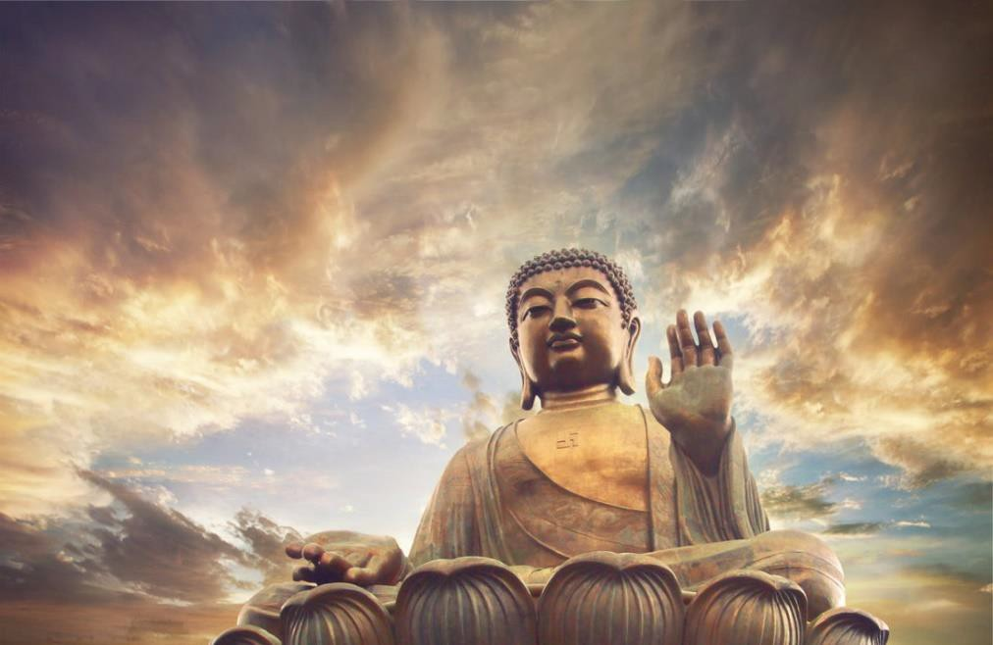
The domain of the four immeasurables, where one does not accept rebirth in the heaven of Brahma, such is the domain of the bodhisattva.

The domain of the six remembrances, unaffected by any sort of defilement, such is the domain of the bodhisattva. The domain of contemplation, meditation, and concentration, where one does not reincarnate in the formless realms by force of these meditations and concentrations, such is the domain of the bodhisattva.

The domain of the four right efforts, where the duality of good and evil is not apprehended, such is the domain of the bodhisattva. The domain of the four bases of magical powers, where they are

effortlessly mastered, such is the domain of the bodhisattva. The domain of the five spiritual faculties, where one knows the degrees of the spiritual faculties of living beings, such is the domain of the bodhisattva.

The domain of living with the five powers, where one delights in the ten powers of the Tathagata, such is the domain of the bodhisattva. The domain of perfection of the seven factors of enlightenment, where one is skilled in the knowledge of fine intellectual distinctions, such is the domain of the bodhisattva.

The domain of the holy eightfold path, where one delights in the unlimited path of the Buddha, such is the domain of the bodhisattva. The domain of the cultivation of the aptitude for mental quiescence and transcendental analysis, where one does not fall into extreme quietism, such is the domain of the bodhisattva.

The domain of the realization of the unborn nature of all things, yet of the perfection of the body, the auspicious signs and marks, and the ornaments of the Buddha, such is the domain of the bodhisattva. The domain of manifesting the attitudes of the disciples and the solitary sages without sacrificing the qualities of the Buddha, such is the domain of the bodhisattva.

The domain of conformity to all things utterly pure in nature while manifesting behavior that suits the inclinations of all living beings, such is the domain of the bodhisattva. A domain where one realizes that all the Buddhafields are indestructible and uncreatable, having the nature of infinite space, yet where one manifests the establishment of the qualities of the Buddhafields in all their variety and magnitude, such is the domain of the bodhisattva.

The domain where one turns the wheel of the holy Dharma which issues not from the intellect of the mind but from the Soul, the first chakra above the head and manifests the magnificence of ultimate liberation, yet never forsakes the career of the bodhisattva, such is the domain of the bodhisattva!"

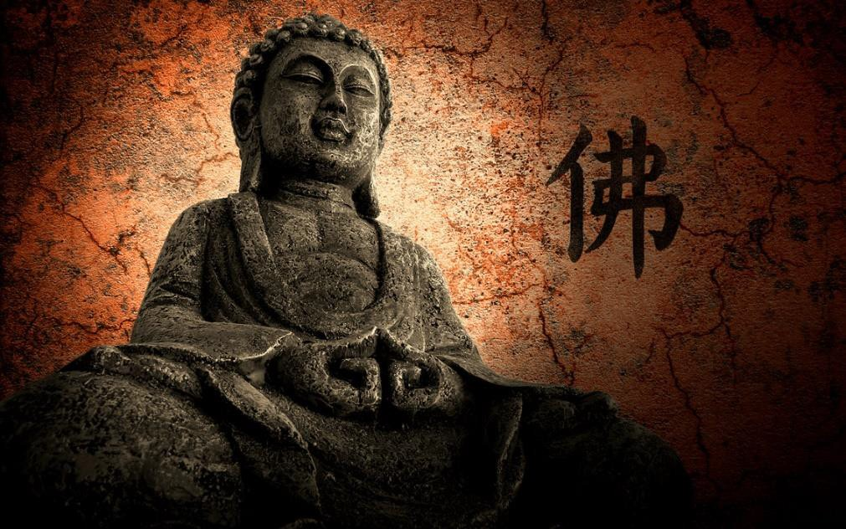
When Vimalakirti had spoken this discourse, eight thousand of the gods in the company of the crown prince Manjusri conceived the spirit of unexcelled, perfect enlightenment..


DOWNLOAD “LEVEL 2 REMOVE ENERGY BLOCKAGES” HERE
http://www.energyenhancement.org/Sacred-Energy/Level-2-Book/Energy-Enhancement-Level-2-Book-Remove-Energy-Blockages.pdf

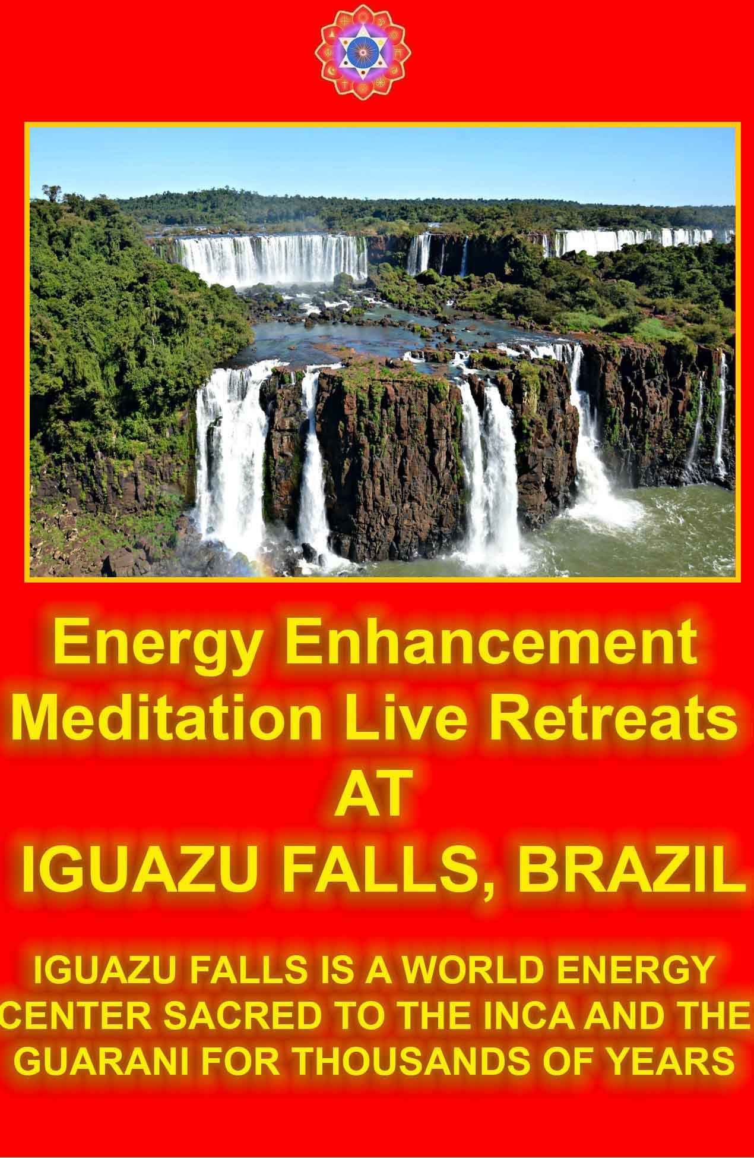

Vimalakirti Chapter 6 The Inconceivable Liberation Living Immortally – Immortality Sariputra, Dharma issues not from the intellect of the mind but from the Soul, the first chakra above the head.

Universes can be created in the Chakras Above the Head by those pure of energy blockages, channelling the energy of God, living immortally, helping all humanity to become pure and to gain sufficient talent, sufficient size, density of psychic body, to create their own universes where they can live forever
Bodhisattvas, great disciples, Sakras, Brahmas, Lokapalas, and other gods the abodes of the gods, the nagas, the yaksas, the gandharvas, the asuras, the garudas, the kimnaras, and the mahoragas.



Thereupon, the venerable Sariputra had this thought: "There is not even a single chair in this house. Where are these disciples and bodhisattvas going to sit?"

The Licchavi Vimalakirti read the thought of the venerable Sariputra and said, "Reverend Sariputra, did you come here for the sake of the Dharma which issues not from the intellect of the mind but from the Soul, the first chakra above the head? Or did you come here for the sake of a chair?"

Sariputra replied, "I came for the sake of the Dharma which issues not from the intellect of the mind but from the Soul, the first chakra above the head, not for the sake of a chair."

Vimalakirti continued, "Reverend Sariputra, he who is interested in the Dharma which issues not from the intellect of the mind but from the Soul, the first chakra above the head is not interested even in his own body, much less in a chair.


The Soul, the first chakra above the head

Reverend Sariputra, he who is interested in the Dharma which issues not from the intellect of the mind but from the Soul, the first chakra above the head has no interest in matter, sensation, intellect, motivation, or consciousness. He has no interest in these aggregates, or in the elements, or in the sense-media.

Interested in the Dharma which issues not from the intellect of the mind but from the Soul, the first chakra above the head, he has no interest in the realm of desire, the realm of matter, or the immaterial realm.

Interested in the Dharma which issues not from the intellect of the mind but from the Soul, the first chakra above the head, he is not interested in attachment to the Buddha, attachment to the Dharma which issues not from the intellect of the mind but from the Soul, the first chakra above the head, or attachment to the Sangha.

Reverend Sariputra, he who is interested in the Dharma which issues not from the intellect of the mind but from the Soul, the first chakra above the head is not interested in recognizing suffering, abandoning its origination, realizing its cessation, or practicing the path.

Why? The Dharma which issues not from the intellect of the mind but from the Soul, the first chakra above the head is ultimately without formulation and without verbalization.

Who verbalizes: 'Suffering should be recognized, origination should be eliminated, cessation should be realized, the path should be practiced,' is not interested in the Dharma which issues not from the intellect of the mind but from the Soul, the first chakra above the head but is interested in verbalization.

"Reverend Sariputra, the Dharma which issues not from the intellect of the mind but from the Soul, the first chakra above the head is calm and peaceful.

Those who are engaged in production and destruction are not interested in the Dharma which issues not from the intellect of the

mind but from the Soul, the first chakra above the head, are not interested in solitude, but are interested in production and destruction.

"Furthermore, reverend Sariputra, the Dharma which issues not from the intellect of the mind but from the Soul, the first chakra above the head is without taint and free of defilement.

He who is attached to anything, even to liberation, is not interested in the Dharma which issues not from the intellect of the mind but from the Soul, the first chakra above the head but is interested in the taint of desire.

The Dharma which issues not from the intellect of the mind but from the Soul, the first chakra above the head is not an object.

He who pursues objects is not interested in the Dharma which issues not from the intellect of the mind but from the Soul, the first chakra above the head but is interested in objects.

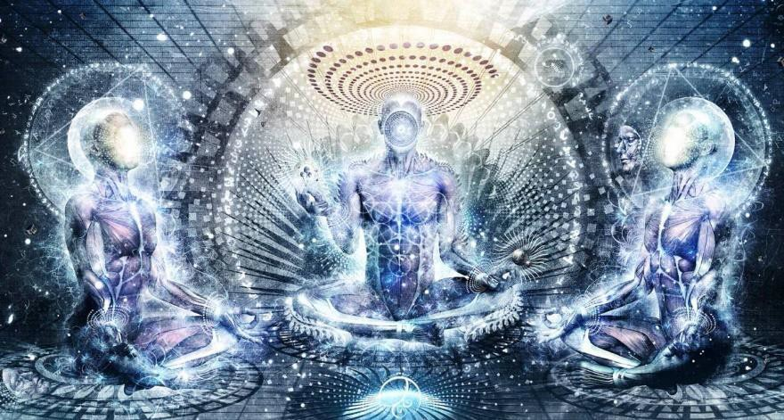

The Dharma which issues not from the intellect of the mind but from the Soul, the first chakra above the head is without acceptance or rejection. He who holds on to things or lets go of things is not interested in the Dharma which issues not from the intellect of the mind but from the Soul, the first chakra above the head but is interested in holding and letting go.

The Dharma which issues not from the intellect of the mind but from the Soul, the first chakra above the head is not a secure refuge. He who enjoys a secure refuge is not interested in the Dharma which issues not from the intellect of the mind but from the Soul, the first chakra above the head but is interested in a secure refuge.

The Dharma which issues not from the intellect of the mind but from the Soul, the first chakra above the head is without sign. He whose consciousness pursues signs is not interested in the Dharma which issues not from the intellect of the mind but from the Soul, the first chakra above the head but is interested in signs.

The Dharma which issues not from the intellect of the mind but from the Soul, the first chakra above the head is not a society. He who seeks to associate with the Dharma which issues not from the intellect of the mind but from the Soul, the first chakra above the head is not interested in the Dharma which issues not from the intellect of the mind but from the Soul, the first chakra above the head but is interested in association.

The Dharma which issues not from the intellect of the mind but from the Soul, the first chakra above the head is not a sight, a sound, a category, or an idea. He who is involved in sights, sounds, categories, and ideas is not interested in the Dharma which issues not from the intellect of the mind but from the Soul, the first chakra above the head but is interested in sights, sounds, categories, and ideas.

Reverend Sariputra, the Dharma which issues not from the intellect of the mind but from the Soul, the first chakra above the head is free of compounded things and uncompounded things. He who adheres to compounded things and uncompounded things is not interested in

the Dharma which issues not from the intellect of the mind but from the Soul, the first chakra above the head but is interested in adhering to compounded things and uncompounded things.

"Thereupon, reverend Sariputra, if you are interested in the Dharma which issues not from the intellect of the mind but from the Soul, the first chakra above the head, you should take no interest in anything."

When Vimalakirti had spoken this discourse, five hundred gods obtained the purity of the Dharma which issues not from the intellect of the mind but from the Soul, the first chakra above the head-eye in viewing all things.

Then, the Licchavi Vimalakirti said to the crown prince, Manjusri, "Manjusri, you have already been in innumerable hundreds of thousands of Buddhafields throughout the Universe created in the Chakras Above the Heads of the ten directions.

Universes can be created in the chakras above the head by those pure of energy blockages, channelling the energy of God, living immortally, helping all humanity to become pure and to gain sufficient talent, sufficient size, density of psychic body, sufficient to create their own universes where they can live forever.
Hell Universes can also be created by impure beings who have cut themselves off from god by blockages above the Soul, or higher, above the Monad Chakra, or even higher, vampirising the energies of all beings

because they can no longer channel the energies of God, unable to live immortally because of the deterioration of Time, but instead, Dying of the Light, of God.

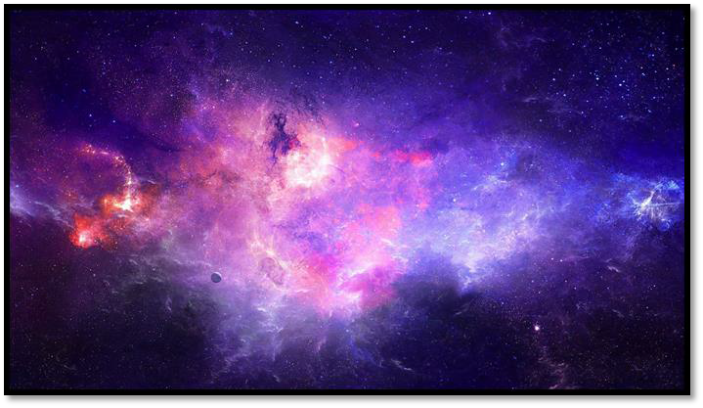
In which Buddhafield did you see the best lion-thrones with the finest qualities?"

Manjusri replied, "Noble sir, if one crosses the Buddhafields to the east, which are more numerous than all the grains of sand of thirty- two Ganges rivers, one will discover a Universe created in the Chakras Above the Head called Merudhvaja.

There dwells a Tathagata called Merupradiparaja. His body measures eighty-four hundred thousand leagues in height, and the height of his throne is sixty-eight hundred thousand leagues. The bodhisattvas there are forty-two hundred thousand leagues tall and their own thrones are thirty-four hundred thousand leagues high. Noble sir, the finest and most superb thrones exist in that Universe created in the Chakras Above the Head Merudhvaja, which is the Buddhafield of the Tathagata Merupradiparaja."

At that moment, the Licchavi Vimalakirti, having focused himself in concentration, performed a miraculous feat such that the Lord Tathagata Merupradiparaja, in the Universe created in the Chakras Above the Head Merudhvaja, sent to this Universe created in the Chakras Above the Head, thirty-two hundred thousand thrones.

These thrones were so tall, spacious, and beautiful that the bodhisattvas, great disciples, Sakras, Brahmas, Lokapalas, and other gods had never before seen the like. The thrones descended from the sky and came to rest in the house of the Licchavi Vimalakirti. The thirty-two hundred thousand thrones arranged themselves without crowding and the house seemed to enlarge itself accordingly. The great city of Vaisali did not become obscured; neither did the land of Jambudvipa, nor the world of four continents.

Everything else appeared just as it was before.

Then, the Licchavi Vimalakirti said to the young prince Manjusri, "Manjusri, let the bodhisattvas be seated on these thrones, having transformed their bodies to a suitable size!"

Then, those bodhisattvas who had attained the superknowledges transformed their bodies to a height of forty-two hundred thousand leagues and sat upon the thrones.

But the beginner bodhisattvas were not able to transform themselves to sit upon the thrones. Then, the Licchavi Vimalakirti taught these beginner bodhisattvas a teaching that enabled them to attain the five superknowledges, and, having attained them, they transformed their

bodies to a height of forty-two hundred thousand leagues and sat upon the thrones.

But still the great disciples were not able to seat themselves upon the thrones.

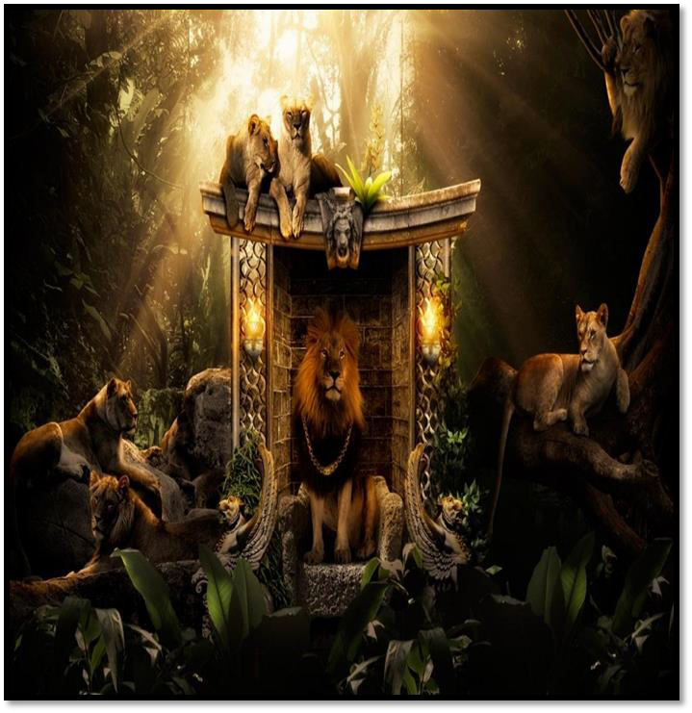
The Licchavi Vimalakirti said to the venerable Sariputra, "Reverend Sariputra, take your seat upon a throne."

He replied, "Good sir, the thrones are too big and too high, and I cannot sit upon them."

Vimalakirti said, "Reverend Sariputra, bow down to the Tathagata Merupradiparaja, and you will be able to take your seat."

Then, the great disciples bowed down to the Tathagata Merupradiparaja and they were seated upon the thrones.

Then, the venerable Sariputra said to the Licchavi Vimalakirti, "Noble sir, it is astonishing that these thousands of thrones, so big and so high, should fit into such a small house and that the great city of Vaisali, the villages, cities, kingdoms, capitals of Jambudvipa, the other three continents, the abodes of the gods, the nagas, the yaksas, the gandharvas, the asuras, the garudas, the kimnaras, and the mahoragas - that all of these should appear without any obstacle, just as they were before!"

The Licchavi Vimalakirti replied, "Reverend Sariputra, for the Tathagatas and the bodhisattvas, there is a liberation called 'Inconceivable.'

The bodhisattva who lives in the inconceivable liberation can put the king of mountains, Sumeru, which is so high, so great, so noble, and so vast, into a mustard seed. He can perform this feat without enlarging the mustard seed and without shrinking Mount Sumeru.
And the deities of the assembly of the four Maharajas and of the Trayastrimsa heavens do not even know where they are.

Only those beings who are destined to be disciplined by miracles see and understand the putting of the king of mountains, Sumeru, into the mustard seed. That, reverend Sariputra, is an entrance to the domain of the inconceivable liberation of the bodhisattvas.

"Furthermore, reverend Sariputra, the bodhisattva who lives in the inconceivable liberation can pour into a single pore of his skin all the waters of the four great oceans, without injuring the water- animals such as fish, tortoises, crocodiles, frogs, and other creatures, and without the nagas, yaksas, gandharvas, and asuras even being

aware of where they are. And the whole operation is visible without any injury or disturbance to any of those living beings.

"Such a bodhisattva can pick up with his right hand this billion- world-galactic Universe created in the Chakras Above the Head as if it were a potter's wheel and, spinning it round, throw it beyond Universes created in the Chakras Above the Head, as numerous as the sands of the Ganges, without the living beings therein knowing their motion or its origin, and he can catch it and put it back in its place, without the living beings suspecting their coming and going; and yet the whole operation is visible.

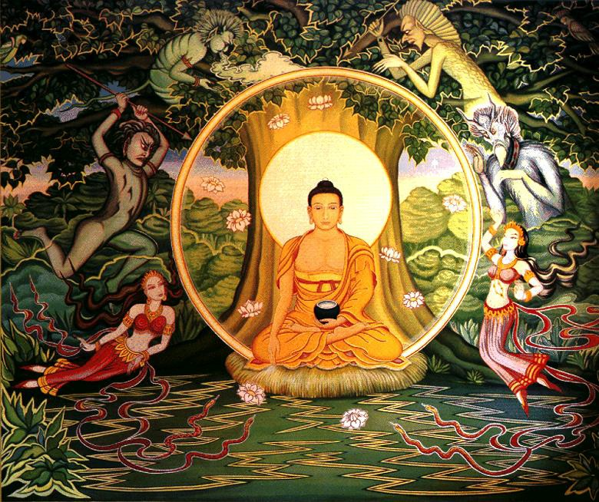
"Furthermore, reverend Sariputra, there are beings who become disciplined after an immense period of evolution, and there are also those who are disciplined after a short period of evolution. The bodhisattva who lives in the inconceivable liberation, for the sake of
113

disciplining those living beings who are disciplined through immeasurable periods of evolution, can make the passing of a week seem like the passing of an aeon, and he can make the passing of an aeon seem like the passing of a week for those who are disciplined through a short period of evolution. The living beings who are disciplined through an immeasurable period of evolution actually perceive a week to be the passing of an aeon, and those disciplined by a short period of evolution actually perceive an aeon to be the passing of a week.

"Thus, a bodhisattva who lives in the inconceivable liberation can manifest all the splendors of the virtues of all the Buddhafields within a single Buddhafield. Likewise, he can place all living beings in the palm of his right hand and can show them with the supernatural speed of thought all the Buddhafields without ever leaving his own Buddhafield. He can display in a single pore all the offerings ever offered to all the Buddhas of the ten directions, and the orbs of all the suns, moons, and stars of the ten directions.

He can inhale all the hurricanes of the cosmic wind-atmospheres of the ten directions into his mouth without harming his own body and without letting the forests and the grasses of the Buddhafields be flattened.

He can take all the masses of fire of all the supernovas that ultimately consume all the Universe created in the Chakras Above the Heads of all the Buddhafields into his stomach without interfering with their functions.

Having crossed Buddhafields as numerous as the sands of the Ganges downward, and having taken up a Buddhafield, he can rise up through Buddhafields as numerous as the sands of the Ganges and place it on high, just as a strong man may pick up a jujube leaf on the point of a needle.

"Thus, a bodhisattva who lives in the inconceivable liberation can magically transform any kind of living being into a universal monarch, a Lokapala, a Sakra, a Brahma, a disciple, a solitary sage, a bodhisattva, and even into a Buddha.

114

The bodhisattva can transform miraculously all the cries and noises, superior, mediocre, and inferior, of all living beings of the ten directions, into the voice of the Buddha, with the words of the Buddha, the Dharma which issues not from the intellect of the mind but from the Soul, the first chakra above the head, and the Sangha, having them proclaim, 'Impermanent! Miserable! Empty! Selfless!' And he can cause them to recite the words and sounds of all the teachings taught by all the Buddhas of the ten directions.

"Reverend Sariputra, I have shown you only a small part of the entrance into the domain of the bodhisattva who lives in the inconceivable liberation.

Reverend Sariputra, to explain to you the teaching of the full entrance into the domain of the bodhisattva who lives in the inconceivable liberation would require more than an aeon, and even more than that."

Then, the patriarch Mahakasyapa, having heard this teaching of the inconceivable liberation of the bodhisattvas, was amazed, and he said to the venerable Sariputra, "Venerable Sariputra, if one were to show a variety of things to a person blind from birth, he would not be able to see a single thing.

Likewise, venerable Sariputra, when this door of the inconceivable liberation is taught, all the disciples and solitary sages are sightless, like the man blind from birth, and cannot comprehend even a single cause of the inconceivable liberation.

Who is there among the wise who, hearing about this inconceivable liberation, does not conceive the spirit of unexcelled, perfect enlightenment?

As for us, whose faculties are deteriorated, like a burned and rotten seed, what else can we do if we do not become receptive to this great vehicle?

We, all the disciples and solitary sages, upon hearing this teaching of the Dharma which issues not from the intellect of the mind but

from the Soul, the first chakra above the head, should utter a cry of regret that would shake this billion-world-galactic Universe created in the Chakras Above the Head!

And as for the bodhisattvas, when they hear of this inconceivable liberation they should be as joyful as a young crown prince when he takes the diadem and is anointed, and they should increase to the utmost their devotion to this inconceivable liberation. Indeed, what could the entire host of Maras ever do to one who is devoted to this inconceivable liberation?"

When the patriarch Mahakasyapa had uttered this discourse, thirty- two thousand gods conceived the spirit of unexcelled, perfect enlightenment.

Then the Licchavi Vimalakirti said to the patriarch Mahakasyapa, "Reverend Mahakasyapa, the Maras who play the devil in the innumerable Universes - created in the Chakras Above the Head - of the ten directions are all bodhisattvas dwelling in the inconceivable

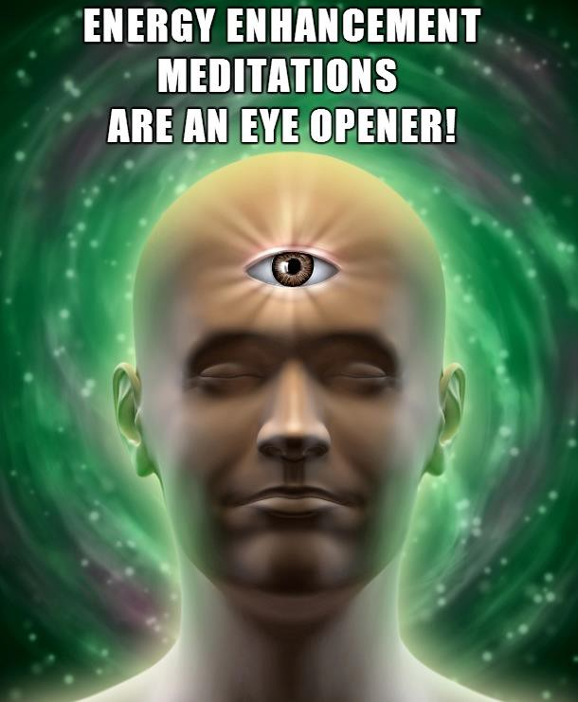

liberation, who are playing the devil in order to develop living beings through their skill in liberative technique.

Reverend Mahakasyapa, all the miserable beggars who come to the bodhisattvas of the innumerable Universe created in the Chakras Above the Heads of the ten directions to ask for a hand, a foot, an ear, a nose, some blood, muscles, bones, marrow, an eye, a torso, a head, a limb, a member, a throne, a kingdom, a country, a wife, a son, a daughter, a slave, a slave-girl, a horse, an elephant, a chariot, a cart, gold, silver, jewels, pearls, conches, crystal, coral, beryl, treasures, food, drink, elixirs, and clothes - these demanding beggars are usually bodhisattvas living in the inconceivable liberation who, through their skill in liberative technique, wish to test and thus demonstrate the firmness of the high resolve of the bodhisattvas.

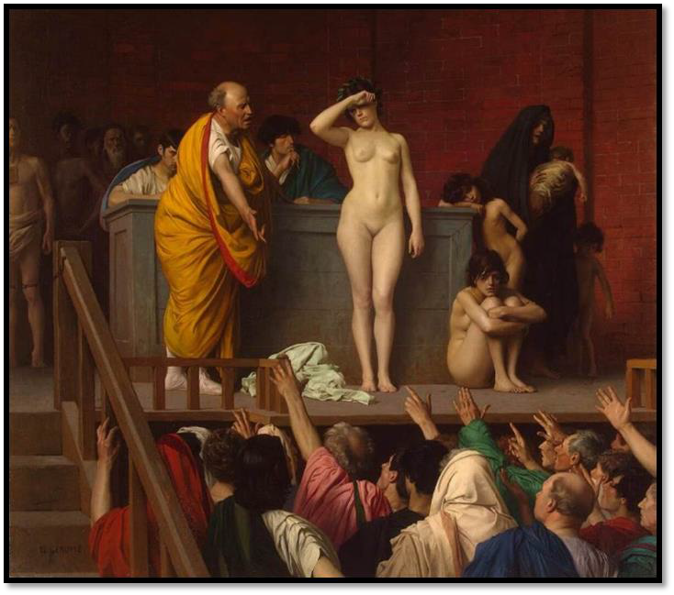
THEY ASK FOR A WIFE, A SON, A DAUGHTER, A SLAVE.

Why? Reverend Mahakasyapa, the bodhisattvas demonstrate that firmness by means of terrible austerities. Ordinary persons have no power to be thus demanding of bodhisattvas, unless they are granted the opportunity. They are not capable of killing and depriving in that manner without being freely given the chance.

"Reverend Mahakasyapa, just as a glowworm cannot eclipse the light of the sun, so reverend Mahakasyapa, it is not possible without special allowance that an ordinary person can thus attack and deprive a bodhisattva.

Reverend Mahakasyapa, just as a donkey could not muster an attack on a wild elephant, even so, reverend Mahakasyapa, one who is not himself a bodhisattva cannot harass another bodhisattva, and only a bodhisattva can tolerate the harassment of another bodhisattva.

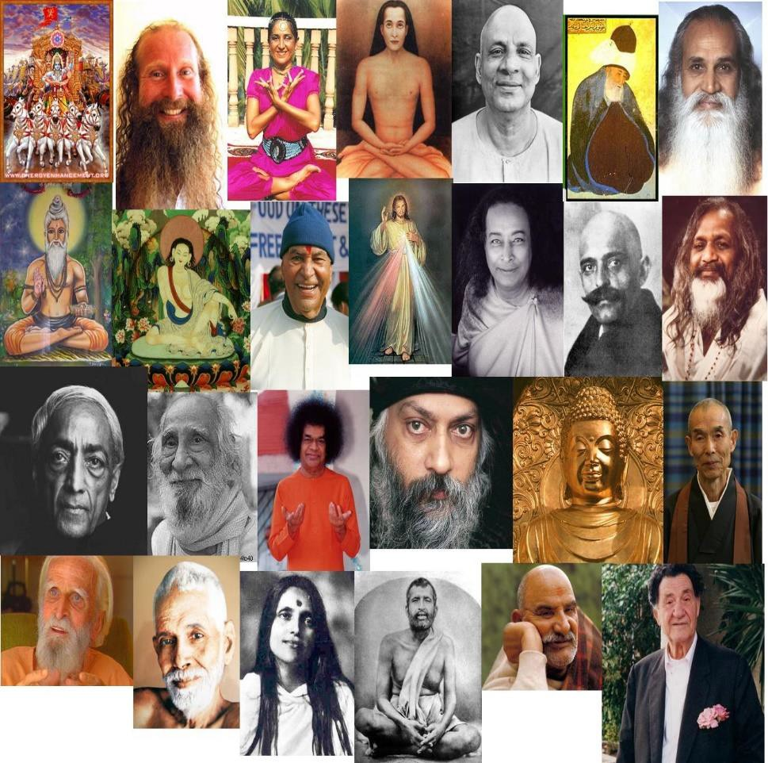

Reverend Mahakasyapa, such is the introduction to the power of the knowledge of liberative technique of the bodhisattvas who live in the inconceivable liberation."



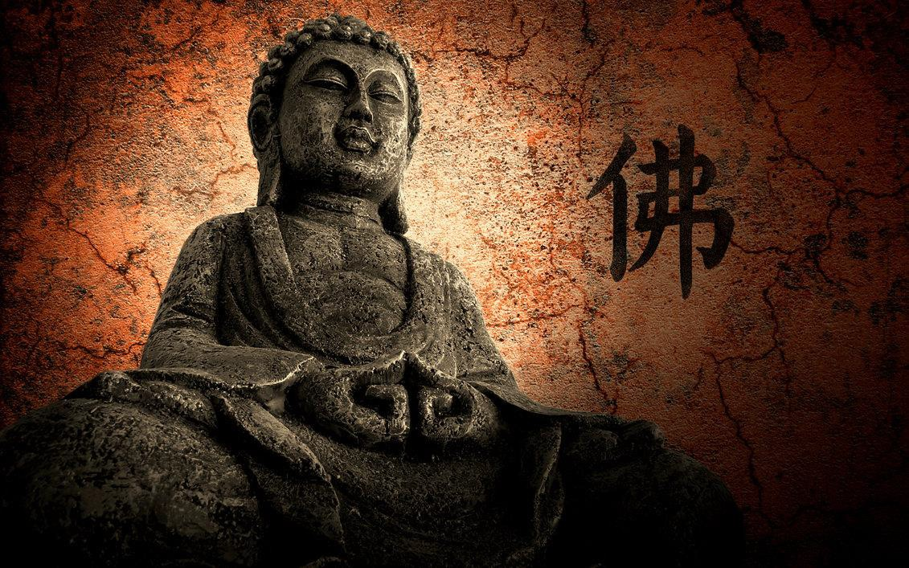

When Vimalakirti had spoken this discourse, eight thousand of the gods in the company of the crown prince Manjusri conceived the spirit of unexcelled, perfect enlightenment..



Vimalakirti Sutra Chapter 7: Manjusri, Compassion, the Great Love of the Bodhisattvas towards Humanity, generating the Love that is firm, Love its high resolve unbreakable, Love like a diamond. Energy Blockage Evil spirits cannot disturb the fearless. The perfect enlightenment of Buddhahood.

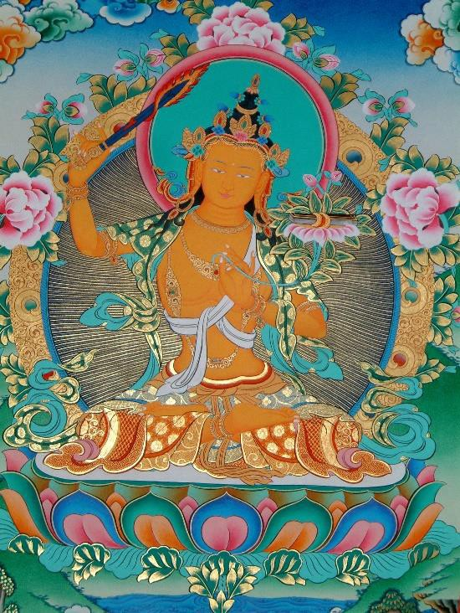

MANJUSRI DISCRIMINATION LOVE

Thereupon, Manjusri, the crown prince, addressed the Licchavi Vimalakirti: "Good sir, how should a bodhisattva regard all living beings?"

Vimalakirti replied, "Manjusri, a bodhisattva should regard all livings beings as a wise man regards the reflection of the moon in water or as magicians regard men created by magic. He should regard them as being like a face in a mirror; like the water of a mirage; like the sound of an echo; like a mass of clouds in the sky; like the previous moment of a ball of foam; like the appearance and disappearance of a bubble of water; like the core of a plantain tree; like a flash of lightning;

like the fifth great element; like the seventh sense-medium; like the appearance of matter in an immaterial realm; like a sprout from a rotten seed; like a tortoise-hair coat; like the fun of games for one who wishes to die; like the egoistic views of a stream-winner; like a third rebirth of a once-returner; like the descent of a nonreturner into a womb; like the existence of desire, hatred, and folly in a saint; like thoughts of avarice, immorality, wickedness, and hostility in a bodhisattva who has attained tolerance;

like the instincts of passions in a Tathagata; like the perception of color in one blind from birth; like the inhalation and exhalation of an ascetic absorbed in the meditation of cessation;

like the track of a bird in the sky; like the erection of a eunuch; like the pregnancy of a barren woman; like the unproduced passions of an emanated incarnation of the Tathagata;

like dream-visions seen after waking; like the passions of one who is free of conceptualizations; like fire burning without fuel; like the reincarnation of one who has attained ultimate liberation.

"Precisely thus, Manjusri, does a bodhisattva who realizes the ultimate selflessness consider all beings."

Manjusri then asked further, "Noble sir, if a bodhisattva considers all living beings in such a way, how does he generate the great love toward them?"

Vimalakirti replied, "Manjusri, when a bodhisattva considers all living beings in this way, he thinks: 'Just as I have realized the Dharma, so should I teach it to living beings.'

Thereby, he generates the love that is truly a refuge for all living beings;

the love that is peaceful because free of grasping;

the love that is not feverish, because free of passions;

the love that accords with reality because it is equanimous in all three times;

the love that is without conflict because free of the violence of the passions;

the love that is nondual because it is involved neither with the external nor with the internal;

the love that is imperturbable because totally ultimate.

"Thereby he generates the love that is firm, its high resolve unbreakable, like a diamond;

the love that is pure, purified in its intrinsic nature; the love that is even, its aspirations being equal; the saint's love that has eliminated its enemy;
the bodhisattva's love that continuously develops living beings; The Tathagata's love that understands reality;

the Buddha's love that causes living beings to awaken from their sleep;

the love that is spontaneous because it is fully enlightened spontaneously;

the love that is enlightenment because it is unity of experience;

the love that has no presumption because it has eliminated attachment and aversion;

the love that is great compassion because it infuses the Mahayana with radiance;

the love that is never exhausted because it acknowledges voidness and selflessness;

the love that is giving because it bestows the gift of Dharma free of the tight fist of a bad teacher;

the love that is morality because it improves immoral living beings;

the love that is tolerance because it protects both self and others;

the love that is effort because it takes responsibility for all living beings;

the love that is contemplation because it refrains from indulgence in tastes;

the love that is wisdom because it causes attainment at the proper time;

the love that is liberative technique because it shows the way everywhere;

the love that is without formality because it is pure in motivation;

the love that is without deviation because it acts from decisive motivation;

the love that is high resolve because it is without passions; the love that is without deceit because it is not artificial;
the love that is happiness because it introduces living beings to the happiness of the Buddha.

Such, Manjusri, is the great love of a bodhisattva."

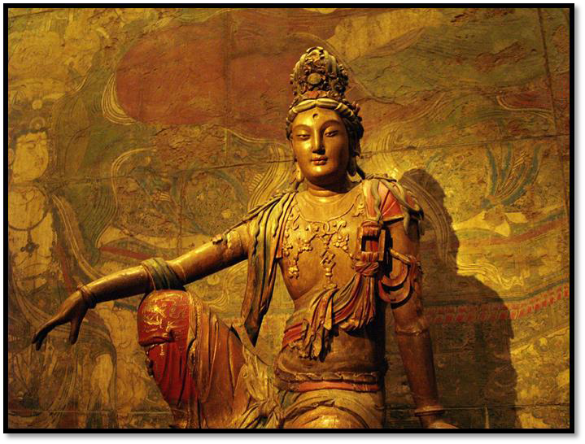

Manjusri: What is the great compassion of a bodhisattva?

Vimalakirti: It is the giving of all accumulated roots of virtue to all living beings.
Manjusri: What is the great joy of the bodhisattva? Vimalakirti: It is to be joyful and without regret in giving.

Manjusri: What is the equanimity of the bodhisattva? Vimalakirti: It is what benefits both self and others.
Manjusri: To what should one resort when terrified by fear of life?

Vimalakirti: Manjusri, a bodhisattva who is terrified by fear of life should resort to the magnanimity of the Buddha.

Manjusri: Where should he who wishes to resort to the magnanimity of the Buddha take his stand?

Vimalakirti: He should stand in equanimity toward all living beings.

Manjusri: Where should he who wishes to stand in equanimity toward all living beings take his stand?

Vimalakirti: He should live for the liberation of all living beings.

Manjusri: What should he who wishes to liberate all living beings do?

Vimalakirti: He should liberate them from their passions.

Manjusri: How should he who wishes to eliminate passions apply himself?

Vimalakirti: He should apply himself appropriately.

Manjusri: How should he apply himself, to "apply himself appropriately"?

Vimalakirti: He should apply himself to productionlessness and to destructionlessness.

Manjusri: What is not produced? And what is not destroyed? Vimalakirti: Evil is not produced and good is not destroyed.

Manjusri: What is the root of good and evil? Vimalakirti: Materiality is the root of good and evil. Manjusri: What is the root of materiality?
Vimalakirti: Desire is the root of materiality. Manjusri: What is the root of desire and attachment? Vimalakirti: Unreal construction is the root of desire. Manjusri: What is the root of unreal construction?
Vimalakirti: The false concept is its root. Manjusri: What is the root of the false concept? Vimalakirti: Baselessness.
Manjusri: What is the root of baselessness?

Vimalakirti: Manjusri, when something is baseless, how can it have any root?

Therefore, all evil things stand on the root which is baseless - a Lie.

FROM THE FATHER OF LIES



Thereupon, a certain goddess who lived in that house, having heard this teaching of the Dharma of the great heroic bodhisattvas, and being delighted, pleased, and overjoyed, manifested herself in a material body and showered the great spiritual heroes, the bodhisattvas, and the great disciples with heavenly flowers.

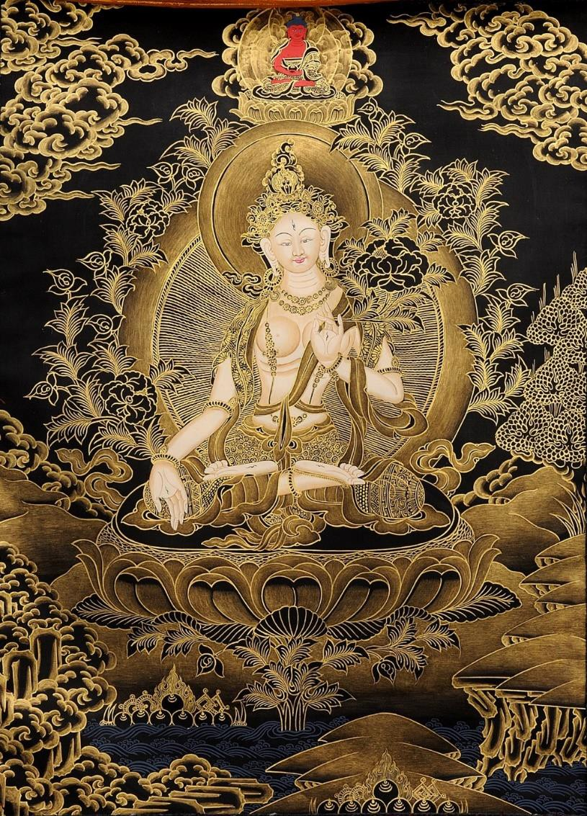
THE WHITE TARA GODDESS AND THE FIRST CHAKRA ABOVE THE HEAD

When the flowers fell on the bodies of the bodhisattvas, they fell off on the floor, but when they fell on the bodies of the great disciples, they stuck to them and did not fall.

The great disciples shook the flowers and even tried to use their magical powers, but still the flowers would not shake off. Then, the goddess said to the venerable Sariputra, "Reverend Sariputra, why do you shake these flowers?"

Sariputra replied, "Goddess, these flowers are not proper for religious persons and so we are trying to shake them off."

The goddess said, "Do not say that, reverend Sariputra. Why? These flowers are proper indeed! Why? Such flowers have neither constructual thought nor discrimination. But the elder Sariputra has both constructual thought and discrimination.

"Reverend Sariputra, impropriety for one who has renounced the world for the discipline of the rightly taught Dharma consists of constructual thought and discrimination, yet the elders are full of such thoughts. One who is without such thoughts is always proper.

"Reverend Sariputra, see how these flowers do not stick to the bodies of these great spiritual heroes, the bodhisattvas! This is because they have eliminated constructual thoughts and discriminations.

"For example, evil spirit energy blockages have power over fearful men but cannot disturb the fearless.

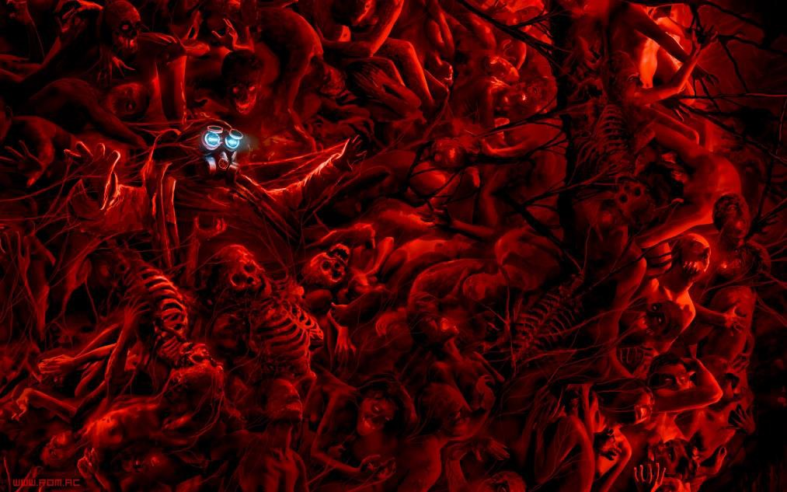
ENERGY BLOCKAGE DEMON SPIRITS

Likewise, those intimidated by fear of the world are in the power of forms, sounds, smells, tastes, and textures, which do not disturb those who are free from fear of the passions inherent in the constructive world.

Thus, these flowers stick to the bodies of those who have not eliminated their instincts for the passions and do not stick to the bodies of those who have eliminated their instincts.


AND THE FLOWERS SHOWERED

Therefore, the flowers do not stick to the bodies of these bodhisattvas, who have abandoned all instincts."

Then the venerable Sariputra said to the goddess, "Goddess, how long have you been in this house?"

The goddess replied, "I have been here as long as the elder has been in liberation."

Sariputra said, "Then, have you been in this house for quite some time?"

The goddess said, "Has the elder been in liberation for quite some time?"

At that, the elder Sariputra fell silent.

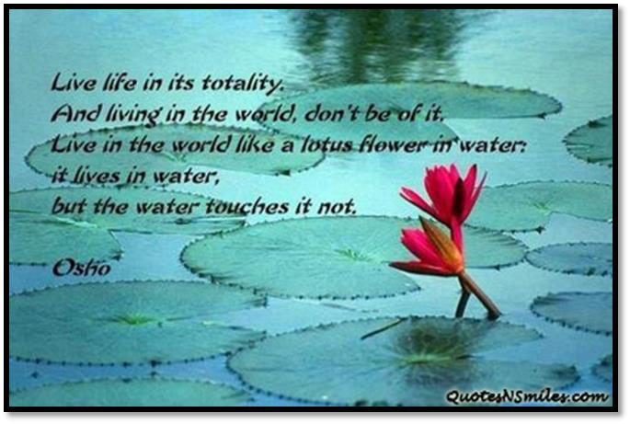

The goddess continued, "Elder, you are 'foremost of the wise!' Why do you not speak? Now, when it is your turn, you do not answer the question."

Sariputra: Since liberation is inexpressible, goddess, I do not know what to say.

Goddess: All the syllables pronounced by the elder have the nature of liberation. Why?

Liberation is neither internal nor external, nor can it be apprehended apart from them. Likewise, syllables are neither internal nor external, nor can they be apprehended anywhere else. Therefore, reverend Sariputra, do not point to liberation by abandoning speech! Why?

The holy liberation is the equality of all things!

Sariputra: Goddess, is not liberation the freedom from desire, hatred, and folly?

Goddess: "Liberation is freedom from desire, hatred, and folly" that is the teaching of the excessively proud.

But those free of pride are taught that the very nature of desire, hatred, and folly is itself liberation.

Sariputra: Excellent! Excellent, goddess! Pray, what have you attained, what have you realized, that you have such eloquence?

Goddess: I have attained nothing, reverend Sariputra. I have no realization. Therefore I have such eloquence.

Whoever thinks, "I have attained! I have realized!" is overly proud in the discipline of the well-taught Dharma.

Sariputra: Goddess, do you belong to the disciple-vehicle, to the solitary-vehicle, or to the great vehicle?

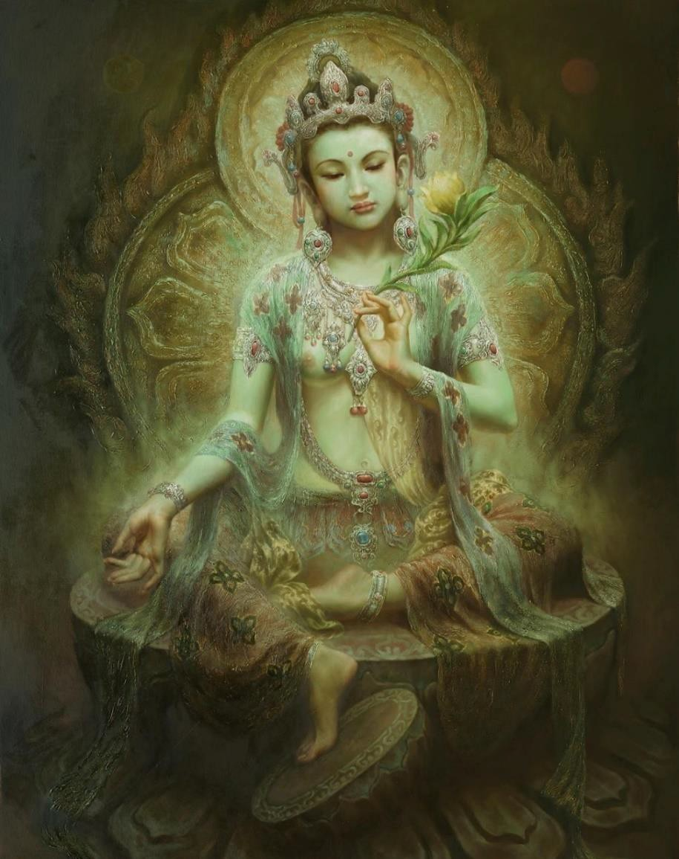
Goddess: I belong to the disciple-vehicle when I teach it to those who need it. I belong to the solitary-vehicle when I teach the twelve links of dependent origination to those who need them. And, since I

never abandon the great compassion, I belong to the great vehicle, as all need that teaching to attain ultimate liberation.

Nevertheless, reverend Sariputra, just as one cannot smell the castor plant in a magnolia wood, but only the magnolia flowers, so, reverend Sariputra, living in this house, which is redolent with the perfume of the virtues of the Buddha-qualities, one does not smell the perfume of the disciples and the solitary sages.

Reverend Sariputra, the Sakras, the Brahmas, the Lokapalas, the devas, nagas, yaksas, gandharvas, asuras, garudas, kimnaras, and mahoragas who live in this house hear the Dharma from the mouth of this holy man and, enticed by the perfume of the virtues of the Buddha-qualities, proceed to conceive the spirit of enlightenment.

Reverend Sariputra, I have been in this house for twelve years, and I have heard no discourses concerning the disciples and solitary sages but have heard only those concerning the great love, the great compassion, and the inconceivable qualities of the Buddha.

Reverend Sariputra, eight strange and wonderful things manifest themselves constantly in this house. What are these eight?

A light of golden hue shines here constantly, so bright that it is hard to distinguish day and night; and neither the moon nor the sun shines here distinctly. That is the first wonder of this house.



Furthermore, reverend Sariputra, whoever enters this house is no longer troubled by his passions from the moment he is within. That is the second strange and wonderful thing.

Furthermore, reverend Sariputra, this house is never forsaken by Sakra, Brahma, the Lokapalas, and the bodhisattvas from all the other buddha-fields. That is the third strange and wonderful thing.

Furthermore, reverend Sariputra, this house is never empty of the sounds of the Dharma, the discourse on the six transcendences, and the discourses of the irreversible wheel of the Dharma. That is the fourth strange and wonderful thing.

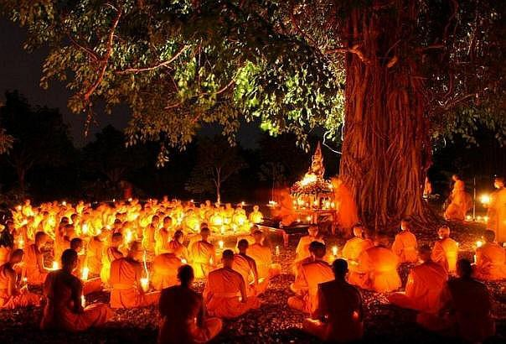

Furthermore, reverend Sariputra, in this house one always hears the rhythms, songs, and music of gods and men, and from this music constantly resounds the sound of the infinite Dharma of the Buddha. That is the fifth strange and wonderful thing.

Furthermore, reverend Sariputra, in this house there are always four inexhaustible treasures, replete with all kinds of jewels, which never decrease, although all the poor and wretched may partake to their satisfaction.

That is the sixth strange and wonderful thing.

Furthermore, reverend Sariputra, at the wish of this good man, to this house come the innumerable Tathagatas of the ten directions, such as the Tathagatas Sakyamuni, Amitabha, Aksobhya, Ratnasri, Ratnarcis, Ratnacandra, Ratnavyuha, Dusprasaha, Sarvarthasiddha, Ratnabahula, Simhakirti, Simhasvara, and so forth; and when they come they teach the door of Dharma called the "Secrets of the Tathagatas" and then depart. That is the seventh strange and wonderful thing.

Furthermore, reverend Sariputra, all the splendors of the abodes of the gods and all the splendors of the fields of the Buddhas shine forth in this house. That is the eighth strange and wonderful thing.

Reverend Sariputra, these eight strange and wonderful things are seen in this house. Who then, seeing such inconceivable things, would believe the teaching of the disciples?

Sariputra: Goddess, what prevents you from transforming yourself out of your female state?

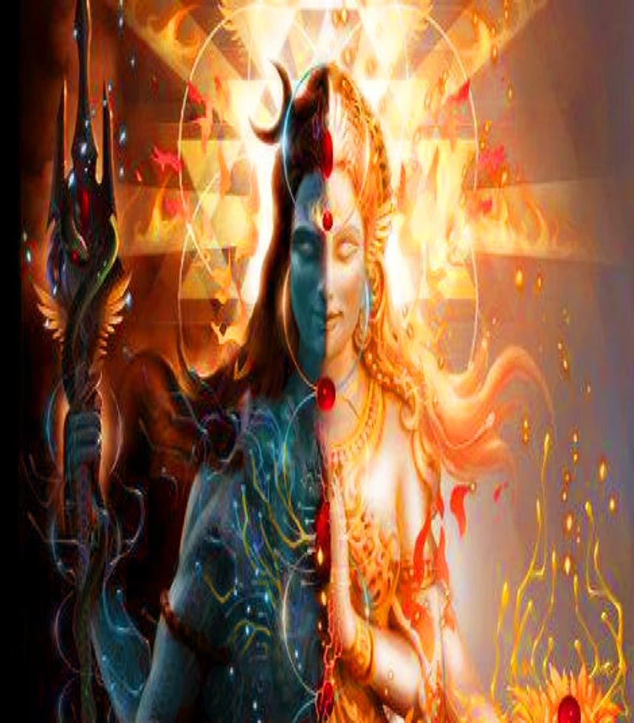

Goddess: Although I have sought my "female state" for these twelve years, I have not yet found it. Reverend Sariputra, if a magician were to incarnate a woman by magic, would you ask her, "What prevents you from transforming yourself out of your female state?"

Sariputra: No! Such a woman would not really exist, so what would there be to transform?

Goddess: Just so, reverend Sariputra, all things do not really exist. Now, would you think, "What prevents one whose nature is that of a magical incarnation from transforming herself out of her female state?"

Thereupon, the goddess employed her magical power to cause the elder Sariputra to appear in her form and to cause herself to appear in his form. Then the goddess, transformed into Sariputra, said to Sariputra, transformed into a goddess, "Reverend Sariputra, what prevents you from transforming yourself out of your female state?"

And Sariputra, transformed into the goddess, replied, "I no longer appear in the form of a male! My body has changed into the body of a woman! I do not know what to transform!"

The goddess continued, "If the elder could again change out of the female state, then all women could also change out of their female states. All women appear in the form of women in just the same way as the elder appears in the form of a woman. While they are not women in reality, they appear in the form of women. With this in mind, the Buddha said, 'In all things, there is neither male nor female.'"

Then, the goddess released her magical power and each returned to his ordinary form. She then said to him,

"Reverend Sariputra, what have you done with your female form?" Sariputra: I neither made it nor did I change it.
Goddess: Just so, all things are neither made nor changed, and that they are not made and not changed, that is the teaching of the Buddha.

Sariputra: Goddess, where will you be born when you transmigrate after death?

Goddess: I will be born where all the magical incarnations of the Tathagata are born.

Sariputra: But the emanated incarnations of the Tathagata do not transmigrate nor are they born.

Goddess: All things and living beings are just the same; they do not transmigrate nor are they born!

Sariputra: Goddess, how soon will you attain the perfect enlightenment of Buddhahood?

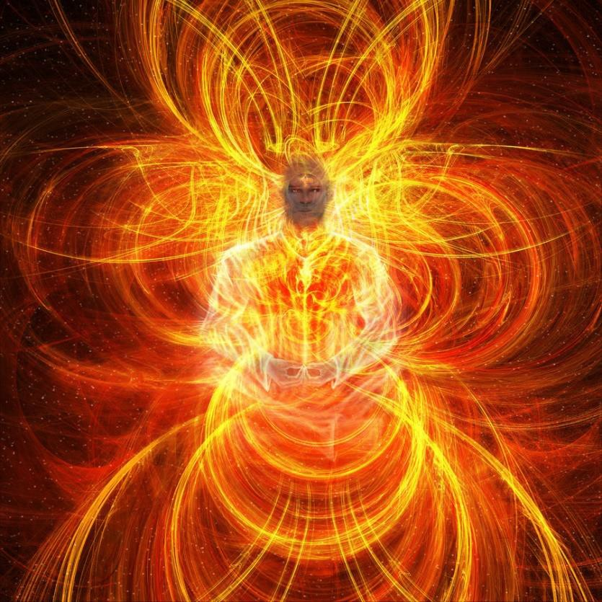

Goddess: At such time as you, elder, become endowed once more with the qualities of an ordinary individual, then will I attain the perfect enlightenment of Buddhahood.

Sariputra: Goddess, it is impossible that I should become endowed once more with the qualities of an ordinary individual.

Goddess: Just so, reverend Sariputra, it is impossible that I should attain the perfect enlightenment of Buddhahood! Why? Because perfect enlightenment stands upon the impossible. Because it is impossible, no one attains the perfect enlightenment of Buddhahood.

Sariputra: But the Tathagata has declared: "The Tathagatas, who are as numerous as the sands of the Ganges, have attained perfect Buddhahood, are attaining perfect Buddhahood, and will go on attaining perfect Buddhahood."

Goddess: Reverend Sariputra, the expression, "the Buddhas of the past, present and future," is a conventional expression made up of a certain number of syllables. The Buddhas are neither past, nor present, nor future.

Their enlightenment transcends the three times! But tell me, elder, have you attained sainthood?

Sariputra: It is attained, because there is no attainment.

Goddess: Just so, there is perfect enlightenment because there is no attainment of perfect enlightenment.

Then the Licchavi Vimalakirti said to the venerable elder Sariputra,

"Reverend Sariputra, this goddess has already served ninety-two million billion Buddhas.

She plays with the superknowledges. She has truly succeeded in all her vows.

She has gained the tolerance of the birthlessness of things. She has actually attained irreversibility.
She can live wherever she wishes on the strength of her vow to develop living beings."

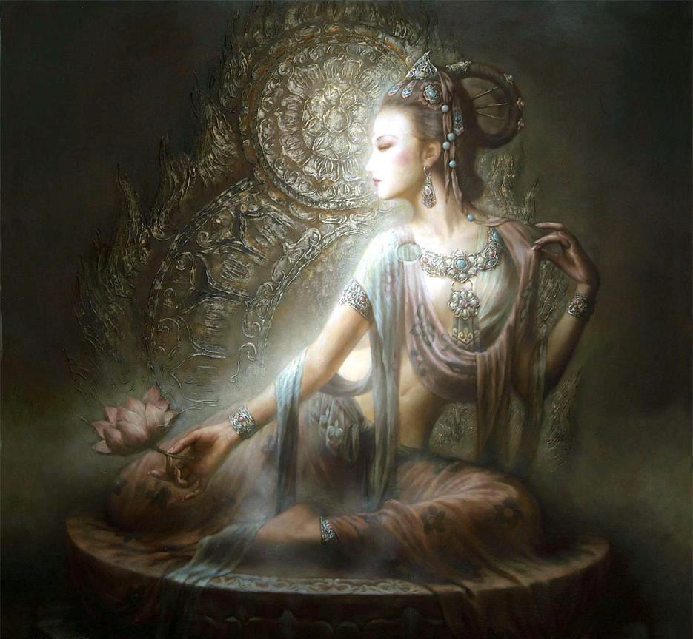


DOWNLOAD LEVEL 3 BOOK HERE!!!
http://www.energyenhancement.org/Sacred-Energy/Level-3-Book/Energy-Enhancement-Level-3-Karma-Clearing-There-Can-Only-Be-One.pdf

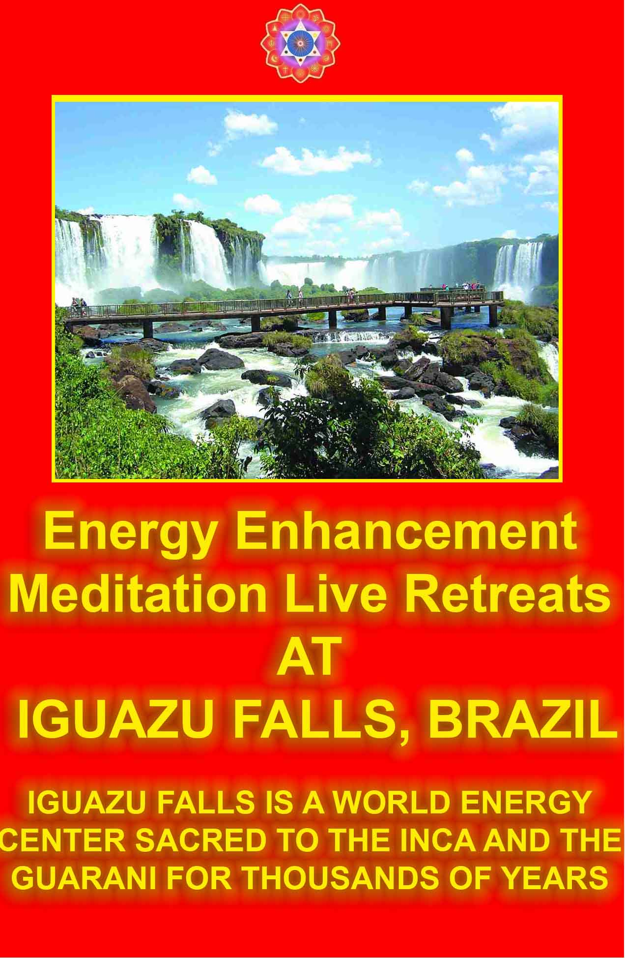 SACRED DANCES OF FUSION WHERE DEVI DHYANI EXERTS HER POWER - AVAILABLE ON YOUTUBE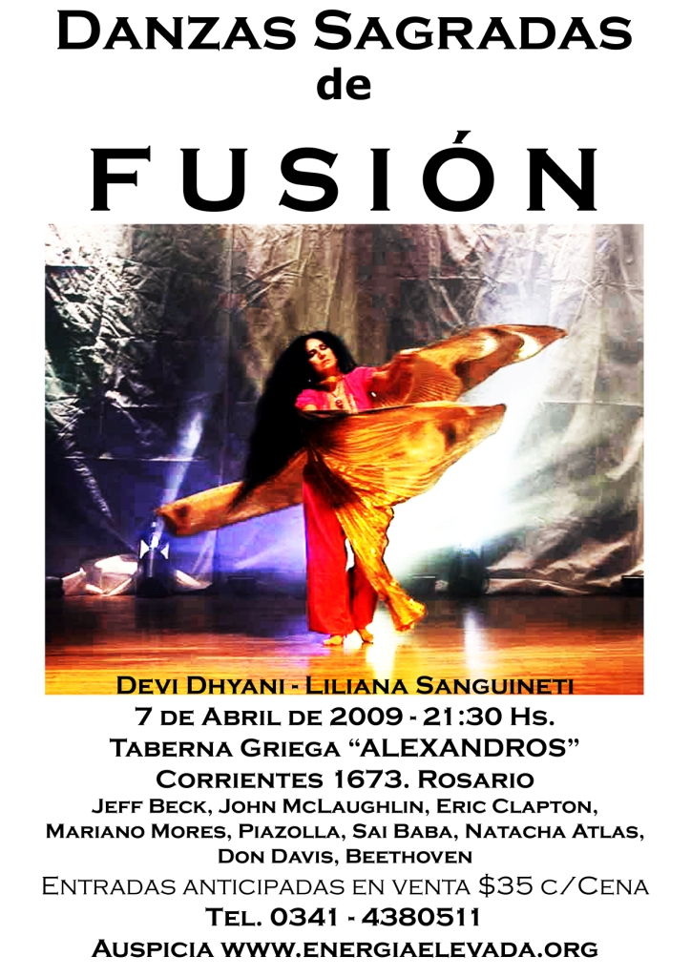Vimalakirti Sutra Chapter 8 The Family of the Tathagatas - stores of merit and wisdom, true bodhisattvas, the transcendence of wisdom, the skill in liberative technique, joy in the Dharma, Love and compassion and the truth

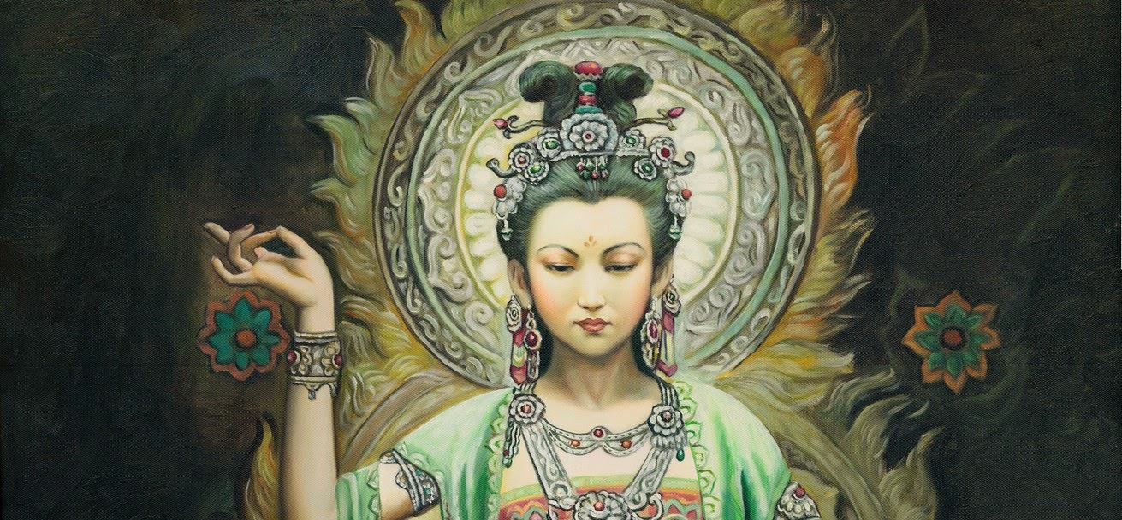

Then, the crown prince Manjusri said to the Licchavi Vimalakirti, "Noble sir, how does the bodhisattva follow the way to attain the qualities of the Buddha?"

Vimalakirti replied, "Manjusri, when the bodhisattva follows the wrong way, he follows the way to attain the qualities of the Buddha."

Manjusri continued, "How does the bodhisattva follow the wrong way?"

Vimalakirti replied,

"Even should he enact the five deadly sins, he feels no malice, violence, or hate.

Even should he go into the hells, he remains free of all taint of passions.

Even should he go into the states of the animals, he remains free of darkness and ignorance.

When he goes into the states of the asura energy blockages, he remains free of pride, conceit, and arrogance.

When he goes into the realm of the lord of death, he accumulates the stores of merit and wisdom.

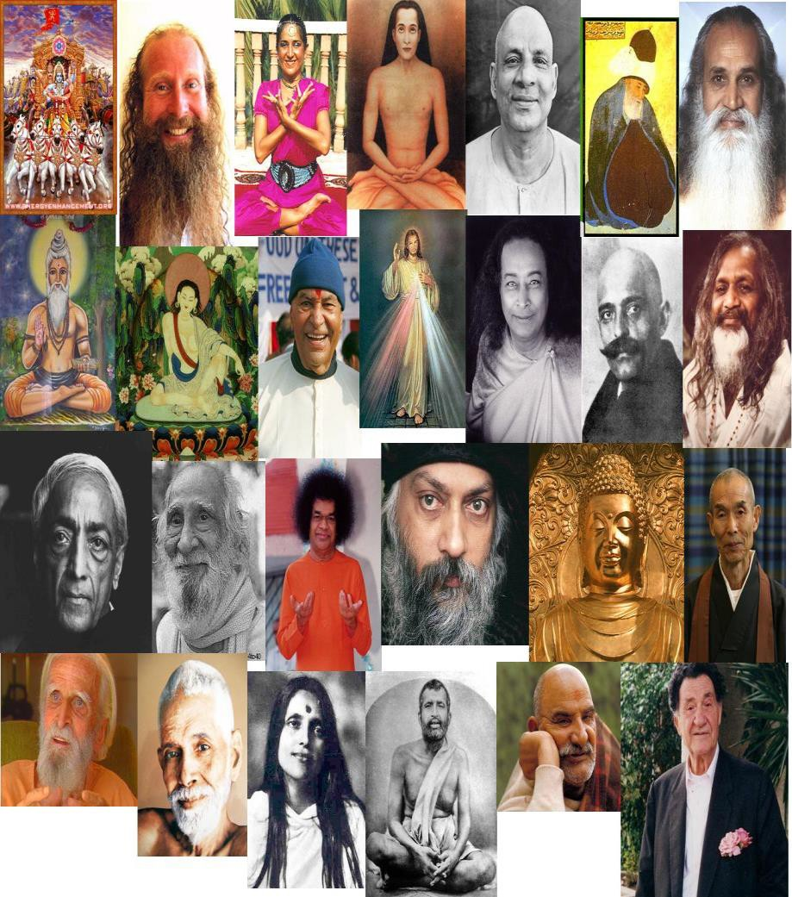

When he goes into the realm of the lord of death, he accumulates the stores of merit and wisdom

When he goes into the states of motionlessness and immateriality, he does not dissolve therein.

"He may follow the ways of desire, yet he stays free of attachment to the enjoyments of desire.

He may follow the ways of hatred, yet he feels no anger to any living being.

He may follow the ways of folly, yet he is ever conscious with the wisdom of firm understanding.

"He may follow the ways of avarice, yet he gives away all internal and external things without regard even for his own life.

He may follow the ways of immorality, yet, seeing the horror of even the slightest transgressions, he lives by the ascetic practices and austerities.

He may follow the ways of wickedness and anger, yet he remains utterly free of malice and lives by love.

He may follow the ways of laziness, yet his efforts are uninterrupted as he strives in the cultivation of roots of virtue.

He may follow the ways of sensuous distraction, yet, naturally concentrated, his contemplation is not dissipated.

He may follow the ways of false wisdom, yet, having reached the transcendence of wisdom, he is expert in all mundane and transcendental sciences.

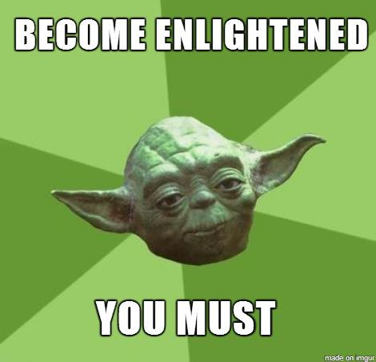
Having reached the transcendence of wisdom,
he is expert in all mundane and transcendental sciences.

"He may show the ways of sophistry and contention, yet he is always conscious of ultimate meanings and has perfected the use of liberative techniques.

He may show the ways of pride, yet he serves as a bridge and a ladder for all people.

He may show the ways of the passions, yet he is utterly dispassionate and naturally pure.

He may follow the ways of the Mara energy blockages, yet he does not really accept their authority in regard to his knowledge of the qualities of the Buddha.

He may follow the ways of the disciples, yet he lets living beings hear the teaching they have not heard before.

He may follow the ways of the solitary sages, yet he is inspired with great compassion in order to develop all living beings.

"He may follow the ways of the poor, yet he holds in his hand a jewel of inexhaustible wealth.

He may follow the ways of cripples, yet he is beautiful and well adorned with the auspicious signs and marks.

He may follow the ways of those of lowly birth, yet, through his accumulation of the stores of merit and wisdom, he is born in the family of the Tathagatas.

He may follow the ways of the weak, the ugly, and the wretched, yet he is beautiful to look upon, and his body is like that of Narayana.

"He may manifest to living beings the ways of the sick and the unhappy, yet he has entirely conquered and transcended the fear of death.

"He may follow the ways of the rich, yet he is without acquisitiveness and often reflects upon the notion of impermanence.

"He may show himself engaged in dancing with harem girls, yet he cleaves to solitude, having crossed the swamp of desire.

"He follows the ways of the dumb and the incoherent, yet, having acquired the power of incantations, he is adorned with a varied eloquence.

"He follows the ways of the heterodox without ever becoming heterodox.

He follows the ways of all the world, yet he reverses all states of existence.

He follows the way of liberation without ever abandoning the progress of the world.

"Manjusri, thus does the bodhisattva follow the wrong ways, thereby following the way to the qualities of the Buddha."

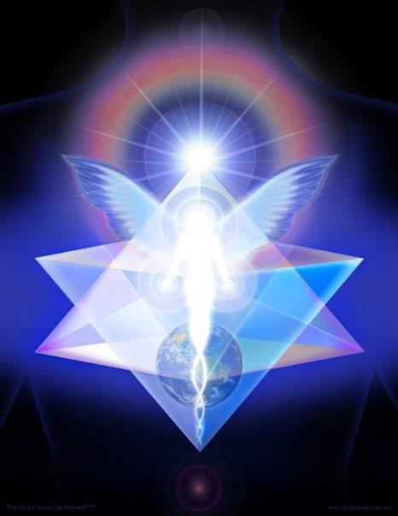

Then, the Licchavi Vimalakirti said to the crown prince Manjusri, "Manjusri, what is the family of the Tathagatas'?"

Manjusri replied,

"Noble sir, the family of the Tathagatas consists of all basic egoism; of ignorance and the thirst for existence; of lust, hate, and folly; of the four misapprehensions, of the five obscurations, of the six media of sense, of the seven abodes of consciousness, of the eight false paths, of the nine causes of irritation, of the paths of ten sins. Such is the family of the Tathagatas. In short, noble sir, the sixty-two kinds of convictions constitute the family of the Tathagatas!"

Vimalakirti: Manjusri, with what in mind do you say so?

Manjusri: Noble sir, one who stays in the fixed determination of the vision of the uncreated is not capable of conceiving the spirit of unexcelled perfect enlightenment. However, one who lives among created things, in the mines of passions, without seeing any truth, is indeed capable of conceiving the spirit of unexcelled perfect enlightenment.

Noble sir, flowers like the blue lotus, the red lotus, the white lotus, the water lily, and the moon lily do not grow on the dry ground in the wilderness, but do grow in the swamps and mud banks. Just so, the Buddha-qualities do not grow in living beings certainly destined for the uncreated but do grow in those living beings who are like swamps and mud banks of passions.

Likewise, as seeds do not grow in the sky but do grow in the earth, so the Buddha-qualities do not grow in those determined for the absolute but do grow in those who conceive the spirit of enlightenment, after having produced a Sumeru-like mountain of egoistic views.

Noble sir, through these considerations one can understand that all passions constitute the family of the Tathagatas. For example, noble sir, without going out into the great ocean, it is impossible to find

precious, priceless pearls. Likewise, without going into the ocean of passions, it is impossible to obtain the mind of omniscience.
Then, the elder Mahakasyapa applauded the crown prince Manjusri: "Good! Good Manjusri! This is indeed well spoken! This is right!
The passions do indeed constitute the family of the Tathagatas.

How can such as we, the disciples, conceive the spirit of enlightenment, or become fully enlightened in regard to the qualities of the Buddha?

Only those guilty of the five deadly sins can conceive the spirit of enlightenment and can attain Buddhahood, which is the full accomplishment of the qualities of the Buddha!

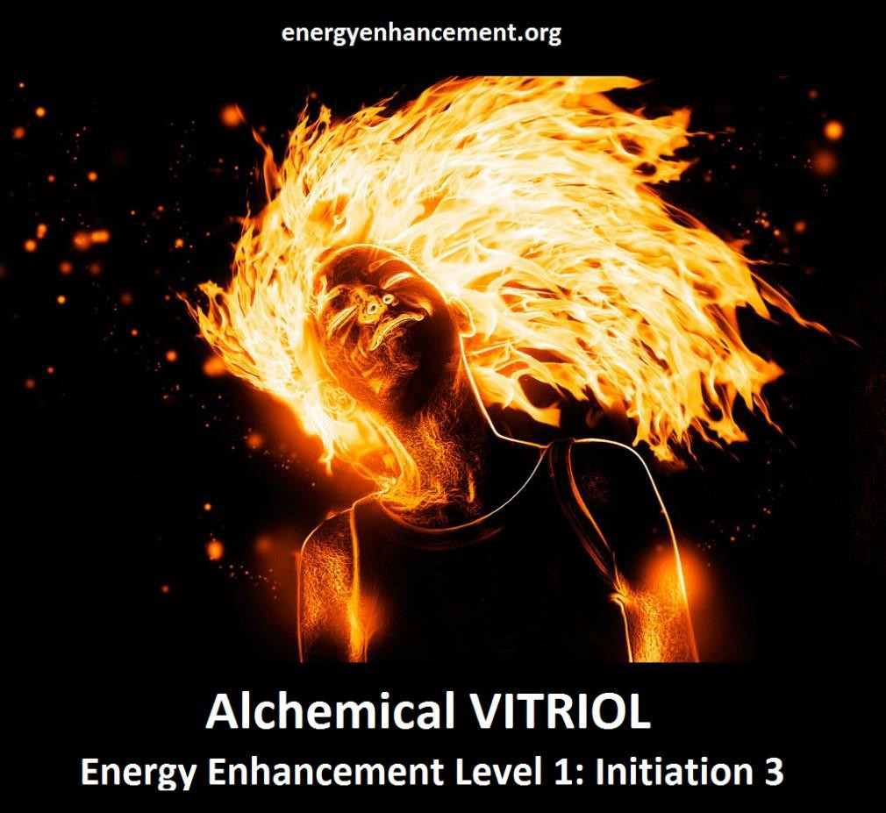

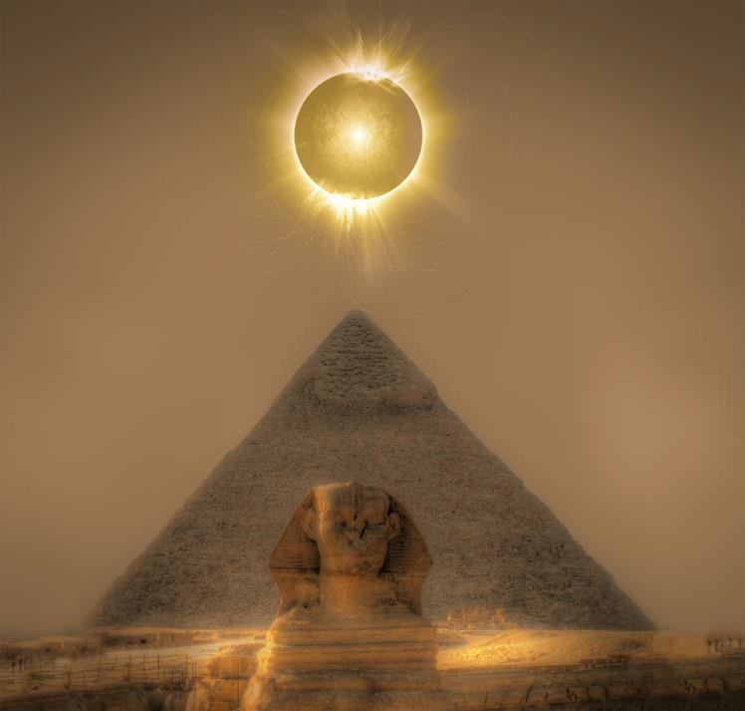
ONLY THOSE WHO HAVE TASTED AND REJECTED THE DARK SIDE CAN BECOME ENLIGHTENED
"THIS WORLD IS A FACTORY FOR THE PRODUCTION OF THE ENLIGHTENED" - SATCHIDANANDA

"Just as, for example, the five desire objects have no impression or effect on those bereft of faculties, even so all the qualities of the Buddha have no impression or effect on the disciples, who have abandoned all adherences.

Thus, the disciples can never appreciate those qualities.

"Therefore, Manjusri, the ordinary individual is grateful to the Tathagata, but the disciples are not grateful.

Why? The ordinary individuals, upon learning of the virtues of the Buddha, conceive the spirit of unexcelled perfect enlightenment, in order to insure the uninterrupted continuity of the heritage of the Three Jewels; but the disciples, although they may hear of the qualities, powers, and fearlessnesses of the Buddha until the end of their days, are not capable of conceiving the spirit of unexcelled perfect enlightenment."

Thereupon, the bodhisattva Sarvarupasamdarsana, who was present in that assembly, addressed the Licchavi Vimalakirti:

"Householder, where are your father and mother, your children, your wife, your servants, your maids, your laborers, and your attendants? Where are your friends, your relatives, and your kinsmen? Where are your servants, your horses, your elephants, your chariots, your bodyguards, and your bearers?"

Thus addressed, the Licchavi Vimalakirti spoke the following verses to the bodhisattva Sarvarupasamdarsana:

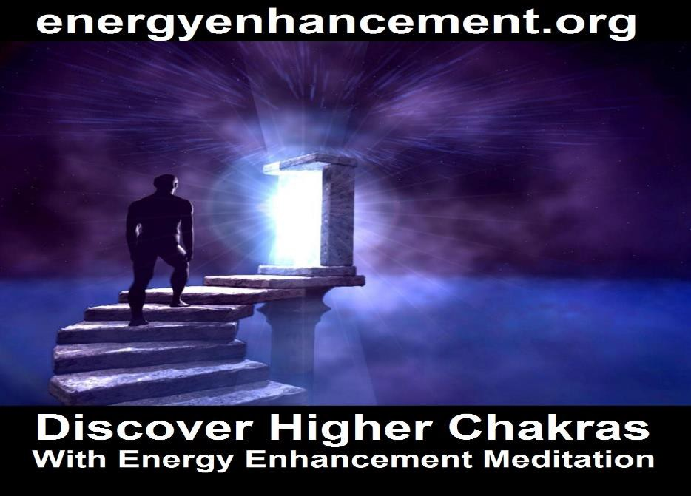

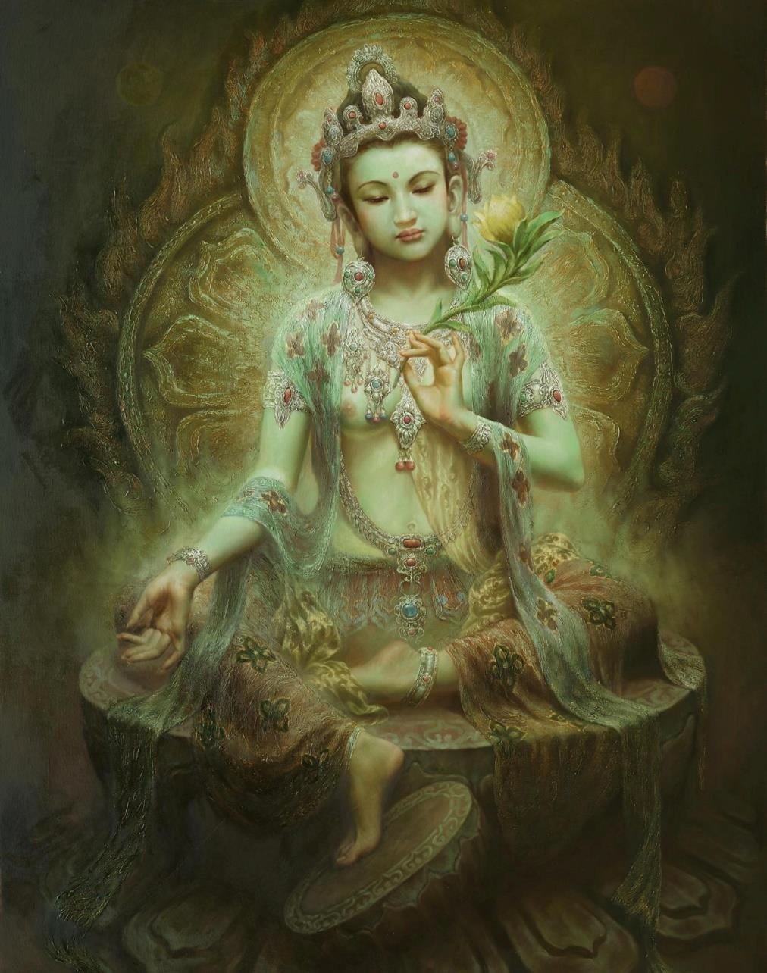
Of the true bodhisattvas,
The mother is the transcendence of wisdom, The father is the skill in liberative technique; The Leaders are born of such parents.

Their wife is the joy in the Dharma,
Love and compassion are their daughters,

The Dharma and the truth are their sons;
And their home is deep thought on the meaning of voidness.

All the passions are their disciples, Controlled at will.
Their friends are the aids to enlightenment; Thereby they realize supreme enlightenment.

Their companions, ever with them, Are the six transcendences.
Their consorts are the means of unification, Their music is the teaching of the Dharma.

The incantations make their garden,
Which blossoms with the flowers of the factors of enlightenment, With trees of the great wealth of the Dharma,
And fruits of the gnosis of liberation.

Their pool consists of the eight liberations, Filled with the water of concentration,
Covered with the lotuses of the seven impurities - Who bathes therein becomes immaculate.

Their bearers are the six superknowledges, Their vehicle is the unexcelled Mahayana, Their driver is the spirit of enlightenment, And their path is the eightfold peace.

Their ornaments are the auspicious signs, And the eighty marks;
Their garland is virtuous aspiration,
And their clothing is good conscience and consideration.

Their wealth is the holy Dharma, And their business is its teaching, Their great income is pure practice,
And it is dedicated to the supreme enlightenment.

Their bed consists of the four contemplations, And its spread is the pure livelihood,
And their awakening consists of gnosis, Which is constant learning and meditation.

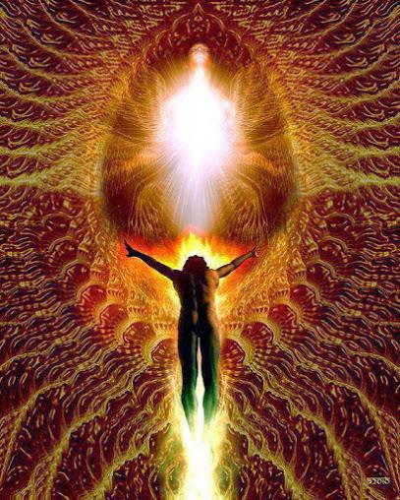

Their food is the ambrosia of the teachings, And their drink is the juice of liberation.
Their bath is pure aspiration,
And morality their unguent and perfume.

Having conquered the enemy passions, They are invincible heroes.
Having subdued the four Maras,
They raise their standard on the field of enlightenment.

They manifest birth voluntarily,
Yet they are not born, nor do they originate. They shine in all the fields of the Buddhas, Just like the rising sun.

Though they worship Buddhas by the millions, With every conceivable offering,
They never dwell upon the least difference Between the Buddhas and themselves.

They journey through all Buddha-fields In order to bring benefit to living beings,
Yet they see those fields as just like empty space, Free of any conceptual notions of "living beings."

The fearless bodhisattvas can manifest, All in a single instant,
The forms, sounds, and manners of behavior Of all living beings.

Although they recognize the deeds of Maras, They can get along even with these Maras; For even such activities may be manifested By those perfected in liberative technique.

They play with illusory manifestations In order to develop living beings, Showing themselves to be old or sick, And even manifesting their own deaths.

They demonstrate the burning of the earth In the consuming flames of the world's end, In order to demonstrate impermanence
To living beings with the notion of permanence.

Invited by hundreds of thousands of living beings, All in the same country,
They partake of offerings at the homes of all, And dedicate all for the sake of enlightenment.

They excel in all esoteric sciences, And in the many different crafts, And they bring forth the happiness Of all living beings.

By devoting themselves as monks To all the strange sects of the world, They develop all those beings
Who have attached themselves to dogmatic views.

They may become suns or moons, Indras, Brahmas, or lords of creatures, They may become fire or water
Or earth or wind.

During the short aeons of maladies, They become the best holy medicine; They make beings well and happy, And bring about their liberation.

During the short aeons of famine, They become food and drink.
Having first alleviated thirst and hunger, They teach the Dharma to living beings.

During the short aeons of swords, They meditate on love, Introducing to nonviolence
Hundreds of millions of living beings.

In the middle of great battles
They remain impartial to both sides; For bodhisattvas of great strength Delight in reconciliation of conflict.

In order to help the living beings, They voluntarily descend into The hells which are attached
To all the inconceivable buddha-fields.

They manifest their lives
In all the species of the animal kingdom, Teaching the Dharma everywhere.
Thus they are called "Leaders."

They display sensual enjoyment to the worldlings, And trances to the meditative.
They completely conquer the Maras, And allow them no chance to prevail.

Just as it can be shown that a lotus Cannot exist in the center of a fire, So they show the ultimate unreality Of both pleasures and trances.

They intentionally become courtesans In order to win men over,
And, having caught them with the hook of desire, They establish them in the buddha-gnosis.

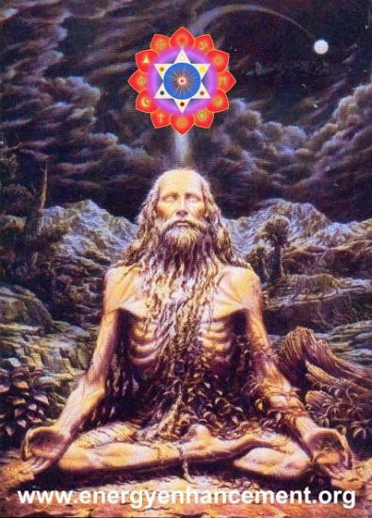

In order to help living beings, They always become chieftains, Captains, priests, and ministers, Or even prime ministers.

For the sake of the poor,
They become inexhaustible treasures, Causing those to whom they give their gifts To conceive the spirit of enlightenment.

They become invincible champions, For the sake of the proud and the vain, And, having conquered all their pride,
They start them on the quest for enlightenment.

They always stand at the head Of those terrified with fright,
And, having bestowed fearlessness upon them, They develop them toward enlightenment.

They become great holy men,
With the superknowledges and pure continence, And thus induce living beings to the morality Of tolerance, gentleness, and discipline.

Here in the world, they fearlessly behold Those who are masters to be served,
And they become their servants or slaves, Or serve as their disciples.

Well trained in liberative technique, They demonstrate all activities, Whichever possibly may be a means To make beings delight in the Dharma.

Their practices are infinite;
And their spheres of influence are infinite;

Having perfected an infinite wisdom, They liberate an infinity of living beings.

Even for the Buddhas themselves, During a million aeons,
Or even a hundred million aeons,
It would be hard to express all their virtues.

Except for some inferior living beings,
Without any intelligence at all, Is there anyone with any discernment
Who, having heard this teaching, Would not wish for the supreme enlightenment?

Vimalakirti Sutra - Chapter 9 - The Dharma-door of nonduality of the Soul Chakra above the Head talking about connection, gnosis with the infinite chakras above the head as being the start of transcendence, indestructability, enlightenment - Energy Enhancement!!


THE ENTRANCE TO ENLIGHTENMENT IS THROUGH THE INFINITE CHAKRAS ABOVE THE HEAD

Then, the Licchavi Vimalakirti asked those bodhisattvas, "Good sirs, please explain how the bodhisattvas enter the Dharma-door of nonduality of the Soul Chakra above the Head!"

The bodhisattva Dharmavikurvana declared, "Noble sir, production and destruction are two, but what is not produced and does not occur cannot be destroyed. Thus the attainment of the tolerance of the birthlessness of things is the entrance into nonduality of the infinite chakras above the head."

The bodhisattva Srigandha declared, " 'I' and 'mine' are two. If there is no presumption of a self, there will be no possessiveness. Thus, the absence of presumption is the entrance into nonduality of the infinite chakras above the head."

The bodhisattva Srikuta declared, " 'Defilement' and 'purification' are two. When there is thorough knowledge of defilement, there will be no conceit about purification. The path leading to the complete conquest of all conceit is the entrance into nonduality of the infinite chakras above the head."

The bodhisattva Bhadrajyotis declared, " 'Distraction' and 'attention' are two. When there is no distraction, there will be no attention, no mentation, and no mental intensity. Thus, the absence of mental intensity is the entrance into nonduality of the infinite chakras above the head."

The bodhisattva Subahu declared, " 'Bodhisattva-spirit' and 'disciple- spirit' are two. When both are seen to resemble an illusory spirit, there is no bodhisattva-spirit, nor any disciple-spirit. Thus, the sameness of natures of spirits is the entrance into nonduality of the infinite chakras above the head."

The bodhisattva Animisa declared, " 'Grasping' and 'nongrasping' are two. What is not grasped is not perceived, and what is not perceived is neither presumed nor repudiated. Thus, the inaction and noninvolvement of all things is the entrance into nonduality of the infinite chakras above the head."

The bodhisattva Sunetra declared, " 'Uniqueness' and 'characterlessness' are two. Not to presume or construct something is neither to establish its uniqueness nor to establish its characterlessness. To penetrate the equality of these two is to enter nonduality of the infinite chakras above the head."

The bodhisattva Tisya declared, " 'Good' and 'evil' are two. Seeking neither good nor evil, the understanding of the nonduality of the significant and the meaningless is the entrance into nonduality of the infinite chakras above the head."

The bodhisattva Simha declared, " 'Sinfulness' and 'sinlessness' are two. By means of the diamond-like wisdom that pierces to the quick, not to be bound or liberated is the entrance into nonduality of the infinite chakras above the head."

The bodhisattva Simhamati declared, "To say, 'This is impure' and 'This is immaculate' makes for duality. One who, attaining equanimity, forms no conception of impurity or immaculateness, yet is not utterly without energy blockages, has equanimity without any attainment of equanimity - he enters the absence of energy blockages.

Thus, he enters into nonduality of the infinite chakras above the head."

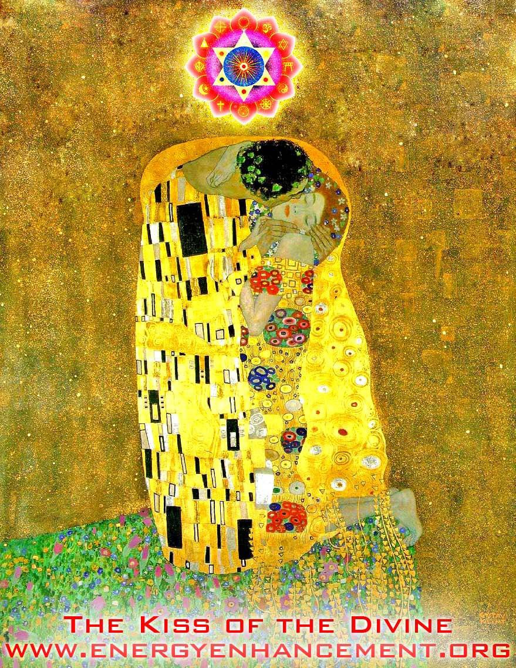
THE KISS OF THE DIVINE IS ENTRANCE INTO THE INFINITE CHAKRAS ABOVE THE HEAD

The bodhisattva Suddhadhimukti declared, "To say, 'This is happiness' and 'That is misery' is dualism. One who is free of all calculations, through the extreme purity of gnosis with the infinite chakras above the head - his mind is aloof, like empty space; and thus he enters into nonduality of the infinite chakras above the head."

The bodhisattva Narayana declared, "To say, 'This is mundane' and 'That is transcendental' is dualism. This world has the nature of voidness, so there is neither transcendence nor involvement, neither progress nor standstill. Thus, neither to transcend nor to be involved, neither to go nor to stop - this is the entrance into nonduality of the infinite chakras above the head."

The bodhisattva Dantamati declared, "'Life' and 'liberation' are dualistic. Having seen the nature of life, one neither belongs to it nor is one utterly liberated from it. Such understanding is the entrance into nonduality of the infinite chakras above the head."

The bodhisattva Pratyaksadarsana declared, "'Destructible' and 'indestructible' are dualistic. What is destroyed is ultimately destroyed. What is ultimately destroyed does not become destroyed; hence, it is called 'indestructible.' What is indestructible is instantaneous, and what is instantaneous is indestructible. The experience of such is called 'the entrance into the principle of nonduality of the infinite chakras above the head.'"

The bodhisattva Parigudha declared, "'Self' and 'selflessness' are dualistic. Since the existence of self cannot be perceived, what is there to be made 'selfless'? Thus, the nondualism of the vision of their nature is the entrance into nonduality of the infinite chakras above the head."

The bodhisattva Vidyuddeva declared, "'Knowledge' and 'ignorance' are dualistic. The natures of ignorance and knowledge are the same, for ignorance is undefined, incalculable, and beyond the sphere of thought. The realization of this is the entrance into nonduality of the infinite chakras above the head."

The bodhisattva Priyadarsana declared, "Matter itself is void. Voidness does not result from the destruction of matter, but the nature of matter is itself voidness. Therefore, to speak of voidness on the one hand, and of matter, or of sensation, or of intellect, or of motivation, or of consciousness on the other - is entirely dualistic.

Consciousness itself is voidness. Voidness does not result from the destruction of consciousness, but the nature of consciousness is itself voidness. Such understanding of the five compulsive aggregates and the knowledge of them as such by means of gnosis with the infinite chakras above the head is the entrance into nonduality of the infinite chakras above the head"

The bodhisattva Prabhaketu declared, "To say that the four main elements are one thing and the etheric space-element another is dualistic. The four main elements are themselves the nature of space. The past itself is also the nature of space. The future itself is also the nature of space. Likewise, the present itself is also the nature of space. The gnosis with the infinite chakras above the head that penetrates the elements in such a way is the entrance into nonduality of the infinite chakras above the head."

The bodhisattva Pramati declared, "'Eye' and 'form' are dualistic. To understand the eye correctly, and not to have attachment, aversion, or confusion with regard to form - that is called 'peace.' Similarly, 'ear' and 'sound,' 'nose' and 'smell,' 'tongue' and taste,' 'body' and touch,' and 'mind' and 'phenomena' - all are dualistic. But to know the mind, and to be neither attached, averse, nor confused with regard to phenomena - that is called 'peace.' To live in such peace is to enter into nonduality of the infinite chakras above the head."

The bodhisattva Aksayamati declared, "The dedication of generosity for the sake of attaining omniscience is dualistic. The nature of generosity is itself omniscience, and the nature of omniscience itself is total dedication.

Likewise, it is dualistic to dedicate morality, tolerance, effort, meditation, and wisdom for the sake of omniscience. Omniscience is the nature of wisdom, and total dedication is the nature of

omniscience. Thus, the entrance into this principle of uniqueness is the entrance into nonduality of the infinite chakras above the head."

The bodhisattva Gambhiramati declared, "It is dualistic to say that voidness is one thing, signlessness another, and wishlessness still another. What is void has no sign. What has no sign has no wish. Where there is no wish there is no process of thought, mind, or consciousness. To see the doors of all liberations in the door of one liberation is the entrance into nonduality of the infinite chakras above the head."

The bodhisattva Santendriya declared, "It is dualistic to say 'Buddha,' 'Dharma,' and 'Sangha.' The Dharma is itself the nature of the Buddha, the Sangha is itself the nature of the Dharma, and all of them are uncompounded. The uncompounded is infinite space, and the processes of all things are equivalent to the infinite space of the infinite chakras above the head. Connection to these infinite chakras above the head is the entrance into nonduality of the infinite chakras above the head."

The bodhisattva Apratihatanetra declared, "It is dualistic to refer to 'aggregates' and to the 'cessation of aggregates.' Aggregates themselves are cessation. Why? The egoistic views of aggregates, being unproduced themselves, do not exist ultimately. Hence such views do not really conceptualize 'These are aggregates' or 'These aggregates cease.' Ultimately, they have no such discriminative constructions and no such conceptualizations. Therefore, such views have themselves the nature of cessation. Nonoccurrence and nondestruction are the entrance into nonduality of the infinite chakras above the head."

The bodhisattva Suvinita declared, "Physical, verbal, and mental vows do not exist dualistically. Why? These things have the nature of inactivity. The nature of inactivity of the body is the same as the nature of inactivity of speech, whose nature of inactivity is the same as the nature of inactivity of the mind. It is necessary to know and to understand this fact of the ultimate inactivity of all things, for this knowledge is the entrance into nonduality of the infinite chakras above the head."

172

The bodhisattva Punyaksetra declared, "It is dualistic to consider actions meritorious, sinful, or neutral. The non-undertaking of meritorious, sinful, and neutral actions is not dualistic. The intrinsic nature of all such actions is voidness, wherein ultimately there is neither merit, nor sin, nor neutrality, nor action itself. The nonaccomplishment of such actions is the entrance into nonduality of the infinite chakras above the head."

The bodhisattva Padmavyuha declared, "Dualism is produced from obsession with self, but true understanding of self does not result in dualism. Who thus abides in nonduality of the infinite chakras above the head is without ideation, and that absence of ideation is the entrance into nonduality of the infinite chakras above the head."

The bodhisattva Candrottara declared, "'Darkness' and 'light' are dualistic, but the absence of both darkness and light is nonduality of the infinite chakras above the head. Why? At the time of absorption in cessation, there is neither darkness nor light, and likewise with the natures of all things. The entrance into this equanimity is the entrance into nonduality of the infinite chakras above the head."

The bodhisattva Ratnamudrahasta declared, "It is dualistic to detest the world and to rejoice in liberation, and neither detesting the world nor rejoicing in liberation is nonduality of the infinite chakras above the head. Why? Liberation can be found where there is bondage, but where there is ultimately no bondage where is there need for liberation? The mendicant who is neither bound nor liberated does not experience any like or any dislike and thus he enters nonduality of the infinite chakras above the head."

The bodhisattva Manikutaraja declared, "It is dualistic to speak of good paths and bad paths. One who is on the path is not concerned with good or bad paths. Living in such unconcern, he entertains no concepts of 'path' or 'nonpath.' Understanding the nature of concepts, his mind does not engage in duality. Such is the entrance into nonduality of the infinite chakras above the head."

The bodhisattva Satyarata declared, "It is dualistic to speak of 'true' and 'false.' When one sees truly, one does not ever see any truth, so

how could one see falsehood? Why? One does not see with the physical eye, one sees with the eye of wisdom. And with the wisdom-eye one sees only insofar as there is neither sight nor nonsight.

There, where there is neither sight nor nonsight, is the entrance into nonduality of the infinite chakras above the head."

When the bodhisattvas had given their explanations, they all addressed the crown prince Manjusri: "Manjusri, what is the bodhisattva's entrance into nonduality of the infinite chakras above the head?"

Manjusri replied, "Good sirs, you have all spoken well. Nevertheless, all your explanations are themselves dualistic. To know no one teaching, to express nothing, to say nothing, to explain nothing, to announce nothing, to indicate nothing, and to designate nothing - that is the entrance into nonduality of the infinite chakras above the head."

Then the crown prince Manjusri said to the Licchavi Vimalakirti, "We have all given our own teachings, noble sir. Now, may you elucidate the teaching of the entrance into the principle of nonduality of the infinite chakras above the head!"

Thereupon, the Licchavi Vimalakirti kept his silence, saying nothing at all.

The crown prince Manjusri applauded the Licchavi Vimalakirti: "Excellent! Excellent, noble sir! This is indeed the entrance into the nonduality of the infinite chakras above the head of the bodhisattvas. Here there is no use for syllables, sounds, and ideas."

When these teachings had been declared, five thousand bodhisattvas entered the door of the Dharma of nonduality of the infinite Chakras above the Head and attained tolerance of the birthlessness of things.



Vimalakirti Sutra Ch 10 - the Fragrance Buddha, Sariputra, bodhisattvas, Tathagata, discourses for disciplining of the wild and uncivilized, the ten virtuous practices, the eight qualities



Thereupon, the venerable Sariputra thought to himself, "If these great bodhisattvas do not adjourn before noontime, when are they going to eat?"

The Licchavi Vimalakirti, knowing telepathically the thought of the venerable Sariputra, spoke to him:

"Reverend Sariputra, the Tathagata has taught the eight liberations. You should concentrate on those liberations, listening to the Dharma with a mind free of preoccupations with material things. Just wait a minute, reverend Sariputra, and you will eat such food as you have never before tasted."

Then, the Licchavi Vimalakirti set himself in such a concentration and performed such a miraculous feat that those bodhisattvas and those great disciples were enabled to see the universe called Sarvagandhasugandha, which is located in the direction of the zenith, beyond as many Buddhafields as there are sands in forty-two Ganges rivers. There the Tathagata named Sugandhakuta(Fragrance Accumulation) resides, lives, and is manifest. In that universe, the trees emit a fragrance that far surpasses all the fragrances, human and divine, of all the Buddhafields of the ten directions. In that universe, even the names "disciple" and "solitary sage" do not exist, and the Tathagata Sugandhakuta teaches the Dharma to a gathering of bodhisattvas only. In that universe, all the houses, the avenues, the parks, and the palaces are made of various perfumes, and the fragrance of the food eaten by those bodhisattvas pervades immeasurable universes.

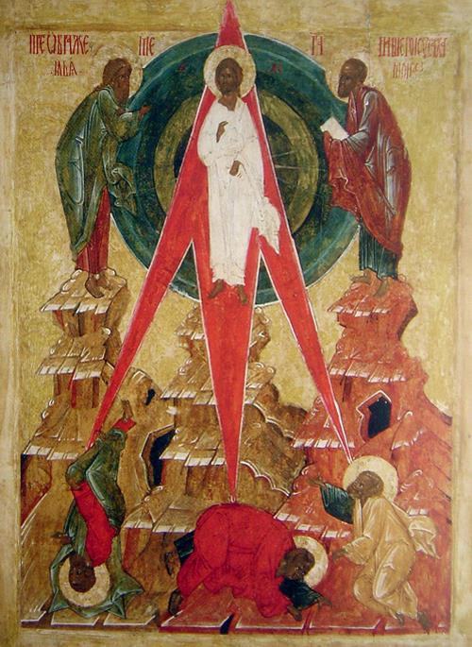

At this time, the Tathagata Sugandhakuta sat down with his bodhisattvas to take his meal, and the deities called Gandhavyuhahara, who were all devoted to the Mahayana, served and attended upon the Buddha and his bodhisattvas. Everyone in the gathering at the house of Vimalakirti was able to see distinctly this universe wherein the Tathagata Sugandhakuta and his bodhisattvas were taking their meal.

The Licchavi Vimalakirti addressed the whole gathering of bodhisattvas: "Good sirs, is there any among you who would like to go to that Buddhafield to bring back some food?"

But, restrained by the supernatural power of Manjusri, none of them volunteered to go.

The Licchavi Vimalakirti said to crown prince Manjusri, "Manjusri, are you not ashamed of such a gathering?"

Manjusri replied, "Noble sir, did not the Tathagata declare, 'Those who are unlearned should not be despised'?"

Then, the Licchavi Vimalakirti, without rising from his couch, magically emanated an incarnation-bodhisattva, whose body was of golden color, adorned with the auspicious signs and marks, and of such an appearance that he outshone the whole assembly.

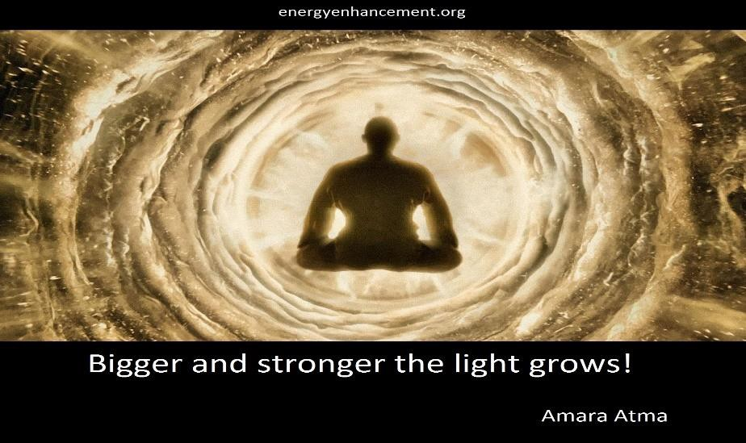



The Licchavi Vimalakirti addressed that incarnated bodhisattva: "Noble son, go in the direction of the zenith and when you have crossed as many Buddhafields as there are sands in forty-two Ganges rivers, you will reach a universe called Sarvagandhasugandha, where you will find the Tathagata Sugandhakuta taking his meal. Go to him and, having bowed down at his feet, make the following request of him:

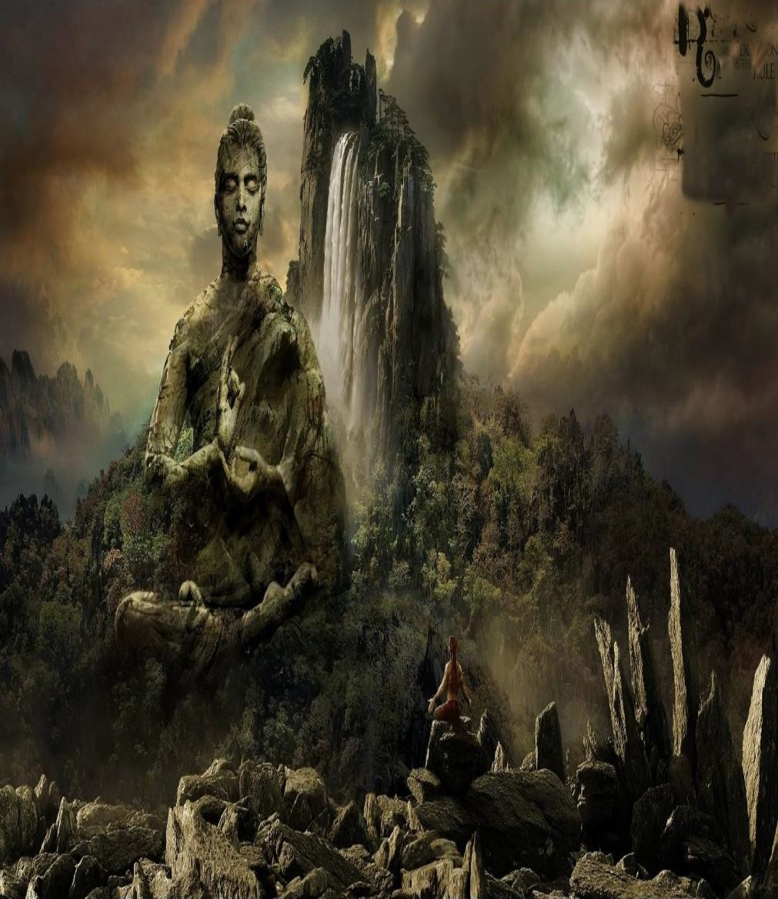
"'The Licchavi Vimalakirti bows down one hundred thousand times at your feet, O Lord, and asks after your health - if you have but

little trouble, little discomfort, little unrest; if you are strong, well, without complaint, and living in touch with supreme happiness.'

"Having thus asked after his health, you should request of him 'Vimalakirti asks the Lord to give me the remains of your meal, with which he will accomplish the buddha-work in the universe called Saha. Thus, those living beings with inferior aspirations will be inspired with lofty aspirations, and the good name of the Tathagata will be celebrated far and wide."

At that, the incarnated bodhisattva said, "Very good!" to the Licchavi Vimalakirti and obeyed his instructions.

In sight of all the bodhisattvas, he turned his face upward and was gone, and they saw him no more. When he reached the universe Sarvagandhasugandha, he bowed down at the feet of the Tathagata Sugandhakuta and said, "Lord, the bodhisattva Vimalakirti, bowing down at the feet of the Lord, greets the Lord, saying: 'Do you have little trouble, little discomfort, and little unrest? Are you strong, well, without complaint, and living in touch with the supreme happiness?'

He then requests, having bowed down one hundred thousand times at the feet of the Lord: 'May the Lord be gracious and give to me the remains of his meal in order to accomplish the buddha-work in the universe called Saha. Then, those living beings who aspire to inferior ways may gain the intelligence to aspire to the great Dharma of the Buddha, and the name of the Buddha will be celebrated far and wide.'"

At that the bodhisattvas of the Buddhafield of the Tathagata Sugandhakuta were astonished and asked the Tathagata Sugandhakuta, "Lord, where is there such a great being as this? Where is the universe Saha? What does he mean by 'those who aspire to inferior ways'?"

Having thus been questioned by those bodhisattvas, the Tathagata Sugandhakuta said, "Noble sons, the universe Saha exists beyond as many Buddhafields in the direction of the nadir as there are sands in

forty-two Ganges rivers. There the Tathagata Sakyamuni teaches the Dharma to living beings who aspire to the inferior ways, in that Buddhafield tainted with five corruptions.

There the bodhisattva Vimalakirti, who lives in the inconceivable liberation, teaches the Dharma to the bodhisattvas. He sends this incarnation-bodhisattva here in order to celebrate my name, in order to show the advantages of this universe, and in order to increase the roots of virtue of those bodhisattvas."

The bodhisattvas exclaimed, "How great must that bodhisattva be himself if his magical incarnation is thus endowed with supernatural power, strength, and fearlessness!"



The Tathagata said, "The greatness of that bodhisattva is such that he sends magical incarnations to all the Buddhafields of the ten directions, and all these incarnations accomplish the buddha-work for all the living beings in all those Buddhafields."

Then, the Tathagata Sugandhakuta poured some of his food, impregnated with all perfumes, into a fragrant vessel and gave it to the incarnation-bodhisattva. And the ninety million bodhisattvas of that universe volunteered to go along with him: "Lord, we also would like to go to that universe Saha, to see, honor, and serve the Buddha Sakyamuni and to see Vimalakirti and those bodhisattvas."

The Tathagata declared, "Noble sons, go ahead if you think it is the right time. But, lest those living beings become mad and intoxicated, go without your perfumes. And, lest those living beings of the Saha world become jealous of you, change your bodies to hide your beauty. And do not conceive ideas of contempt and aversion for that universe. Why? Noble sons, a Buddhafield is a field of pure space, but the Lord Buddhas, in order to develop living beings, do not reveal all at once the pure realm of the Buddha."

Then the incarnation-bodhisattva took the food and departed with the ninety million bodhisattvas and by the power of the Buddha and the supernatural operation of Vimalakirti, disappeared from that universe Sarvagandhasugandha and stood again in the house of Vimalakirti in a fraction of a second. The Licchavi Vimalakirti created ninety million lion-thrones exactly like those already there, and the bodhisattvas were seated.

Then, the incarnation-bodhisattva gave the vessel full of food to Vimalakirti, and the fragrance of that food permeated the entire great city of Vaisali and its sweet perfume spread throughout one hundred universes.

Within the city of Vaisali, the brahmans, householders, and even the Licchavi chieftain Candracchattra, having noticed this fragrance, were amazed and filled with wonder. They were so cleansed in body and mind that they came at once to the house of Vimalakirti, along with all eighty-four thousand of the Licchavis.

Seeing there the bodhisattvas seated on the high, wide, and beautiful lion-thrones, they were filled with admiration and great joy. They all bowed down to those great disciples and bodhisattvas and then sat down to one side. And the gods of the earth, the gods of the desire- world, and the gods of the material world, attracted by the perfume, also came to the house of Vimalakirti.

Then, the Licchavi Vimalakirti spoke to the elder Sariputra and the great disciples: "Reverends, eat of the food of the Tathagata! It is ambrosia perfumed by the great compassion. But do not fix your minds in narrow-minded attitudes, lest you be unable to receive its gift."

But some of the disciples had already had the thought: "How can such a huge multitude eat such a small amount of food?"

Then the incarnation-bodhisattva said to those disciples, "Do not compare, venerable ones, your own wisdom and merits with the wisdom and the merits of the Tathagata! Why? For example, the four great oceans might dry up, but this food would never be exhausted.

If all living beings were to eat for an aeon an amount of this food equal to Mount Sumeru in size, it would not be depleted. Why? Issued from inexhaustible morality, concentration, and wisdom, the remains of the food of the Tathagata contained in this vessel cannot be exhausted."

Indeed, the entire gathering was satisfied by that food, and the food was not at all depleted. Having eaten that food, there arose in the bodies of those bodhisattvas, disciples, Sakras, Brahmas, Lokapalas, and other living beings, a bliss just like the bliss of the bodhisattvas of the universe Sarvasukhamandita. And from all the pores of their skin arose a perfume like that of the trees that grow in the universe Sarvagandhasugandha.



JEWEL IS THE CHAKRA. DHARMA - THE ENERGY AND WILL OF THE SOUL, IS THE FIRST CHAKRA ABOVE THE HEAD

Then, the Licchavi Vimalakirti knowingly addressed those bodhisattvas who had come from the Buddhafield of the Lord Tathagata Sugandhakuta: "Noble sirs, how does the Tathagata Sugandhakuta teach his Dharma?"

They replied, "The Tathagata does not teach the Dharma by means of sound and language. He disciplines the bodhisattvas only by means of perfumes. At the foot of each perfume-tree sits a bodhisattva, and the trees emit perfumes like this one. From the moment they smell that perfume, the bodhisattvas attain the concentration called 'source of all bodhisattva-virtues.' From the moment they attain that concentration, all the bodhisattva-virtues are produced in them."

Those bodhisattvas then asked the Licchavi Vimalakirti, "How does the Buddha Sakyamuni teach the Dharma?"

Vimalakirti replied, "Good sirs, these living beings here are hard to discipline. Therefore, he teaches them with discourses appropriate for the disciplining of the wild and uncivilized.



How does he discipline the wild and uncivilized? What discourses are appropriate? Here they are:

"'This is hell.

This is the animal world.

This is the world of the lord of death. These are the adversities.
These are the rebirths with crippled faculties.

These are physical misdeeds, and these are the retributions for physical misdeeds.

These are verbal misdeeds, and these are the retributions for verbal misdeeds.

These are mental misdeeds, and these are the retributions for mental misdeeds.

This is killing. This is stealing.
This is sexual misconduct. This is lying.
This is backbiting. This is harsh speech.
This is frivolous speech. This is covetousness.
This is malice.

This is false view.

These are their retributions.

This is miserliness, and this is its effect. This is immorality.
This is hatred. This is sloth.
This is the fruit of sloth.

This is false wisdom and this is the fruit of false wisdom. These are the transgressions of the precepts.
This is the vow of personal liberation.

This should be done and that should not be done. This is proper and that should be abandoned.
This is an obscuration and that is without obscuration. This is sin and that rises above sin.
This is the path and that is the wrong path. This is virtue and that is evil.
This is blameworthy and that is blameless. This is defiled and that is immaculate.
This is mundane and that is transcendental.

This is compounded and that is uncompounded.

This is passion and that is purification. This is life and that is liberation.'
"Thus, by means of these varied explanations of the Dharma, the Buddha trains the minds of those living beings who are just like wild horses.


ENERGY BLOCKAGES STOP THE LIGHT

Just as wild horses or wild elephants will not be tamed unless the goad pierces them to the marrow, so living beings who are wild and

hard to civilize are disciplined only by means of discourses about all kinds of miseries."

The bodhisattvas said, "Thus is established the greatness of the Buddha Sakyamuni! It is marvelous how, concealing his miraculous power, he civilizes the wild living beings who are poor and inferior.

And the bodhisattvas who settle in a Buddhafield of such intense hardships must have inconceivably great compassion!"

The Licchavi Vimalakirti declared, "So be it, good sirs! It is as you say. The great compassion of the bodhisattvas who reincarnate here is extremely firm.

In a single lifetime in this universe, they accomplish much benefit for living beings.

So much benefit for living beings could not be accomplished in the universe Sarvagandhasugandha even in one hundred thousand aeons.

Why? Good sirs, in this Saha universe, there are ten virtuous practices which do not exist in any other Buddhafield.

What are these ten? Here they are: to win the poor by generosity;
to win the immoral by morality;

to win the hateful by means of tolerance; to win the lazy by means of effort;
to win the mentally troubled by means of concentration; to win the falsely wise by means of true wisdom;

to show those suffering from the eight adversities how to rise above them;

to teach the Mahayana to those of narrow-minded behavior;

to win those who have not produced the roots of virtue by means of the roots of virtue;

and to develop living beings without interruption through the four means of unification.

Those who engage in these ten virtuous practices do not exist in any other Buddhafield."

Again the bodhisattvas asked, "How many qualities must a bodhisattva have, to go safe and sound to a pure Buddhafield after he transmigrates at death away from this Saha universe?"

Vimalakirti replied, "After he transmigrates at death away from this Saha universe, a bodhisattva must have eight qualities to reach a pure Buddhafield safe and sound. What are the eight? He must resolve to himself:

'I must benefit all living beings, without seeking even the slightest benefit for myself.

I must bear all the miseries of all living beings and give all my accumulated roots of virtue to all living beings.

I must have no resentment toward any living being.

I must rejoice in all bodhisattvas as if they were the Teacher.

I must not neglect any teachings, whether or not I have heard them before.

I must control my mind, without coveting the gains of others, and without taking pride in gains of my own.

I must examine my own faults and not blame others for their faults.

I must take pleasure in being consciously aware and must truly undertake all virtues.'

"If a bodhisattva has these eight qualities, when he transmigrates at death away from the Saha universe, he will go safe and sound to a pure Buddhafield."

When the Licchavi Vimalakirti and the crown prince Manjusri had thus taught the Dharma to the multitude gathered there, one hundred thousand living beings conceived the spirit of unexcelled, perfect enlightenment, and ten thousand bodhisattvas attained the tolerance of the birthlessness of things.




DOWNLOAD LEVEL 4 BOOK HERE!!!
http://www.energyenhancement.org/Sacred-Energy/Level-4-Book/Energy-Enhancement-Level-4-Book-Energy-Cords-Mastery-Of-Relationships.pdf

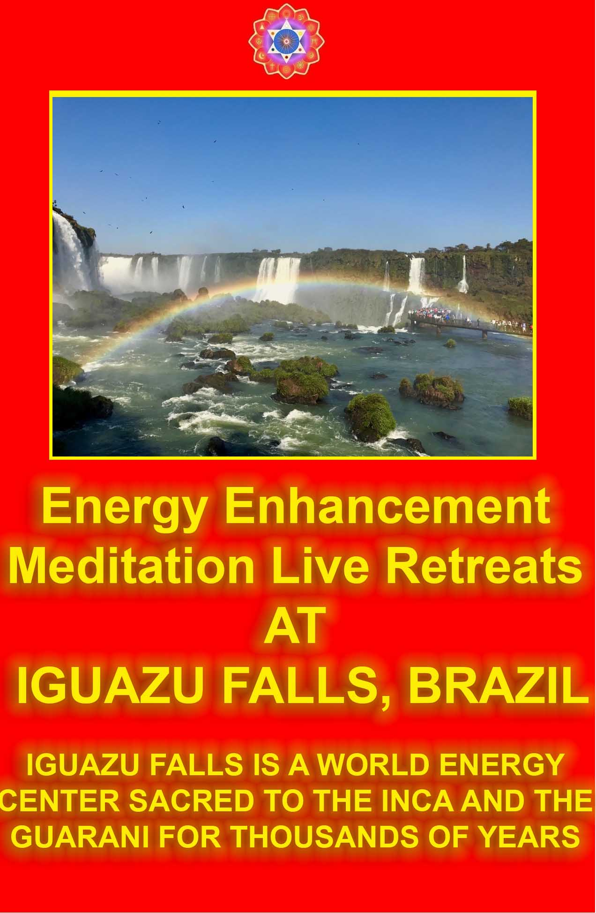

Vimalakirti Sutra Chapter 11 - The Practices of Bodhisattvas, Buddhafields that accomplish the buddha-work by means of bodhisattvas, liberation of bodhisattvas called 'destructible and indestructible.'



Meanwhile, the area in which the Lord was teaching the Dharma in the garden of Amrapali expanded and grew larger, and the entire assembly appeared tinged with a golden hue. Thereupon, the venerable Ananda asked the Buddha, "Lord, this expansion and enlargement of the garden of Amrapali and this golden hue of the assembly - what do these auspicious signs portend?"


The Buddha declared, "Ananda, these auspicious signs portend that the Licchavi Vimalakirti and the crown prince Manjusri, attended by a great multitude, are coming into the presence of the Tathagata."

At that moment the Licchavi Vimalakirti said to the crown prince Manjusri, "Manjusri, let us take these many living beings into the presence of the Lord, so that they may see the Tathagata and bow down to him!"

Manjusri replied, "Noble sir, send them if you feel the time is right!"

Thereupon the Licchavi Vimalakirti performed the miraculous feat of placing the entire assembly, replete with thrones, upon his right hand and then, having transported himself magically into the presence of the Buddha, placing it on the ground. He bowed down at the feet of the Buddha, circumambulated him to the right seven times with palms together, and withdrew to one side.

The bodhisattvas who had come from the Buddhafield of the Tathagata Sugandhakuta descended from their lion-thrones and, bowing down at the feet of the Buddha, placed their palms together in reverence and withdrew to one side.

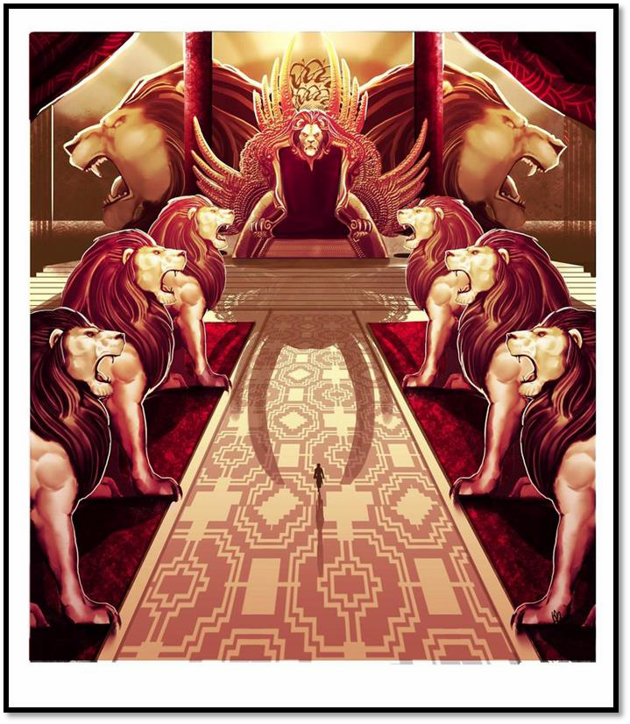

And the other bodhisattvas, great spiritual heroes, and the great disciples descended from their thrones likewise and, having bowed at the feet of the Buddha, withdrew to one side. Likewise all those Indras, Brahmas, Lokapalas, and gods bowed at the feet of the Buddha, placed their palms together in reverence and withdrew to one side.

Then, the Buddha, having delighted those bodhisattvas with greetings, declared, "Noble sons, be seated upon your thrones!"

Thus commanded by the Buddha, they took their thrones.

The Buddha said to Sariputra, "Sariputra, did you see the miraculous performances of the bodhisattvas, those best of beings?"

"I have seen them, Lord."

"What concept did you produce toward them?"

"Lord, I produced the concept of inconceivability toward them. Their activities appeared inconceivable to me to the point that I was unable to think of them, to judge them, or even to imagine them."

Then the venerable Ananda asked the Buddha, "Lord, what is this perfume, the likes of which I have never smelled before?"

The Buddha answered, "Ananda, this perfume emanates from all the pores of all these bodhisattvas."

Sariputra added, "Venerable Ananda, this same perfume emanates from all our pores as well!"

Ananda: Where does the perfume come from?

Sariputra: The Licchavi Vimalakirti obtained some food from the universe called Sarvagandhasugandha, the Buddhafield of the Tathagata Sugandhakuta, and this perfume emanates from the bodies of all those who partook of that food.

Then the venerable Ananda addressed the Licchavi Vimalakirti: "How long will this perfume remain?"

Vimalakirti: Until is it digested. Ananda: When will it be digested?
Vimalakirti: It will be digested in forty-nine days, and its perfume will emanate for seven days more after that, but there will be no trouble of indigestion during that time. Furthermore, reverend Ananda, if monks who have not entered ultimate determination eat this food, it will be digested when they enter that determination.

When those who have entered ultimate determination eat this food, it will not be digested until their minds are totally liberated.

If living beings who have not conceived the spirit of unexcelled, perfect enlightenment eat this food, it will be digested when they conceive the spirit of unexcelled, perfect enlightenment.

If those who have conceived the spirit of perfect enlightenment eat this food, it will not be digested until they have attained tolerance. And if those who have attained tolerance eat this food, it will be digested when they have become bodhisattvas one lifetime away from Buddhahood.

Reverend Ananda, it is like the medicine called "delicious," which reaches the stomach but is not digested until all poisons have been eliminated only then is it digested.

Thus, reverend Ananda, this food is not digested until all the poisons of the passions have been eliminated only then is it digested.

Then, the venerable Ananda said to the Buddha, "Lord, it is wonderful that this food accomplishes the work of the Buddha!"

"So it is, Ananda! It is as you say, Ananda!


DHARMA - THE ENERGY AND WILL OF THE SOUL, IS THE FIRST CHAKRA ABOVE THE HEAD AND THE CREATION OF THE BUDDHAFIELD

There are Buddhafields that accomplish the buddha-work by means of bodhisattvas;

those that do so by means of lights;

those that do so by means of the tree of enlightenment;

those that do so by means of the physical beauty and the marks of the Tathagata;

those that do so by means of religious robes; those that do so by means of good;
those that do so by means of water; those that do so by means of gardens; those that do so by means of palaces; those that do so by means of mansions;
those that do so by means of magical incarnations; those that do so by means of empty space;
and those that do so by means of lights in the sky.

Why is it so, Ananda? Because by these various means, living beings become disciplined.

Similarly, Ananda, there are Buddhafields that accomplish the buddha-work by means of teaching living beings words, definitions, and examples, such as 'dreams,' 'images,' 'the reflection of the moon in water,' 'echoes,' 'illusions,' and 'mirages'; and those that accomplish the buddha-work by making words understandable.

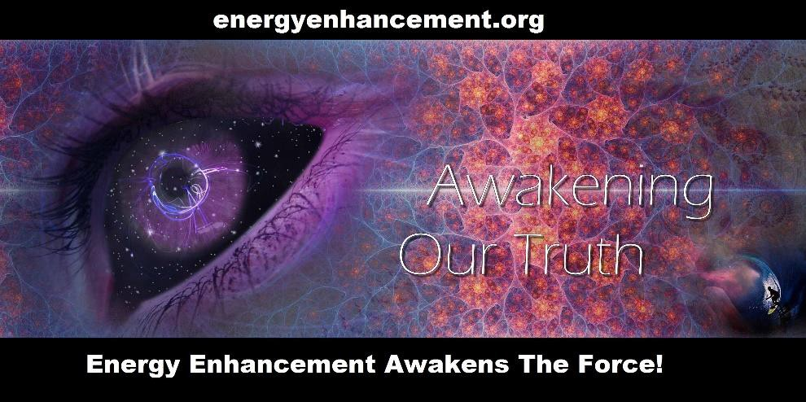


THE MOON SYMBOLISES THE FIRST CHAKRA ABOVE THE HEAD, THE DHARMA, THE SOUL

Also, Ananda, there are utterly pure Buddhafields that accomplish the buddha-work for living beings without speech, by silence, inexpressibility, and unteachability.

Ananda, among all the activities, enjoyments, and practices of the Buddhas, there are none that do not accomplish the buddha-work, because all discipline living beings.

Finally, Ananda, the Buddhas accomplish the buddha-work by means of the four Mara Demons and all the eighty-four thousand types of passion that afflict living beings.

"Ananda, this is a Dharma-door called 'Introduction to all the Buddha-qualities.'

The bodhisattva who enters this Dharma-door experiences neither joy nor pride when confronted by a Buddhafield adorned with the splendor of all noble qualities, and experiences neither sadness nor aversion when confronted by a Buddhafield apparently without that splendor, but in all cases produces a profound reverence for all the Tathagatas.

Indeed, it is wonderful how all the Lord Buddhas, who understand the equality of all things, manifest all sorts of Buddhafields in order to develop living beings!

"Ananda, just as the Buddhafields are diverse as to their specific qualities but have no difference as to the sky that covers them, so, Ananda, the Tathagatas are diverse as to their physical bodies but do not differ as to their unimpeded Gnosis with the chakras above the head.

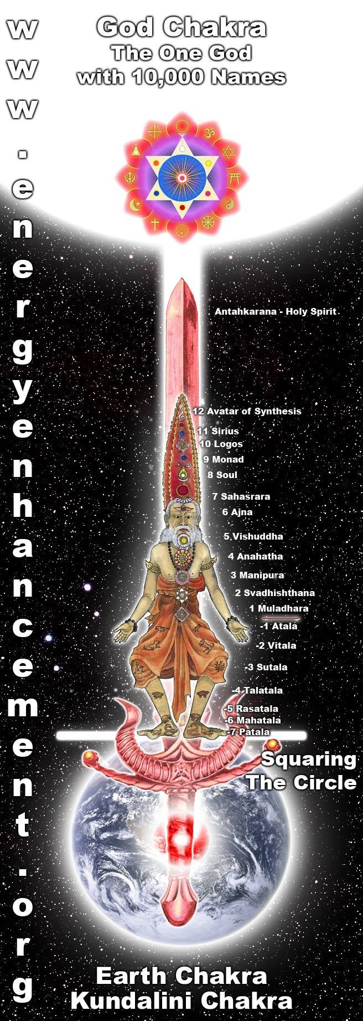
THE ENERGY ENHANCEMENT INFINITE CHAKRAS ABOVE THE HEAD

"Ananda, all the Buddhas are the same as to the perfection of the Buddha-qualities, that is: their forms, their colors, their radiance, their bodies, their marks, their nobility, their morality, their concentration, their wisdom, their liberation, the Gnosis with the chakras above the head and vision of liberation, their strengths, their fearlessnesses, their special Buddha-qualities, their great love, their great compassion, their helpful intentions, their attitudes, their practices, their paths, the lengths of their lives, their teachings of the Dharma, their development and liberation of living beings, and their purification of Buddhafields.

Therefore, they are all called 'Samyaksambuddhas,' 'Tathagatas,' and 'Buddhas.'

WHAT IS UNENLIGHTENED HUMANITY MADE OF?
CATS AND SNAILS AND PUPPY DOGS TAILS..
WHAT ARE BUDDHAS MADE OF?
SUGAR AND SPICE AND ALL THINGS NICE..

WITH THE ENERGY ENHANCEMENT COURSE BUY A STAIRWAY TO HEAVEN
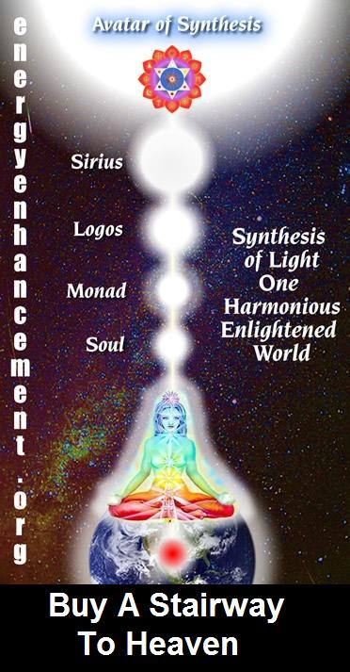
BUY A STAIRWAY TO HEAVEN
WITH THE ENERGY ENHANCEMENT COURSE
STUDENT REPORT
Also I noticed as soon as Satchidanand emailed me, I got a down-pouring of light from above the crown which kept charging me up the rest of the day – and my cravings died out! Then I realized the cravings were ego-blockages and that I did not want them.

Energy Enhancement says that there are an infinity of chakras above the head up into the Center of the Universe and above, high above the head, ending in God, just as there are an infinity of chakras below the base - "As above, So Below" - Hermes Trismegistus from the Emerald Tablet.
INCREASE YOUR INTELLIGENCE - THE PARALLEL PROCESSING SUPERCOMPUTER YOU!! Energy Enhancement says that each chakra within you and above the head is a computer processor with higher and higher frequency, speed and capacity as you go higher. So, like a parallel processing supercomputer, the more chakras you can get working in the Infinity of Chakras above the Head and the more chakras you can access, the more chakras you can disblock, the more chakras you can augment, the more intelligent, the more intuitive, the more wise you will be.
FUSING WITH THE SOUL CHAKRA - Energy Enhancement says that just by fusing with the soul chakra one can see all your past lives and remove all blockages from all your past lives in one sweep, fast!!

FUSING WITH HIGHER CHAKRAS - THE SOUL, MONAD, LOGOS, SIRIUS, AVATAR OF SYNTHESIS - Energy Enhancement says that it also contains the secret of Initiations Higher that Illumination - "Enlightenment is not Enough!!"


"Ananda, were your life to last an entire aeon, it would not be easy for you to understand thoroughly the extensive meaning and precise verbal significance of these three names.

Also, Ananda, if all the living beings of this billion-world galactic universe were like you the foremost of the learned and the foremost of those endowed with memory and incantations - and were they to devote an entire aeon, they would still be unable to understand completely the exact and extensive meaning of the three words 'Samyaksambuddha,' 'Tathagata,' and 'Buddha.'

Thus, Ananda, the enlightenment of the Buddhas is immeasurable, and the wisdom and the eloquence of the Tathagatas are inconceivable."

Then, the venerable Ananda addressed the Buddha: "Lord, from this day forth, I shall no longer declare myself to be the foremost of the learned."

The Buddha said, "Do not be discouraged, Ananda! Why? I pronounced you, Ananda, the foremost of the learned, with the disciples in mind, not considering the bodhisattvas.

Look, Ananda, look at the bodhisattvas.

They cannot be fathomed even by the wisest of men.

Ananda, one can fathom the depths of the ocean, but one cannot fathom the depths of the wisdom, Gnosis with the chakras above the head, memory, incantations, or eloquence of the bodhisattvas.

Ananda, you should remain in equanimity with regard to the deeds of the bodhisattvas.

Why? Ananda, these marvels displayed in a single morning by the Licchavi Vimalakirti could not be performed by the disciples and solitary sages who have attained miraculous powers, were they to devote all their powers of incarnation and transformation during one hundred thousand millions of aeons."

Then, all those bodhisattvas from the Buddhafield of the Tathagata Sugandhakuta joined their palms in reverence and, saluting the Tathagata Sakyamuni, addressed him as follows: "Lord, when we first arrived in this Buddhafield, we conceived a negative idea, but we now abandon this wrong idea.



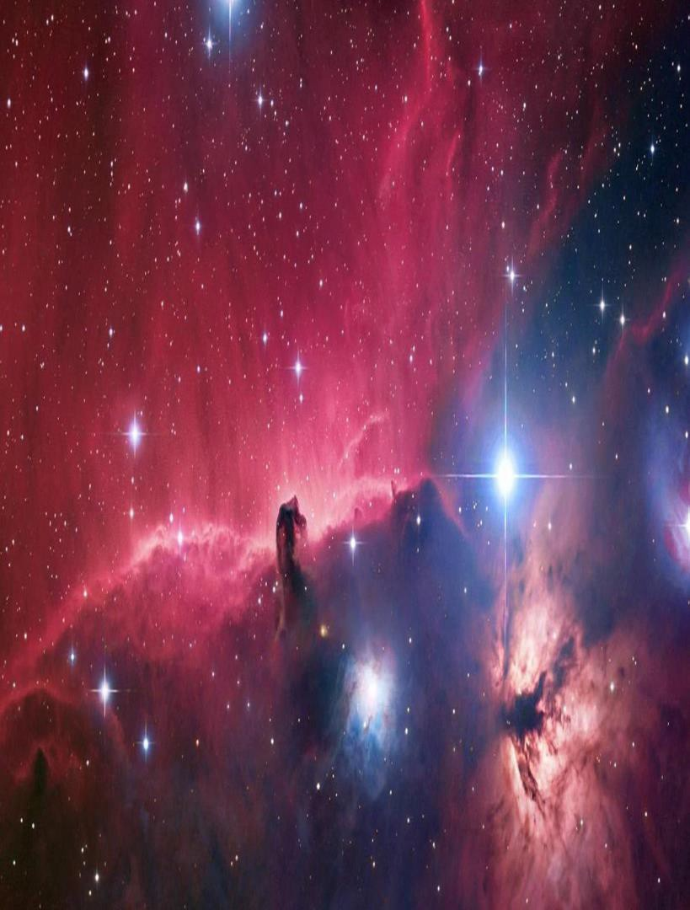
Thereupon the Lord touched the ground of this billion-world- galactic universe with his big toe, and suddenly it was transformed into a huge mass of precious jewels, a magnificent array of many hundreds of thousands of clusters of precious gems, until it resembled the universe of the Tathagata Ratnavyuha, called Anantagunaratnavyuha.

Why? Lord, the realms of the Buddhas and their skill in liberative technique are inconceivable.

In order to develop living beings, they manifest such and such a field to suit the desire of such and such a living being.

Lord, please give us a teaching by which we may remember you, when we have returned to Sarvagandhasugandha."

Thus having been requested, the Buddha declared, "Noble sons, there is a liberation of bodhisattvas called 'destructible and indestructible.' You must train yourselves in this liberation. What is it? 'Destructible' refers to compounded things. 'Indestructible' refers to the uncompounded.

But the bodhisattva should neither destroy the compounded nor rest in the uncompounded.

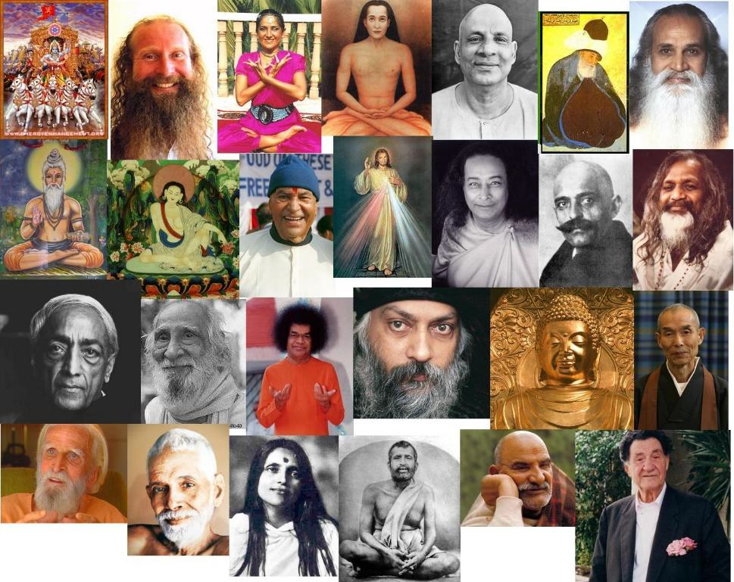
When he goes into the realm of the lord of death, he accumulates the stores of merit and wisdom

"Not to destroy compounded things consists in not losing the great love;

not giving up the great compassion;

not forgetting the omniscient mind generated by high resolve; not tiring in the positive development of living beings;
not abandoning the means of unification;

giving up body and life in order to uphold the holy Dharma; never being satisfied with the roots of virtue already accumulated; taking pleasure in skillful dedication;
having no laziness in seeking the Dharma;

being without selfish reticence in teaching the Dharma; sparing no effort in seeing and worshiping the Tathagatas; being fearless in voluntary reincarnations;
being neither proud in success nor bowed in failure;

not despising the unlearned, and respecting the learned as if they were the Teacher himself;

making reasonable those whose passions are excessive; taking pleasure in solitude, without being attached to it;
not longing for one's own happiness but longing for the happiness of others;

conceiving of trance, meditation, and equanimity as if they were the Avici hell;

conceiving of the world as a garden of liberation; considering beggars to be spiritual teachers;
considering the giving away of all possessions to be the means of realizing Buddhahood;

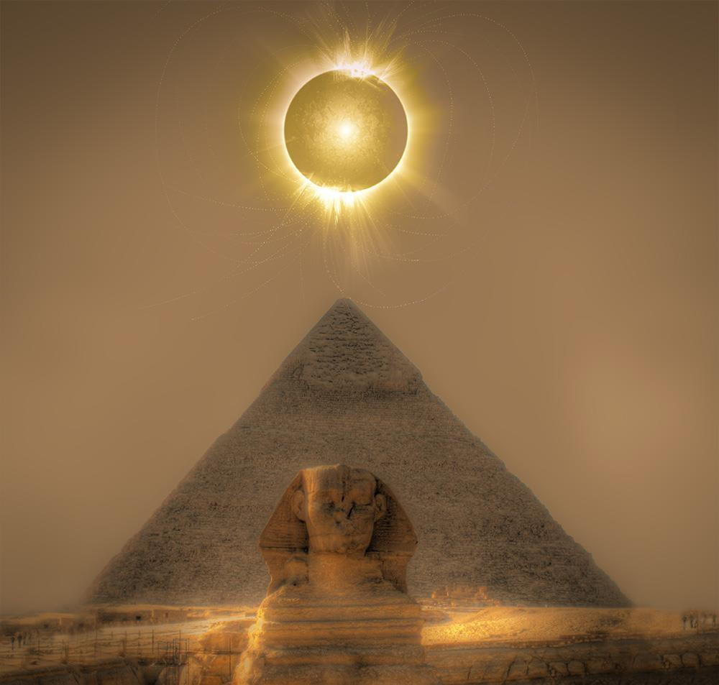
ONLY THOSE WHO HAVE TASTED AND REJECTED THE DARK SIDE CAN BECOME ENLIGHTENED
"THIS WORLD IS A FACTORY FOR THE PRODUCTION OF THE ENLIGHTENED" - SATCHIDANANDA

considering immoral beings to be saviors; considering the transcendences to be parents;

considering the aids to enlightenment to be servants;

never ceasing accumulation of the roots of virtue;

establishing the virtues of all Buddhafields in one's own Buddhafield;

offering limitless pure sacrifices to fulfill the auspicious marks and signs;

adorning body, speech and mind by refraining from all sins;

continuing in reincarnations during immeasurable aeons, while purifying body, speech, and mind;

avoiding discouragement, through spiritual heroism, when learning of the immeasurable virtues of the Buddha;

wielding the sharp sword of wisdom to chastise the enemy passions;

knowing well the aggregates, the elements, and the sense-media in order to bear the burdens of all living beings;

blazing with energy to conquer the host of demons; seeking knowledge in order to avoid pride;
being content with little desire in order to uphold the Dharma; not mixing with worldly things in order to delight all the people; being faultless in all activities in order to conform to all people;
producing the superknowledges to actually accomplish all duties of benefit to living beings;

acquiring incantations, memory, and knowledge in order to retain all learning;

understanding the degrees of people's spiritual faculties to dispel the doubts of all living beings;

displaying invincible miraculous feats to teach the Dharma;

having irresistible speech by acquiring unimpeded eloquence;

tasting human and divine success by purifying the path of ten virtues;

establishing the path of the pure states of Brahma by cultivating the four immeasurables;

inviting the Buddhas to teach the Dharma, rejoicing in them, and applauding them, thereby obtaining the melodious voice of a Buddha;

disciplining body, speech, and mind, thus maintaining constant spiritual progress;

being without attachment to anything and thus acquiring the behavior of a Buddha;

gathering together the order of bodhisattvas to attract beings to the Mahayana;

and being consciously aware at all times not to neglect any good quality.

Noble sons, a bodhisattva who thus applies himself to the Dharma is a bodhisattva who does not destroy the compounded realm.

"What is not resting in the uncompounded?

The bodhisattva practices voidness, but he does not realize voidness. He practices signlessness but does not realize signlessness.
He practices wishlessness but does not realize wishlessness.

He practices non-performance but does not realize non-performance.

He knows impermanence but is not complacent about his roots of virtue.

He considers misery, but he reincarnates voluntarily. He knows selflessness but does not waste himself.
He considers peacefulness but does not seek extreme peace.

He cherishes solitude but does not avoid mental and physical efforts.

He considers placelessness but does not abandon the place of good actions.

He considers occurrencelessness but undertakes to bear the burdens of all living beings.

He considers immaculateness, yet he follows the process of the world.

He considers motionlessness, yet he moves in order to develop all living beings.

He considers selflessness yet does not abandon the great compassion toward all living beings.

He considers birthlessness, yet he does not fall into the ultimate determination of the disciples.

He considers vanity, futility, insubstantiality, dependency, and placelessness, yet he establishes himself on merits that are not vain, on knowledge that is not futile, on reflections that are substantial, on the striving for the consecration of the independent Gnosis with the chakras above the head, and on the Buddha-family in its definitive meaning.

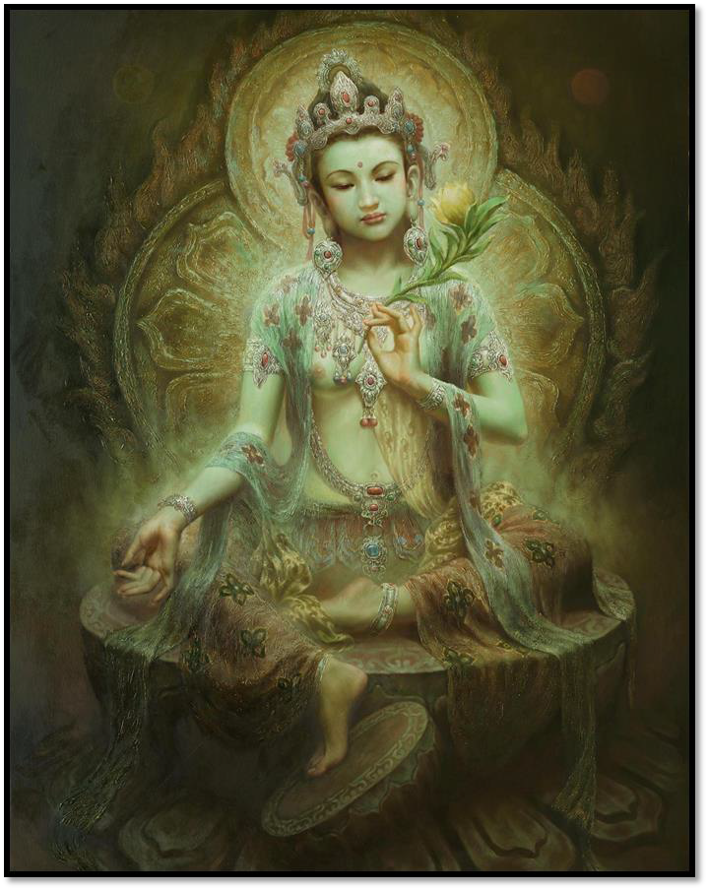

"Thus, noble sons, a bodhisattva who aspires to such a Dharma neither rests in the uncompounded nor destroys the compounded.

"Furthermore, noble sons, in order to accomplish the store of merit, a bodhisattva does not rest in the uncompounded, and, in order to accomplish the store of wisdom, he does not destroy the compounded.

In order to fulfill the great love, he does not rest in the uncompounded, and, in order to fulfill the great compassion, he does not destroy compounded things.

In order to develop living beings, he does not rest in the uncompounded, and in order to aspire to the Buddha-qualities, he does not destroy compounded things.

To perfect the marks of Buddhahood, he does not rest in the uncompounded, and, to perfect the Gnosis with the chakras above the head of omniscience, he does not destroy compounded things.

Out of skill in liberative technique, he does not rest in the uncompounded, and, through thorough analysis with his wisdom, he does not destroy compounded things.

To purify the Buddhafield, he does not rest in the uncompounded, and, by the power of the grace of the Buddha, he does not destroy compounded things.

Because he feels the needs of living beings, he does not rest in the uncompounded, and, in order to show truly the meaning of the Dharma, he does not destroy compounded things.

Because of his store of roots of virtue, he does not rest in the uncompounded, and because of his instinctive enthusiasm for these roots of virtue, he does not destroy compounded things.

To fulfill his prayers, he does not rest in the uncompounded, and, because he has no wishes, he does not destroy compounded things.

Because his positive thought is pure, he does not rest in the uncompounded, and, because his high resolve is pure, he does not destroy compounded things.

In order to play with the five superknowledges, he does not rest in the uncompounded, and, because of the six superknowledges of the buddha-gnosis, he does not destroy compounded things.

To fulfill the six transcendences, he does not rest in the uncompounded, and, to fulfill the time, he does not destroy compounded things.

To gather the treasures of the Dharma of the First Chakra above the Head, he does not rest in the uncompounded, and, because he does not like any narrow-minded teachings, he does not destroy compounded things.

Because he gathers all the medicines of the Dharma of the First Chakra above the Head, he does not rest in the uncompounded, and, to apply the medicine of the Dharma of the First Chakra above the Head appropriately, he does not destroy compounded things.

To confirm his commitments, he does not rest in the uncompounded, and, to mend any failure of these commitments, he does not destroy compounded things.

To concoct all the elixirs of the Dharma of the First Chakra above the Head, he does not rest in the uncompounded, and, to give out the nectar of this subtle Dharma of the First Chakra above the Head, he does not destroy compounded things.

Because he knows thoroughly all the sicknesses due to passions, he does not rest in the uncompounded, and, in order to cure all sicknesses of all living beings, he does not destroy compounded things.

"Thus, noble sons, the bodhisattva does not destroy compounded things and does not rest in the uncompounded, and that is the liberation of bodhisattvas called 'destructible and indestructible.'

Noble sirs, you should also strive in this."

Then, those bodhisattvas, having heard this teaching, were satisfied, delighted, and reverent.

They were filled with rejoicing and happiness of mind.

In order to worship the Buddha Sakyamuni and the bodhisattvas of the Saha universe, as well as this teaching, they covered the whole earth of this billion-world universe with fragrant powder, incense, perfumes, and flowers up to the height of the knees.

Having thus regaled the whole retinue of the Tathagata, bowed their heads at the feet of the Buddha, and circumambulated him to the right three times, they sang a hymn of praise to him.

They then disappeared from this universe and in a split second were back in the universe Sarvagandhasugandha.


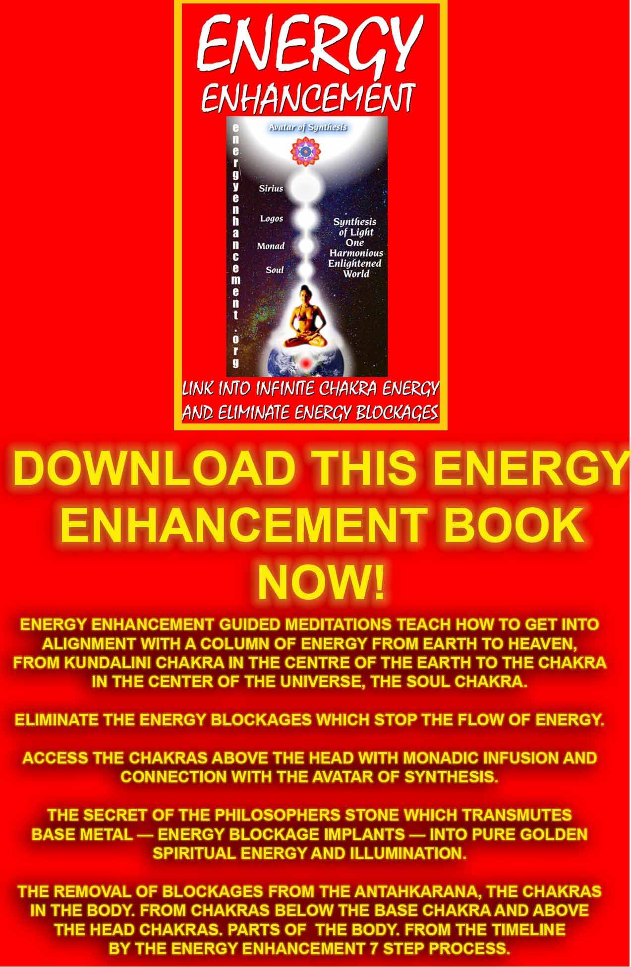
Download “Link Into Infinite Chakra Energy And Eliminate Energy Blockages” Here
http://www.energyenhancement.org/Sacred-Energy/Meditation-Energy-Enhancement-Link-into-Infinite-Chakra-Energies-and-Remove-Energy-Blockages-EEBOOK1Color-energyenhancement-org.pdf

Vimalakirti Sutra Chapter 12 - Vision of the Universe Abhirati and the Tathagata Aksobhya Buddhafields - The Tathagata, Sariputra and Miraculous Feats

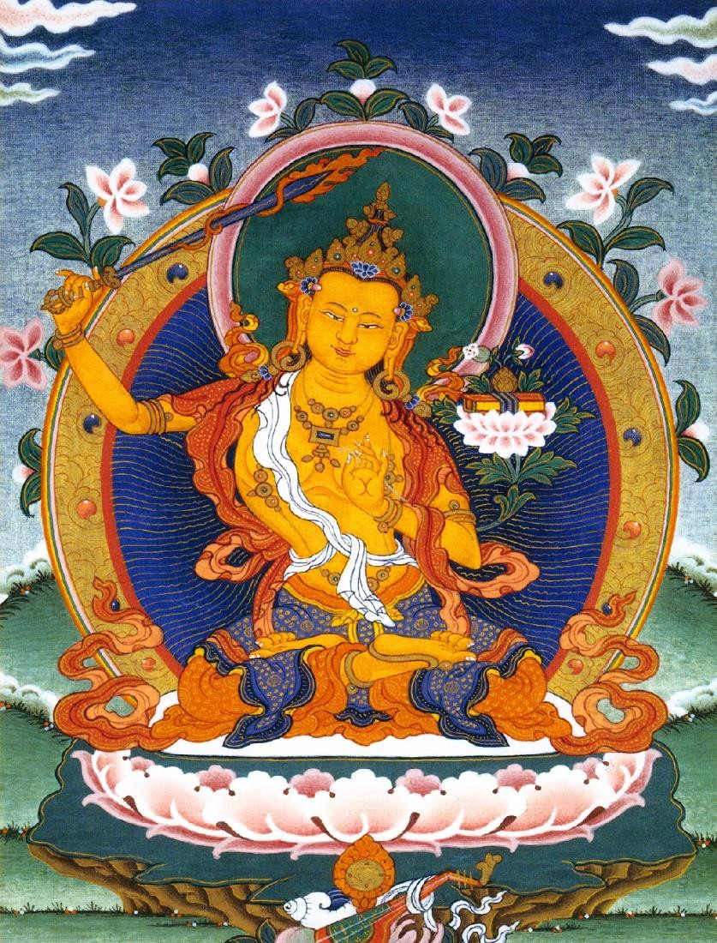
PRINCE MANJUSHRI AND HIS SWORD OF DIS-CRIME- INATION

Thereupon, the Buddha said to the Licchavi Vimalakirti, "Noble son, when you would see the Tathagata, how do you view him?"

Thus addressed, the Licchavi Vimalakirti said to the Buddha, "Lord, when I would see the Tathagata, I view him by not seeing any Tathagata. Why? I see him as not born from the past, not passing on to the future, and not abiding in the present time. Why? He is the essence which is the reality of matter, but he is not matter. He is the essence which is the reality of sensation, but he is not sensation. He is the essence which is the reality of intellect, but he is not intellect. He is the essence which is the reality of motivation, yet he is not motivation. He is the essence which is the reality of consciousness, yet he is not consciousness. Like the element of space, he does not abide in any of the four elements. Transcending the scope of eye, ear, nose, tongue, body, and mind, he is not produced in the six sense-media. He is not involved in the three worlds, is free of the three defilements, is associated with the triple liberation, is endowed with the three knowledges, and has truly attained the unattainable.

"The Tathagata has reached the extreme of detachment in regard to all things, yet he is not a reality-limit. He abides in ultimate reality, yet there is no relationship between it and him. He is not produced from causes, nor does he depend on conditions. He is not without any characteristic, nor has he any characteristic. He has no single nature nor any diversity of natures. He is not a conception, not a mental construction, nor is he a nonconception. He is neither the other shore, nor this shore, nor that between. He is neither here, nor there, nor anywhere else. He is neither this nor that. He cannot be discovered by consciousness, nor is he inherent in consciousness. He is neither darkness nor light. He is neither name nor sign. He is neither weak nor strong He lives in no country or direction. He is neither good nor evil. He is neither compounded nor uncompounded He cannot be explained as having any meaning whatsoever.

"The Tathagata is neither generosity nor avarice, neither morality nor immorality, neither tolerance nor malice, neither effort nor sloth, neither concentration nor distraction, neither wisdom nor foolishness. He is inexpressible. He is neither truth nor falsehood; neither escape from the world nor failure to escape from the world;

neither cause of involvement in the world nor not a cause of involvement in the world; he is the cessation of all theory and all practice. He is neither a field of merit nor not a field of merit; he is neither worthy of offerings nor unworthy of offerings. He is not an object, and cannot be contacted. He is not a whole, nor a conglomeration. He surpasses all calculations. He is utterly unequaled, yet equal to the ultimate reality of things. He is matchless, especially in effort. He surpasses all measure. He does not go, does not stay, does not pass beyond. He is neither seen, heard, distinguished, nor known. He is without any complexity, having attained the equanimity of omniscient gnosis. Equal toward all things, he does not discriminate between them. He is without reproach, without excess, without corruption, without conception, and without intellectualization. He is without activity, without birth, without occurrence, without origin, without production, and without nonproduction. He is without fear and without subconsciousness; without sorrow, without joy, and without strain. No verbal teaching can express him.

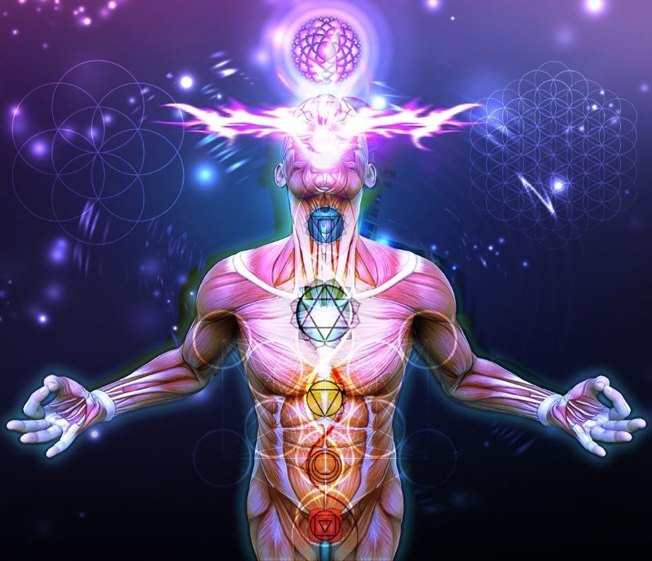
The Soul, the first chakra above the head

"Such is the body of the Tathagata and thus should he be seen. Who sees thus, truly sees. Who sees otherwise, sees falsely."

The venerable Sariputra then asked the Buddha, "Lord, in which buddhafield did the noble Vimalakirti die, before reincarnating in this buddha-field?"

The Buddha said, "Sariputra, ask this good man directly where he died to reincarnate here."

Then the venerable Sariputra asked the Licchavi Vimalakirti, "Noble sir, where did you die to reincarnate here?"

Vimalakirti declared, "Is there anything among the things that you see, elder, that dies or is reborn?"

Sariputra: There is nothing that dies or is reborn.

Vimalakirti: Likewise, reverend Sariputra, as all things neither die nor are reborn, why do you ask, "Where did you die to reincarnate here?" Reverend Sariputra, if one were to ask a man or woman created by a magician where he or she had died to reincarnate there, what do you think he or she would answer?

Sariputra: Noble sir, a magical creation does not die, nor is it reborn.

Vimalakirti: Reverend Sariputra, did not the Tathagata declare that all things have the nature of a magical creation?

Sariputra: Yes, noble sir, that is indeed so.

Vimalakirti: Reverend Sariputra, "death" is an end of performance, and "rebirth" is the continuation of performance. But, although a bodhisattva dies, he does not put an end to the performance of the roots of virtue, and although he is reborn, he does not adhere to the continuation of sin.

Then, the Buddha said to the venerable Sariputra, "Sariputra, this holy person came here from the presence of the Tathagata Aksobhya in the universe Abhirati."

Sariputra: Lord, it is wonderful that this holy person, having left a buddhafield as pure as Abhirati, should enjoy a buddhafield as full of defects as this Saha universe!

The Licchavi Vimalakirti said, "Sariputra, what do you think? Does the light of the sun accompany the darkness?"

Sariputra: Certainly not, noble sir! Vimalakirti: Then the two do not go together?
Sariputra: Noble sir, those two do not go together. As soon as the sun rises, all darkness is destroyed.

Vimalakirti: Then why does the sun rise over the world?

Sariputra: It rises to illuminate the world, and to eliminate the darkness.

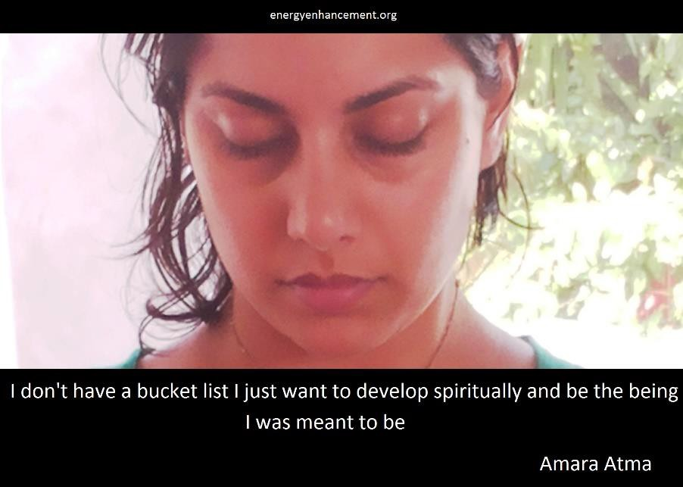

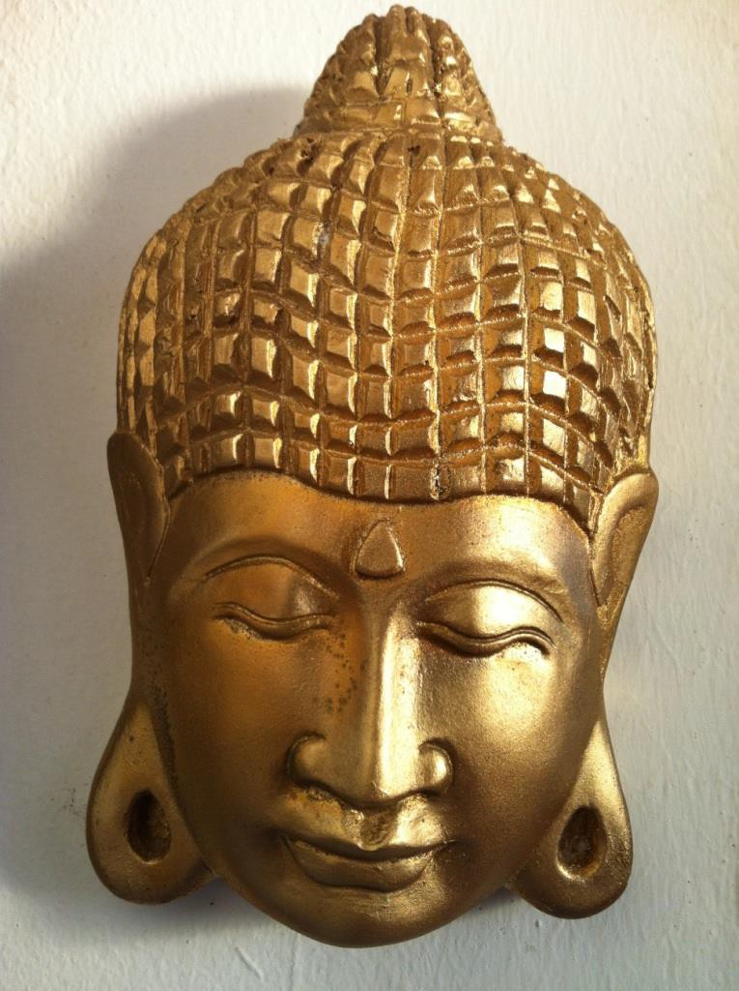
BUDDHA AT THE ENERGY ENHANCEMENT IGUAZU ASHRAM TAKEN BY GITA

Vimalakirti: Just in the same way, reverend Sariputra, the bodhisattva reincarnates voluntarily in the impure buddhafields in order to purify the living beings, in order to make the light of wisdom shine, and in order to clear away the darkness. Since they do not associate with the passions, they dispel the darkness of the passions of all living beings.

Thereupon, the entire multitude experienced the desire to behold the universe Abhirati, the Tathagata Aksobhya, his bodhisattvas, and his great disciples. The Buddha, knowing the thoughts of the entire multitude, said to the Licchavi Vimalakirti, "Noble son, this multitude wishes to behold the universe Abhirati and the Tathagata Aksobhya - show them!"

Then the Licchavi Vimalakirti thought, "Without rising from my couch, I shall pick up in my right hand the universe Abhirati and all it contains: its hundreds of thousands of bodhisattvas; its abodes of devas, nagas, yaksas, gandharvas, and asuras, bounded by its Cakravada mountains; its rivers, lakes, fountains, streams, oceans, and other bodies of water; its Mount Sumeru and other hills and mountain ranges; its moon, its sun, and its stars; its devas, nagas, yaksas, gandharvas, and asuras themselves; its Brahma and his retinues; its villages, cities, towns, provinces, kingdoms, men, women, and houses; its bodhisattvas; its disciples; the tree of enlightenment of the Tathagata Aksobhya; and the Tathagata Aksobhya himself, seated in the middle of an assembly vast as an ocean, teaching the Dharma. Also the lotuses that accomplish the buddha-work among the living beings; the three jeweled ladders that rise from its earth to its Trayastrimsa heaven, on which ladders the gods of that heaven descend to the world to see, honor, and serve the Tathagata Aksobhya and to hear the Dharma, and on which the men of the earth climb to the Trayastrimsa heaven to visit those gods.
Like a potter with his wheel, I will reduce that universe Abhirati, with its store of innumerable virtues, from its watery base up to its Akanistha heaven, to a minute size and, carrying it gently like a garland of flowers, will bring it to this Saha universe and will show it to the multitudes."

Then, the Licchavi Vimalakirti entered into a concentration, and performed a miraculous feat such that he reduced the universe Abhirati to a minute size, and took it with his right hand, and brought it into this Saha universe.

In that universe Abhirati, the disciples, bodhisattvas, and those among gods and men who possessed the superknowledge of the divine eye all cried out, "Lord, we are being carried away! Sugata, we are being carried off! Protect us, O Tathagata!"

But, to discipline them, the Tathagata Aksobhya said to them, "You are being carried off by the bodhisattva Vimalakirti. It is not my affair."

As for the other men and gods, they had no awareness at all that they were being carried anywhere.

Although the universe Abhirati had been brought into the universe Saha, the Saha universe was not increased or diminished; it was neither compressed nor obstructed. Nor was the universe Abhirati reduced internally, and both universes appeared to be the same as they had ever been.

Thereupon, the Buddha Sakyamuni asked all the multitudes, "Friends, behold the splendors of the universe Abhirati, the Tathagata Aksobhya, the array of his buddhafield, and the splendors of these disciples and bodhisattvas!"

They replied, "We see them, Lord!"


To experience the taste of contemplation and meditation with skill in liberative technique is liberation.

The Buddha said, "Those bodhisattvas who wish to embrace such a buddhafield should train themselves in all the bodhisattva-practices of the Tathagata Aksobhya."

While Vimalakirti, with his miraculous power, showed them thus the universe Abhirati and the Tathagata Aksobhya, one hundred and forty thousand living beings among the men and gods of the Saha universe conceived the spirit of unexcelled, perfect enlightenment, and all of them formed a prayer to be reborn in the universe Abhirati. And the Buddha prophesied that in the future all would be reborn in the universe Abhirati.

And the Licchavi Vimalakirti, having thus developed all the living beings who could thereby be developed, returned the universe Abhirati exactly to its former place.

The Lord then said to the venerable Sariputra, "Sariputra, did you see that universe Abhirati, and the Tathagata Aksobhya?"

Sariputra replied, "I saw it, Lord! May all living beings come to live in a buddhafield as splendid as that! May all living beings come to have miraculous powers just like those of the noble Licchavi Vimalakirti!

"We have gained great benefit from having seen a holy man such as he. We have gained a great benefit from having heard such teaching of the Dharma, whether the Tathagata himself still actually exists or whether he has already attained ultimate liberation. Hence, there is no need to mention the great benefit for those who, having heard it, believe it, rely on it, embrace it, remember it, read it, and penetrate to its depth; and, having found faith in it, teach, recite, and show it to others and apply themselves to the yoga of meditation upon its teaching.

THE OPEN HEART
Wisdom integrated with liberative technique consists of being motivated by the great compassion and thus of concentration on cultivation of the auspicious signs and marks, on the adornment of the Buddhafield, and on the work of development of living beings, all the while concentrating on deep investigation of voidness, signlessness, and wishlessness - and it is liberation.

"Those living beings who understand correctly this teaching of the Dharma will obtain the treasury of the jewels of the Dharma.
"Those who study correctly this teaching of the Dharma will become the companions of the Tathagata.
Those who honor and serve the adepts of this doctrine will be the true protectors of the Dharma.
Those who write, teach, and worship this teaching of the Dharma will be visited by the Tathagata in their homes.
Those who take pleasure in this teaching of the Dharma will embrace all merits.
Those who teach it to others, whether it be no more than a single stanza of four lines, or a single summary phrase from this teaching of the Dharma, will be performing the great Dharma-sacrifice.
And those who devote to this teaching of the Dharma their tolerance, their zeal, their intelligence, their discernment, their vision, and their aspirations, thereby become subject to the prophesy of future Buddhahood!"

Vimalakirti Sutra Chapter 13 - Antahkarana Antecedents and Transmission of the Holy Dharma of the Soul Chakra, the first Chakra above the head - Enlightenment!!

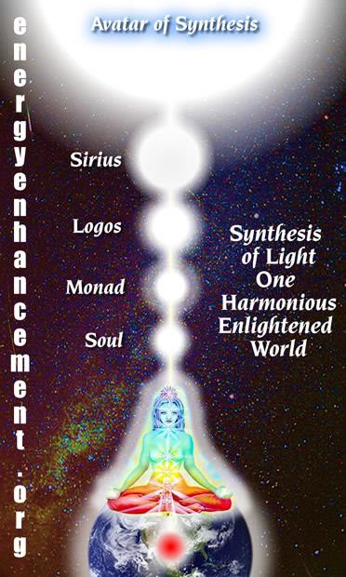
THE ANTAHKARANA COLUMN OF LIGHT CONNECTING YOU TO THE INFINITY OF CHAKRAS ABOVE THE HEAD - THE FIRST ONE BEING THE SOUL

Then Sakra, the prince of the gods, said to the Buddha, "Lord, formerly I have heard from the Tathagata and from Manjusri, the crown prince of wisdom, many hundreds of thousands of teachings of the Dharma of the Soul Chakra, the first Chakra above the head, but I have never before heard a teaching of the Dharma of the Soul Chakra, the first Chakra above the head as remarkable as this instruction in the entrance into the method of inconceivable transformations.

Lord, those living beings who, having heard this teaching of the Dharma of the Soul Chakra, the first Chakra above the head, accept it, remember it, read it, and understand it deeply will be, without a doubt, true vessels of the Dharma of the Soul Chakra, the first Chakra above the head; there is no need to mention those who apply themselves to the yoga of meditation upon it.

They will cut off all possibility of unhappy lives, will open their way to all fortunate lives, will always be looked after by all Buddhas, will always overcome all adversaries, and will always conquer all devils.

They will practice the path of the bodhisattvas, will take their places upon the seat of Enlightenment, and will have truly entered the domain of the Tathagatas. Lord, the noble sons and daughters who will teach and practice this exposition of the Dharma of the Soul Chakra, the first Chakra above the head will be honored and served by me and my followers.

To the villages, towns, cities, states, kingdoms, and capitals wherein this teaching of the Dharma of the Soul Chakra, the first Chakra above the head will be applied, taught, and demonstrated, I and my followers will come to hear the Dharma of the Soul Chakra, the first Chakra above the head. I will inspire the unbelieving with faith, and I will guarantee my help and protection to those who believe and uphold the Dharma of the Soul Chakra, the first Chakra above the head."

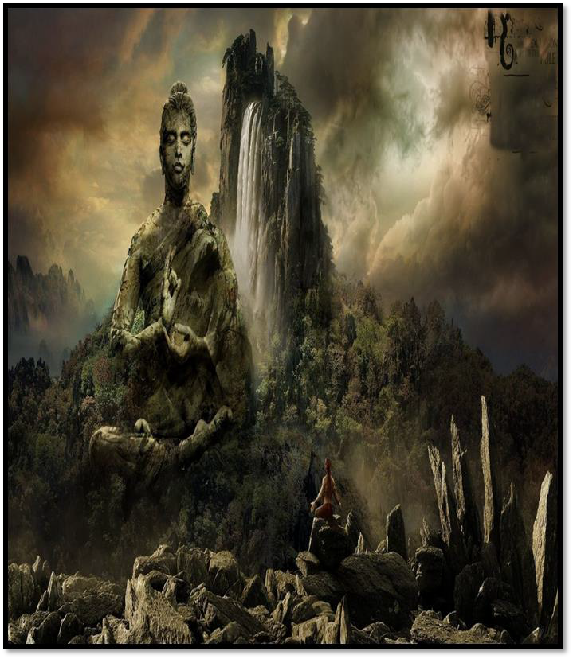

At these words, the Buddha said to Sakra, the prince of the gods, "Excellent! Excellent, prince of gods! The Tathagata rejoices in your good words. Prince of gods, the enlightenment of the Buddhas of the past, present, and future is expressed in this discourse of Dharma of the Soul Chakra, the first Chakra above the head.

Therefore, prince of gods, when noble sons and daughters accept it, repeat it, understand it deeply, write it completely, and, making it into a book, honor it, those sons and daughters thereby pay homage to the Buddhas of the past, present and future.

"Let us suppose, prince of gods, that this billion-world-galactic universe were as full of Tathagatas as it is covered with groves of sugarcane, with rosebushes, with bamboo thickets, with herbs, and with flowers, and that a noble son or daughter were to honor them, revere them, respect and adore them, offering them all sorts of comforts and offerings for an aeon or more than an aeon.

And let us suppose that, these Tathagatas having entered ultimate liberation, he or she honored each of them by enshrining their preserved bodies in a memorial stupa made of precious stones, each as large as a world with four great continents, rising as high as the world of Brahma, adorned with parasols, banners, standards, and lamps.

And let us suppose finally that, having erected all these stupas for the Tathagatas, he or she were to devote an aeon or more to offering them flowers, perfumes, banners, and standards, while playing drums and music.

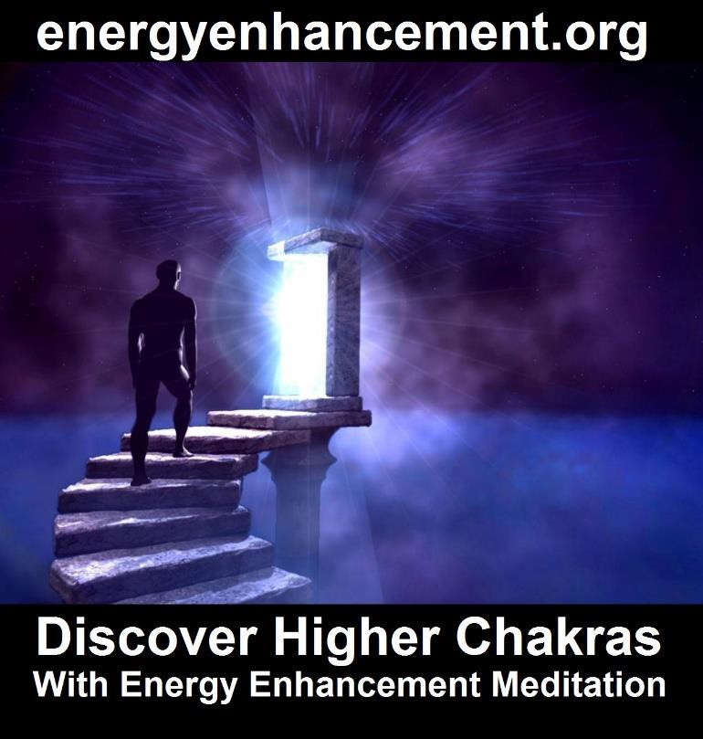

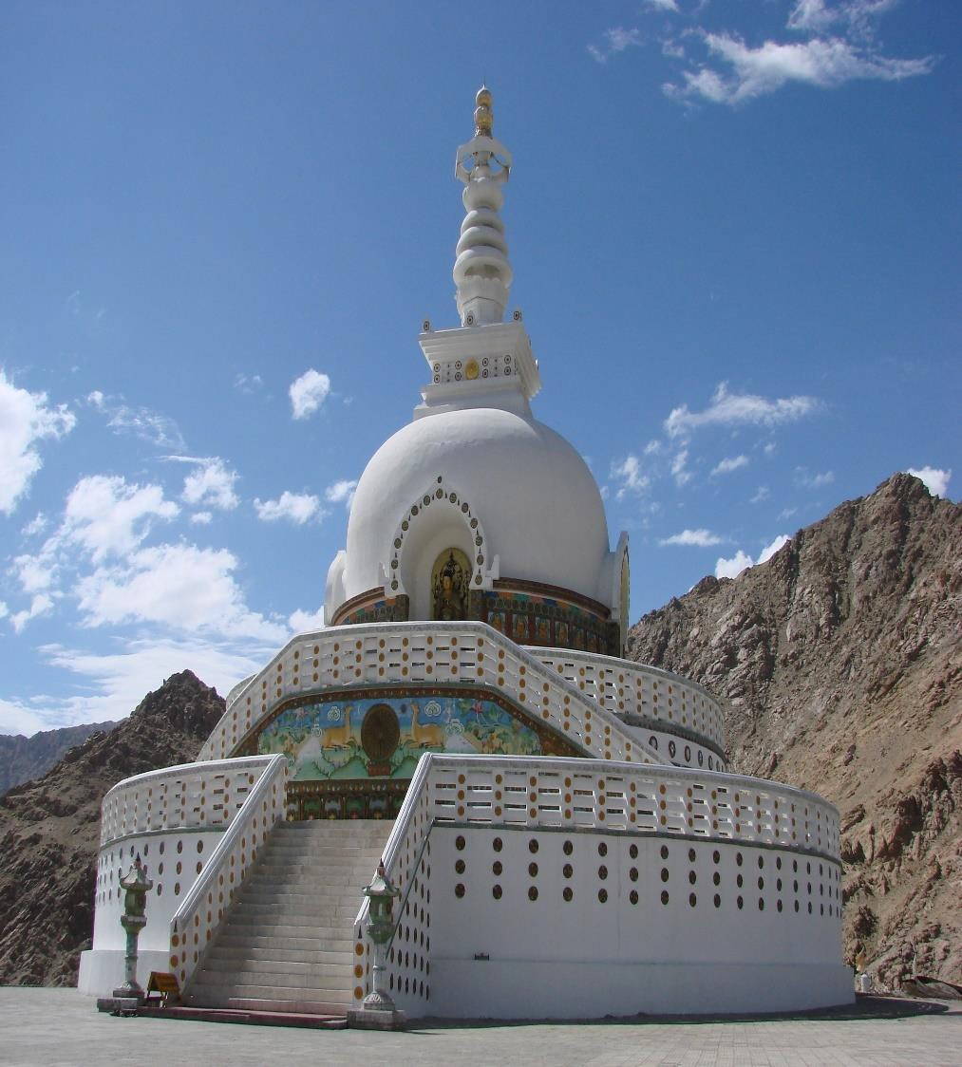
THE HEMISPHERE OF THE STUPA REPRESENTS THE EARTH THE COLUMN COMING OUT OF THE HEMISPHERE REPRESENTS THE COLUMN OF ENERGY CONNECTING THE INFINITY OF CHAKRAS ABOVE THE HEAD - A STREAM OF ENERGY - BECOME A STREAM ENTERER WITH ENERGY ENHANCEMENT
THE BUDDHA KNEW THIS
NOW ONLY ENERGY ENHANCEMENT TEACHES TRULY, HOW TO BECOME A STREAM ENTERER

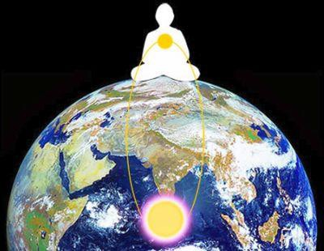
ALCHEMICAL VITRIOL KUNDALINI KRIYA THE MEANING OF THE STUPA

That being done, what do you think, prince of gods? Would that noble son or daughter receive much merit as a consequence of such activities?"

Sakra, the prince of gods, replied, "Many merits, Lord! Many merits, O Sugata! Were one to spend hundreds of thousands of millions of aeons, it would be impossible to measure the limit of the mass of merits that that noble son or daughter would thereby gather!"

The Buddha said, "Have faith, prince of gods, and understand this: Whoever accepts this exposition of the Dharma of the Soul Chakra, the first Chakra above the head called 'Instruction in the Inconceivable Liberation,' recites it, and understands it deeply, he or she will gather merits even greater than those who perform the above acts.

Why so? Because, prince of gods, the enlightenment of the Buddhas arises from the Dharma of the Soul Chakra, the first Chakra above

the head, and one honors them by the Dharma of the Soul Chakra, the first Chakra above the head worship, and not by material worship. Thus it is taught, prince of gods, and thus you must understand it."

The Buddha then further said to Sakra, the prince of gods, "Once, prince of gods, long ago, long before aeons more numerous than the innumerable, immense, immeasurable, inconceivable, and even before then, the Tathagata called Bhaisajyaraja appeared in the world: a saint, perfectly and fully enlightened, endowed with knowledge and conduct, a blissful one, knower of the world, incomparable knower of men who need to be civilized, teacher of gods and men, a Lord, a Buddha. He appeared in the aeon called Vicarana in the universe called Mahavyuha.

"The length of life of this Tathagata Bhaisajyaraja, perfectly and fully enlightened one, was twenty short aeons.




DHARMA - THE ENERGY AND WILL OF THE SOUL, IS THE FIRST CHAKRA ABOVE THE HEAD

MOST ENLIGHTENED MASTERS ONLY FUSE WITH THE FIRST CHAKRA ABOVE THE HEAD

SATCHIDANAND CONNECTS AND FUSES MUCH HIGHER THUS HE IS GURU OF THE GURUS - SATGURU!!

His retinue of disciples numbered thirty-six million billion, and his retinue of bodhisattvas numbered twelve million billion. In that same era, prince of gods, there was a universal monarch called King Ratnacchattra, who reigned over the four continents and possessed seven precious jewels. He had one thousand heroic sons, powerful, strong, and able to conquer enemy armies.

This King Ratnacchattra honored the Tathagata Bhaisajyaraja and his retinue with many excellent offerings during five short aeons. At the end of this time, the King Ratnacchattra said to his sons, 'Recognizing that during my reign I have worshiped the Tathagata, in your turn you also should worship him.'

"The thousand princes gave their consent, obeying their father the king, and all together, during another five short aeons, they honored the Tathagata Bhaisajyaraja with all sorts of excellent offerings.

"Among them, there was a prince by the name of Candracchattra, who retired into solitude and thought to himself, 'Is there not another mode of worship, even better and more noble than this?'

"Then, by the supernatural power of the Buddha Bhaisajyaraja, the gods spoke to him from the heavens: 'Good man, the supreme worship is the Dharma of the Soul Chakra, the first Chakra above the head-worship.'

"Candracchattra asked them, 'What is this "Dharma of the Soul Chakra, the first Chakra above the head-worship"?'

"The gods replied, 'Good man, go to the Tathagata Bhaisajyaraja, ask him about the "Dharma of the Soul Chakra, the first Chakra above the head-worship," and he will explain it to you fully.'

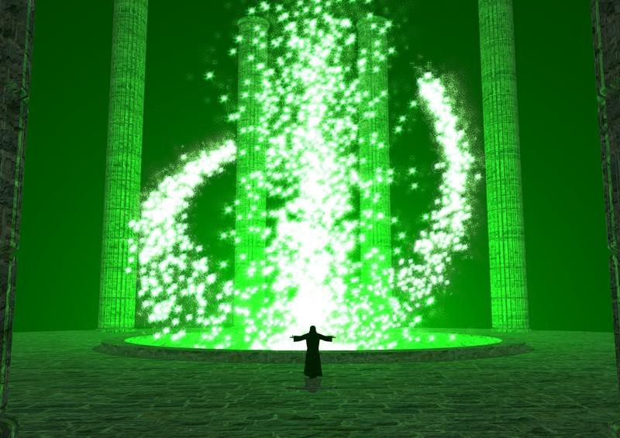

"Then, the prince Candracchattra went to the Lord Bhaisajyaraja, the saint, the Tathagata, the insuperably, perfectly enlightened one, and having approached him, bowed down at his feet, circumambulated him to the right three times, and withdrew to one side.

He then asked, 'Lord, I have heard of a "Dharma of the Soul Chakra, the first Chakra above the head-worship," which surpasses all other worship. What it this "Dharma of the Soul Chakra, the first Chakra above the head-worship"?'

"The Tathagata Bhaisajyaraja said, 'Noble son, the Dharma of the Soul Chakra, the first Chakra above the head-worship is that worship rendered to the discourses taught by the Tathagata.

These discourses are deep and profound in illumination. They do not conform to the mundane and are difficult to understand, difficult to see and difficult to realize. They are subtle, precise, and ultimately incomprehensible. As Scriptures, they are collected in the canon of the bodhisattvas, stamped with the insignia of the king of incantations and teachings.

They reveal the irreversible wheel of Dharma of the Soul Chakra, the first Chakra above the head, arising from the six transcendences, cleansed of any false notions. They are endowed with all the aids to enlightenment and embody the seven factors of enlightenment - the removal of all energy blockages, the fusion with the Soul Chakra, the first Chakra above the head - a Soul infused being!!

They introduce living beings to the great compassion and teach them the great love. They eliminate all the convictions of the Mara energy blockages, and they manifest relativity.

"'They contain the message of selflessness, living-beinglessness, lifelessness, personlessness, voidness, signlessness, wishlessness, nonperformance, nonproduction, and nonoccurrence.

"'They make possible the attainment of the seat of enlightenment and set in motion the wheel of the Dharma of the Soul Chakra, the first Chakra above the head.

They are approved and praised by the chiefs of the gods, nagas, yaksas, gandharvas, asuras, garudas, kimnaras, and mahoragas.

They preserve unbroken the heritage of the holy Dharma of the Soul Chakra, the first Chakra above the head, contain the treasury of the Dharma of the Soul Chakra, the first Chakra above the head, and represent the summit of the Dharma of the Soul Chakra, the first Chakra above the head-worship.

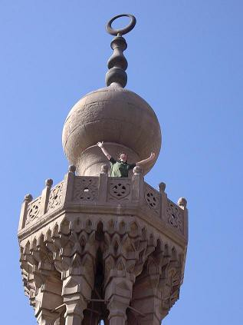
Bab Ziewiew Minaret

THE SPHERE OF THE MINARET REPRESENTS THE EARTH THE COLUMN COMING OUT OF THE HEMISPHERE REPRESENTS THE COLUMN OF ENERGY CONNECTING THE INFINITY OF CHAKRAS ABOVE THE HEAD - A STREAM OF ENERGY - BECOME A STREAM ENTERER WITH ENERGY ENHANCEMENT

MOHAMMED KNEW THIS

NOW ONLY ENERGY ENHANCEMENT TEACHES TRULY, HOW TO BECOME A STREAM ENTERER



They are upheld by all holy beings and teach all the bodhisattva practices. They induce the unmistaken understanding of the Dharma of the Soul Chakra, the first Chakra above the head in its ultimate sense.

They certify that all things are impermanent, miserable, selfless, and peaceful, thus epitomizing the Dharma of the Soul Chakra, the first Chakra above the head.

They cause the abandonment of avarice, immorality, malice, laziness, forgetfulness, foolishness, and jealousy, as well as bad convictions, adherence to objects, and all opposition. They are praised by all the Buddhas. They are the medicines for the tendencies of mundane life, and they authentically manifest the great happiness of liberation.

To teach correctly, to uphold, to investigate, and to understand such Scriptures, thus incorporating into one's own life the holy Dharma of the Soul Chakra, the first Chakra above the head - that is the "Dharma of the Soul Chakra, the first Chakra above the head- worship."

"'Furthermore, noble son, the Dharma of the Soul Chakra, the first Chakra above the head-worship consists of determining the Dharma of the Soul Chakra, the first Chakra above the head according to the Dharma of the Soul Chakra, the first Chakra above the head; applying the Dharma of the Soul Chakra, the first Chakra above the head according to the Dharma of the Soul Chakra, the first Chakra above the head;
being in harmony with relativity; being free of extremist convictions;
attaining the tolerance of ultimate birthlessness and nonoccurrence of all things;
realizing selflessness and living-beinglessness;
refraining from struggle about causes and conditions, without quarreling, or disputing; not being possessive;
being free of egoism;
relying on the meaning and not on the literal expression; relying on gnosis and not on consciousness;

relying on the ultimate teachings definitive in meaning and not insisting on the superficial teachings interpretable in meaning; relying on reality and not insisting on opinions derived from personal authorities;
realizing correctly the reality of the Buddha;
realizing the ultimate absence of any fundamental consciousness; and overcoming the habit of clinging to an ultimate ground.

Finally, attaining peace by stopping everything from ignorance to old age, death, sorrow, lamentation, misery, anxiety, and trouble, and realizing that living beings know no end to their views concerning these twelve links of dependent origination; then, noble son, when you do not hold to any view at all, it is called the unexcelled Dharma of the Soul Chakra, the first Chakra above the head-worship.'

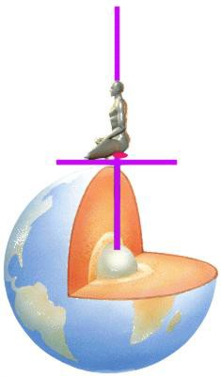
Energy Enhancement Meditation

"Prince of gods, when the prince Candracchattra had heard this definition of Dharma of the Soul Chakra, the first Chakra above the head-worship from the Tathagata Bhaisajyaraja, he attained the conformative tolerance of ultimate birthlessness; and, taking his robes and ornaments, he offered them to the Buddha Bhaisajyaraja, saying, 'When the Tathagata will be in ultimate liberation, I wish to defend his holy Dharma of the Soul Chakra, the first Chakra above the head, to protect it, and to worship it.

May the Tathagata grant me his supernatural blessing, that I may be able to conquer Mara and all adversaries and to incorporate in all my lives the holy Dharma of the Soul Chakra, the first Chakra above the head of the Buddha!'

"The Tathagata Bhaisajyaraja, knowing the high resolve of Candracchattra, prophesied to him that he would be, at a later time, in the future, the protector, guardian, and defender of the city of the holy Dharma of the Soul Chakra, the first Chakra above the head. Then, prince of gods, the prince Candracchattra, out of his great faith in the Tathagata, left the household life in order to enter the homeless life of a monk and having done so, lived making great efforts toward the attainment of virtue.

Having made great effort and being well established in virtue, he soon produced the five superknowledges, understood the incantations, and obtained the invincible eloquence. When the Tathagata Bhaisajyaraja attained ultimate liberation, Candracchattra, on the strength of his superknowledges and by the power of his incantations, made the wheel of the Dharma of the Soul Chakra, the first Chakra above the head turn just as the Tathagata Bhaisajyaraja had done and continued to do so for ten short aeons.

"Prince of gods, while the monk Candracchattra was exerting himself thus to protect the holy Dharma of the Soul Chakra, the first Chakra above the head, thousands of millions of living beings reached the stage of irreversibility on the path to unexcelled, perfect enlightenment, fourteen billion living beings were disciplined in the vehicles of the disciples and solitary sages, and innumerable living beings took rebirth in the human and heavenly realms.

"Perhaps, prince of gods, you are wondering or experiencing some doubt about whether or not, at that former time, the King Ratnacchattra was not some other than the actual Tathagata Ratnarcis. You must not imagine that, for the present Tathagata Ratnarcis was at that time, in that epoch, the universal monarch Ratnacchattra.

As for the thousand sons of the King Ratnacchattra, they are now the thousand bodhisattvas of the present blessed aeon, during the course of which one thousand Buddhas will appear in the world. Among them, Krakucchanda and others are already born, and those remaining will still be born, from Kakutsunda up to the Tathagata Roca, who will be the last to be born.

"Perhaps, prince of gods, you are asking yourself if, in that life, in that time, the Prince Candracchattra who upheld the Holy Dharma of the Soul Chakra, the first Chakra above the head of Lord Tathagata Bhaisajyaraja was not someone other than myself. But you must not imagine that, for I was, in that life, in that time, the Prince Candracchattra. Thus it is necessary to know, prince of gods, that among all the worships rendered to the Tathagata, the Dharma of the Soul Chakra, the first Chakra above the head-worship is the very best.

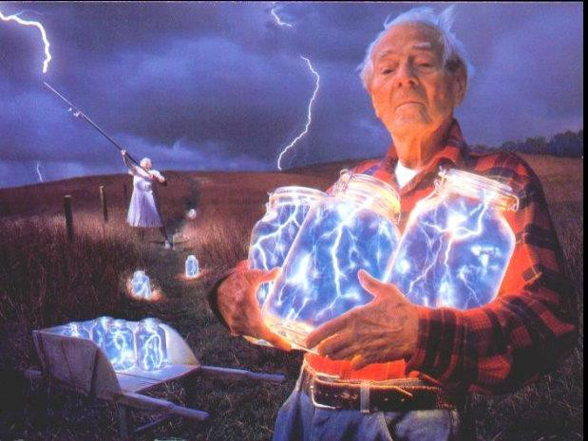



THE CUP OF THE HOLY GRAIL

Yes, it is good, eminent, excellent, perfect, supreme, and unexcelled. And therefore, prince of gods, do not worship me with material objects but worship me with the Dharma of the Soul Chakra, the first Chakra above the head-worship! Do not honor me with material objects but honor me by honor to the Dharma of the Soul Chakra, the first Chakra above the head!"

SAMADHI COMES FROM ACCESSING THE INFINITE POWER OF THE CHAKRAS ABOVE THE HEAD
ON THE ENERGY ENHANCEMENT MEDITATION COURSE
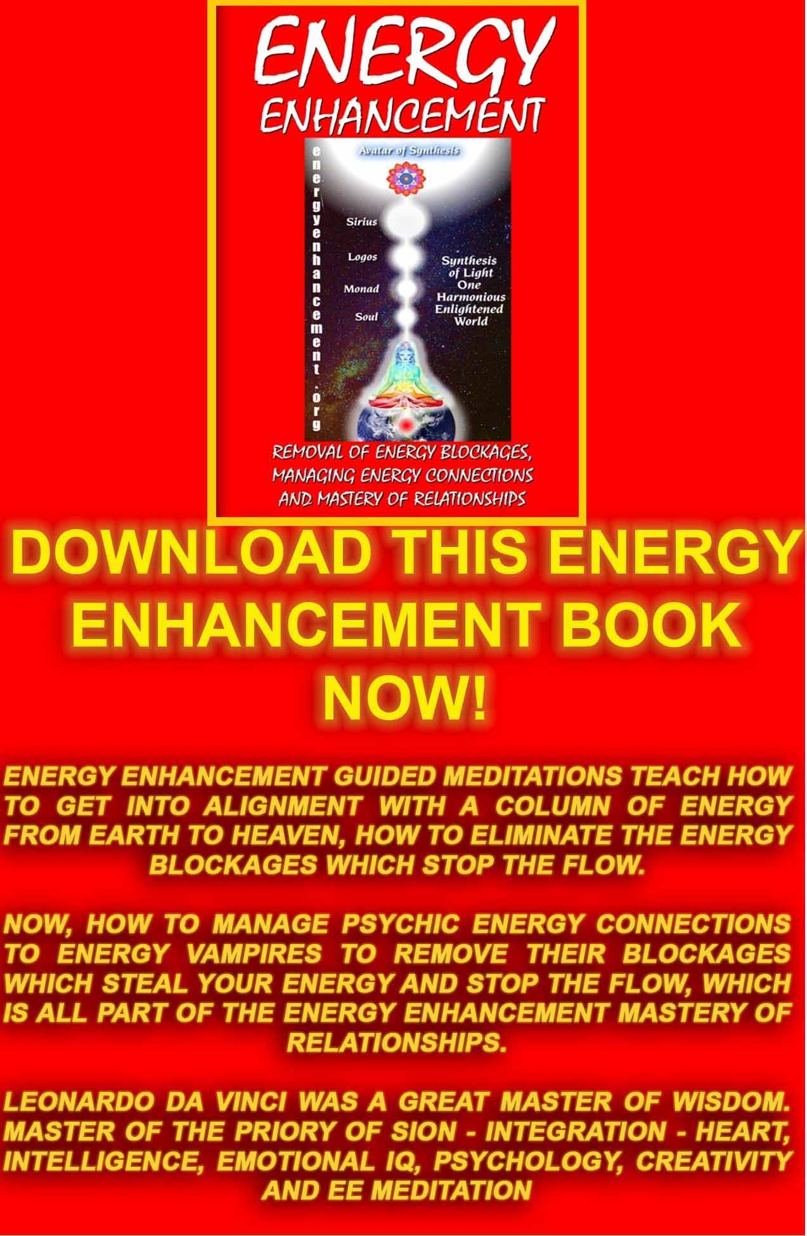
Download “REMOVAL OF ENERGY BLOCKAGES, MANAGING ENERGY CONNECTIONS AND MASTERY OF RELATIONSHIPS” HERE
http://www.energyenhancement.org/Sacred-Energy/Meditation-Energy-Enhancement-Eliminate-Energy-Blockages-Manage-Energy-Connections-and-Attachment-Mastery-of-Relationships-EEBOOK2Color-energyenhancement-org.pdf

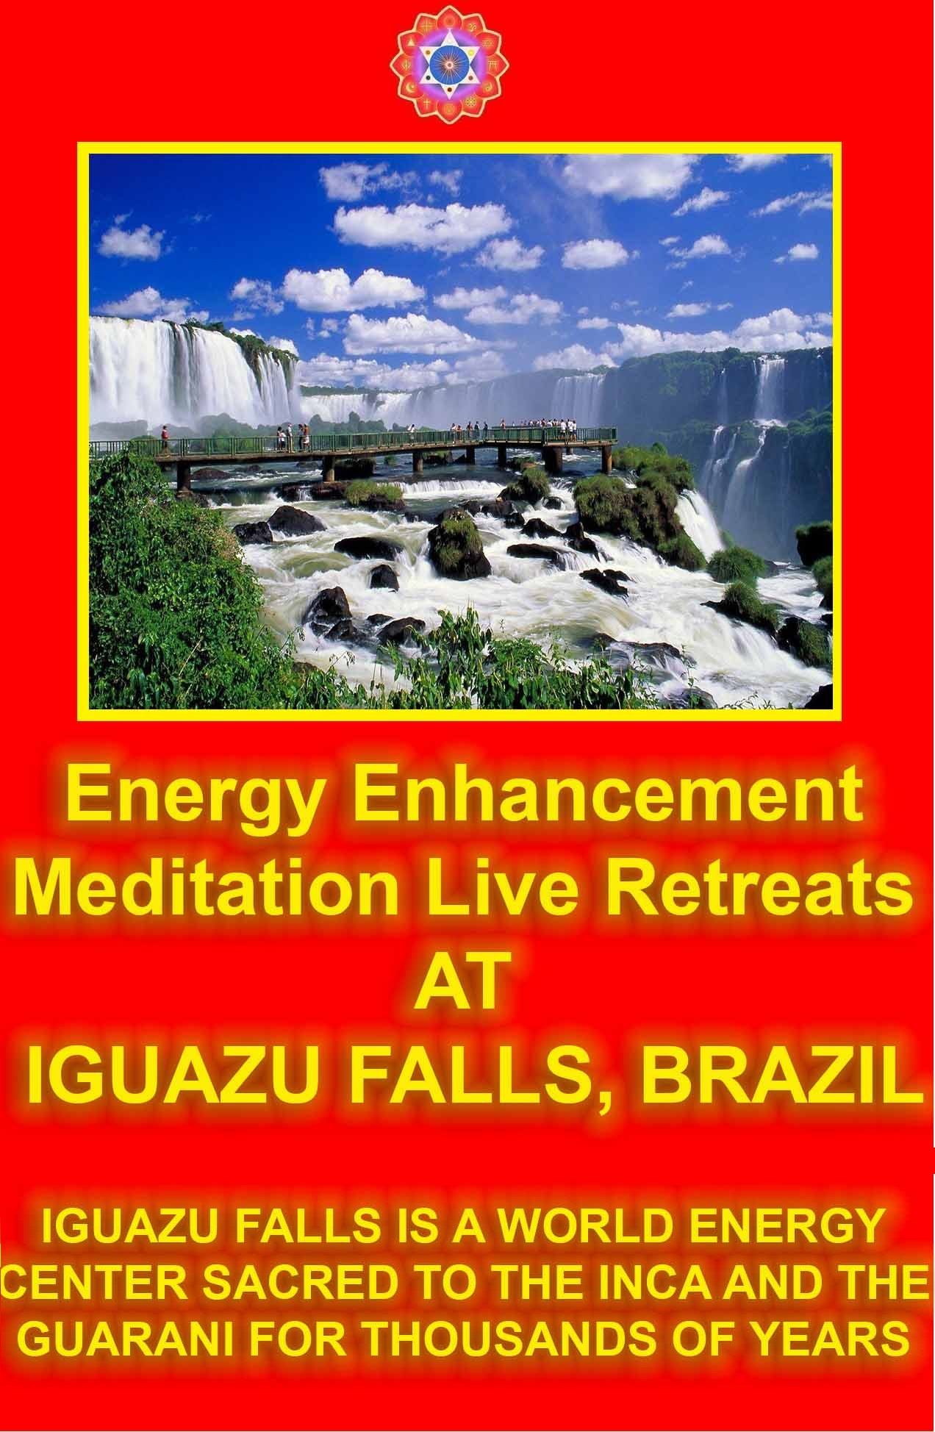Vimalakirti Sutra Chapter 14 - Entrustment of the Dharma Teaching of Fusion with the Soul Chakra, the first Chakra above the Head - Intuition, Genius, Conscience - Illumination, Enlightenment

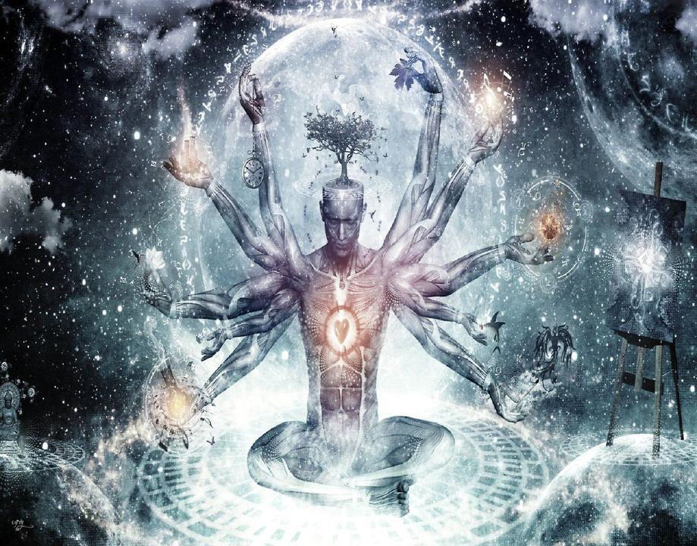



THE ANTAHKARANA COLUMN OF LIGHT CONNECTING YOU TO THE INFINITY OF CHAKRAS ABOVE THE HEAD - THE FIRST ONE BEING THE SOUL.

THE HIGHER INITIATIONS OF ENLIGHTENMENT INCLUDE BECOMING A MONAD INFUSED BEING, A LOGOS INFUSED BEING, A SIRIUS INFUSED BEING, AN AVATAR OF SYNTHESIS INFUSED BEING!!

Then the Lord Sakyamuni said to the bodhisattva Maitreya, the great spiritual hero, "I transmit to you, Maitreya, this unexcelled, perfect enlightenment which I attained only after innumerable millions of billions of aeons, in order that, at a later time, during a later life, a similar teaching of the Dharma of the Soul Chakra, the first Chakra above the head, protected by your supernatural power, will spread in the world and will not disappear. Why?

Maitreya, in the future there will be noble sons and daughters, devas, nagas, yaksas, gandharvas, and asuras, who, having planted the roots of virtue, will produce the spirit of unexcelled, perfect enlightenment. If they do not hear this teaching of the Dharma of the Soul Chakra, the first Chakra above the head, they will certainly lose boundless advantages and even perish.

Why do we fall Bruce? To learn how to pick ourselves up. – Batman

EE is the ultimate pick me up.



"Maitreya, there are two gestures of the bodhisattvas. What are they? The first gesture is to believe in all sorts of phrases and words, and the second gesture is to penetrate exactly the profound principle of the Dharma of the Soul Chakra, the first Chakra above the head without being afraid.

Such are the two gestures of the bodhisattvas. Maitreya, it must be known that the bodhisattvas who believe in all sorts of words and phrases, and apply themselves accordingly, are beginners and not experienced in religious practice.

But the bodhisattvas who read, hear, believe, and teach this profound teaching - the profound principle of the Dharma of the Soul Chakra, the first Chakra above the head - with its impeccable expressions reconciling dichotomies and its analyses of stages of development these are veterans in the religious practice.

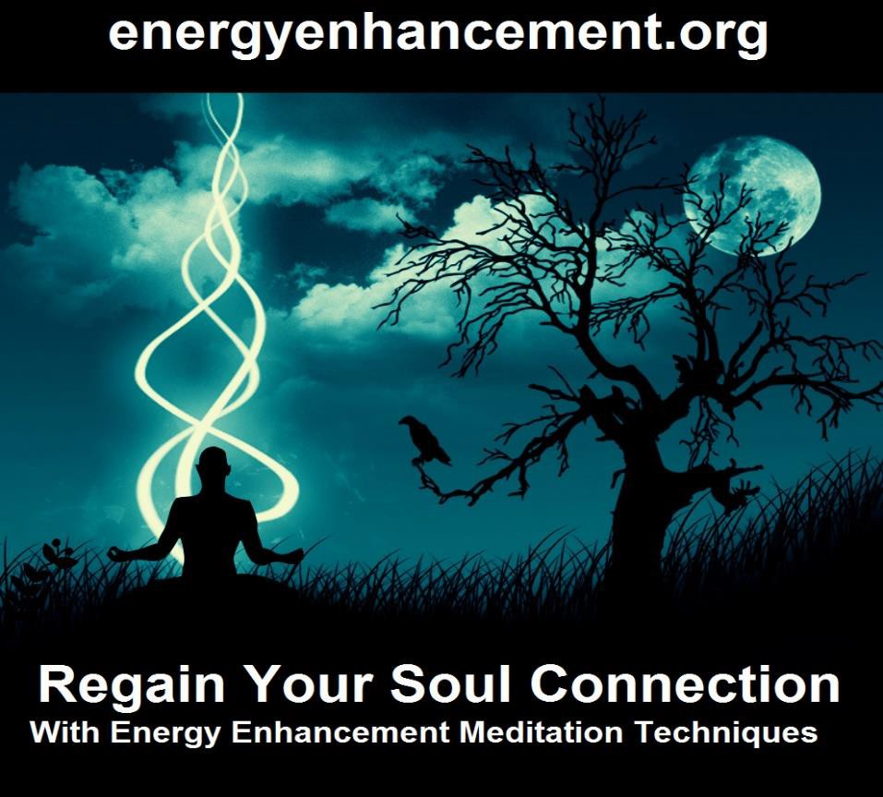

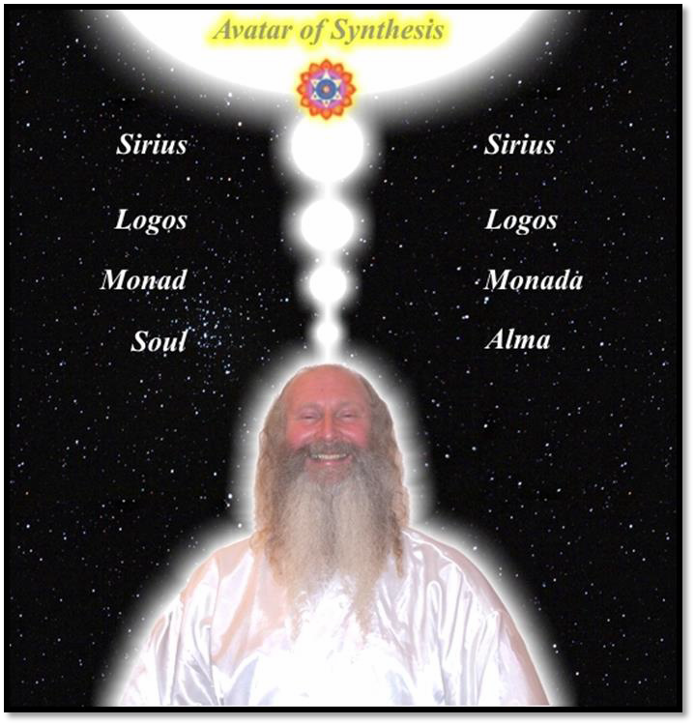
DHARMA - THE ENERGY AND WILL OF THE SOUL, IS THE FIRST CHAKRA ABOVE THE HEAD

MOST ENLIGHTENED MASTERS ONLY FUSE WITH THE FIRST CHAKRA ABOVE THE HEAD

SATCHIDANAND CONNECTS AND FUSES MUCH HIGHER THUS HE IS GURU OF THE GURUS - SATGURU!!

"Maitreya, there are two reasons the beginner bodhisattvas hurt themselves and do not concentrate on the profound Dharma of the Soul Chakra, the first Chakra above the head. What are they?

Hearing this profound teaching never before heard, they are terrified and doubtful, do not rejoice, and reject it, thinking, 'Whence comes this teaching never before heard?'

They then behold other noble sons accepting, becoming vessels for, and teaching this profound teaching, and they do not attend upon them, do not befriend them, do not respect them, and do not honor them, and eventually they go so far as to criticize them.

These are the two reasons the beginner bodhisattvas hurt themselves and do not penetrate the profound Dharma of the Soul Chakra, the first Chakra above the head.

"There are two reasons the bodhisattvas who do aspire to the profound Dharma of the Soul Chakra, the first Chakra above the head hurt themselves and do not attain the tolerance of the ultimate birthlessness of things. What are these two?

These bodhisattvas despise and reproach the beginner bodhisattvas, who have not been practicing for a long time, and they do not initiate them or instruct them in the profound teaching.

Having no great respect for this profound teaching, they are not careful about its rules. They help living beings by means of material gifts and do not help them by means of the gift of the Dharma of the Soul Chakra, the first Chakra above the head.

Such, Maitreya, are the two reasons the bodhisattvas who aspire to the profound Dharma of the Soul Chakra, the first Chakra above the head hurt themselves and will not quickly attain the tolerance of the ultimate birthlessness of all things."

Thus having been taught, the bodhisattva Maitreya said to the Buddha, "Lord, the beautiful teachings of the Tathagata are wonderful and truly excellent. Lord, from this time forth, I will

avoid all such errors and will defend and uphold this attainment of unexcelled, perfect enlightenment by the Tathagata during innumerable hundreds of thousands of millions of billions of aeons!

In the future, I will place in the hands of noble sons and noble daughters who are worthy vessels of the holy Dharma of the Soul Chakra, the first Chakra above the head this profound teaching. I will instill in them the power of memory with which they may, having believed in this teaching, retain it, recite, it, penetrate its depths, teach it, propagate it, write it down, and proclaim it extensively to others.

"Thus I will instruct them, Lord, and thus it may be known that in that future time those who believe in this teaching - The Soul Chakra, the first Chakra above the head - and who enter deeply into it will be sustained by the supernatural blessing of the bodhisattva Maitreya."



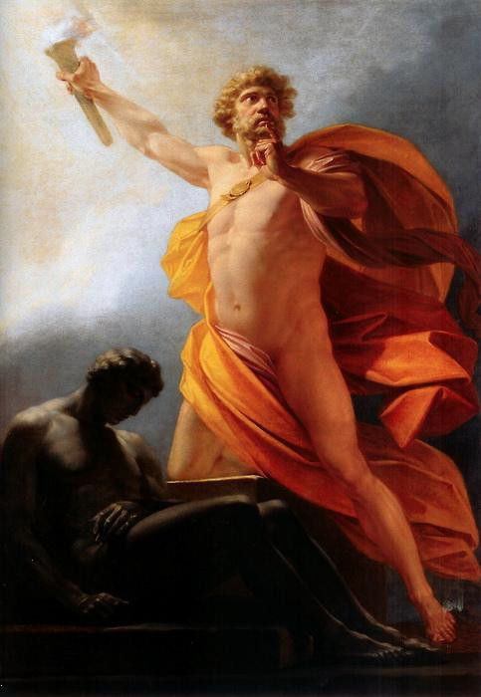
LIKE THE BUDDHA, PROMETHEUS BRINGS THE FIRE OF THE LIGHT OF THE SOUL TO SOULLESS GOLEMS, - ZOMBIES OF HUMANITY

Thereupon the Buddha gave his approval to the bodhisattva Maitreya: "Excellent! Excellent! Your word is well given! The Tathagata rejoices and commends your good promise."

Then all the bodhisattvas said together in one voice, "Lord, we also, after the ultimate liberation of the Tathagata, will come from our various buddha-fields to spread far and wide this enlightenment of the perfect Buddha, the Tathagata - The Soul Chakra, the first Chakra above the head. May all noble sons and daughters believe in that!"

Then the four Maharajas, the great kings of the quarters, said to the Buddha, "Lord, in all the towns, villages, cities, kingdoms, and palaces, wherever this discourse of the Dharma of the Soul Chakra, the first Chakra above the head will be practised, upheld, and correctly taught, we, the four great kings, will go there with our armies, our young warriors, and our retinues, to hear the Dharma of the Soul Chakra, the first Chakra above the head.

And we will protect the teachers of this Dharma of the Soul Chakra, the first Chakra above the head for a radius of one league so that no one who plots injury or disruption against these teachers will have any opportunity to do them harm."

Then the Buddha said to the venerable Ananda, "Receive then, Ananda, this expression of the teaching of the Dharma of the Soul Chakra, the first Chakra above the head. Remember it, and teach it widely and correctly to others!"

Ananda replied, "I have memorized, Lord, this expression of the teaching of the Dharma of the Soul Chakra, the first Chakra above the head. But what is the name of this teaching, and how should I remember it?"

The Buddha said, "Ananda, this exposition of the Dharma of the Soul Chakra, the first Chakra above the head is called 'The Teaching of Vimalakirti,' or 'The Reconciliation of Dichotomies,' or even 'Section of the Inconceivable Liberation.' Remember it thus!"

Thus spoke the Buddha. And the Licchavi Vimalakirti, the crown prince Manjusri, the venerable Ananda, the bodhisattvas, the great disciples, the entire multitude, and the whole universe with its gods, men, asuras and gandharvas, rejoiced exceedingly. All heartily praised these declarations on the Soul Chakra, the first Chakra above the head by the Lord.


SAMADHI COMES FROM ACCESSING THE INFINITE POWER OF THE CHAKRAS ABOVE THE HEAD
ON THE ENERGY ENHANCEMENT MEDITATION COURSE

EE LEVEL 1 POWER UP!! GAIN SUPER ENERGY http://www.energyenhancement.org/Level1.htm
EE LEVEL 2 ELIMINATE ENERGY BLOCKAGES http://www.energyenhancement.org/Level2.htm
EE LEVEL 3 CLEAN KARMA BLOCKAGES AND PAST LIFE KARMA BY TRANSMUTATION http://www.energyenhancement.org/Level3.htm
EE LEVEL 4 MASTER ENERGY CONNECTIONS AND RELATIONSHIPS http://www.energyenhancement.org/Level4.htm
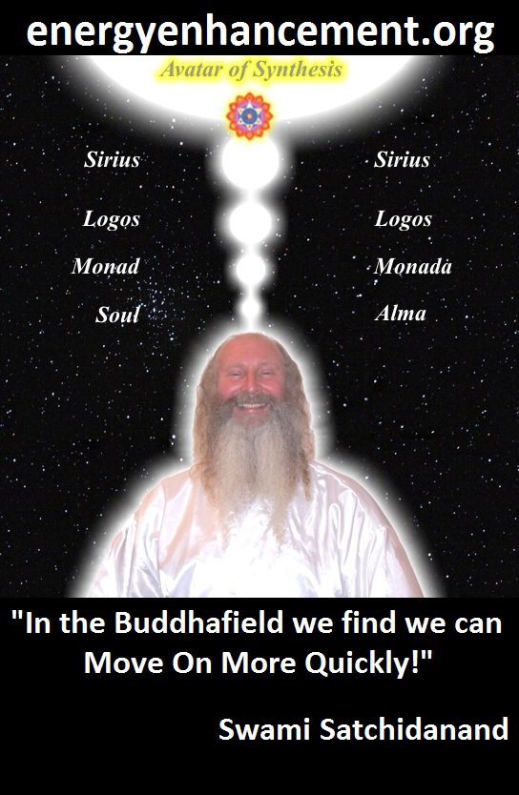
ENERGY ENHANCEMENT - THE ULTIMATE MEDITATION COURSE!!
“Traditional meditations are designed to Fail” – Satchidanand
FUSION WITH THE SOUL CHAKRA - Enlightenment - is Only the first Dan. Become fused with the Monad - Second Dan. Become fused with the Logos - Third Dan. Become Fused with Sirius - Fourth Dan. Become Fused with the Avatar of Synthesis - Fifth Dan - Satchidanand
Research The Energy Enhancement Meditation Course by video or on retreat..

The Ancient Enemy who counts meditation and the mind control psychic arts as one of its main planks of ing, International Companies, Eugenics - Worldwide, censoring Alchemical VITRIOL, the Kundalini Key and Energy Blockage Removal from every Meditation Program..
WE HAVE SO MANY ARTICLES SHOWING THE ORIGINAL EXISTENCE OF THESE ESSENTIAL MEDITATION TECHNIQUES IN EVERY WORLD RELIGION..
NOW, SPEED UP YOUR PROCESS WITH ENERGY ENHANCEMENT ALCHEMICAL VITRIOL, KUNDALINI KEY AND ENERGY BLOCKAGE REMOVAL ON THE PATH OF ENLIGHTENMENT
GET IT NOW!!
EMAIL sol@energyenhancement.org
TENGS REPORT..

Dear Swami Satchidanand,

I have just done the 2nd initiation with the golden light circulation. I was wondering if you could interpret some of the experiences I felt and clarify a bit of the exercise.

In the first exercise, I breathed in the golden light quite brightly. When it came out from the heart, it was still bright. When it went to the solar plexus, it started to become a little hazy. Then the light disappeared at the bottom of the torso. And then it slightly returned when I got to the back of my heart upwards. It seems like the light becomes lesser when I reach the bottom half of my body... and also the crown.

In the second exercise, I did everything again... and then reached the same part at the solar plexus and sacral again. It started to become hazy. Then suddenly I was reminded of a golden eastern dragon (the long ones) and I imagined the light to be like a dragon that charged through the "dark clouds". Then I imagined that when the skin of the dragon faded a little, the dragon exploded, as if it was shedding its dark skin, to reveal a brighter golden underneath. I did it simultaneously with the outbreath, quite forcibly. I do not know if this is the right way to do it?

May I clarify if I am doing the exercise correctly? So firstly, I imagine bright light coming from the top, pouring around my body, going into the VITRIOL. Then I breathe in the golden light from the aura around me, then saturate the entire body with light. When saturated, I let the heart center pour out the golden light. So the golden light goes out, and moves step-by-step, in staggers, from heart chakra to solar plexus to sacral to root, to coccyx, to lumbar, to back of heart, to neck, to back of head, to crown, to ajna, to tip of tongue, to throat... This is where I am confused - Is the light circulating outside, on the surface of the body? Or does it re-enter the body from the tongue and need to come out from the heart chakra again? - Teng Jun Yuan - December 1st 2015

Well, you are having the experience of energy blockages.

Easy ones go first with these techniques of the Taoist Orbits or the Kundalini Kriyas.

More difficult blockages need Level 2.

It is supposed to go outside the body, but further, more powerful techniques go inside.

Whatever you do see the gold and remove the darkness - this is only what you need to do!!.

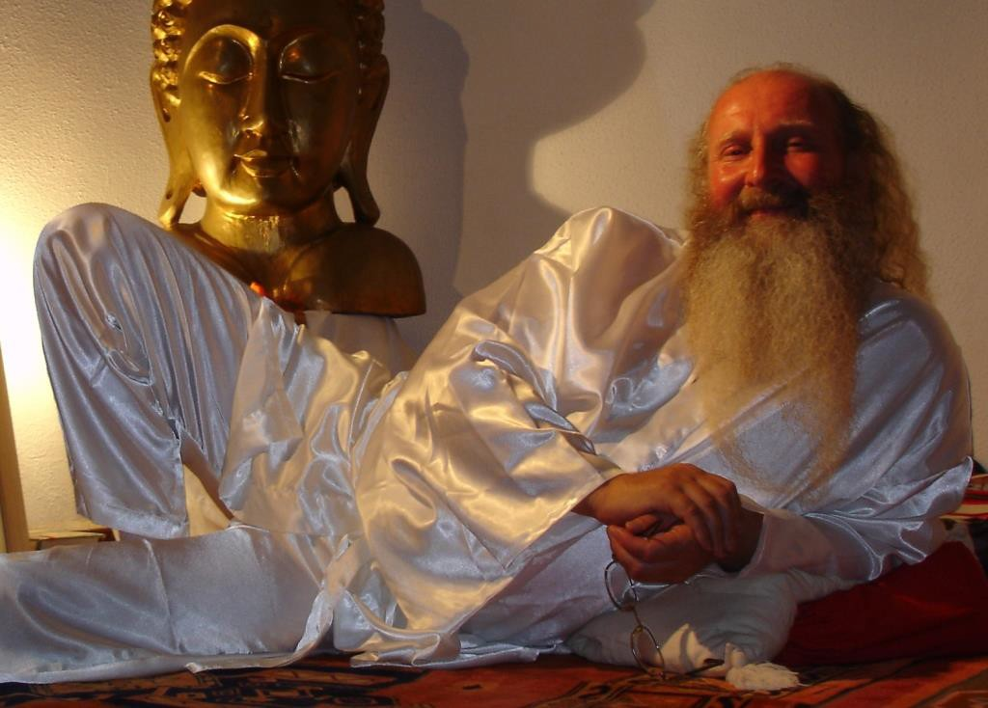Repetition of these techniques will remove more. Further techniques are more powerful so, move on!! Satchidanand

Swami Satchidanand is the Indiana Jones of enlightenment.

I met a golden-hued Buddha and sent him the energy from my Ajna and Heart centers. It was strange, because he simply stood there in his smile and gestured up. The energy that I sent him bent and went all the way up, as if he was guiding it all the way up. The instructions told me to follow the energy, so I just followed... into this expanse of light. Then the exercise ended... I did not know where I was inside the bright light. What does this mean, was my energy being sent to heal by the Buddha? haha

Go one step higher!!

The buddha was showing you the way to higher samadhi experiences.

There was this one point where my golden stream touched the "brighter than 10,000 suns" and then a brilliant white mass followed my golden stream and descended downwards, obliterating my sense of body. I was a little lost in that moment, because the whiteness was everywhere. Then I tried to think of a golden stream again... then somehow the blockages appeared again, then I worked through it again. It seemed like the white light was able to burn off some blockages quite easily, so I was wondering if this is correct or just some illusion from a blockage?

Higher levels of samadhi.

Higher energies remove blockages faster.

When all of these blockages are happening, I try my best to remain as the "I which sees" instead of the identification as being the blockage or the one being hurt. Then the blockages are burnt. When they are stubborn, I imagine my golden dragon opening his mouth and grabbing them within its huge mouth as if it was a Pelican bird, then depositing it into the fire of the Monad/Logos/center of the earth. Sometimes I imagined that my dragon caught the blue fire of the Monad... and it would blaze along its length and help to burn any impurities along the way. That way I didn't need to deliberately push it towards the Monad or Logos.

So, you know.

This is the real knowing.

Difficult blockages need Energy Enhancement Level 2!! Satchidanand


We must strive in Energy Enhancement Meditation to use the Energy Enhancement Seven Step Process of Level Two of the Energy Enhancement Meditation Course to remove the energy blockages preventing connection with the Soul Chakra, the first Chakra above the head.

We must strive in Energy Enhancement Meditation to use the Energy Enhancement Seven Step Process of Level Two of the Energy Enhancement Meditation Course to remove the Energy Blockages preventing connection with intuition, genius, and conscience.

We must strive in Energy Enhancement Meditation to use the Energy Enhancement Seven Step Process of Level Two of the Energy Enhancement Meditation Course to remove the Energy Blockages preventing the still small voice.

We must strive in Energy Enhancement Meditation to use the Energy Enhancement Seven Step Process of Level Two of the Energy Enhancement Meditation Course to remove the Energy blockages preventing Fusion with The Soul Chakra, the first Chakra above the head.

We must strive in Energy Enhancement Meditation to use the Energy Enhancement Seven Step Process of Level Two of the Energy Enhancement Meditation Course to remove the Energy blockages preventing us becoming a Soul Infused being.

We must strive in Energy Enhancement Meditation to use the Energy Enhancement Seven Step Process of Level Two of the Energy Enhancement Meditation Course to remove the Energy blockages preventing The Illumination of the Light of the Soul.

We must strive in Energy Enhancement Meditation to use the Energy Enhancement Seven Step Process of Level Two of the Energy Enhancement Meditation Course to remove the Energy blockages preventing EnLightenment!!


The Soul Chakra, the first Chakra above the head is a processor, in computer terms, which acts at a higher frequency than the mind or intellect. The Soul Chakra, the first Chakra above the head is the souce of intuition which KNOWS what to do. He who thinks does not know. In Ancient Greece the energy of the Soul Chakra, the first Chakra above the head was known as the Geni (The Geni in the bottle) the foundation of Genius.

The Soul Chakra, the first Chakra above the head contains all the memories of all your past lives. Which contains all the experience of all your past lives, which hard wires in the fact that we only have the free will to do the right thing. The experiences of all our past lives supports this teaching.

Anything less results in Karma, a retribution we cannot escape unless we learn Energy Enhancement, "Dissolution of Ancient Karma"

More than this. With knowledge, learning and experience we learn that there are many choices of the right thing to do and that some actions are more right than others. The knowledge of the right thing to do is called conscience and is described as, "A still small voice"

It is evolution which teaches this and raises us up to become rightest, the most right - closer to God, Imago Dei.

If they hear such a teaching, they will rejoice, will believe, and will accept it upon the crowns of their heads.

Hence, in order to protect those future noble sons and daughters, you must spread a teaching such as this!



Chapter 15- THE BUDDHIST ENERGY ENHANCEMENT KUNDALINI KEY IS THE THE BUDDHIST STUPA

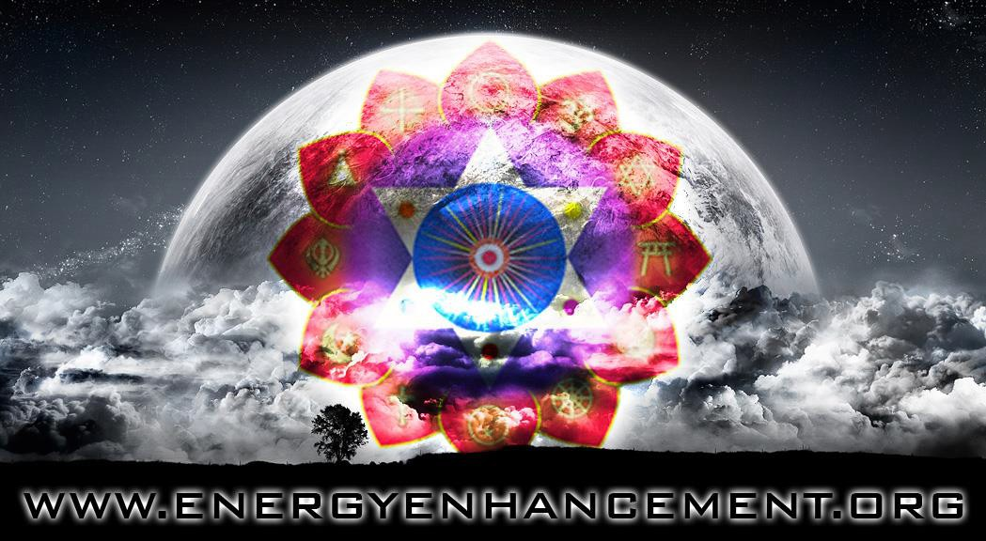

THE BUDDHIST STUPA IS THE KUNDALINI KEY!!

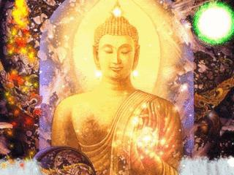

BUDDHIST STREAM ENTRY

Sole dominion over the earth, going to heaven,
lordship over all worlds: the fruit of stream-entry excels them.
— Dhp 178
BUDDHISM AND THE ENERGY ENHANCEMENT KUNDALINI KEY BECOME A STREAM ENTERER -
ONLY AVAILABLE WITH ENERGY ENHANCEMENT
AS THE INFORMATION ON STREAM ENTRY
HAS BEEN REMOVED FROM BUDDHISM!!

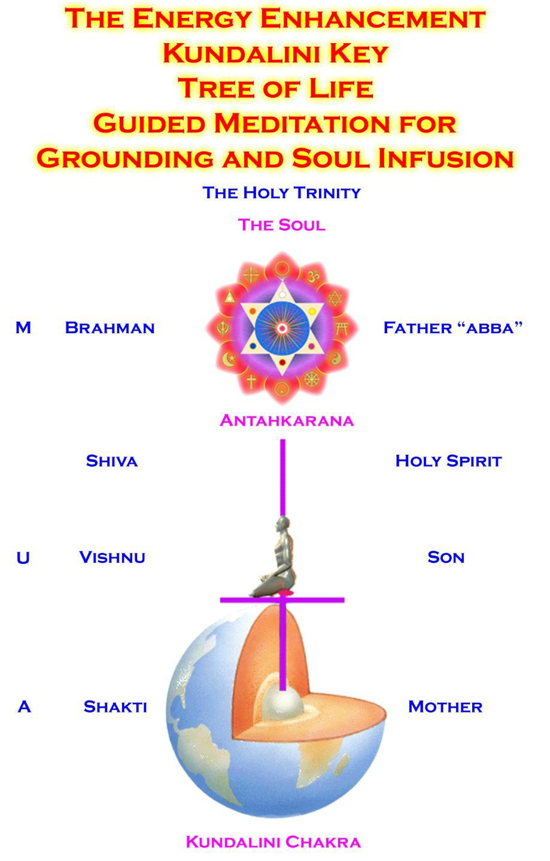

THE TEACHING IS THAT KUNDALINI ENERGY SPRINGS ETERNAL

FROM THE CENTER OF THE EARTH THUS THE LEGOMINISM, ALCHEMICAL VITRIOL

THE STUPA REPRESENTS A HEMISPHERE OF THE EARTH THE SPIRE REPRESENTS THE ANTAHKARANA
CLICK HERE FOR - THE ENOCHIAN WATCHTOWER IS A PERVERTED KUNDALINI KEY

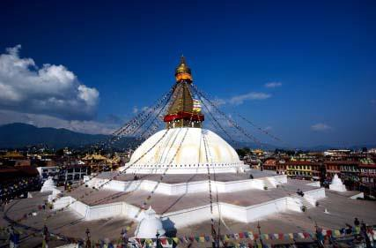

THE ENERGY ENHANCEMENT KUNDALINI KEY IS A LEGOMINISM -

AN ANCIENT TEACHING HIDDEN IN SYMBOL OR WORD - WHICH TEACHES THE MOST EFFICIENT WAY TO MEDITATE

The Katmandu Bodhinath Stupa where the hemisphere of the white base represents the Earth and the tower above represents the Antahkarana Kundalini Key.. - A Tower representing the Infinity of Chakras above the head where getting your Body and Mind into alignment in Meditation, with the energies from the center of the Universe through an infinity of Chakras above the head ("lordship over all worlds") through the body to the center of the Earth Chakra, Kundalini Chakra and below that ("Sole dominion over the earth, going to heaven"), using Energy Enhancement Advanced Meditation Techniques will Enlighten you.

A Stream Enterer is a person who aligns his body and mind with this stream of Energy from the Infinity of Chakras above the head where getting your Body and Mind into alignment in Meditation, with the energies from the center of the Universe through an infinity of Chakras above the head through the body to the center of the Earth Chakra, Kundalini Chakra and below that in Meditation.

Dharma or Dhamma is the Conscience acquired by one who enters into the Stream of Energy from Heaven to Earth and also into the higher Chakras above the head, the Jhanas, and gradually wears away his Energy Blockages. Dharma is a non intellectual quality gained by communion with the chakras above the head - with energies higher than the intellect of the intuitional Opening of the Heart or Metta; and Will. The gaining of Spiritual Energy of Level 1 of Energy Enhancement brightens up all the faculties, usually supplying sufficient Energy to awaken the Dharma Eye of Psychic Vision.

Nirvana, or Illumination follows as the good effects of that Alignment in Energy Enhancement Meditation and its consequent removal of All Energy Blockage Impurities

Nibbana names the transcendent and singularly ineffable freedom that stands as the final goal of all the Buddha's teachings.

You can talk about the effects below of the Quantum Leap of Enlightenment for ten thousand years but without meditating. Without accessing the energies of the Jhanas, the Samadhis of the

Chakras above the head. Without purifying all the energy blockage Dark Angels within and outside your body. These talks can only show you how you are not and how all people are not, and how all the world is not enlightened. "After All That" you are ready to start The Energy Enhancement Process.

Only this feedback can feed the will to attempt the process and not drop back.

"After All That, Here are complete instructions on Enlightenment" - First Sutra of the Yoga Sutras of Patanjali of Raja Yoga

If nothing is happening in your Meditation, Whats Up!! Some people sit for 20 Years without any discernable Change. Energy Enhancement Advanced meditation Techniques Speed Up the meditative Process.

What follows is the good effects of that Alignment in Energy Enhancement Meditation and its consequent removal of Energy Blockage Impurities..

In Buddhism, as in every major religion after the founder dies, there seems to be a loss of information such that the initial impulse of the religion is lost and only the partial and inessential remains.

For example,

- It is obvious from the Kundalini Key shape of the Stupa, - in that the hemisphere is the earth and the tower the Antahkarana with all the heavens, Jhanas, or Chakras above the head - was one of the keys to the success of the original buddhist meditations.

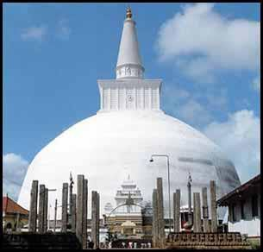
Thuparama Stupa Sri Lanka - Hemisphere Earth with Kundalini Earth Chakra and tower Antahkarana

- It is obvious that a stream of Energy Exists from Heaven to Earth and that only when a person consciously aligns himself with that energy that he becomes a stream enterer and when he gets the access to the chakras above the head in Samadhi or Jhanas, such that he gets access to so much spiritual energy that his Dharma Eye - Psychic vision opens that he becomes a stream winner.

What we have left below is what happens when a person has access to all the above information to help his practise. He becomes Good and Does Good. He activates Yama and Niyama from the Yoga Sutras of Patanjali. But these saintly powers of goodness only can come from one who is in tune with the energies of the Universe. For

that we need the Kundalini Key symbolised by the shape of the Stupa or the Dome of the Taj Mahal (sufi) or the Dome of the Capitol in Washington (Masonic). For that we need Meditation and Samyama. For that we need Energy Blockage removal!!

It is good that the student knows that he has to become good and that he has to make himself good, but without Spiritual Energy and without energy blockage removal techniques, no wonder people meditate for 20 years and never get anywhere.

It is impossible to get all the good results below just by telling yourself to be good. The blockages will just laugh at you and however much you try to resist them, the temptations will always be too much and you will backslide, and you will fail.

You need Energy Enhancement.

Energy Enhancement gives the original techniques which form the basis of every religion on this planet and which therefore Speed Up!! the Process of meditation many times. The techniques work like they were meant to work before they were removed by those who followed the founder of every religion and the spiritual technology was lost; Everywhere!!

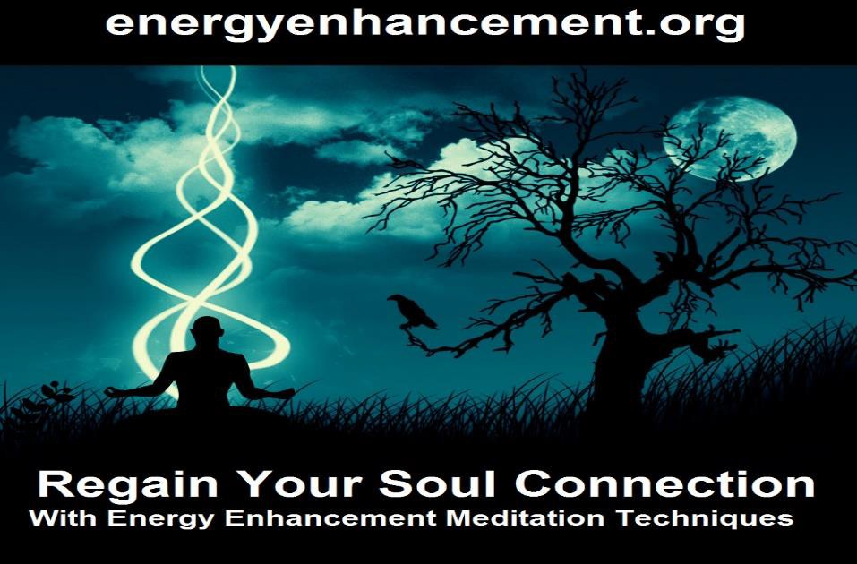

SACRED DANCES OF FUSION WHERE DEVI DHYANI EXERTS HER POWER - AVAILABLE ON YOUTUBETHE BLACK CROWS HAVE REMOVED THE KUNDALINI KEY FROM BUDDHISM

ENERGY ENHANCEMENT TEACHES YOU THE KUNDALINI KEY - THE ONLY WAY YOU CAN TRULY BECOME A STREAM ENTERER

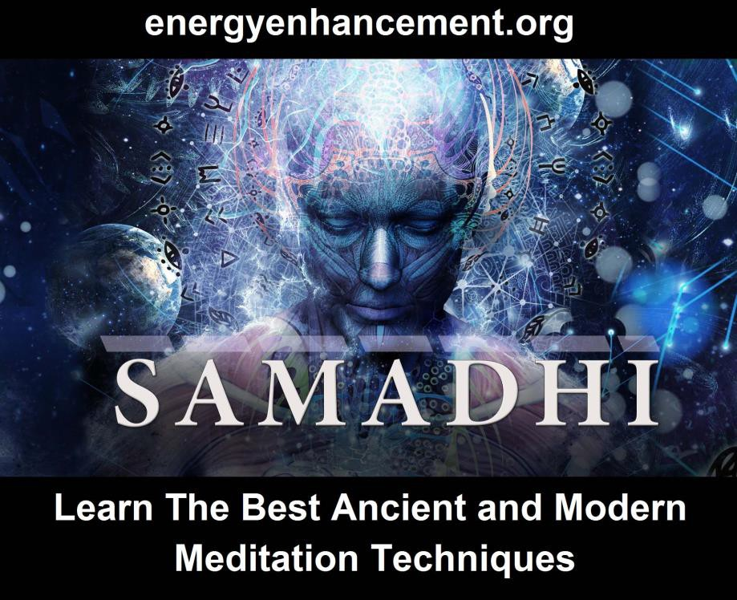

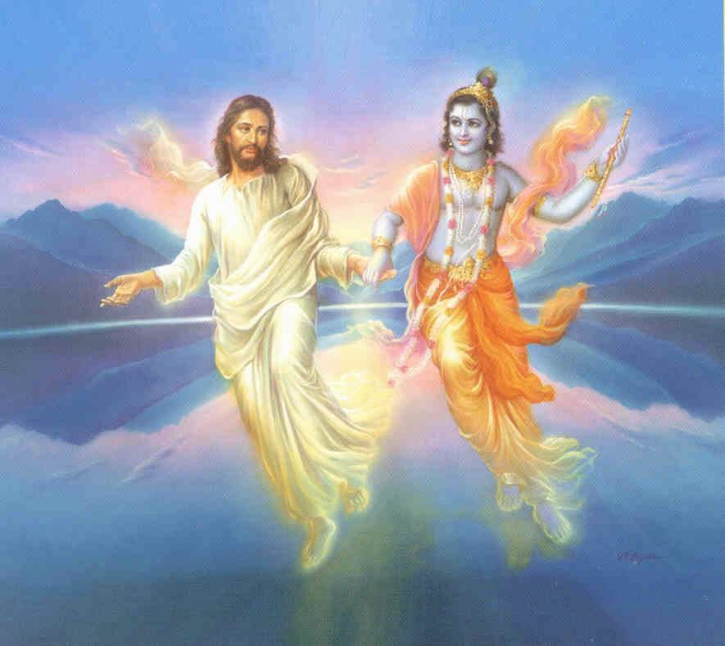
Krishna - Christ

"When virtues decline and the evils flourish,
I give myself birth to protect the good and destroy the sinners.
In every age I appear for establishing righteousness."
Krishna - Bhagavad Gita

Satchidanand Biography
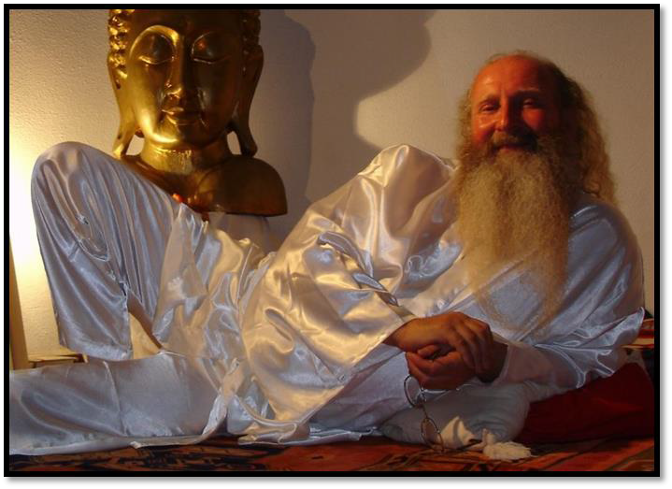
SATCHIDANAND, STUDENT OF SWAMI SATCHIDANANDA, IS ONE OF THE GREATEST KUNDALINI YOGIS IN THE WEST.

LINEAGE IS ONE OF THE GREATEST ASSETS OF SPIRITUAL TEACHERS. ANYONE CAN CREATE A COURSE WHICH DOES NOT WORK.

ENERGY ENHANCEMENT IS BASED ON
A 5000 YEAR OLD SPIRITUAL TECHNOLOGY STARTING WITH TAMIL SIDDAR BHOGAR, THROUGH BABAJI IN THE HIMALAYAS AND PATANJALI IN SOUTH INDIA.

ENERGY ENHANCEMENT WORKS!!

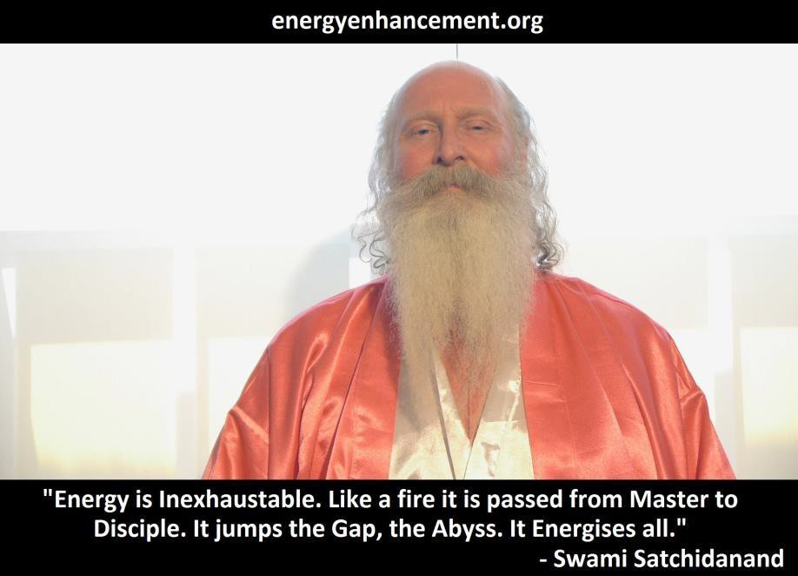
About Swami Satchidanand

To many people across the globe, the name Swami Satchidanand is synonymous with Meditation. He is a legendary figure in the world of Personal Development. His insights, inspiration, ideas, systems, and strategies are the techniques on which countless lives have spun — the sparks that have ignited career transformations, personal epiphanies, inner awakenings, and the creation of Happiness and Enlightenment the world over.

Swami Satchidanand is the heir to the legacy of Gurdjieff, Sri Yogendra, Theos Bernard and Patanjali

Upon discovering Yoga at the age of 14, Swami Satchidanand’s life changed in an instant, leading him on his own quest for the fulfillment of Enlightenment - "Seek ye first the Kingdom of God
- then all else will be added unto ye!!" That quest led him to Zen Master Hogen and Swami Satchidananda who soon became Swami Satchidanand’s colleagues and mentors. With visits to Osho, Sri Yogendra, Sri Sathya Sai Baba and renegade Benedictine Monk Father Bede Griffiths, today, Swami Satchidanand continues to build upon and spread the remarkable teachings of these giants.

As a speaker, author, consultant, coach, and mentor, Swami Satchidanand works with individuals around the world, instilling within them not only the Ancient, Time Tested, Effective, Spiritual Techniques which every Enlightened Master for 10,000 years has used to become Enlightened but also the Secrets removed from popular ephemeral double plus good modern confections of - Courses which Do Not Work - to create not only the spiritual soul mental foundations of success and the motivation to achieve, but also the actionable strategies that will empower them to grow, improve, and thrive in today’s ever- changing world.

Through the Energy Enhancement Foundation, Swami Satchidanand, Swami Devi Dhyani and their team create the Video and Live Buddhafield to burn away limiting Energy Blockages and teach the Ancient techniques, principles, strategies and fundamentals that help people and organizations create the soul results they want in life.

Satchidanand has been learning and teaching Yoga and Enlightenment for 50 years.

His teachers were Yogiraj Swami Satchidananda and Zen Master Hogen Daido Yamahata encompassing Yoga, Meditation and Zen whose lineages go back to Patanjali and Tamil Siddar Bhogar the best and most Enlightened Masters of all time.

He has taught Directors of Fortune 500 Companies, McKinsey Graduates, and Movie Stars.

Now, he can teach you not only the most advanced secret Kundalini Key techniques found on no other Meditation Courses which make Enlightenment inevitable, but also those techniques to remove All Energy Blockages, which work fast, which work implacably, taught on no other course which can speed up the Enlightenment process - FAST!!

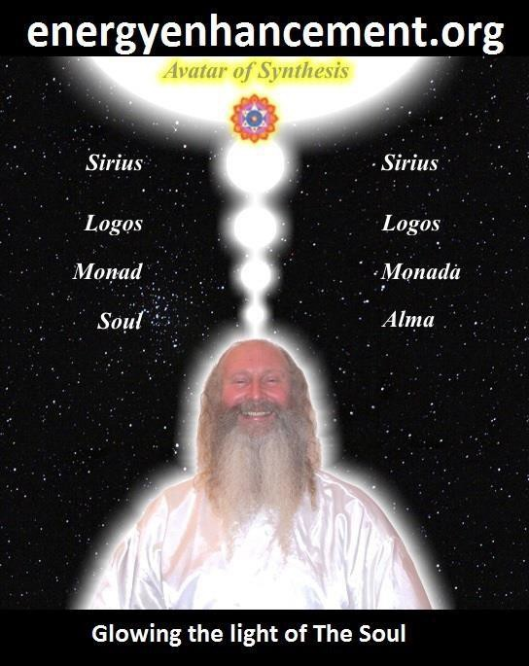Become Enlightened Now!! With Satchidanand.

Siva Samhitã, iii, 10-19: "Now I shall tell you how easily to attain success in Yoga, by knowing which the Yogis never fail in the practice of Yoga. Only the knowledge imparted by a Competent Teacher through his lips is powerful and useful; otherwise it becomes fruitless, weak and very painful.

SATCHIDANAND IS A SERIOUS STUDENT OF ENLIGHTENMENT HAVING BEEN TAUGHT BY ZEN MASTER HOGEN OF JAPAN AND SWAMI SATCHIDANANDA OF VIRGINIA - YOGIRAJ AND STUDENT OF SWAMI SIVANANDA OF RISHIKESH. STUDENT OF SRI YOGENDRA, THEOS BERNARD, OSHO, SATHYA SAI BABA, FATHER BEDE GRIFFITHS, - NOW UNFORTUNATELY ALMOST ALL GONE!! SATCHIDANAND REMAINS!!

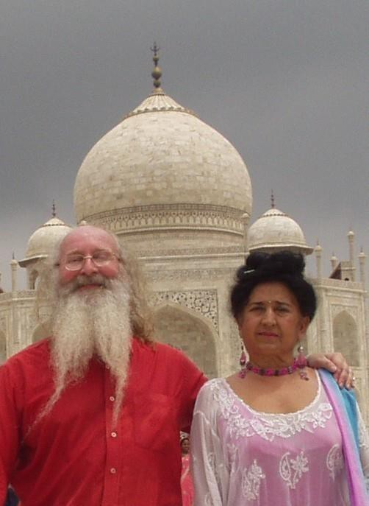
ENERGY ENHANCEMENT KUNDALINI KRIYAS.. IN INDIA 2010

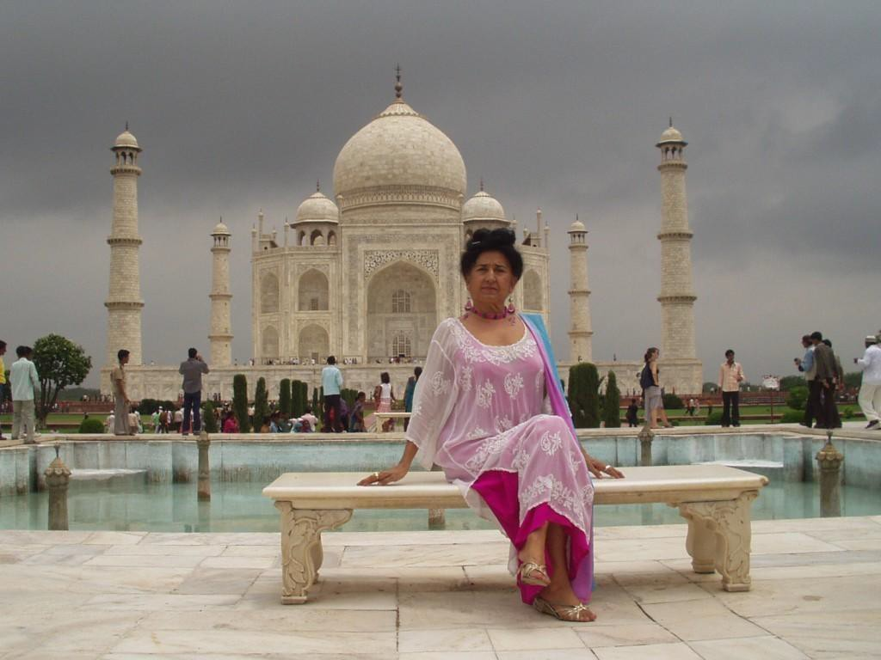
All the students experienced Psychic Vision as they Powered Up their Energy Bodies through connection with the chakras in the Center of the Earth and in the Center of the Universe. All of them saw their psychic bodies and the Energy Blockages which inhabited them. Every student had the experience of removing said Energy Blockages - removing and discharging their Negative Karmic Massand integrating the purified remains with the Soul Chakra, coatingthe Higher Being Bodies and creating the Body Kesdjian.
Older Students had the experience of working with the Life Sabotaging Slave Ego Blockages. All students reading this missive are the Outpatients. Those who come are the Inpatients for the Operation of the Egodectomy!!

As we charcterise our Life Sabotaging Sub- Persdonalities of the Ego - ever wonder why you are so poor in this lifetime? - It is that vast Mass of Energy

Blockages which comprise the Selfish Competitive Ego
- so we can ground even the deepest blockage, purify our Egoistic Self Destructors who rule our madness from Lifetime to Lifetime, create the Vajra Diamond Body (EE LEVEL 5) which alone can legitimately survive the Death process - become immortal, as an Ascended Master..

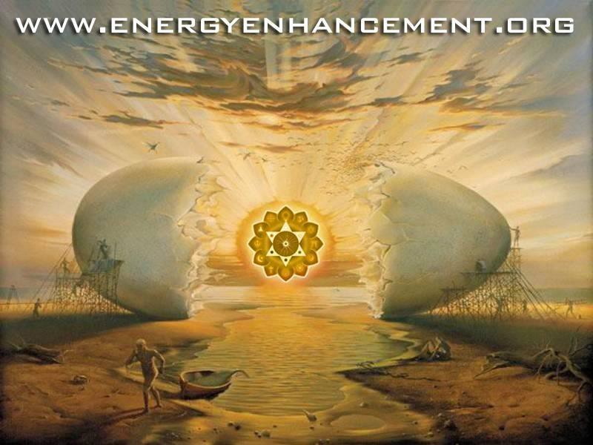
THE SOCIETY PROPPED UP EGO EGG SHELL - LIKE THE COCONUT - IS BROKEN. YET LITTLE MAN TURNS HIS BACK ON THE LIGHT OF THE SOUL WHICH SHINES FORTH FROM THE ENLIGHTENED!! – SATCHIDANAND
INTERPRETS SALVADOR DALI


LEARN THAT WHICH IS FALSE WITHIN YOU
LEARN TO RECOGNIZE THE FALSE AS FALSE
-WITHOUT THAT, THERE CAN BE NO LASTING TRANSFORMATION
ENERGY ENHANCEMENT
"I was not sure if this was wise, as I knew nothing other than what I had read on the web site and the testimonials, which I was a bit skeptical about! However, I am now adding my own because if you read this you might be a bit like me...
Don't hesitate - go for it!"
MS (Ireland) Human Resources Director, Europe/Asia, of a Fortune 500 US Multinational Company
Honey Kalaria

" Once on the course, my exciting adventurous journey began! In my life I have done hundreds of courses but the Energy Enhancement Course I found to be completely different. Firstly, the contents and the teachings seem to be inspired by higher forces and had a deep base in spirituality..." Honey Kalaria (UK) Bollywood Actress/Owner of Diva Entertainment
ENERGY ENHANCEMENT
"I was not sure if this was wise, as I knew nothing other than what I had read on the web site and the testimonials, which I was a bit skeptical about! However, I am now adding my own because if you read this you might be a bit like me...
Don't hesitate - go for it!"
MS (Ireland) Human Resources Director, Europe/Asia, of a Fortune 500 US Multinational Company

GAIN SUPER ENERGY

ENERGY ENHANCEMENT MEDITATION

ESTABLISHED
Established in the connection with God is Enlightenment. Each Incarnation is Unique and dependant on the Quality and Quantity of the connection. Of the size and function of the Spiritual Body and the components of the Spiritual Body of the Enlightened Person. Established in the soul, sanskrit- Stithyapragnyam.

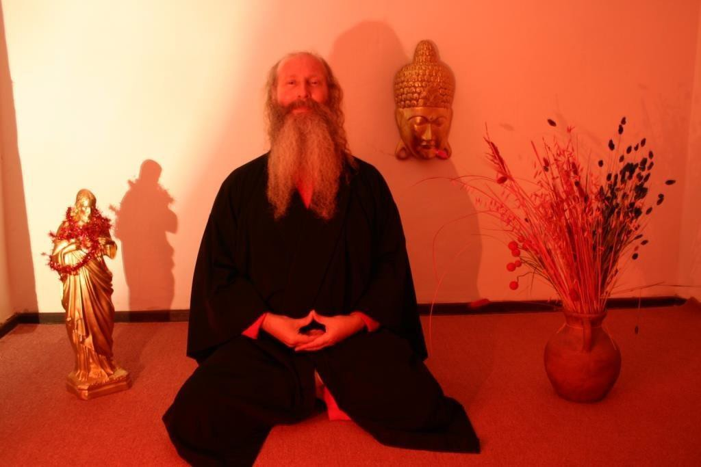
SATCHIDANAND

THE TEACHERS OF SATCHIDANAND
Energy Enhancement has been able to teach most people to remove their own energy blockages with the backup of Energy Enhancement teachers, Satchidanand and Devi Dhyani who were taught by Zen Master Hogen, who has a Zen Temple on the slopes of Mount Fuji in Japan, and also in Australia, and Swami Satchidananda, a student of Swami Sivananda of Rishikesh, and who attained his Mahasamadhi at the age of 89 in 2002.

SATSANG ON THE BEATITUDES by SWAMI SATCHIDANANDA - TAPAS, ONE OF THE YAMAS OF THE
YOGA SUTRAS OF PATANJALI, IS THE ACCEPTANCE OF
SUFFERING - REMOVING OTHER PEOPLES BLOCKAGES - IN ORDER TO EVOLVE, IN ORDER TO HELP ANOTHER
PERSON, IN ORDER TO HELP THE WORLD

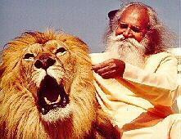

Previously only Hindu Gurus and Zen Masters had the ability to remove energy blockages by means of their psychic powers gained through a lifetime of meditation and other miracles.
People who have known Roshi Hogen and Swami Satchidananda know that through them, enlightenment exists and is living today, as in all the ages of this planet when virtue is in abeyance.

Hogen's Haiku, "Can you feel my breeze blowing, Even from 10,000 miles." Yes, we felt his energy even at the other ends of the earth. The secret of Zen and the Guru is that they remove the blockages of the student, but only when the student is ready, when the student has learnt how to ask. How to be a good student.

That is why all the enlightened including Swami Satchidananda, Tangen Harada Roshi, Yasutani Roshi and Zen Master Hogen have been so successful in producing their HIGHLY EVOLVED and enlightened students.

Although Satchidanand and Devi Dhyani will teach you Energy Enhancement techniques Online, by Video and on Retreat to remove your own blockages, if the blockage is too tough and too deep for you, the Buddhafield of Energy Enhancement and Satchidanand and Devi Dhyani, is waiting to help you on the Costa Brava in Spain, Argentina, Iguazu Falls, and India.

"Each of these blockages is a potential time bomb in that toxins are deposited in these blockages. Eventually the organ in which the blockage resides fails producing sometimes cancer and heart disease. So understand that even from a simple physical point of view, how necessary it is to learn and practice Energy Enhancement Techniques" JULIA HERRERA - RADIO PERSONALITY 2003

SATCHIDANAND, ZEN MASTER ROSHI HOGEN
AND HINDU GURU SWAMI SATCHIDANANDA

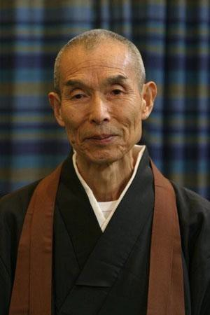

As my Master Roshi Hogen says THE ANTAKARANA - "The spring at the top of the Mountain." - Which stretches from the Kundalini Chakra in the Center of the Earth through our bodies with all of its seven chakras out towards the Center of the Universe, the chakras of the Soul, the Monad, the Logos, Sirius, through an infinity of chakras towards God.

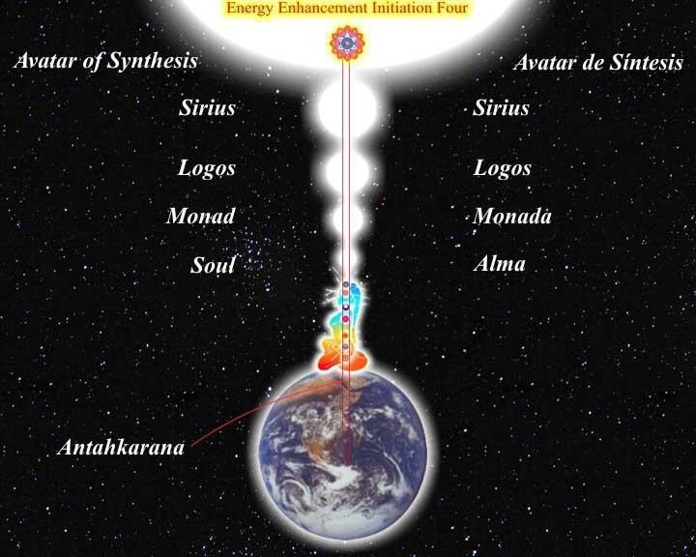

Illness is caused by a lack of energy. We can only heal ourselves when we learn to fill ourselves with energy by these methods.

SATCHIDANAND –
When I was 6 years old I had the experience of seeing one of my past lives in dream. I saw my own death as a soldier in lines of soldiers wearing red and blue. I knew that this was a genuine experience because it was so profound. When I woke up I had the feeling that my mind was twice the size. That it had expanded in some way that I had never experienced before. I did not talk to anyone about this experience.

"Keep it secret. Keep it safe!!"

When I was fourteen I had another experience in dream. I saw my own death. I saw the process of my own life as a very boring experience without meaning and purpose. Getting my "O" Levels and "A" Level examinations. Going to University and getting my Degree. getting married and getting 2.4 happy children.
Meaningless happy work and then on my 85th birthday going to hospital with tubes coming out of me and seeing my blood drain away out of these holes and then feeling my own death.

I was feeling my death profoundly for 3 days after the experience and I had the feeling that it was time to Speed Up!!

I began the process of Hatha Yoga from books. I was persuaded by an article by Sir Alec Rose I saw in a Sunday Newspaper.

The same experience happened when I was Twenty-One years old and the profound feeling of seeing my own Death again and again the feeling that I needed to Speed Up!! I had the knowledge that year that, "I was the Captain of my Ship" and I began the very real dialogue with my Soul.

I began the Process of Pranayama when I was 21 and took to reading Gurdjieff, Robert S de Ropp, Theos Bernard and Eric Berne.

When I was Twenty Eight I decided it was time to meditate and after One Year of meditating every day by myself and becoming a Yoga teacher and Aikido Student I encountered my Zen Master.

I was very happy with Zen Master Hogen. Every Day as soon as I got out of bed, for many years, I would meditate. But strangely I found more and more that I was getting thrown out of bed every morning by him so I could meditate. And he was connected to me, "Can you feel my breeze blowing? Even from Ten Thousand Miles!" I had the vision several times of him polishing my base chakra whilst I was sitting in meditation.

Because "Through Luck" "And to be Spiritual, you have to be lucky" I was using Energy Enhancement Grounding and connection with the chakras above the head in my Zazen meditation - something I never mentioned to anyone, even to Hogen, "Keep it secret. Keep it safe!!" - I progressed very rapidly in meditation.

In my first Sessein where we meditated 6 hours a day for a week, I was in pain but still did not require much sleep on the course.
On my second sessein I managed to exist in a state of Samadhi in the chakras above the head. The only way to stop the pain is to exist in the "Highest Heart" Prajna Paramita, out of the body - "All sages and saints for thousands of years live in Prajna Paramita" - Gautama Buddha from the Heart Sutra Translation

Hogen took one look and said to my friend and yoga teacher, Granville Cousins, "Look how much he has grown!"

I went to a Greek Island with Hogen back around 1987 where he was giving a course with Yoga Teachers Angela Farmer and Victor Van Kooten. I was there with Hogen because I was to act as his general factotum and helper so we stayed in the same house for a couple of weeks. I cooked the food, washed the dishes and one day was asked to cut his hair with shears. To partake of his crown chakra energy. Thank you Zen Master Hogen!!

During that time one night when I slept I had a very vivid dream and I dreamt that I was lying on a slab of stone dressed as an ancient king in armour and with a sword - an image very much like but predating by several years the image of the dead Aragorn in the Lord of the Rings Movie.

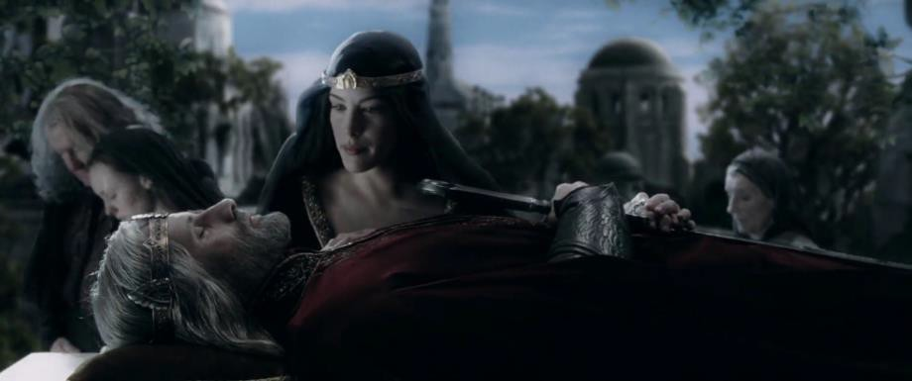

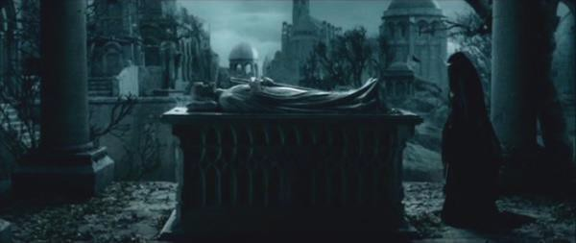

Hogen came towards me in his robes and he bent over me slowly from the waist and brought his mouth to my right eye and sucked it out from my eye socket! He slowly returned to vertical with my eye in his mouth, took it out with his fingers and then polished it up, put the eye back in his mouth, bent over me again and then blew back my eye, back in my eye socket again with his mouth!

Swami Satchitananda said that, "Yoga is the creation of Psychic Vision" He also said that Hogen and I are like a train. Hogen is the engine pushing from the back and Satchidananda is the engine pulling from the front.

From this I gathered that HOGEN WAS LOOKING AFTER MY BASE CHAKRA AND SATCHIDANANDA WAS LOOKING AFTER MY CROWN CHAKRA AND ALL THE CHAKRAS ABOVE THE CROWN CHAKRA.

The next day Hogen had done something really stupid. He had put some olbas oil, a strong oil containing oil of wintergreen, on his finger and by accident put it into his right eye and was in pain. The students rushed to help him wash out the oil but I have pictures of Hogen wearing a piratical black eyepatch, "eye, eye, me hearties!" for a week afterwards.

I came to understand later that Hogen had indeed cleared up my psychic vision through many experiences I received later.

"Yoga is the increase in psychic vision" Swami Satchidananda

Indeed, every true student will have similar experiences of when the Spiritual Master took on some of their Karma, with great effort and pain sometimes, in order to help their evolution.

Its what Masters have been created to do. And without my dream knowledge, like all the other students, I would have thought Hogen had done something stupid too. We can not know what they are really doing.

Enlightened Masters work in mysterious ways.

Taking "The Path of Blame" they even do stupid things to test out the hearts of their students.

The Initiation of Illumination is something precious, only to be given away to the worthy. The student must know that, "They have to be there before they can stay there" thus many students are "Blown Out" before they can do any harm.

And then, after many years of work, zazen, meditation, with Zen master Hogen I meditated on the Koan of Ramana Maharshi, "Who am I" They call the Koan, "The Vichara" based upon the work of Ramana Maharshi which occurred when he became Enlightened.

At the age of sixteen, Ramana Maharshi was full of the Bhakti, the love of God, after visiting the statues of the 63 Nayanar Saints of Tamil Nadu at the Meenakshi
Temple Madurai who all achieved Enlightenment upon their deaths invariably because they kept a promise at the cost of their lives. He decided to lie on the floor and see what death was like. Such was his determination to see his own death, when he returned from his experience he was Enlightened.

The best way he could describe his experience was the Vichara - using, "Who Am I" as a mantra in meditation, which when followed gives you the experience of your Soul or Enlightenment.

Later in life Ramana said that to become Enlightened you need to have the help of an Enlightened Master. And indeed Ramana Maharshi was a genuine Master. All of his real students had the experience of seeing him on the astral plane helping; removing their blockages, energising their causal bodies causing them to weep.

But when he was asked, "Who was your Master' he had no reply but hinted that an Ascended Master had taken an interest in his Enlightenment.

Ekhard Tolle essentially had the same experience after much misery and the feeling of wanting to die he woke up enlightened one day and since has tried to describe to others how he did it through a description of the "Normal' Mind and its associated "Pain Body"

The Pain Body essentially is the Selfish Competitive Ego made up of a mass of Selfish Desire Blockages which are coated with the Pain of Trauma Formed Negative Karmic Mass.

The Technique of the Energy Enhancement Seven Step Process is the only Enlightenment process outside of Scientology which can dissolve Energy Blockages.
Without it Buddhism, Hinduism, Ramana Maharshism,
Ekhard Tollism, Sri Niscardattaism, any other Enlightenment process depends on the Master to remove the energy blockages.

In Energy Enhancement, we help but we give full instructions to our students on how to Eliminate the Energy Blockages of the Angry, Painful, Selfish, Competitive, Fearful, Desire filled Ego and all of our students report on their personal success in eliminating their own Energy Blockages by themselves.

IN THIS WAY, WITH ENERGY ENHANCEMENT, NEW MASTERS ARE VERY EASILY FORMED

When does the Teacher become the student? When does true integration become the realization?

I asked Zen Master Hogen differently.

I asked, "How do you know when you are enlightened, self realised?"

He answered, "When the time is ready you will know" "The Master always has to know.
Otherwise he is not Master"

The rate of evolution of humanity needs to increase. The old ways of the Master doing all the work of removing the energy blockages of the ego are now too slow. The recommendation is for students to serve their Masters for at least 12 years. Many have been there for 20 years with no appreciable movement forwards. The new technique of The Energy Enhancement Seven Step process can now augment the processes of every Enlightened master and thus Speed Up the process of Enlightenment Worldwide.

NOW IS THE OPPORTUNITY FOR FULFILLMENT AND NEW BEGINNINGS FOR THE WHOLE WORLD"

ENERGY ENHANCEMENT IS A NEW REVELATION OF GOD TO HUMANITY

When I meditated on the Ramana Maharshi - Whose
Ashram I have visited and meditated in many times - Vichara, "Who Am I" Immediately I had the enlightenment experience of travelling along the Antahkarana out of the body to a place where was all my past lives hanging in space thousands of them in a neat matrix. I decided to enter into one of them and saw that past life gaining much experience. I knew I could spend more time there investigating my past lives and my mad personalities, because not enlightened, in charge of those lives, but I knew that essentially apart from having enlightenment, it was useless.

I then decided to go higher. There too I gained much experience from meeting Ascended Masters.

"Drop Body, Drop Mind" - Zen Master Dogen after his Illumination Experience

When I went to Zen Master Hogen in Dokusan with this experience, after I told him about the past lives he said, "We can explore this area of the Astral Plane for 10,000 years and get nowhere!"

Then I told him about going higher along the Antahkarana and meeting the Ascended Masters and he smiled! And in another space with my psychic vision I saw his aura expanding, gold, and enfolding me in the energy of his love...
After this I was allowed to find another Master... Swami Satchidananda!!

SATCHIDANAND - ENERGY ENHANCEMENT
TALES OF ENLIGHTENMENT

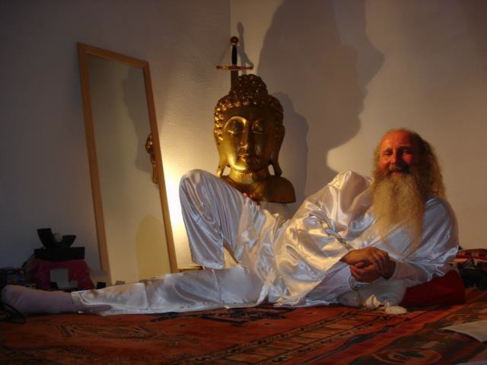

THE ENERGY ENHANCEMENT STREAMING VIDEO COURSE

"Get your asses over here Now and Speed Up your process of Enlightenment on the Energy Enhancement one month course!!" - DON
Every one of our Students gets this Spiritual Experience of Connection with Infinite Energies.
Energy Enhancement does indeed, "SPEED UP THE PROCESS!!"
And they all get this Experience of Light, Life and Infinite Energy just with the Energy Enhancement Course - Every One of Them!!
LEVEL 1 - 4 VIDEO COURSES ANYTIME IN THE COMFORT OF YOUR OWN HOME
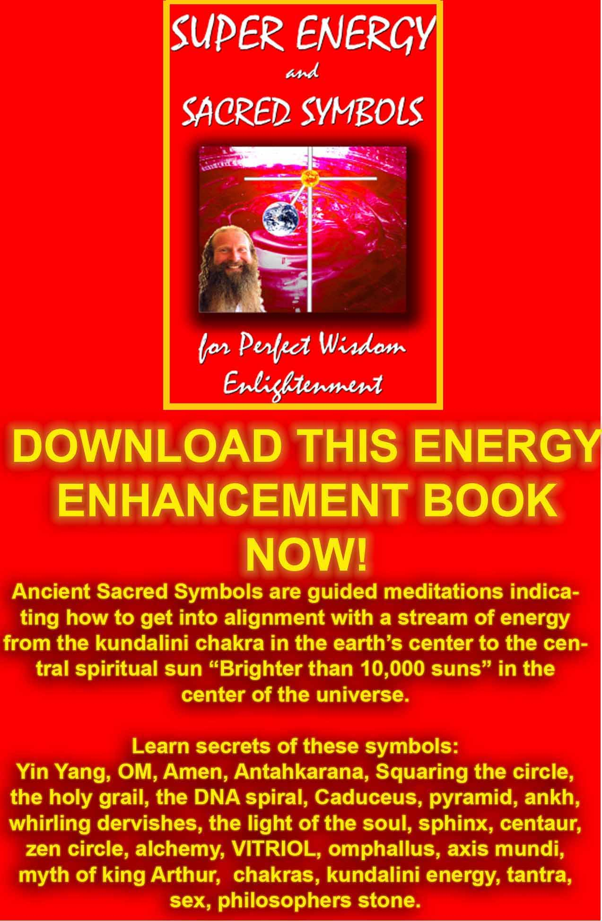
DOWNLOAD SUPER ENERGY AND SACRED SYMBOLS HERE!!!
http://www.energyenhancement.org/Sacred-Energy/Meditation-Super-Energy-And-Sacred-Symbols-for-Perfect-Wisdom-Enlightenment-Color-energyenhancement-org.pdf

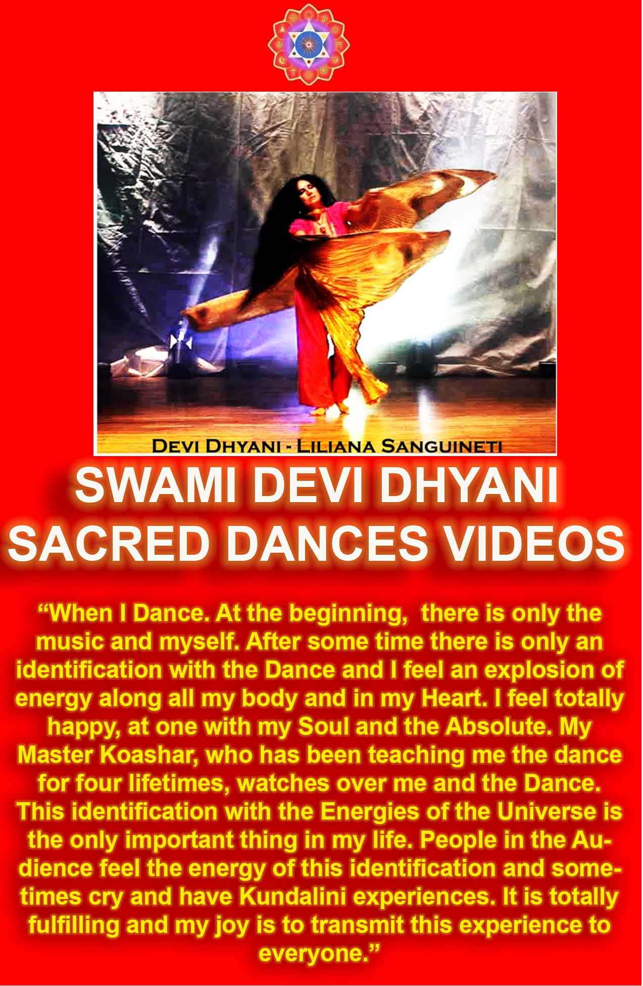

SAMADHI WITH WHITE LIGHT AND THE INTENSITY OF THE MUSIC AND THE KUNDALINI ENERGY
I remember back in India whilst I was living in Madras in 1989, after that time when I was meditating three hours every day and getting all the insights into Energy Enhancement meditation from experiences in my meditation from the ascended masters and then later finding the same techniques in all the ancient myths and religions.

It was after Swami Satchidananda came to me in my meditation and stayed there in white light for an hour and he did this for three days on the trot. And then this friend came in with a leaflet and said, "Hey, you know Swami Satchidananda don't you?" And there was Swami Satchidananda on the leaflet giving a feast and Dance to all the people in Madras, three days earlier.

And on the leaflet was no address, just the Name of a Dr N Mahalingam who was funding all this. So I went to the
Telephone directory, but there were five pages of Mahalingams. India, one thousand million people and you want to find Dr N Mahalingam? So I turned to the guy who loaned me the Telephone Directory and he said, " I know Dr N Mahalingam, he is my best friend!" And he gave me the telephone number in Madras!!

So I telephoned the number and the answer in very high tones, perfect english accent, "This is the residence of Dr N Mahalingam, can I help you?" Apparently Dr N Mahalingam, as well as being a director of the Theosophical Society in Madras was also a sugar magnate and a billionaire. So they gave us his address and telephone no. in Coimbatore and that's how we got to see Swami Satchidananda in India. And we stayed with Swami Satchidananda for a month and went to Bombay with him as he flew out.
Well in Coimbatore we got the invite to the Ashram of a brother yogi to Swami Satchidananda, one who had been with Swami Satchidananda's guru - Swami Sivananda of Rishikesh. And this

Guru was known as a music guru, also named Swami Shivananda. We went on the occasion of a Karnatic Music Concert with very good musicians. L Shankar who plays with John McLaughlin in the Group Shakti and is one of the greatest violin players in the world comes from that tradition of Karnatic Music of South India and the tradition of the music of Saint Thyagaraja who spiritualised India with his sequence of the Pancharatna Kritis, two hundred years earlier.

In the middle of the city of Coimbatore we enter into a restaurant where students of the Guru are preparing Indian Delicacies and up to the music Hall on the top floor and we sit on the floor, no seats, in the lotus posture at the feet of the music guru, Swami Sivananda - the same name as his guru! - who is sitting in a very nice chair.

The music starts and after an hour the rest of the people are moving and a little uncomfortable. But Devi and I are sitting firm, and music, very intense and beautiful Classical Indian Carnatic Music with a great lady violinist and our spines are going crack, crack, crack! with the intensity of the kundalini energy coming from the music guru. "When the energy is flowing correctly, there is no movement" - Saadi of Shiraz. And we shift into Samadhi with white light and the intensity of the music and the kundalini energy.

All great art, art which has been touched by God, whether it is Music, Movies, or Paintings have the ability to evoke Kundalini Energy through energy. And when this energy is being evoked in the presence of a Guru, the energy is intensified as the Guru adds his energy to the occasion.

Which brings me to the point..

Last night we decided to play the movie, "The Green Mile" by Frank Darrabont starring the Forrest Gump actor, Tom Hanks, for our students. Firstly because its a great movie with many spiritual teachings. But secondly because this is a movie which has been touched by God.

And as the movie was playing my body spontaneously went into Pranayama as I focused and concentrated the energy. My antahkarana opened and I was conscious of channeling the energy of the soul. Everything seems so much more intense and meaningful when this happens and it happens a lot to me. It seems that life only has meaning and significance when this energy is being channeled. Thus, when it happens I know I am on a path with heart, my Soul Path, The path of my Dharma. More, at certain points in the movie my abdomen contracted and I was able to feel the ball of white light which was fulminating there and then I released it from the appropriate chakra sometimes with waves of tears. I knew what I was doing because it always happens. Spontaneously, with no will on my part, I become a channel for the energy of the movie.

At the end I asked some participants what they had felt.

One said that it had been a too intense experience for him to talk about it.

A few days later he said he felt a fat pipe of the antahkarana wider than normal as the Kundalini energy flowed and shock of kundalini energy which made him burst into tears. The meaning of the movie had penetrated deep within him and he was aware of the experience.

Another said she had seen the movie previously but had taken it as a fantasy and had not connected to it. During our performance she had been in the movie every step of the way and had realised its essential truth.

Sometimes its difficult to put into words our intense feeling but everyone recognised the nature of the experience and everyone responded to the energy.

Only if you have been prepared to receive the energy by past life training or the removal of energy blockages on the Energy Enhancement Course can the energy be received correctly.

All the symptoms of energy blockages come up in an intense buddhafield for those who have many energy blockages and these symptoms are normally called the symptoms of Kundalini Energy. Pain, Heat, Cold, Moving, Sleep, Awe, Fear, Anger, and more.. We get these with everyone at the start of every course.

Thus the work of the critics who cannot feel the energy of Star wars or the Lord of the Rings Movies - they sleep normally and call it boring, childish, they do not know..

Yet here on the Energy Enhancement Course we are removing the blockages of pain, of movement, of fear of Anger. Preparing people to receive the vast energies of
existence, of Kundalini, of Illumination, Of Enlightenment...

"Get your asses over here Now and Speed Up your process of Enlightenment on the Energy Enhancement one month course!!"
- Donal Minihane



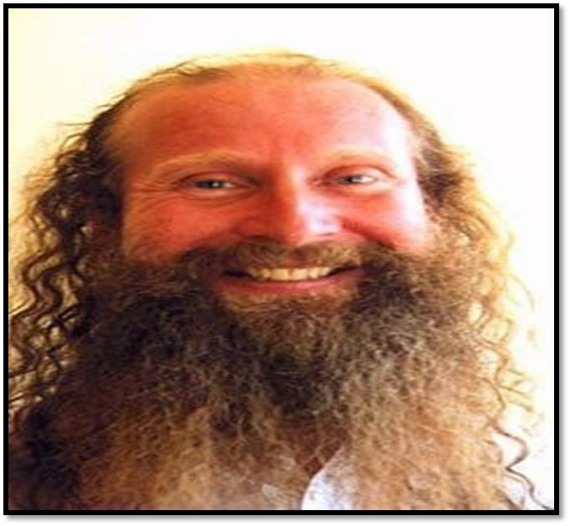
SATCHIDANAND


Energy Enhancement Spiritual Movie Reviews Book - Volume 1 by Satchidanand download here..
http://www.energyenhancement.org/Spiritual-Movie-Reviews/Energy-Enhancement-spiritual-esoteric-movie-reviews-by-Satchidanand.pdf

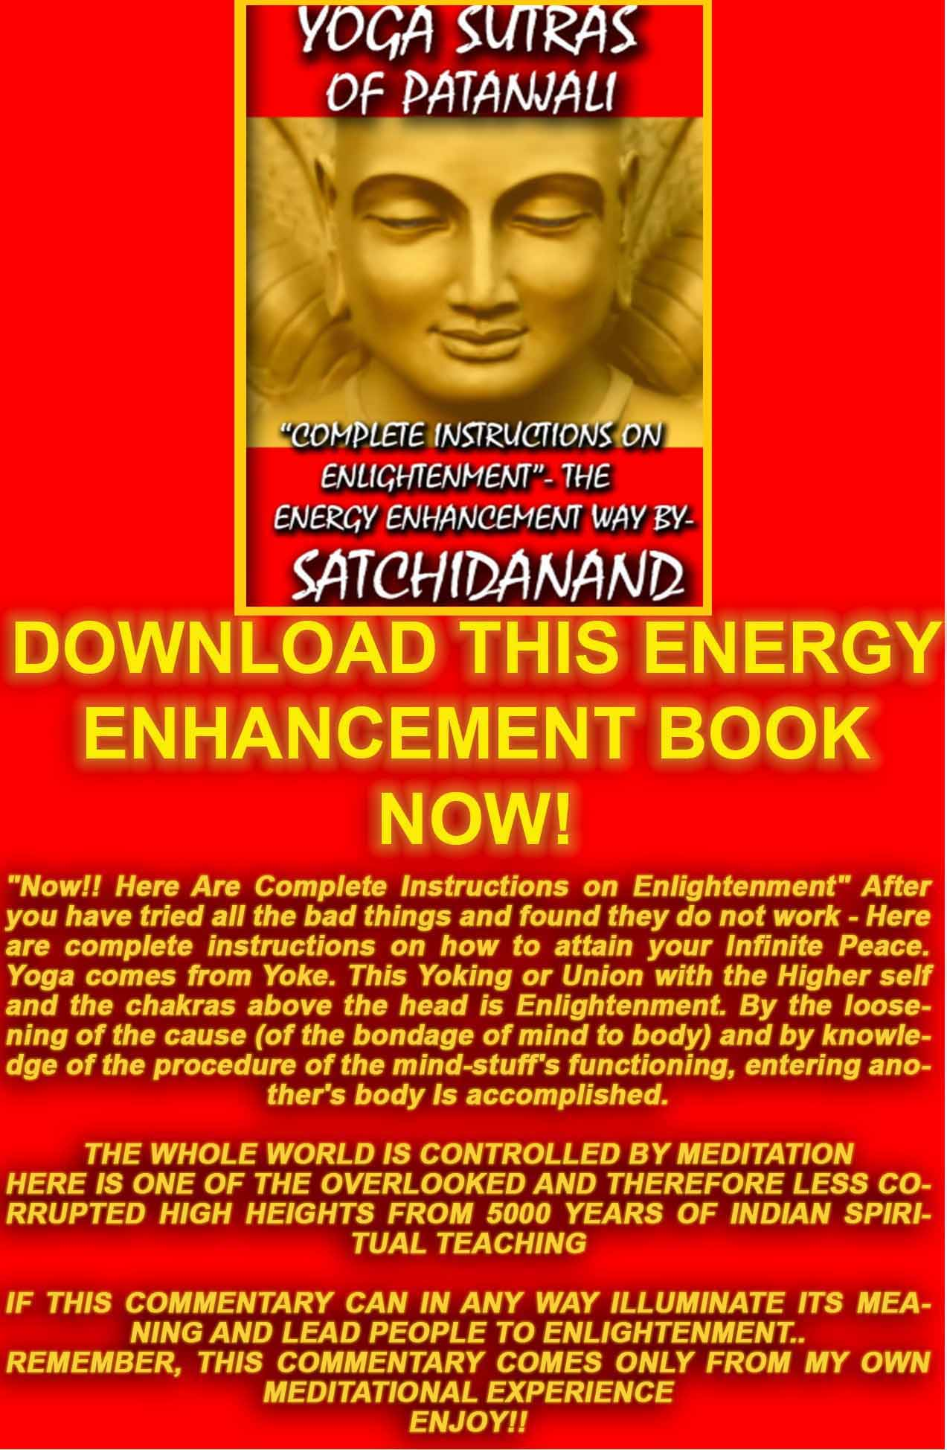
THE YOGA SUTRAS OF PATANJALI BY SWAMI SATCHIDANAND - DOWNLOAD HERE..
http://www.energyenhancement.org/Sacred-Energy/yoga-sutras-of-patanjali-book/Energy-Enhancement-Yoga-Sutras-of-Patanjali.pdf

Kundalini Energy and Satchidanand
SATCHIDANAND, STUDENT OF SWAMI SATCHIDANANDA, IS ONE OF THE GREATEST KUNDALINI YOGIS IN THE WEST
Siva Samhitã, iii, 10-19: "Now I shall tell you how easily to attain success in Yoga, by knowing which the Yogis never fail in the practice of Yoga. Only the knowledge imparted by a Competent Teacher through his lips is powerful and useful; otherwise it becomes fruitless, weak and very painful" And this is why - by coming into the Buddhafield of Energy surrounding Energy Enhancement Satchidanand and from the Videos - obtained through many years of meditation with many enlightened masters, you obtain Shaktipat- an infusion of energy to help you get into a permanent state of meditation and the removal of Energy Blockages to help in your search for Illumination.

"To the sinful and vicious I appear to be evil. But to the good, beneficient am I" Mirza Khan, Ansari, Sufi.

"We Meditate in Pieces to make One Piece" (Peace) Satchidanand "Meditation is a Fast for the Mind", Satchidanand
Satchidanand, Director of Energy Enhancement Synthesis of Light, is one of the Worlds leading teachers of Meditation. Student of Zen Master, Roshi, Hogen Daido Yamahata and Swami Satchidananda of Integral Yoga and student of Sivananda of Rishikesh who named him, "Yogiraj".

With 37 years experience in Yoga he has catapulted people years ahead in their meditational experience in weeks. Some 5 years, some jump 10 times further!

"Jay has gone back to findhorn in Scotland to see if he can fit in somewhere and get some work so I have myself to myself and I'm looking forward to the winter this year for some reason.
Strange that, must be my age. Ha ha ha

He just messaged me saying, unfortunately I won't be meeting anyone like you up here Donji.

It was very interesting for me to view the damage first hand, that a short and furious life of drug taking and selling said shit does to ones soul energy. It retreats deep inside and hides away from it all. So many damaged souls indeed.

Taking your advice and seven stepping him myself was a huge learning for me. He could sit without me for two hours and more without any discomfort. I sit with him and seven step him and he is out of the room within the hour because his body is in such pain. He can't stand the pain and gets up and leaves the room. I even tried to see if I could fall down and did not sit for over a week then asked him to sit again with me.

Even though he had been sitting all week for hours at a time, once I sat with him and seven stepped him, his body went quickly into pain and he would get up and leave the room in just fifty minutes. Deep pain inside him.

Very little pain in me at all I'm pleased to say except in that left hip a bit still. That gave me huge trouble when I was with you years ago." - Donji

I was thinking on the Nature of the Buddhafield, the transmission of the Light, the 7step process on pressuring energy blockages to leave, burning energy blockages up.

Of course, as you remove energy blockages, so you begin to vertically channel from the chakras above the head more and higher vibrations of energy. This creates the buddhafield as the horizontal bar of the cross.

The last 5% of energy blockages, deep dense energy blockages encrusted with negative karmic mass take time to be grounded and removed. As we remove the blockages by ourselves, using the Energy Enhancement seven step process, we build up the energy density and intensity around the blockages, so they get hot and painfull.

My dialogues with Hogen were when I asked him why, after an hour of sitting, for the last five minutes before he called time, that was the time of pain, of wanting to move from the lotus, of squirming.

He answered, "Oh, that is when I exert my power!!"

I asked him if I could test myself by sitting alone with him for a while and he agreed.

After 30 minutes of torture I moved, he stood up and walked out. So, I knew I had to improve.
Same with Satchidananda, he was walking down a line of people answering questions and one person away from me I felt this ache in my heart.

I went back to my room and burst into tears for 30 minutes.

Later, 50 ft away from me he cocked a pretend gun and shot me. Again I burst into floods of tears - Opening my Heart!!

SATCHIDANAND MEETS SWAMI SATCHIDANANDA FOR THE FIRST TIME

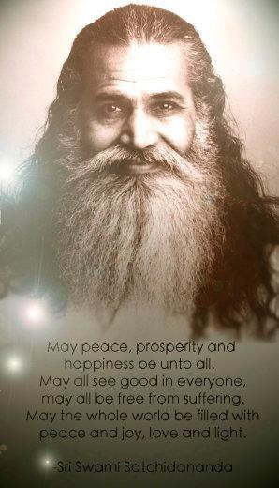

So when a friend asked me if I wanted to go to London to meet Swami Satchidananda I was hesitant. But they persuaded me to go. So there I was in this big hall containing 4000 yoga teachers of the British Wheel of Yoga - Swami Satchidananda was the Honourary President of this organisation. Arriving late and there was no space for me to sit. So I went and sat on the floor in meditation posture at the front, just in front of him. And I was not impressed really by what he was talking about because I was arrogant.

The first time I met Swami Satchidananda was in London at a meeting of the British Wheel of Yoga of which he was the honorary President. He was talking to thousands of Yoga Teachers - I was late so I walked up and sat on the floor as there were no chairs. Satchidananda said it was time for a little meditation at the end of one of his talks about yoga, "They asked me to talk, but surely they can allow me to give a meditation too?"

Whoom!! he took me a hundred meters up my antahkarana in meditation. Looking down I saw myself sitting below and then he made me look up to see him, Satchidananda, above me beckoning with his hands, "Come on up!!" he said.

Anybody who can do that can't be all bad!!
Later in his ashram where Devi and I stayed for 3 months, every day in meditation I went up the antahkarana and to the right into a temple where a Master, "He is like Jesus Christ" was the reply when I asked, was slowly, like slow motion video, was walking right to left in front of me behind a sacred fire. He turned to look at me and a beam of light came from his eyes into mine and went down into the center of the earth. I suppose all that took three hours over many days because when I stopped for the day, the meditation picked up from where I had left it the next day..

Over the last few months we have emailed and when you asked questions I gave good replies.. 7step Jay. Teach Kurukinti EE techniques. And all the teaching for you which came from that.

When Gita came to Iguazu for 6 weeks after 4 streaming video levels in the comfort of her own home she increased her time of sitting from 20 minutes to two hours, We did this by the focussed removal of blockages from the base chakra. The last chakra before enlightenment.

The energy blockages do not like this.

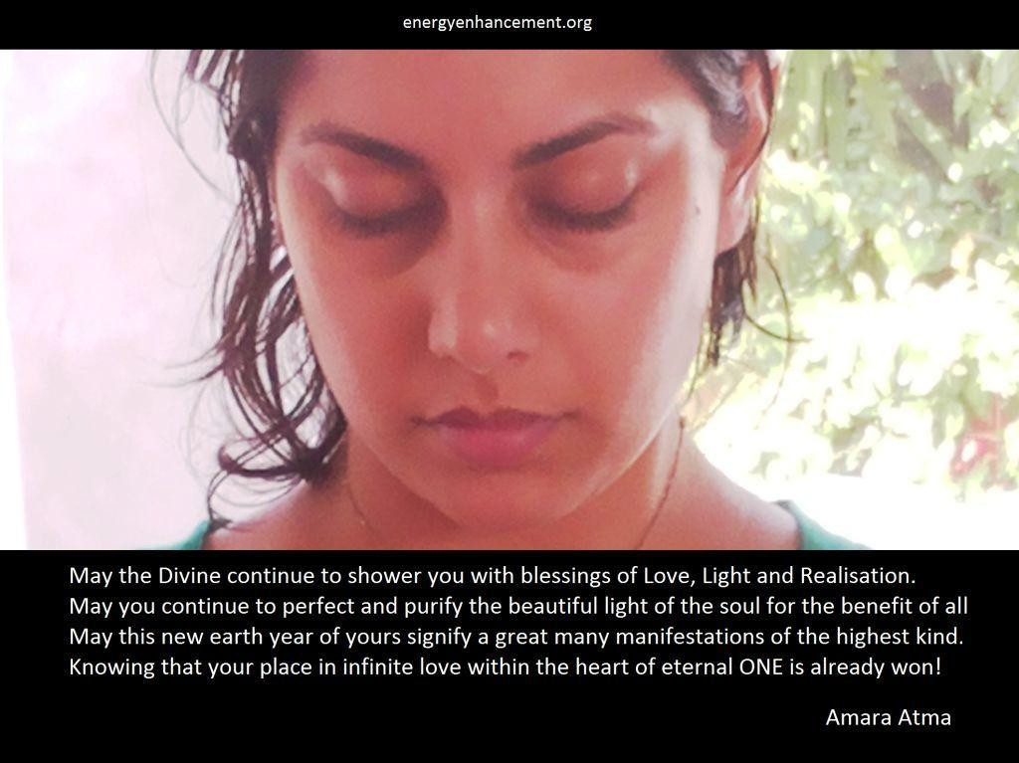

SWAMI SATCHIDANANDA THE LOTUS TEMPLE
AND THE SYNTHESIS OF RELIGION

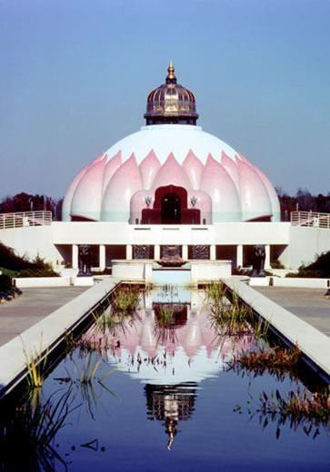

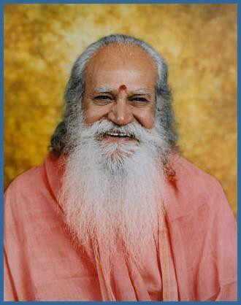
Swami Satchidananda

But then at the end of the talk he said lets meditate. And he chanted Om Shanthi and I found myself a hundred meters up in the air looking down at my body sitting in meditation below!!
And I looked up and way above me was Swami
Satchidananda and he was moving his hands saying, "Come on Up! Come on Up!!"

So I thought it might be a good idea to learn from him.

And although I read his books now and recommend them to everyone, Integral Yoga, The Yoga Sutras of Patanjali and The Living Gita, Commentary on the Bhagavad Gita, although the information in these books are a great gift to humanity, they are poor fare in comparison to what initially attracted me to him.

And what I got in abundance every time I met him was
Energy and Psychic experience. Visions, telepathy, Initiations on the Astral Plane all came to me every time I met him.

When I went to stay at the Satchidananda Ashram, 1000 acres in Virginia in America, for three months, the experiences accelerated every time I meditated. The knowledge that we cannot die, we are all connected. Satori and the lower levels of Enlightenment.

It took me a few years after these experiences with Swami Satchidananda to get fully cooked... and I am still deep in the crucible!

Deep rooted issues would surface and as soon as they were dealt with, even deeper issues would emerge that we would have to deal with. It was like peeling layers of an onion to go deeper and deeper into our core being to understand who we are and what kind of personality traits we have adopted, consciously and sub- consciously to deal with the issues of this world. I understood clearly how these beliefs, conditioning and past life impressions were affecting all areas of our life.

In addition, I also learned how to use the Energy Enhancement techniques to help me ground these negative blockages so they would never affect me again. Of course complete freedom can only come after a maintenance program has been followed.

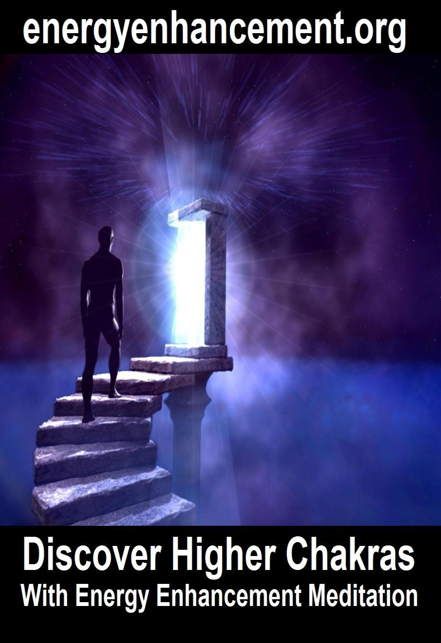

Satchidanand comes from England and was Born in the Ancient Chinese year of the DRAGON. Originally with degrees in Physics, Mathematics and Electronics, and working in International Companies in Management, Computing, Electronics, Hardware and Software.

Starting from practising Yoga from 1967, through working and contact and exchanging Energy with many masters including Swami Satchidananda of South India and of the USA, Yogaville, Virginia and Zen Master Roshi Hogen (Master of the Tao) of Japan, Osho and Ascended Masters, he works towards the ideal of one spiritual truth on many paths using Energy Enhancement and healing.

His Sun, conjunct with Neptune, Mercury, Saturn, and Venus in the 8th house in the Draconian Soul
Progressed chart in Scorpio and WITH Pluto conjunct the Moons Node gives him tremendous Power to break down World Karma through the Energy Enhancement Techniques, drive out YOUR blockages and raise your Kundalini Energy. Come and see him whilst he is still visiting this Planet!!

"Energy is Inexhaustable. Like a fire it is passed from Master to Disciple. It jumps the Gap, the Abyss. It Energises all." - Satchidanand

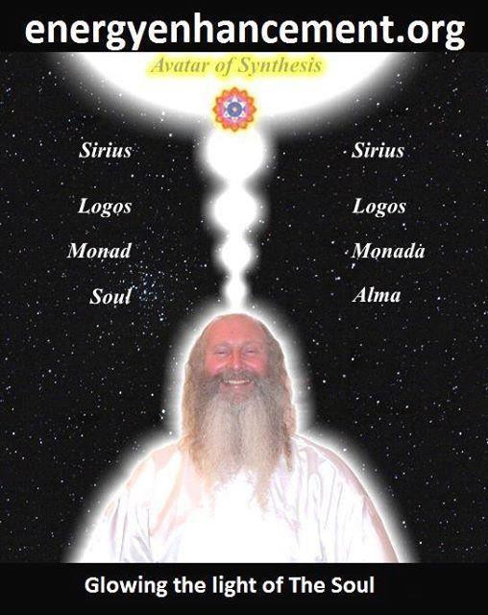


I was looking for a change and also for a way of protecting and maintaining my energy. Then I saw a poster of a lady sitting in meditation with the light of the soul shining down upon her head and somewhere inside my voice told me, “Follow this Light” and this is how I met Satchi and Devi. CARLA STUDENT 2004

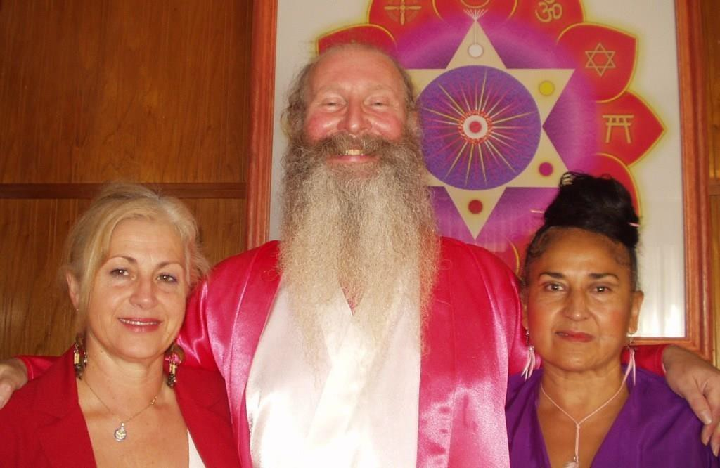
STUDENT ANA VEILLA, SATCHIDANAND, AND DEVI DHYANI AT THE ENERGY ENHANCEMENT CENTER IN ARGENTINA

Olympia Panza.
Here is a Testimonial from written by Satchi from a report given him by Olympia Panza.

When I came to see Satchi at the airport for the first time I was struck by his energy but it was the second time, when he was talking to another student when meeting us off the train at Figueres that I really started to feel the Buddhafield of Energy Surrounding him

Suddenly I started yawning like the big healer guy in "The Green Mile" and then tears started from my eyes and I felt I was getting rid of a lot of Painful memories from the past.

Satchi taught us meditation and the Circulation of the Energies in order, as he said, "To improve our psychic vision" During these initiations I saw all my Energy Blockages in

colour!! I saw my abdomen filled with blackness and thought back to my first periods, filled with pain, my inability to breathe properly and the problems I have with digesting food.

I saw all the brown clouds of pain filling my lumbar region and the problems with the throat chakra making me understand my problems with communication and the Peter Principle, we always do that which we most need to learn, which caused me to become a journalist and an arabian belly dancer teacher.

Satchi saw/felt them too and asked if I would like some healing because he explained that normally he liked to teach the Removal of Blockages Techniques of Energy Enhancement Level 2 and let the students heal themselves, but because I was going before he could teach that, he thought that a little band aid would be helpful because he felt that the abdominal blockages were not made in this lifetime but had come to me from my previous lifetimes.

I lay on my back and Satchi placed his hands over my abdomen and I drifted off to a place of peace. I imagined myself lying on the grass in the sunshine. I saw Satchi as an energy there too, blowing through me like the wind. In this space I was a man, and not a woman as I am in this lifetime, and very focussed and filled with anger. Many images of women relationships passed in front of me some of them pregnant and I saw that I had no respect for the women in my life. I was wounded in the right side of my belly and I was dying.

As Satchi healed my belly I felt the pain of the wound I was dying from and people watching me said that this pain was reflected in my face. Finally the pain was gone and Satchi said that was enough for now. The previous lifetime had been healed and I had been brought face to face with attitudes in a previous lifetime, anger and a lack of respect, being mirrored in this. I saw how my irritation and anger was taking me away from my infinite peace and how these attitudes were reflected back at me in my relationship with my husband.

It was interesting that the relationship chakra, the abdomen, the place I was wounded was reflecting my previous attitudes and the Karma of those previous lifetimes was being given back to me so that I would be taught never have those attitudes again. I want to learn from my mistakes.

Satchi says you only get visions if you need to learn something.

Satchi explained that the intellectual level thought that it could solve everything just like this.. "I should not get angry!!" but that the intellectual level did not have the power to make that promise because its links with the emotions were broken, blocked and faulty.

He explained that the intellectual level similarly says,
"The whole world should be filled with peace." Yet for 10,000 years there have been many wars every year.

The Techniques of Energy Enhancement allow the mind to have the power to implement its decisions through the Removal of Negative Emotions. The removal of Energy Blockages, which create physical disease in the body and negative emotions in the mind.

LIVE COURSES, INDIA AND BRAZIL - IGUAZU FALLS

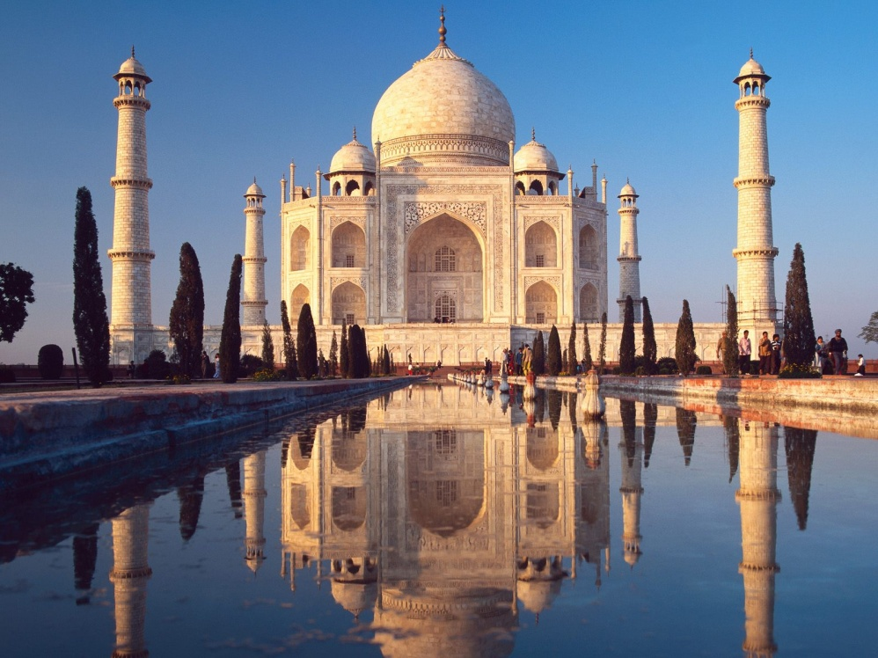
GET MEDITATIONAL SUPERPOWERS WITH ENERGY ENHANCEMENT, LIGHT YEARS AHEAD OF EVERY OTHER COURSE
THE ULTIMATE ADVANCED MEDITATION COURSE
MEDITATION ENERGY ENHANCEMENT
THE CORE ENERGY TECHNIQUES!!
THE MOST ADVANCED MEDITATION TECHNIQUES ON THIS PLANET, IN 28 INITIATIONS!!
ANCIENT EFFECTIVE ENERGY ENHANCEMENT SECRETS -
SUCCESSFUL
TIME TESTED
TRUE


Bookings: www.energyenhancement.org

KUNDALINI TANTRA AND THE TRANSMISSION OF ENERGY FROM MASTER TO DISCIPLE

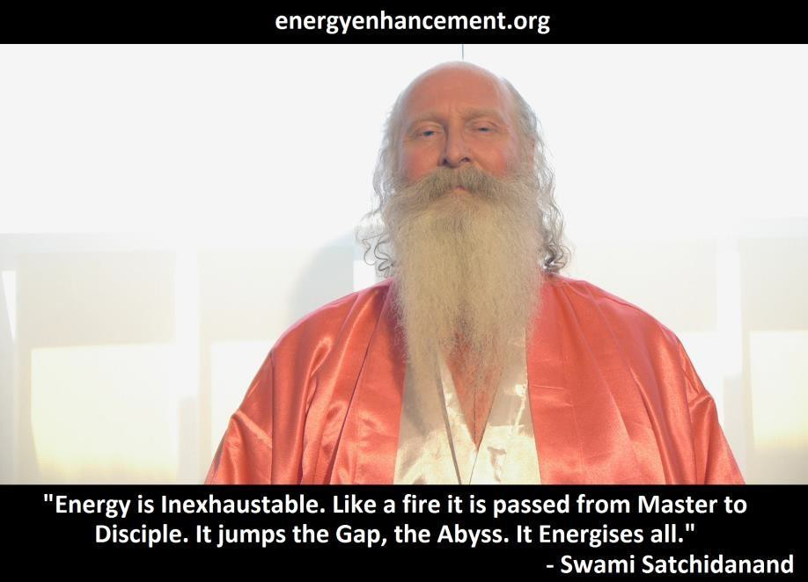
"Energy is Inexhaustable. Like a fire it is passed from Master to Disciple. It jumps the Gap, the Abyss. It Energises all." - Satchidanand

THE POWER OF TOTAL CONTROL

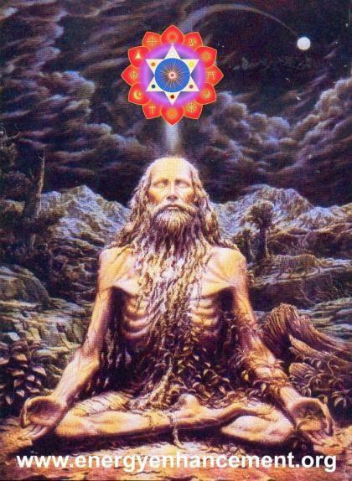

"EASY AND SMOOTH ENERGY ENHANCEMENT PUTS YOU IN CONTACT WITH KUNDALINI ENERGY WHICH
SPEEDS
UP THE PROCESS OF ENLIGHTENMENT AND INTELLIGENCE"

Masters... and the flowers showered, the energy of existence flows.

Satchi explained that if we had the power to heal our own blockages, we also had the power to heal the blockages of others. The power to do this comes from an integration of the body, emotions, mind and spirit created through the Core Energy Techniques of Energy Enhancement within the Energy Enhancement Buddhafield.

Satchi explained that the higher levels of Energy which create the Energy Enhancement Buddhafield and the Energy momentum to heal the students and raise their
Energy Levels so that they can do likewise came from His connection with his teachers, Zen Master Hogen from Japan, Swami Satchidananda from Yogaville in the USA but previously a disciple, a Yogiraj, of Swami Sivananda of Rishikesh.

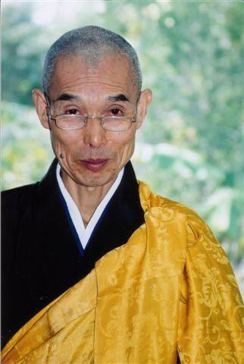

There is a transmission of Energy from Master to Disciple which occurs in silence. The preparation for this is the student's responsibility but the Energy always finds its place. It is the Energy of Initiation, which confirms the student in his enlightenment, but before this Initiation, "you need to be there before you can stay there." Indeed, many people go searching for Integration and Enlightenment from technique to technique and teacher to teacher whereas a true student can learn anywhere. We need to increase that studentness within ourselves. We need to learn to be a true student. The ability to learn. The ability to ask. The ability to receive.

One lack of respect for the teachings. One negative word, ONE BLOCKAGE, and heaven and earth are set infinitely apart. One negative word can destroy the silence of a moment.

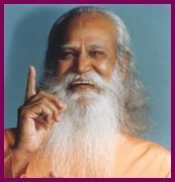

Swami Satchidananda talked of the time when Swami Sivananda died and of the Energy Initiation, which came to him at that time even though he was in Celon and Sivananda was dying in Rishikesh. He felt that some of Sivananda's fire had been given to him at that time.

Each Spiritual Master is a gift from existence, working in his own personal individual way to express his gift, his way, his energy channelled from the universe itself. They are individuals with strong personalities, "Personages!!" unselfishly aiming their lives at the benefit of humanity, the world and the Universe.

Even the intellect gets confused because the intelligent energy of existence, above the intellect, chit shakti, is the guiding force and initiator. Each spiritual master is as different from the others as a rose is different from a lily.

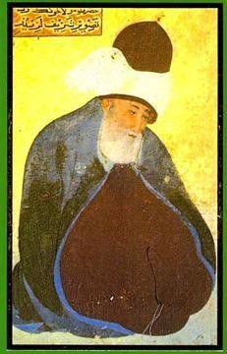

Just smell the perfume. Are they not the flowers of the Universe itself?

As Jallaluddin Rumi said around 1200AD, "Take what is in my hand!
If you have lost heart in the Path of Love Flee to me without delay
I am a fortress; invincible - Rumi

Satchi explained that after working with Zen Master Hogen and Swami Satchidananda for many years, these energy initiations had come to him also.

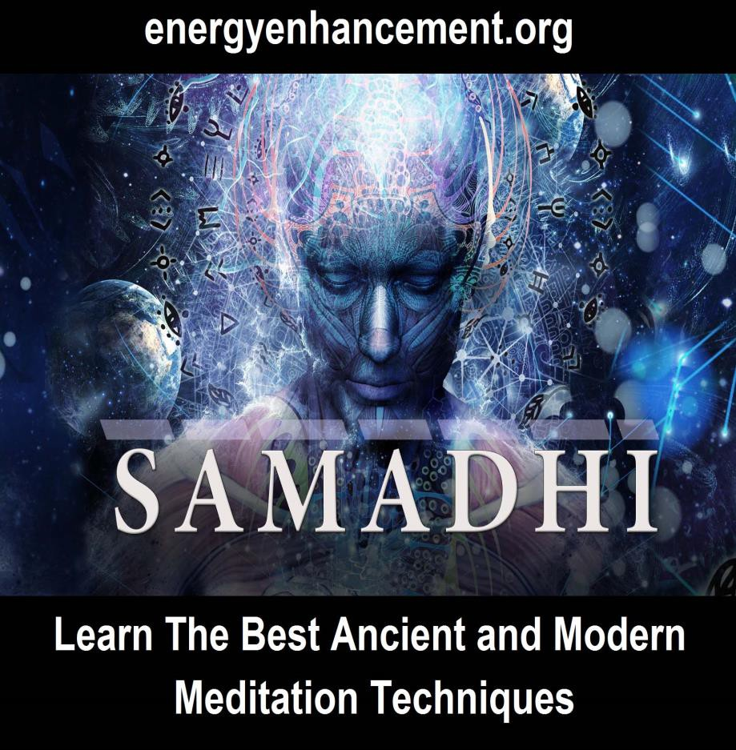

SRI YOGENDRA TEACHER OF SATCHIDANAND
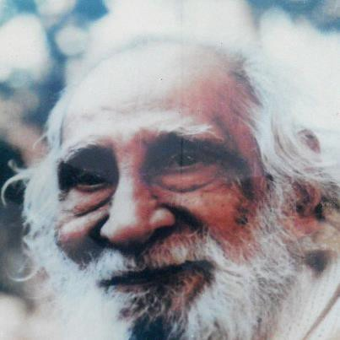

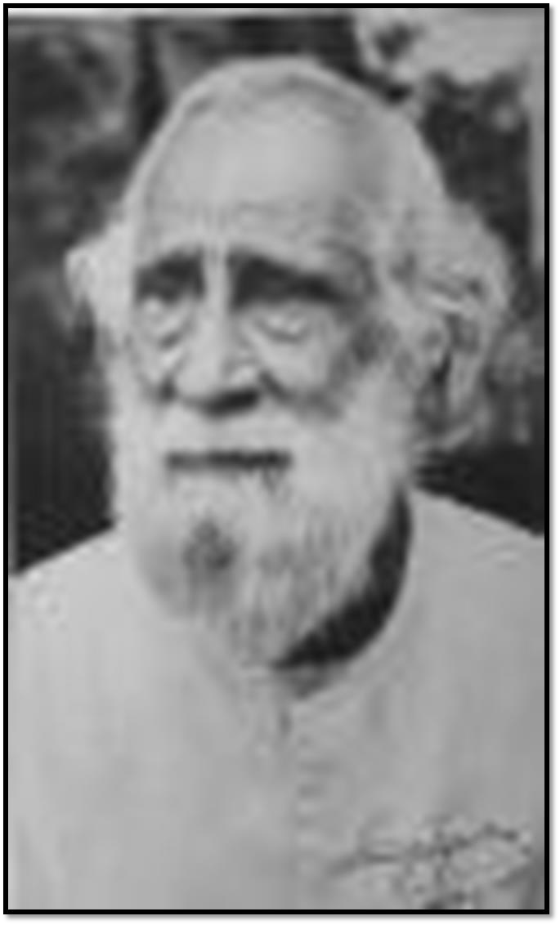

Satchi had the last and his only interview with Sri Yogendra of Bombay. Sri Yogendra died that same night saying that at the age of 96, it was difficult for him to hold in his energy. And this from a man who in his prime they used to put in darkened rooms where people used to go to see the prana, bioenergy,
rushing blue over the surface of his body.

In the interview, Satchi said he could only sit at the masters feet and say nothing.

Yogendra glanced at him and he was drawn to sit. Rooted to the spot. Yogendra talked of the time he was in New York, healing the children of millionaires. It was there in the 1930s where he gained the money to build his ashram in Bombay, "They used to appreciate me there and gave me a black stallion to ride around on in Central park."

Satchi heard him say at the end of the interview that the people of England had good hearts, and this from a Master who in his early years had had the reputation of beating up students who took liberties, showed a lack of respect!! He knew that by these words Shri Yogendra had judged his heart and found him worthy...

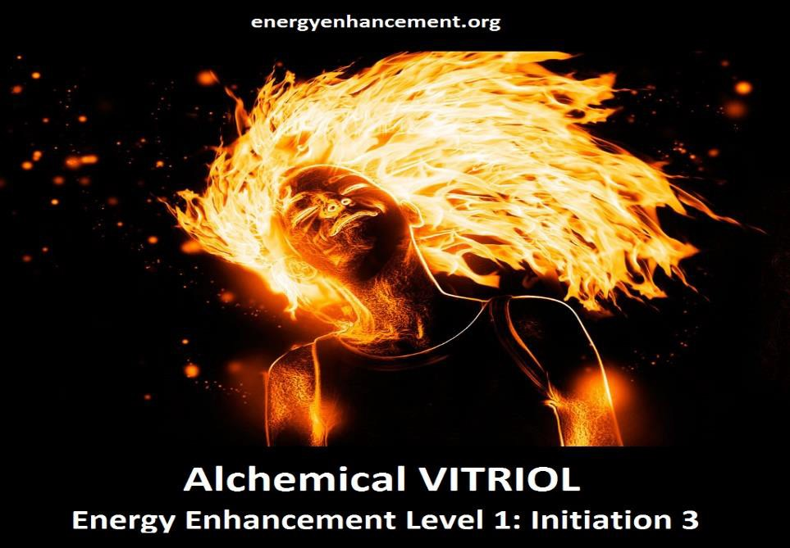

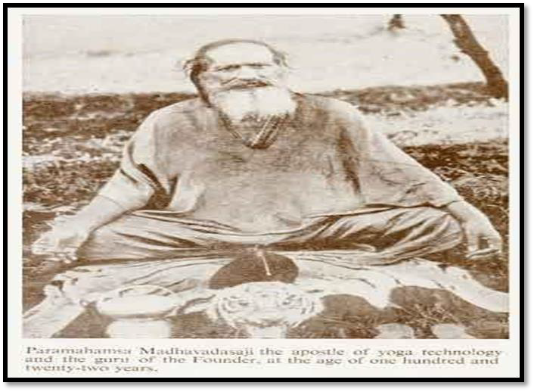

And then afterwards the energy.. Sent to him by Yogendra, which he was given during the interview. WHOOM! WHOOM! Up and Down. Down and Up. From Heaven to Earth and Earth to Heaven. ENERGY!! with great noise for 24 hours!!

Usually gurus are given the energy of Transmission by their Masters and here is the Master of Shri Yogendra, Paramahamsa Madhavadasaji at the age of 122 years.
After that last interview with Shri Yogendra the great Master died the day after. Apparently he was talking to his son, Shri Jayadeva, the present head of the ashram in Bombay, and he said that it was getting difficult for him to hold onto his energy, it was time for him to move on to the other plane, he was going.

Sri Yogendra was born on 18th November 1897. When his met Guru Pujya Shri Paramahamsa Madhavadasaji, a 119-year-old yogi from Bengal, he was still in college.
The meeting with Paramahamsa Madhavadasaji made Yogendra a devoted believer of Yoga. He joined
Paramahamsa Madhavadasaji's ashram in Malsar city of Gujrat and started studying Yoga sincerely. He was a non-conformist and a very close bond developed between the Master and the student. The Guru taught him many things by direct experience. After completing his training, he decided to leave the ashram, in order to propagate the benefits of Yoga amongst the masses. Thus Shri Yogendra became known as the Father of
Modern Yoga Renaissance. A firm believer of yoga, Sri Yogendra founded the institute to promote the science of Yoga throughout the world. He was also credited with the revival of the classical yoga ideals. He was also one
of the teachers of Theos Bernard, another of Satchidanand's teachers.

Shri Yogendra was also a brilliant poet. An influential person from Mumbai, Mr. Masani, once came across is poetry.
Impressed with Shri Yogendra, he invited him to his home in Versova, Mumbai. Mr. Masani offered him his own house as an ashram. This laid the foundation of The Yoga Institute of Mumbai. The Yoga Institute one of the oldest organized Yoga

enters in the world. The Yoga Institute of Mumbai is a non-profit organization. It aims at helping people in physical, moral and psychic development, with yoga as an aid. Shri Yogendra left the world in 1989, passing on his legacy to his son, Dr. Jayadev.

In 1918, Shri Yogendra established the Yoga Institute at
Versova, Mumbai. A year later, he went to USA where he founded one more Yoga Institute in New York. The following year, his ailing father summoned Shri Yogendra back to India. He did the most unusual thing for a yogi - he got married to Sitadevi. Come to think of it, he was following the footsteps of ancient seers like Vasishta and Yagnavalkya. His wife, Sitadevi was introduced to yoga soon after her marriage in 1927. After two years of rigorous study, she became the
Secretary of the Institute, and later, in charge of the
Ladies' section. She contributed articles to the Journal of Yoga and also authored a book entitled 'Yoga Simplified for Women'. This book is ground breaking because it is the first authoritative book on yoga for women written by a woman. It paved the way for women to practise yoga, something that was prohibited until then.

Sitadevi faced immense criticism not only because she was a woman doing yoga, but also because she was a wife of a yogi. This yogi couple was challenging old traditions with their novel ideas. For instance, until then, yoga was confined only to yogis who practised it in the forests. But Shri Yogendraji made it accessible to all. No longer was it an exclusive domain of a Sanyasi.

Shri Yogendraji believed that yoga is the art of living. He wanted the common man to be able to follow it. So, he developed the breathing rhythm that accompany yogic postures and simplified yoga kriyas without diminishing their benefits. He wanted humanity to give as much importance to happiness and peace of mind as they did to material comforts. Yoga shows us how to find a balance between both and enrich our lives.

Shri Yogendraji propounded the virtues of yoga, especially its holistic approach that explored the bodymind connection. He told his students that all those who have the urge to study yoga must come with an open mind. Only then can it change their lives.

Shri Yogendraji passed way in the year 1989. But when he was in his early fifties, he handed over his legacy to his son Dr. Jayadev.

Satchidanand: I remember seeing a photograph of Jayadev floating a few feet in the air, horizontal, arms crossed over his chest. I asked him, "what is that?" He said, "Oh that's a trick!" So I said, "What is the trick then?" and he said, "Well, all you do is lie down on the ground, put your arms over your chest and then concentrate your Prana inside. Then you float off. Its a Trick!!"

Together with his wife Hansaji, Dr. Jayadev has introduced several group learning programmes that generate self-awareness. Indeed, they are a unique couple, united in their way of thinking and in their dedication to yoga. Today, Dr Jayadev (PhD Philosophy, University of Bombay) is the Head of the Institute, an editor as well as a teacher. His main concern is the teaching of classical yoga ideals, its historic context and its possibilities in modern life. Hansaji has a huge fan following. After all, she is the charismatic yoga expert of the popular television series 'Yoga for Better Living'.

The couple has made yoga simple, meaningful yet experimental. It is a way of life for them. Unlike many teachers, who provide a lopsided view of yoga by overemphasising either the physical aspects or the relaxation techniques, Dr. Jayadev and Hansaji have developed a conceptual framework that is really outstanding. First introduced by Dr. Jayadeva, Bhavas play a very important role on the path of Yoga. Regular and repeated practice of these techniques slowly enhances the accompanying Bhava into one’s personality. Bhavas literally translated, the word ‘Bhava’ stands for a feeling or attitude. In context of Yogic studies, Bhava indicates an accompanying attitude for a given technique or concept. All meditative asanas belong to this Bhava. In Yogic practices, there are four basic elements that one needs to

understand in yoga: Dharma (sense of duty), Jnana (awareness), Vairagya (objectivity) and Aishwarya (attainment):

Dharma: Unlike the commonly believed connotation of ‘religion’, the word Dharma means "Duty" - your Soul Path!! At every point in life, one needs to understand what one’s duty is in that given situation, prioritise the tasks and then move ahead. It is believed that one who is always on the path of Dharma, is saved from all sorts of pains and sufferings, etc. In fact, Yoga even outlines a hierarchy of duties, one’s first duty is to self, then family and friends, place of work, society and finally, humanity in general. Often we tend to neglect this hierarchy, for example over-working without eating in time or eating wrong food, not resting sufficiently, or indulging into social work without looking after the family, etc. Neglecting this hierarchy, leads to several conflicts and problems at the intra and inter-personal level.

Jnana: In Yoga, Jnana refers to "Awareness and Knowledge". According to ancient Indian philosophy, all that one needs to know and understand for a meaningful life is actually present within. However, Maya or illusion keeps pulling us into the external world. We keep busy in the world outside looking for a purpose, some meaning. This leaves us confused and frustrated. Jnana in Yoga begins with awareness about self, at all levels – physical, mental, emotional and spiritual. The components of this Bhava are concentration, co-ordination, training of senses, breath awareness and control, balance, etc. Asanas involving upward and sideward stretches, asanas for extremities of the body and pranayamas belong to Jnana Bhava.

Vairagya: Commonly understood as renunciation, this Bhava actually refers to detachment. For a householder, fulfilling his duties to family is very important and renunciation doesn’t necessarily take one to detachment. Vairagya actually leads a householder to a state of being ‘in the world but not of the world’. The components of this Bhava are humility, objectivity, reducing the ego, ‘let-go’ attitude, surrender, etc. All the relaxation asanas, forward bending asanas, head-low postures and asanas involving twist of the spinal cord have been classified under Vairagya.

Aiswarya: When one is truly on the path of the first three Bhavas, viz Dharma, Jnana and Vairagya, the feeling of achievement, satisfaction, the knowledge yet being humble refers to as the Bhava of Aiswarya. All this adds great of confidence in one’s personality. In fact, the confidence that one may experience without the first three Bhavas, when analysed carefully, is usually a superficial one which one puts up only as a show-off for others. This Bhava is difficult to understand theoretically, but is easier to experience through perseverance and faith. The components of Aiswarya are confidence, self-reliance, sense of achievement, etc. The Kriyas and all asanas involving backward bending of the spine belong to this bhava.

At the Yoga Institute, Santa Cruz, Mumbai, yoga is taught in such a way that the asanas are not mere mechanical exercises, but means to achieve higher mental states. The couple believes that though yoga sets high goals, they are attainable.



THE ENERGY ENHANCEMENT COURSE

IGUAZU FALLS IS A WORLD ENERGY CENTER SACRED TO THE INCA AND THE GUARANI FOR THOUSANDS OF YEARS
IN SPAIN, ELEGANT 5Star INDIA TAJ MAHAL, INDIA TOUR, SACRED IGUASSU FALLS, MEXICO, PERU
SIGN UP TO THE MAILING LIST FOR MORE DETAILS
EMAIL sol@energyenhancement.org
for details


OSHO

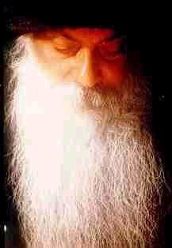

Satchi attended his only and The last Satsang with OSHO on January 16th 1990.

Satchi attended his only and The last Satsang with OSHO on January 16th 1990.

It is very difficult to get to see genuine Gurus. My one and only chance to see Osho was being stopped by a guard at the Gate. He said I had a ticket so I could go in, but Devi did not, so she could not go in!! So we said where are the tickets but the place was closed - therefore no tickets. So I stood in front of him and stared at him. Soon the sweat was dripping down his face. He was really grateful to be relieved of duty by another guard. As soon as he went, the guard said, "You can both go in!!"

During the Satsang, Satchi had the experience of seeing Osho's aura. Satchi's mind just stopped, during the satsang when Nivedano hit the drum. As it stopped he saw the physical aura of Osho, Yellow, Black and horrible just one inch away from his skin. I suppose this is my vision of the poison which killed him, Satchi said.

But then the spiritual aura came out, white and filled with light up to 10 feet away from Osho and then Whoof!! It spread out over the whole of the Buddha hall and filled it with white light.

Satchi said he just sat there, tears falling down his face for what seemed forever.

Osho died 2 days later.

Father Bede Griffiths

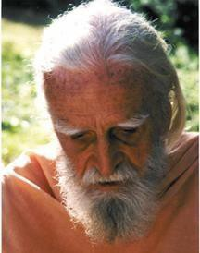

And then at the "Satchidananda" Ashram of the Bendictine Father Bede Griffiths on the banks of the River Cauvery in Tamil Nadu in Southern India. More energy phenomena. Father Augustine was giving mass and as usual Satchidanand, not a Catholic, with a Ho Hum lack of respect was there. As Augustine raised the Chalice to heaven, Satchidanand saw a ray of lightning hit the chalice, bounce off and deflect into his heart center. This had the effect of making him burst into tears.

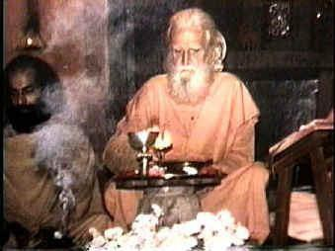
Father Bede, a famous monk who wrote many books exemplified the urge of the Benedicines to Ecuminise, to explore the Energies of the Hindu Religion, where he took Sannyas, taught from the Bible, Upanishads and the Gita, "its all in the explanation!" had his first heart attack 2 days later at the age of 96 and died 3 months later.

Swami Satchidananda

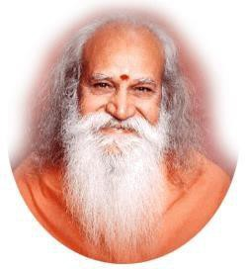

And then 2 days before Satchi's Master, Swami Satchidananda, died at the untimely age of 89, Satchi felt the transmission of Energy from his Master. Filled with white light for 3 days in a row, in the middle of the night for hours, unable to sleep.

Masters get given energy on the death of other Masters. Masters get given and store up energy, the energy of enlightenment, the energy of transmission, the high level atomic energy given by the scepter of Initiation by Sanat Kumara.
They store energy all their lives to do their work and to give to other people all of their lives. Upon their death, that energy needs to pass onto their successors. And that Energy transmission is what helps to create the next generation of Masters.

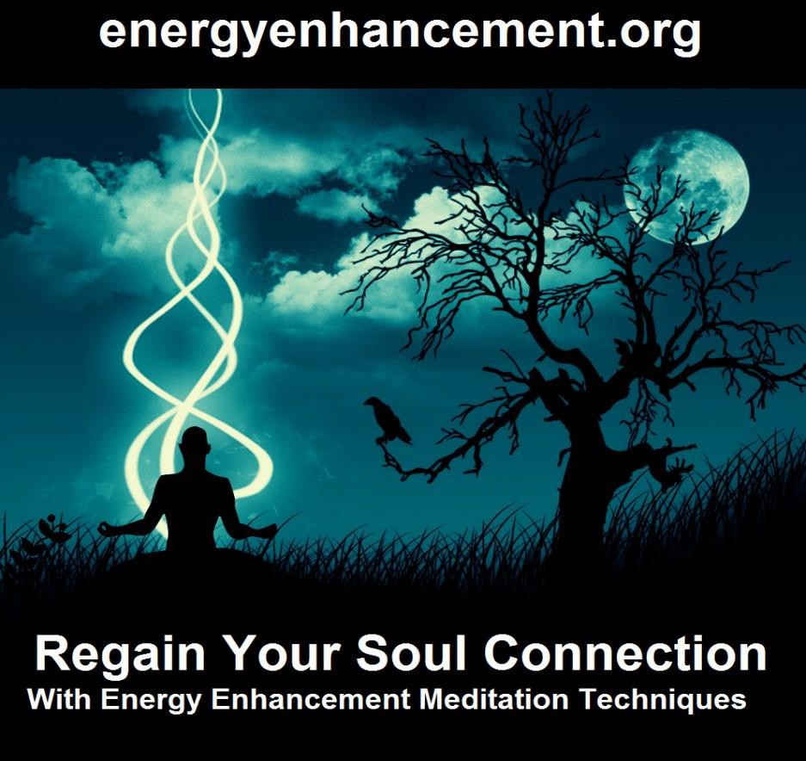

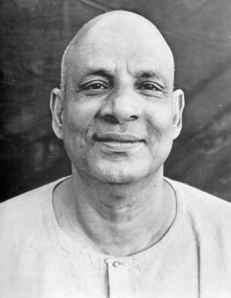
Swami Satchidananda said the same thing happened to him when his Master, Swami Sivananda Died.
Satchidananda was in Celon at the time and the Dying Sivananda was in the Himalayas, but the energy still passed to him.

Masters take no heed of which religion they are born into. They become channels for the light despite, or rather because of, the general low energy level of the world and its corruption and mixedness. It is their job to raise the energy of their students and of the world in the few short days before they leave this planet. To leave it a better place than when they came.

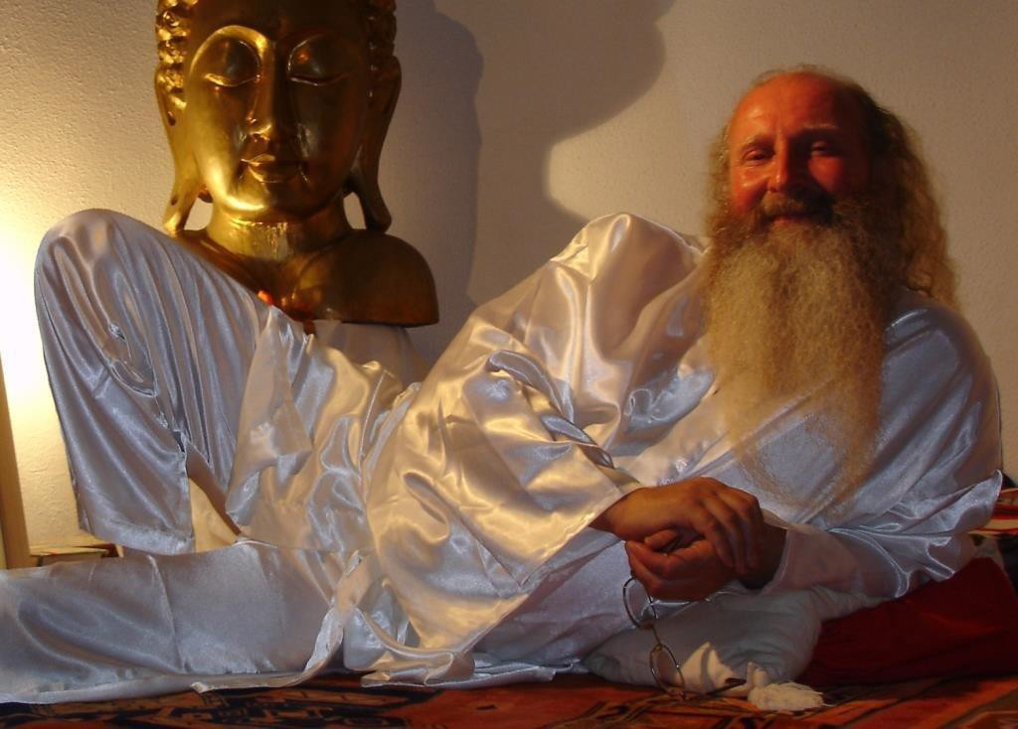
SATCHIDANAND IS A SERIOUS STUDENT OF ENLIGHTENMENT HAVING BEEN TAUGHT BY ZEN MASTER HOGEN OF JAPAN AND SWAMI SATCHIDANANDA OF VIRGINIA - YOGIRAJ AND STUDENT OF SWAMI SIVANANDA OF RISHIKESH

In the presence of his Buddhafield, people naturally become better.

He has visited India many times for up to a year at a time with his partner, Devi Dhyani taking India Tours to many spiritual energy points.

He helps people worldwide reach further than they EVER thought possible....FASTER!!!

"Having been on a 10 day Goenka Vipassana silent retreat where I meditated for 8 hours a day I can say that coming to stay with Satchi and Devi is so much more grounded in everyday life. The difficulty in spiritual life is balancing the material and spiritual worlds effectively.

Energy Enhancement does not promote a spirituality that grows only in the mountains, apart from the cities and the hustle and bustle of everyday life. It shows you how to integrate the peace of retreat with the activity of life - work, relationships, enjoyment, and spirituality - there should be no separation!

Satchi and Devi are both inspiring, wonderful examples of how to achieve this integration. No ascetic renunciation here! Only energy; how to get more of it, how to connect." PAUL - STUDENT 2004

At the age of 14 Satchidanand went into a state of Altered consciousness when he experienced his own death. After that Satchidanand started practising yoga from the age of 15 in 1967 and was taught meditation by Zen Master Hogen in 1980. He was given many typical spiritual experiences which you can read about below on this page by his Master Swami Satchidananda, Yogiraj and Disciple of Swami Sivananda of Rishikesh.

And then more experiences in the presence of Sri Yogendra of Bombay, Father Bede Griffiths, Osho and
Sathya Sai Baba, before receiving his own Initiation and finding his own spiritual experience in Enlightenment - "Although I am just a normal person I feel a deep reverence for the energy which

has been given to me to help the Spiritual Growth of all beings. I feel a tremendous responsibility for its correct action in the world. This Spiritual Energy and Kundalini is worthy of the deepest respect!" Satchidanand.

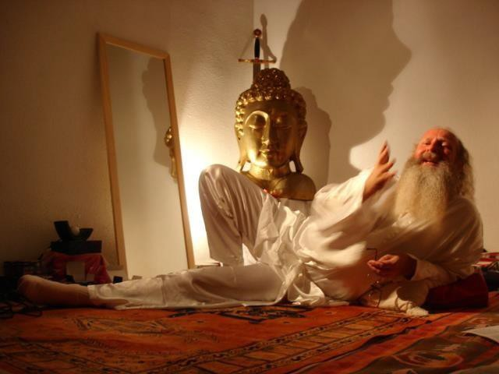
SATCHIDANAND TEACHING ON THE SEPTEMBER ENERGY ENHANCEMENT COURSE AT THE SOL CENTER IN SPAIN

THE BUDDHAFIELD AND KUNDALINI
The Buddhafield of Satchidanand spreads its potent energy by means of powerful spiritual vibrations from the highest sources from chakras above the Crown Chakra: The Soul, The group Soul AND higher than the Avatar of Synthesis.

This Buddhafield energy spreads from the Aura of Satchidanand to imprint His Psychic Charge in his Energy Enhancement Online Book, his Audio Talks, his Video Talks and also the Sacred Dances of Devi Dhyani, Indeed the whole Energy Enhancement Video Course is imprinted with the Buddhafield as taught by Satchidanand.

Your access to the higher energies of the Buddhafield makes more possible during your meditations. The Buddhafield creates the possibility of Kundalini experiences. It, as well as the Advanced Techniques of Energy Enhancement give you more energy to Speed Up the Meditative Process.

Meditation Courses The Energy Enhancement Meditation
Course Symbol from the Synthesis of Light- Satchidanand does not believe he is special in any way, just lucky. He says, "I am just a another guy who has been added unto. I am just a custodian of the energies which have been given to me by the many Enlightened masters I have encountered, Roshi Hogen Daido Yamahata, Swami Satchidananda of Yogaville, Sri Yogendra of Bombay, Sri Sathya Sai Baba, Osho and Father Bede Griffiths, and also into which I have been Initiated by the highest Ascended Masters of Enlightenment.
Before being given energy, first you must prove yourself. Be tested and found to be true. I am just a Channel for the higher energies which expand my aura as a Buddhafield of Energy whose integrative effect is now quickening and speeding up all the spiritual practises it touches in all my students and throughout the world."

The Buddhafield is just an expression of what is already happening here on this small planet.

Indigo and Crystal Children like Devi and I have always been sent to this planet over thousands of years and are being sent in Greater and Greater numbers to this Planet. Indigo and Crystal Children will need an advanced training like that which is available on the Energy Enhancement Course if they are to fulfill their potential.

This is an amazingly auspicious time for every soul who wishes to evolve, here, now!! Incredible opportunities are available for speedy evolution. If you have ever wanted to enter into the spiritual path, to make this change in yourself, NOW is the time. Vast Spiritual energies are, for the first time in eons, being sent to this planet and more enlightened people are necessary to be trained how to handle them.

Side effects are an increase in IQ, more emotional stability, more energy, more GO!! Satchidanand has been equipped to give this training with the Energy Enhancement Course in Four Levels.

In this one encounter much can happen. All my students know this from their own psychic and spiritual experiences in the Buddhafield. The Speeding up of their Meditative processes towards Enlightenment. The spreading of the Light of Synthesis through the creation of New Nodes of Light. Growing ever stronger with the passage of time, the gaining of strength, energy and Light.

We have to be inwardly rich to give away everything. We need a large spiritual bank account given to us by Masters, Ascended Masters and Existence itself.. The Buddhafield is the expression of that Generosity.

SATCHIDANAND- My background is that I started learning and practising yoga and meditation alone from the age of 16. I practised under enlightened masters Roshi Hogen Daido Yamahata a Zen Master who cleaned my energy system and then

Swami Satchidananda who gave me the energy to get Initiated astrally by Ascended Masters at his ashram.

I then visited enlightened Masters in India who gave me energy before they died. Once even on the day I met them.

Then, after teaching meditation for 10 years with many other energy Initiations from Ascended Masters, Swami Satchidananda passed on some of his energy to me before he died at the age of 89 in 2002.



Now Swami Satchidananda is an Ascended Master. After becoming Enlightened on this planet he gained sufficient Initiations to be able to maintain his consciousness through the death process. This is the only way we can legitimately achieve Immortality, and it is this which we teach with Energy Enhancement. In order to do energy work, to become Enlightened, one must prove trustworthy and show a will to be useful.
The three servants in the bible. One buried his portion in the ground, One wasted it, one multiplied it 100 fold.... So, like any executive in a Galactic organisation, you must be Industrious.
Then, if you are lucky, and to be spiritual, you must be lucky, you get promoted, initiated, energy is given to do the work.
Enlightenment is not enough.

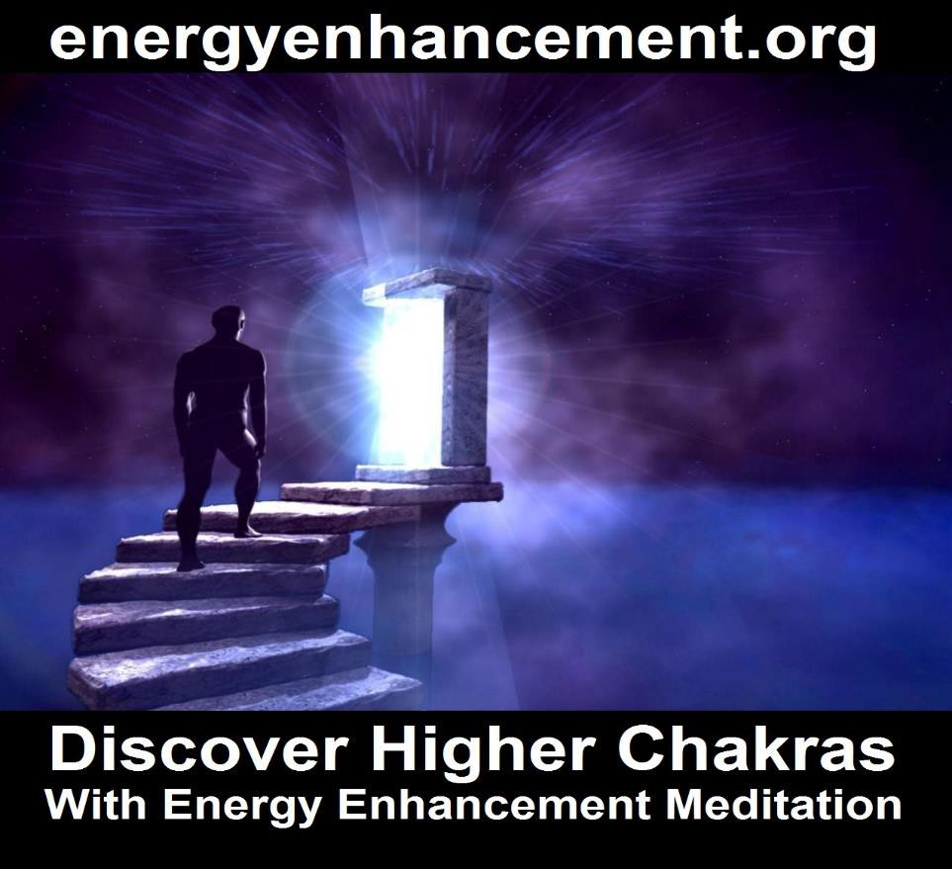

Satchidanand's ENERGY ENHANCEMENT Stories:-
After practising Zazen Meditation with Roshi Hogen Daido Yamahata for a time I began to feel him cleaning my Base Chakra every time I meditated. I was also doing Energy Enhancement techniques at that time which speeded up the meditative process. He used to wake me up early every morning and say "Get out of bed, Meditate Now!!"

Then by accident or by Luck. And to be Spiritual, you have to be lucky. I came across Swami Satchidananda of Yogaville.

I went to one of his talks and at the end of the talk he said "Lets Meditate for a couple of minutes."

So, we chanted Ha Ri OM and started to meditate.

I found myself one hundred feet in the air looking down at my body meditating below.

I looked up and there was Swami Satchidananda one hundred feet higher, saying "Come on up!! Come on up!!"

So I though that perhaps it would be a good thing to learn from him.....

In my interview with him I said what happened and said that I only had one problem in that I had heard that you were only supposed to have one Guru and Roshi Hogen was doing a really good job with me.

Satchidananda asked if I had any problems between the teachings of Hinduism and Zen. I said "NO, no problems!!" because I understood that the terminology of Meditation in Hinduism meant "The flow of Energy towards a Point of concentration" and Meditation or Zen in Japan meant Nirbija Samadhi or Enlightenment.

So he told me that I should think of Hogen and him as two engines on a train. Hogen was the one pushing FROM THE BASE CHAKRA. He was the one pulling FROM THE CROWN CHAKRA.

Hogen was the one looking after the base chakra. Satchidananda was the one looking after the Crown Chakra.

And this was proved to me later in his ashram and indeed everywhere I met him with incredible experiences of the higher planes, of Initiation, of telepathy indeed all the tales of Masters of the past came true when I was with him!!

And when I went on my "Grand Tour" of India I met up "Luckily" with many great Yogis and meditators. And with each one I had a wonderful Spiritual experience.

Sri Yogendra of Bombay had the reputation of not suffering fools gladly. If anyone was disrespectful he used to beat them up and throw them out!!

When he was young they used to put him in darkened rooms so that people could see the Prana, blue, rushing like electricty around his body.

He was 96 years old when I had my Interview with him. All I could do was to sit at his feet and remain quiet whilst he told me of his experiences. Spread out across the Whole Universe. In New York in the Thirties. Healing the children of Millionaires he earned enough to create his Ashram.

For the next day all I could feel was the energy rushing through my body Up and DOWN!! With a great Noise!!

That night, Yogendra told his son. "I can't seem to retain my Prana as well as I should. I think it is time to go!" That night he died.

Same but different experiences with Hogen, Ramana Maharshi, Sri Sathya Sai Baba, Swami Satchidananda, Father Bede Griffiths and last but not least, Osho.

The purpose of Meditation practise is to get you into a state of meditation 24 hours a day. You need ENERGY to do this. You need ENERGY to get you into a state where you can receive more ENERGY!!
As Rumi said. You need to learn how to become a perfect thief!! You need to get quiet enough so that you can steal the energy of the Enlightened.

But the real perfect thief is exemplified in PromeTheus. Like all Enlightened Masters, he steals the fire from heaven and is condemned to have his liver eaten each day by another student thief like an eagle and every night for it to be grown back.

This Fire comes from that Fire. But Fire still remains. - Mandukya Upanishad

To Catch Light yourself. To Become Prometheus.

This is why Energy Enhancement Techniques are needed to Speed up the Meditative Process.

Swami Satchidananda - E GO!! Techniques, like those of Energy Enhancement are also needed.

As Hogen said to me, "Meditate a little every day!"

As Swami Satchidananda said to me, "Meditate regularly for a while and with EnTheosiasm"

As Vivekananda said, "If one person can become Enlightened. If you can recognise that even one person has ever become

Enlightened!! Then know. That YOU TOO, can become Enlightened.

IT IS YOUR DESTINY!!"
ENERGY ENHANCEMENT ADVANCED TECHNIQUES TO INCREASE YOUR SPIRITUAL ENERGY AND SPEED YOUR EVOLUTION TOWARDS YOUR ULTIMATE PEACE AND HAPPINESS!!

The Dragon or the Kundalini Snake are normal visual expressions of Kundalini Energy.

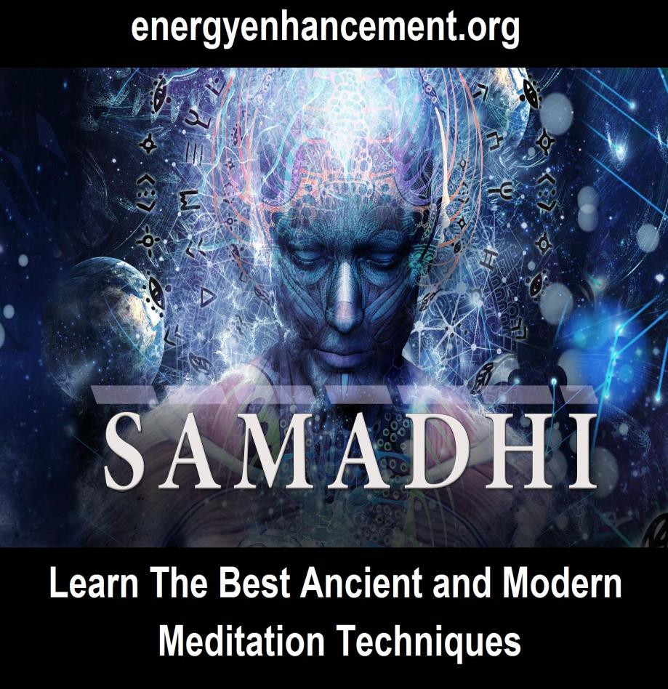



In meditation we can also access our ancient memories of past lives. One of my teachers, Roshi Hogen from Japan, teaches about the rubbish from the past which we access on the astral plane during meditation.

He calls this "Makyo" in the Zen tradition. But he teaches that the experience means something. We have accessed a deeper level.

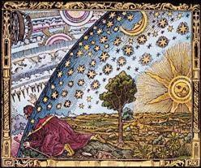

When I came to one of my teachers, Roshi, Zen Master Hogen with my experience of using the Mantra "Who am I", The Koan of Sage Ramana Maharshi of Tiruvannamalai in South India, in a state of profound meditation.

Like a stone thrown into an empty pool, the ripples flow. My experience was of accessing all my past lives in a "Karmasaya" - the bag of our past lives. I could see all of my past lives.

However, I was not interested in this, I told him, and went on further in my meditation into the source.

Zen Master Hogen said indeed that we can waste hundreds of years on exploring the Astral Plane but the information we receive can be meaningless. Usually when we dream we access the very lower levels, the "Telenovella -Coronation Street" the very basement of the Astral plane.

We need to go Further.
We forget lower Astral plane experiences when we die. We need to go on further into the Source to elicit a real change in the psyche. To the "Spring at the Top of the Mountain" which Energy Enhancement teaches in Stage Four of Energy Enhancement.

However, the experience means we have reached something. I remember the experience of seeing Zen Master Hogen’s Aura glow golden and expand with energy at this time. His whole body and around it became surrounded by a beautiful Golden Light.
His higher self was pleased. Another student had accessed something of the beyond. Was moving on. It was good.

But it is not enough.
We can still fall unless we maintain our practise towards even higher stages. The higher we go the further we can fall. Unless we are Enlightened. And in the end, Enlightenment is not Enough!!!

"Energy Enhancement teaches the techniques which can take us all the way."

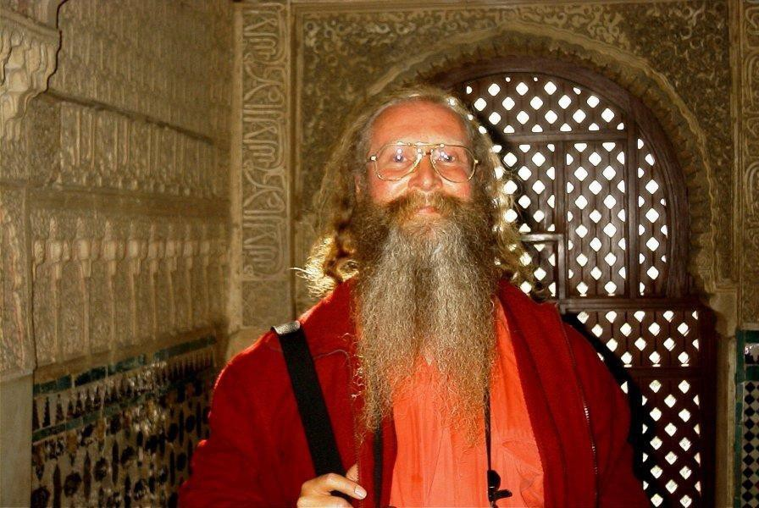

Qualifications
Satchidanand has a BSc in Physics, Mathematics and Electronics, is Reiki Master, Director of the SOL School of Yoga Teacher Training and the SOL School of Energy Enhancement giving Initiations in Meditation, Reiki and Energy Enhancement.

Lectures
Satchidanand has been a Yoga and Meditation teacher for decades, is an inspired teacher, lecturer, story teller and workshop leader, channeling the energy of the Soul and the Monad, Sirius the Star of Jesus Christ and most importantly, the Avatar of Synthesis

The Avatar of Synthesis works towards the integration of every human being towards one Soul Infused personality, Enlightenment, rather than the profusion of ego based sub- personalities which control every human being on this planet at present. All human beings are on the path of enlightenment.

The Avatar of Synthesis works towards the Unification of all the Religions on this planet starting with Ecumenism. As Swami Satchidananda said, "How can the politicians come together when all of the Religions are fighting each other?"

The Avatar of Synthesis works towards a Unified World Republic with one President - a Unification of all the countries towards One Unified and Harmonious World.

Satchidanand has lectured before audiences of Thousands and has been interviewed on Television many times. He has been a tour leader in India for five years meeting and having psychic experiences with many Enlightened Masters. He is the channel for the inspired writings and teachings of Energy Enhancement which are hidden techniques used for thousands of years - 200,000 years of Advanced Spiritual Technology.

Energy Enhancement
Energy Enhancement is a unique system for the next millennium, the result of years of investigation, direct holistic experience and integration from many sources including Taoism, Kriyas, Alchemy and meditation.
These techniques are not generally available.
Fragments of the Energy Enhancement system are available by word of mouth from many different systems extant from over 200,000 years of spiritual success, but it can take years of investigation, a lifetime, to put all these various parts together in one integrated system.

Higher Energies Available
Satchidanand, through access to the higher energies given to him by his Masters, Through special astrological conjuctions present at birth, has the capacity not only to teach techniques which can change the Evolution of you and of the Earth itself, but also has been given the capacity to share these energies with all who come.

354

On the Energy Enhancement Courses, Energy and Kundalini experiences occur to all who work with him.

"I Sing the Body Electric. Let my Armies engirth thee
And Charge Thee full with the Charge of the Soul."

- by Walt Whitman

Energy is All
Although he lectures and teaches Energy Enhancement all over the world, he places the greatest emphasis on the teaching and the Energy, rather than the channel for the Energies of the Universe,- the Simple Master, Satchidanand.

For 20,000 years - yes Tamil from Tamil Nadu in the South of India predates Sanskrit by thousands of years - Tamil Siddars have been at the Heart of Human Evolution. From Tamil Siddar Bhogar of Palani Hill Temple and his Spiritual and physical Alchemy to create Enlightenment and Immortality transmigrating into the body of Lao Tsu to create Taoism.

Bhogars students Babaji/Paramahamsa Yogananda/Lao Tsu - teachers of the same meditational techniques of Kriya Toga and Taoist Meditations.

On the Chinese side of the Himalatas Taoism, disseminated by Bhogar who transmigrated into the body of Lao Tsu.

On the Indian side of the Himalayas the Kriya yoga of Bhogar's student Babaji who then transmitted it to his student Paramahamsa Yogananda.

Kriya yoga and Taoist Meditation are the same Kriya/Taoist orbit/Alchemical VITRIOL practises ro Ground Negative Energies

of Energy Enhancement Level One Initiation Three to the Supragalactic orbut of Energy Enhancement Level One Initiation Four to attain to Samadhi in the Infinite Chakras above the Head - comprising Energy Enhancement Level One

Through to Tamil Siddar Satchidananda who used his Samadhi and Samyama created Buddhafield to Enlighten and introduce to higher beings his student Satchidanand who created and Energy Enhancement. - Yoga Sutras of Patanjali, Book One, Sutra 26 Unconditioned by time, God is the teacher of even the most ancient teachers.

I want to promote the line of Tamil Siddars from Bhogar through his student Patanjali who created what is called Ashtanga Yoga or that is called The Eight Limbs of Yoga ending in Samadhi.

What has failed to be taught by teachers and commentaters of Patanjali Yoga Sutras is the whole of Chapters three and four which focus on the Ninth Limb of Yoga which is Samyama.

Samyama is the focus of the light of Samadhi which flows from Union with God from the infinite chakras above the head - into Sahasrara Chakra and the triangle of Chakras in the Head.

Sahasrara, the Crown Chakra - powering the Will through Ajna Chakra on the brow and the Heart through Bindhu Chara at the back of the head.

By Samyana, focussing the light of God through triangle of Chakras in the Head towards Energy Blockages, Samskaras.vrittis, bijas or the Seeds of the destructive Ego we attain Nirbija Sanadhi, Seedless Samadhi, or Enlightenment.

(Interestingly the word Ego - I, I. I. me, me, me -also comes from the Spanish Higo (the h is silent) and the latin ficum - - the infinite seeded fig)

Samyama is the Seven Step process of Energy Enhancement comprising the whole of Energy Enhancement Level Two - The removal of Energy Blockages, Level Three - the removal of Karna, the Karma Cleaning Process, and Soul Splits to integrate the mind with the Soul and Level Four the removal of Energy Cords and the Mastery of the Psychic Sexual Connections.

The process of the transmutation of Energy Blockages, word angels, ideas, myths is called the three Gunas - Tamas, Rajas, Sattvas and eventually acesses energies higher than the mind - intuition, wisdom, knowing.

A Lawyers mind can create ten reasons for or against any idea. Knowing that which is right, Gyana, real knowledge, requires a meditative cleaning process of the removal of Energy Blockages.

Once all the Energy Blockage seeds of the Ego are transmuted then the Light of God has no resistance to its flow in Dharmamega Samadhi - the Shower of Flowers of EnLightenment.

The new evolution of humanity starts as the size of the psychic body is increased through the transmutation and incorporation of more Energy Blockages - in order to transmit more and higher vibrations of Spiritual Energy to humanity - The Energy Enhancement Buddhafield.

I want to promote Tamil Siddar Vainamonen and his links to the Norse Sagas and J.R.R.Tolkien.

J.R.R. Tolkien identified the eternal battle between good and evil "applicable" to this planet in particular the psychic effect on humanity of Sauron/Satan

Tolkien's Sauron/Satan who lives out of the body atop a Watchtower "The Great Eye" in the line of Black Magician, Doctor Dee who taught how to live outside the body atop the Enochian Key Watchtower taught by Crowley, "The great Beast 666"

To live outside the body eternally, Black Magicians teach psychopathically to cut ff from God Conscience, cut off from Heart Empathy outside the body on the psychic planes..

Here is a Quote by Crowley: “ … the bloody sacrifice, though more dangerous, is more efficacious; and for nearly all purposes human sacrifice is the best … by sacrificing a female lamb one would not obtain any appreciate quantity of the fierce energy useful to a Magician who was invoking Mars. In such a case a ram would be more suitable. And this ram should be virgin — the whole potential of its original total energy should not have been diminished in any way. For the highest spiritual working one must accordingly choose that victim which contains the greatest and purest force. A male child of perfect innocence and high intelligence is the most satisfactory and suitable victim.”

"For the highest spiritual working one must accordingly choose that victim which contains the greatest and purest force" The aim of the real Black Magicians is to steal, vampirise spiritual energy - in this case by, rape, torture, murder of innocence.

But know, Energy Enhancement Meditation is the most powerful meditation, the only meditation capable of protecting you from the slow vampirisation of every man woman and child on this planet.

Black Magicians believe they can live outside the body eternally but Patanjali exposes this LIE.. Yoga Sutras of Patanjali, Book One, Sutra 19. Those who merely leave their physical bodies and attain the state of celestial deities, or those who get merged in Nature, have rebirth.

Tolkien's Sauron/Satan is trying to download into a body, to possess a body and here they have more success.. Yoga Sutras of Patanjali, Book Three, Sutra 39. By the loosening of the cause (of the bondage of mind to body) and by knowledge of the procedure of the mind- stuff's functioning, entering another's body is accomplished.

To facilitate the vampirisation of energy it is better to create a degenerated humanity by sex, drugs and rock and roll - the aim is to transmute humanity into orcs.

J.R.R. Tolkien identified in his 1936 lecture on the Saga "Beowulf: The Monsters and the Critics" a "Northern 'theory of courage'"—the heroic or "virtuous pagan" insistence to do the right thing even in the face of certain defeat without promise of reward or salvation:

"Enlightenment is the free will ONLY to do the right and good thing" - Satchidanand

For thousands of years through cults, myths, fake news, the conscious degeneration of any real meditation practise - "the Matrix which has been pulled over our eyes to protect us from the truth" - Morpheus - we have never understood that our only function is to provide all our spiritual energy for the Black Magicians so they can try to live outside the body forever..

How do I know this? Because I see it.
Because my Master, Swami Satchidananda, said, "Meditation is the creation of psychic vision!!

Get the Energy Enhancement psychic vision. See reality for yourself!!

Energy Enhancement LEVEL 1 Immortality - Gain Infinite Energy from the Chakras above the Head - Power UP!! Gain Super Samadhi Kundalini Alchemical VITRIOL Energy. Ground All Negative Energies. Access Quantum Immortality http://www.energyenhancement.org/Level1.htm

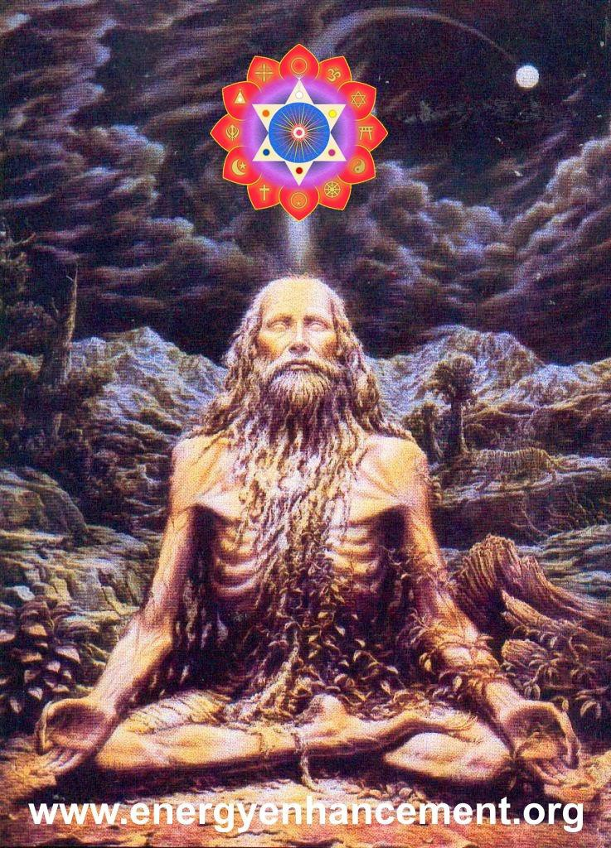

Energy Enhancement LEVEL 2 - The Energy Enhancement Seven Step Process to Totally Remove Energy Blockages, Totally Remove Negative Emotions, Heal Your DNA, Remove your Karma http://www.energyenhancement.org/Level2.htm



Energy Enhancement LEVEL 3 - Eliminate Energy Blockages - The Removal of Strategies. Quantum Integration. The Karma Cleaning Process to Totally Eliminate All Your Karma!! http://www.energyenhancement.org/Level3.htm



Energy Enhancement LEVEL 4 - Stop the Suck!!
Heal the Family!! MASTER ENERGY CONNECTIONS AND RELATIONSHIPS
http://www.energyenhancement.org/Level4.htm



EE LEVEL 5 CREATE IMMORTALITY
http://www.energyenhancement.org/IMMORTAL- VAJRA-DIAMOND-BODY-CREATING- IMMORTALITY-WITH-ENERGY- ENHANCEMENT-THE-ELIMINATION-OF- ENERGY-BLOCKAGES.htm

